Hepatitis C Elimination in Georgia: Identification, Care and Treatment of Persons Infected with Hepatitis C Virus, 2015 - 2016

Muazzam Nasrullah MD, PhD¹ ; David Sergeenko, MD²; Lia Gvinjilia, MD, PhD³, Amiran Gamkrelidze, MD, PhD⁴; Tengiz Tsertsvadze, MD, PhD⁵; Maia Butsashvili, MD, PhD⁶; David Metreveli, MD, PhD⁷; Lali Sharvadze, MD, PhD⁸; Maia Alkhazashvili, MD⁴; Shaun Shadaker, MPH³; John W. Ward, MD¹; Juliette Morgan, MD⁹; Francisco Averhoff, MD¹

(Author affiliations at end of text)
¹Division of Viral Hepatitis, National Center for HIV/AIDS, Viral Hepatitis, STD and TB Prevention, Centers for Disease Control and Prevention, Atlanta, Georgia (Corresponding author: Muazzam Nasrullah, snasrullah@cdc.gov , 404-639-3271)
²Ministry of Labor Health and Social Affairs of Georgia
³CDC Foundation
⁴National Center for Disease Control and Public Health of Georgia
⁵Infection Diseases, AIDS, and Clinical Immunology Research Center, Tbilisi, Georgia
⁶Neolab, Tbilisi, Georgia
⁷Medical Center Mrcheveli, Tbilisi, Georgia
⁸Joint Georgian-French Hepatology Clinic Hepa, Tbilisi, Georgia
⁹Global Disease Detection, Division of Global Health Protection, South Caucasus CDC Office, Tbilisi, Georgia.

Total Words: 2129/1400; References: 7/10; Tables/Figures: 3/3

Summary Box

What is already known on the topic?
The country of Georgia has a large burden of hepatitis C virus (HCV) infection. In April 2015, in collaboration with CDC and other partners, Georgia embarked on a program to eliminate HCV transmission and disease by 2020. A key strategy is the identification of HCV infected persons and provision of curative anti-viral therapies.

What is added by this report?
During April 28, 2015-December 31, 2016, a total of 27,595 HCV infected persons started treatment, of which 19,778 (71.7%) completed their course of treatment. Of those who completed treatment, 6,366 (32.2%) were eligible and were tested to determine treatment response, 5,356 (84.1%) were cured of their HCV infection. The average number of persons who initiated treatment increased from 661 per month during the initial phase of program when treatment was limited to persons with severe liver disease, April, 2015-May, 2016, to 2,619 per month during June-December, 2016, following the liberalization of the eligibility criteria to allow treatment of all HCV infected persons. However, during the last three months of 2016, the number of persons entering the treatment program declined steadily, suggesting that identification and linkage to care of HCV infected persons in the country may be slowing.

What are the implications for public health practice?
The Georgia HCV Elimination Program has made significant progress since it was launched in April 2015, and the country has demonstrated the ability to rapidly scale-up care and treatment services. The data highlight the need for the program to enhance HCV testing and linkage to care services in order to stay on track to reach elimination by 2020. This will require the need to develop and implement innovative strategies which can provide important lessons for other countries embarking on HCV elimination and facing similar challenges.

The country of Georgia has a large burden of hepatitis C virus (HCV) infection with 5.4% of the adult population living with active HCV infection [1]. In April 2015, Georgia embarked on an HCV elimination program with support from CDC and other partners. The goal of the program is to achieve a 90% reduction in HCV prevalence by 2020 [2, 3]. To reduce prevalence, and morbidity and mortality, a key strategy of the program is the identification of HCV infected persons through testing and linkage to care and treatment. Direct acting anti-viral (DAA) medications are provided at no cost to the program through a partnership with Gilead Sciences. Over 470,000 screening tests have been conducted since 2015. Initially, HCV infected persons with advanced liver disease were prioritized for treatment, this was followed by a liberalized eligibility criteria starting June of 2016 allowing treatment of all HCV infected persons, regardless of disease severity. From April 2015 through December 2016, a total of 30,107 HCV infected persons completed a diagnostic workup and were eligible for treatment. The number of persons entering the program and initiating treatment increased dramatically following the liberalization of eligibility criteria in June of 2016, peaking in September (n=4,595); however, the monthly number initiating treatment declined steadily from October (n=3,691) through December (n=2,138). Through December 2016, 19,778 (65.7%) had completed their course of treatment, of which 6,366 were eligible for and received polymerase chain reaction (PCR) testing for HCV RNA at least 12 weeks after completion of treatment; of these, 5,356 (84.1%) had no detectable virus, indicative of a cure of their infection. Georgia has made great strides in increasing the treatment capacity. Strategies to enhance identification of persons living with HCV infection and linking them to care and treatment are needed to reach the 2020 elimination goals. The government of Georgia has developed a comprehensive strategic plan that includes screening and linkage to care and treatment; the strategic plan provides a roadmap to reach the elimination goals. Lessons from Georgia’s model program on HCV elimination can help guide other countries with a high burden of HCV infection to undertake similar initiatives.

Globally there are an estimated 71 million people living with chronic HCV infection of which an estimated 400,000 die annually, primarily due to the sequelae of chronic infection, primarily cirrhosis and hepatocellular carcinoma [4]. Most new infections result from unsafe health-care practices and injection drug use [4]. Georgia, a middle-income country at the cross-roads of Europe and Asia, has a high prevalence of HCV infection (7.7% anti-HCV+, and 5.4% RNA positive) [1]. Georgia with strong stakeholder support, including partnership and technical assistance from the CDC, and commitment from Gilead Sciences to donate DAAs free of charge to treat all Georgians infected with HCV, launched the world’s first HCV Elimination Program on April 28, 2015 [2, 3]. The elimination goal set by the country is the reduction of HCV prevalence by 90% in 2020. The initial phase of the program was focused on providing HCV treatment to infected persons with advanced liver disease (F3 or F4 by METAVIR fibrosis score and/or FIB-4 score >3.25 [5]) that were at highest risk for HCV-associated morbidity and mortality [2, 3], followed by treatment for all HCV infected persons, regardless of disease severity, beginning June, 2016.

At the time of the launch of the elimination program, only four treatment centers located in Georgia’s capital Tbilisi were providing HCV care and treatment as part of the program. By December 31, 2016, the number of treatment centers had increased to 27 throughout the country. Services provided to the patients include diagnostic, disease staging, and care and treatment. Non-invasive tests including FIB-4 score [5], and ultrasound or transient elastography [6] are used to determine the degree of hepatic fibrosis. A sliding-scale approach is used for diagnostics and clinical monitoring services, with patients charged based on their ability to pay and the local government or Ministry of Labour, Health, and Social Affairs (MoLHSA) paying the balance [3]. All program participants receive DAAs, initially only sofosbuvir (SOF)-based treatment regimens, followed by sofosbuvir/ ledipasvir (SOF/LED)-based regimens beginning in March of 2016; the Georgian government purchases additional medications (i.e., pegylated interferon and ribavirin), if indicated and provides them at no cost to program participants [3]. In addition to the treatment program, Georgia has also developed a comprehensive strategic plan to guide efforts for reaching the elimination goals.

HCV screening has been conducted at several sites and programs since 2015 (Figure 1). These screening programs utilize HCV rapid tests and are free of charge to the public. From January, 2015 through December, 2016 a total of 472,890 rapid HCV tests have been reported, and 50,962 (10.8%) were reported as positive for HCV antibody. Programs that provide harm reduction services such as opioid substitution therapy and needle and syringe provision to people who inject drugs (PWID) reported the highest rate of anti-HCV positive results (45%) than any of the programs. Data on individuals testing positive through the screening programs being linked to the treatment program are not available.

During April 28, 2015–December 31, 2016, a total of 58,223 patients with evidence of HCV infection (positive HCV antibody test results) presented to the treatment program for determination of eligibility. Of these, 38,113 (65.5%) initiated a diagnostic workup, beginning with confirmation of active HCV infection by polymerase chain reaction (PCR) for HCV RNA (i.e., presence of HCV virus in the blood). Those with confirmed HCV infection by PCR received genotype testing, assessment of hepatic fibrosis, and additional testing to determine eligibility for treatment; 30,107 (79.0%) met the eligibility criteria, and of those 27,595 (91.7%) initiated treatment for HCV. A greater proportion of men (n=23,062; 83.6%) than women (n=4,533; 16.4%) initiated treatment. Treatment initiation also varied by age groups, with the largest number and proportion being men aged 40-49 years (n=9,180, 33.3% of all participants) (Figure 2). The average number of persons who initiated treatment monthly increased nearly 400% from 661 persons per month during April, 2015-May, 2016 to 2,619 persons per month during June-December, 2016, after the liberalization of the eligibility criteria allowing treatment of all HCV infected persons, regardless of disease severity. However, the number of persons who initiated treatment peaked in September 2016 (n=4,595) and then declined from October to December 2016 (Figure 3). This trend paralleled the decrease in persons entering the treatment program following confirmation of HCV infection by PCR (data not shown). During April, 2015-May, 2016, the majority of persons who initiated treatment, 9,088 (98.1%) had advanced liver disease (≥F3 METAVIR fibrosis score and/or FIB-4 score >3.25), while from June 1 to December 31 2016, most, 14,381 (78.4%) people initiating treatment had less severe liver disease (<F3 METAVIR fibrosis score and/or FIB-4 score <1.45) (Figure 3).

As of December 31, 2016, of 6,366 persons who completed treatment and were tested for HCV at least 12 weeks after completion of treatment, HCV RNA was undetectable (Sustained Virologic Response [SVR]) in 5,356 (84.1%), indicating a cure. Of those who received SOF-based treatment regimens (3,793/4,774) 79.5% achieved SVR, while persons who received SOF/LED-based treatment regimens (1,563/1,592) 98.2% achieved SVR.

Among those who initiated treatment, 537 did not complete the treatment course; the leading causes for discontinuation included 371 (69.1%) who died during treatment, and 83 (15.4%) who discontinued treatment because of an adverse event.

DISCUSSION
The Georgia HCV Elimination Program has made significant progress since it was launched in April 2015. Notably, with the expansion of treatment sites and by expanding eligibility criteria so that all patients can be treated regardless of level of liver disease which resulted in the monthly average number of patients initiating treatment increased by nearly 400% during the second half of 2016. While patients with advanced liver disease only were enrolled in the program until May 2016, the loosening of the eligibility criteria in June 2016 resulted in a major shift in severity of liver disease among patients starting the treatment . In addition, the introduction of SOF/LED-based regimens has greatly improved cure rates, approaching 100%, for those completing their treatment and receiving PCR testing at least 12 weeks following completion of treatment. More men than women were treated, reflecting the epidemiology of HCV in the country, where men are four times more likely to be HCV infected than women [1]. The age distribution of persons being treated also is reflective of the epidemiology, where infection rates are highest among persons 30–59 years of age [1]. Data presented in this report also showed that since 2015 nearly 500,000 screening tests have been conducted and over 10% of those were positive. Ominously, enrollment in the treatment program declined during the last three months of 2016. This suggests that the program, initially focused on providing care and treatment to persons with severe liver disease, followed by a relaxation of the eligibility criterial allowing all HCV infected persons to be treated, now needs to identify and link to care HCV infected individuals who may not be aware of their infection, and/or are less motivated to seek care and treatment if aware of their infection because of no symptoms. This highlights the need to focus efforts not only on identification of persons infected with HCV through screening, but the need to link them to the care and treatment program, once identified.

There are an estimated 150,000 adults living with HCV in Georgia [7]. Through 2016, approximately 20% of people living with HCV have entered the treatment program, therefore to reach the 2020 elimination goal of 90% reduction in prevalence, there is a need for major efforts in identifying infected persons and linking them to the treatment program. The screening programs in the country are not currently linked to the treatment program; there is no way to know how many of the 47,000 positive screening tests resulted in persons presenting for confirmation of infection and entry into the treatment program if infected. Innovative strategies coupled with technologic advances that ensure persons testing positive in a screening program are linked to the treatment program, are urgently needed. Data from the 2015 seroprevalence survey identifies regions with higher infection rates, and characteristics of persons, including age (30–59 years) and sex (males), at highest risk of being HCV infected [1], allowing for precise targeting of screening and linkage to care efforts. These data can guide future screening and linkage to care efforts. Screening and linkage to care efforts that target persons over age 30 years and high-risk populations, such as PWID, were recommended by the Technical Advisory Group (TAG) during the 2nd annual meeting in October, 2016 [8]. Following these TAG recommendations, the government of Georgia is actively taking steps to improve screening and linkage to care, including updating national screening recommendations and exploring innovative strategies.

A robust information systems that provide high quality and timely treatment data has been critical in monitoring patient care, treatment outcomes, and identifying challenges. Currently efforts are underway to enhance information systems in the screening programs, and eventually link these systems to the treatment program, which could improve monitoring, efficiency, and effectiveness of the overall program.

A comprehensive Strategic Plan for Elimination of Hepatitis C [7] in Georgia was developed by the Georgian Ministry of Labour, Health, and Social Affairs, Georgia (MoLHSA) in close collaboration with the CDC, and other international partners. The strategic plan provides a roadmap for reaching HCV elimination in Georgia and will be key to addressing other priority areas.

Georgia is on track to successfully achieve HCV elimination; it has a small population, high burden of disease, highly motivated government and civil society, donation of DAAs from Gilead Sciences, technical assistance from CDC, and support and collaboration from an increasing number of partners. While current treatment regimens have been highly effective, pan-genotypic DAAs that are associated with high rates of virologic cure regardless of HCV genotype [9] may be soon available in Georgia. Pan-genotypic regimens provide an opportunity to greatly simplify diagnostics, treatment, and monitoring, reducing the burden on the patient, the health system, and costs. Lessons learned from this model elimination program can inform similar initiatives in other low- and middle-income countries considering embarking on HCV elimination. The lessons from Georgia will evolve as screening strategies, diagnostics, information systems, and treatment options continue to improve and are implemented and evaluated.
References
1. Hagan L, Kasradze A, Salyer SJ, Gamkrelidze A, Alkhazashvili M, Chanturia G, et al. Hepatitis C Virus Seroprevalence Survey in the Country of Georgia. American Association for the Study of Liver Diseases; Boston, Massachusetts, USA, Nov 11-15. 2016.
2. Mitruka K, Tsertsvadze T, Butsashvili M, Gamkrelidze A, Sabelashvili P, Adamia E, et al. Launch of a Nationwide Hepatitis C Elimination Program--Georgia, April 2015. MMWR Morb Mortal Wkly Rep. 2015; 64: 753-7.
3. Gvinjilia L, Nasrullah M, Sergeenko D, Tsertsvadze T, Kamkamidze G, Butsashvili M, et al. National Progress Toward Hepatitis C Elimination - Georgia, 2015-2016. MMWR Morb Mortal Wkly Rep. 2016; 65: 1132-1135.
4. World Health Organization. Hepatitis C factsheet no. 164. 2017 [cited 2017 May 19]; Available from: http://www.who.int/mediacentre/factsheets/fs164/en/.
5. Vallet-Pichard A, Mallet V, Nalpas B, Verkarre V, Nalpas A, Dhalluin-Venier V, et al. FIB-4: an inexpensive and accurate marker of fibrosis in HCV infection. comparison with liver biopsy and fibrotest. Hepatology. 2007; 46: 32-6.
6. Afdhal NH. Fibroscan (transient elastography) for the measurement of liver fibrosis. Gastroenterol Hepatol (N Y). 2012; 8: 605-7.
7. Ministry of Labour Health and Social Affairs of Georgia. Strategic plan for the elimination of hepatitis C virus in Georgia, 2016-2020. 2017.
8. 2nd Hepatitis Technical Advisory Group (TAG) recommendations for the Georgia hepatitis C Elimination Program, Tbilisi, Georgia 2016.
9. U.S. Food and Drug Administration. FDA approves Epclusa for treatment of chronic Hepatitis C virus infection: First regimen to treat all six major HCV genotypes. 2016 [cited 2017 May 5]; Available from: https://www.fda.gov/newsevents/newsroom/pressannouncements/ucm508915.htm.

Figure 1: Number (n=472,890) of screening tests and percent testing HCV positive, by screening program, Georgia, January 1, 2015 - December 31, 2016
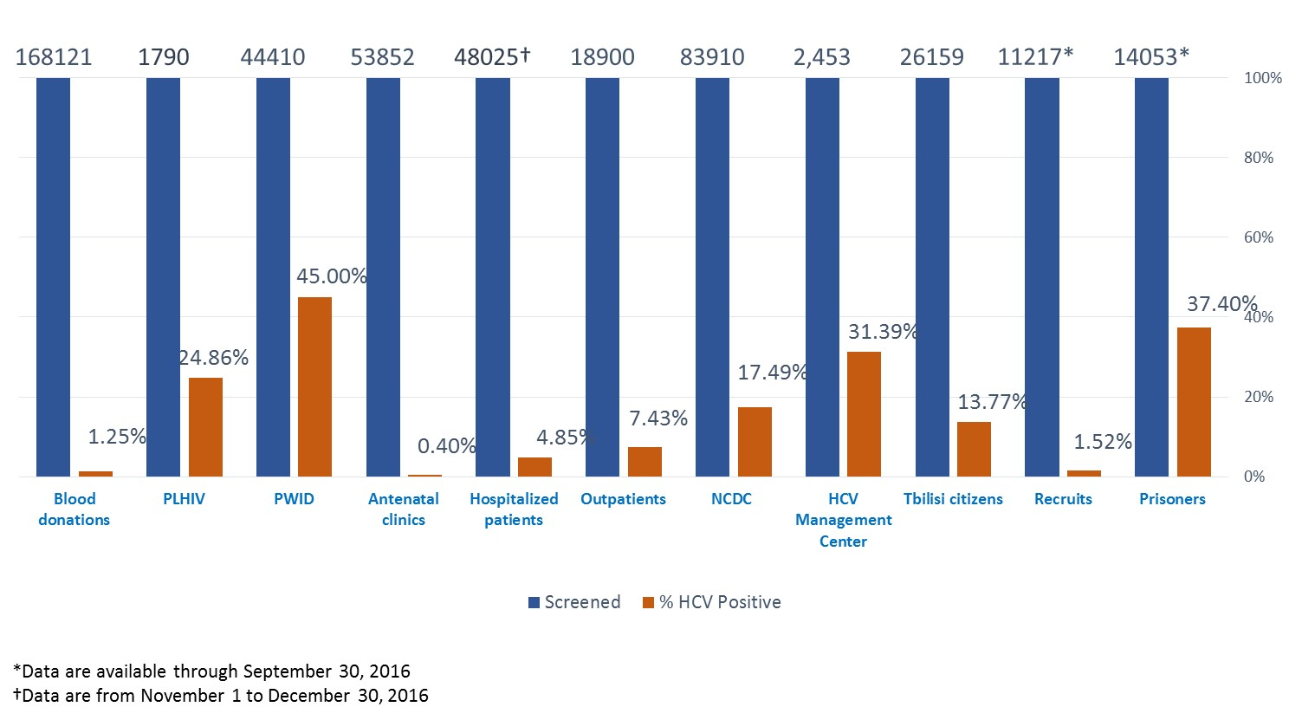
Abbreviations:
PLHIV: People living with HIV
PWID: Persons who inject drugs
NCDC: National Centers for Disease Control and Public Health
Figure 2: Number of hepatitis C virus (HCV)-infected persons who initiated anti-viral HCV treatment (n=27,595) by age groups and sex — nationwide HCV elimination program, Georgia, April 28, 2015–December 31, 2016

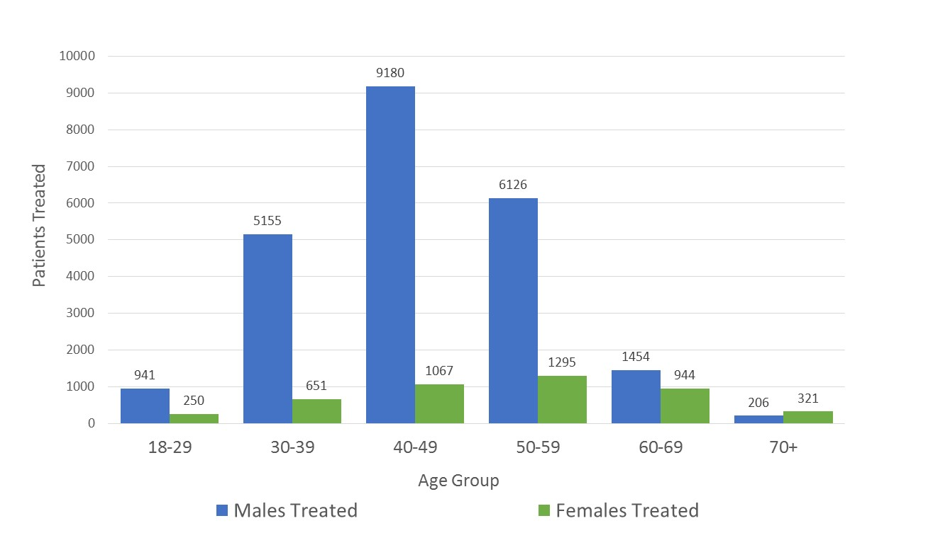

Figure 3: Number of persons with HCV infection who initiated anti-viral HCV treatment (n=27,595), by month — nationwide HCV elimination program, Georgia, April 28, 2015 - December 31, 2016
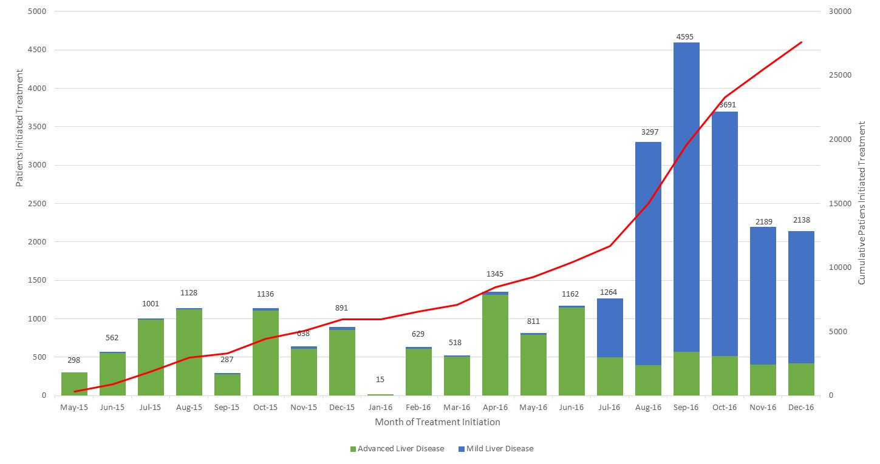
Advanced liver disease: ≥F3 METAVIR fibrosis score and/or FIB-4 score >3.25
Mild liver disease: <F3 METAVIR fibrosis score and/or FIB-4 score <1.45

The METAVIR score is a semi-quantitative classification system that consists of an activity score and a fibrosis score, specifically designed and validated for patients with HCV (Bedossa P et al., 1996)
A total of 10-15 experts in the field of viral hepatitis prevention and control from outside the country of Georgia serve as members of TAG
Georgian Harm Reduction Network, World Health Organization, Extension for Community Healthcare Outcomes (ECHO), Liver Institute and Foundation for Education and Research (LIFER), Foundation for Innovative Diagnostics (FIND), Médecins du Monde (MDM), Abbott

