Epidemiological situation of Rabies in Georgia and in some other countries

- Rabies - acute zoonotic viral disease, which is distributed in more then 150 countries and territories.
- Dogs are the main source of human rabies deaths, contributing up to 99% of all rabies transmissions to humans. 40% of people bitten by suspect rabid animals are children under 15 years of age.
- Rabies elimination is feasible through vaccination of dogs and prevention of dog bites.
- Tens of thousands die every year from this infectious disease, mainly in Asia and Africa. According to the data of WHO 2015, 7 cases of rabies were registered in Algeria, 854 in China, 4 in Iran, 8 in Madagascar, 236 in Philippines, 19 in Sri Lanka, 23 in Uganda, 78 in Viet Nam, 16 in Zimbabwe, and 800 in Cambodia. There is a particularly difficult situation in India where 20565 people died from rabies in 2015. Countries free of Rabies in Asia – Japan, Malaysia, Oman, Qatar
- 3 cases of rabies in Brazil, 2 in Columbia, 3 in Guatemala, 8 in Haiti, 2 in Mexico, 15 in Peru were registered in 2016, in Americas. Countries free of Rabies: French Guinea, Uruguay and Jamaica.
- It should be noted, that in poor countries, where accessibility of veterinary and medical services is limited, the registration of rabies cases is imperfect.
- It has been already 40-50 years that rabies cases are not being registered in a different Northern American and European countries. This epizootic and epidemiological situation was achieved by accessibility of human anti-rabies treatment, full vaccination coverage of domestic animals and implementation of oral vaccination in wild animals. Countries free of Rabies in Europe: UK, Scandinavian countries, Spain, Portugal.
- WHO, the World Organisation for Animal Health (OIE), the Food and Agriculture Organization of the United Nations (FAO) and the Global Alliance for Rabies Control (GARC) have established a global “United Against Rabies” collaboration to provide a common strategy to achieve "Zero human rabies deaths by 2030".

Rabies cases in Georgia

During ten-year period - 1997-2006, 96 cases were registered, after the decate, in 2007-2016, 42 hydrophobia cases were recorded, the number of cases decresed 2,3 times.

Human rabies cases in Georgia, 1997-2016 (Absolute Numbers).
1997- 12;
1998-4;
1999-13;
2000- 7;
2001-10;
2002-10;
2003-11;
2004-12;
2005-10;
2006-7;
2007-10;
2008-7;
2009-6;
2010-5;
2011-3;
2012-3;
2013-4;
2014-4;

Human rabies cases upward trend reached the maximum number in 1996, by then 21 people died from this disease. Since 2015, there are no human rabies cases registered in Georgia.

The number of persons who received anti-rabies vaccination varied by years from 35000 to 49000. Specifically: in 2016 anti-rabies prophylaxis was provided to 48786 affected persons (90%); among them, 19,2% of the affected persons received combined anti-rabies prophylaxis (vaccine + immunoglobulin). These medical services are provided under the state program.

Anti - rabies prophylactic treatment after exposure to animals, according to the type of anti -rabies service, 2007- 2016, Georgia

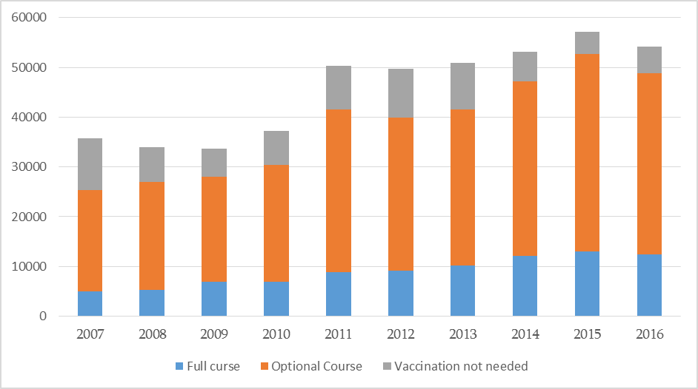

Since 2011, number of affected was steadily high, but from 2016, downward trend was revealed.
Georgia is one of the first in the world for post-exposure anti-rabies prophylactic vaccination rates (per 100 000 1311,3 are vaccinated). Improvement of access to health services without the Regulation of stray / homeless animals, dealing with the issue of vaccination, registration of domestic animals and the improvement of their vaccination coverage is not enough to resolve the problem, as cases of hydrophobia may still reveal.
41794 patient addresed medical services to receive anti-rabial treatment during 9 months in 2017.

In order to reduce the cases of rabies, responsibilities were defined for MoH, MoAg, Ministry of Environment and Natural Resources Protection of Georgia and for local self-governments in the direction of rabies prevention within N690 governmental order (April 14, 2014) on preventive measures against rabies. Within this framework, Ministry of Labour Health and Social Affairs provides regular procurement of anti-rabies vaccine and immunoglobulin and provides it for free for affected ones within the national immunization program.

According to the same framework, National Food Agency initiated the registration of carnivores (cats and dogs), with the relevant marking and massive anti-rabies vaccination campaign. More then 3000 residential areas are covered by vaccination in every region, each year.

Number of vaccinated animals by years

Year | Number of vaccinated animals
2013 | 124,202
2014 | 235,454
2015 | 254,799
2016 | 259,706
2017 (plan) | 289,311

After implementation of these activities, laboratory confirmed cases of rabies cases in dogs were reduced by 48,9% in 2016, with comparison to 2015.

Cases of hydrophobia and rabies in animals, Georgia, 2002-2016

In order to mobilise population, Ministry of Labour Health and Social Affairs conducated press conference on September 28, regarding World Rabies Day (WHO). Additionally, discussions were conducted in educational facilities (kindergartens, schools) on the topics of disease, on the rules of animal care and interaction.
According to the plan, Ministry of Agriculture and Ministry of Environment and Natural Resources Protection of Georgia were tasked to prepare the project of state program for oral vaccination of wild animals with the appropriate financial calculations.

Post-expositional prophylaxis per 100 000 population, in neighbouring countries and lethal cases.

