- Project Title
Harmonization of Blood Safety National Regulations with the EU Legislation under the Association Agreement between the European Union and Georgia

- EU assistance tool
Twinning
- Beneficiary Administration:

- The name of the institution:
LEPL “L. Sakvarelidze National Center for Disease Control and Public Health” (hereinafter The NCDC)

- General structure:

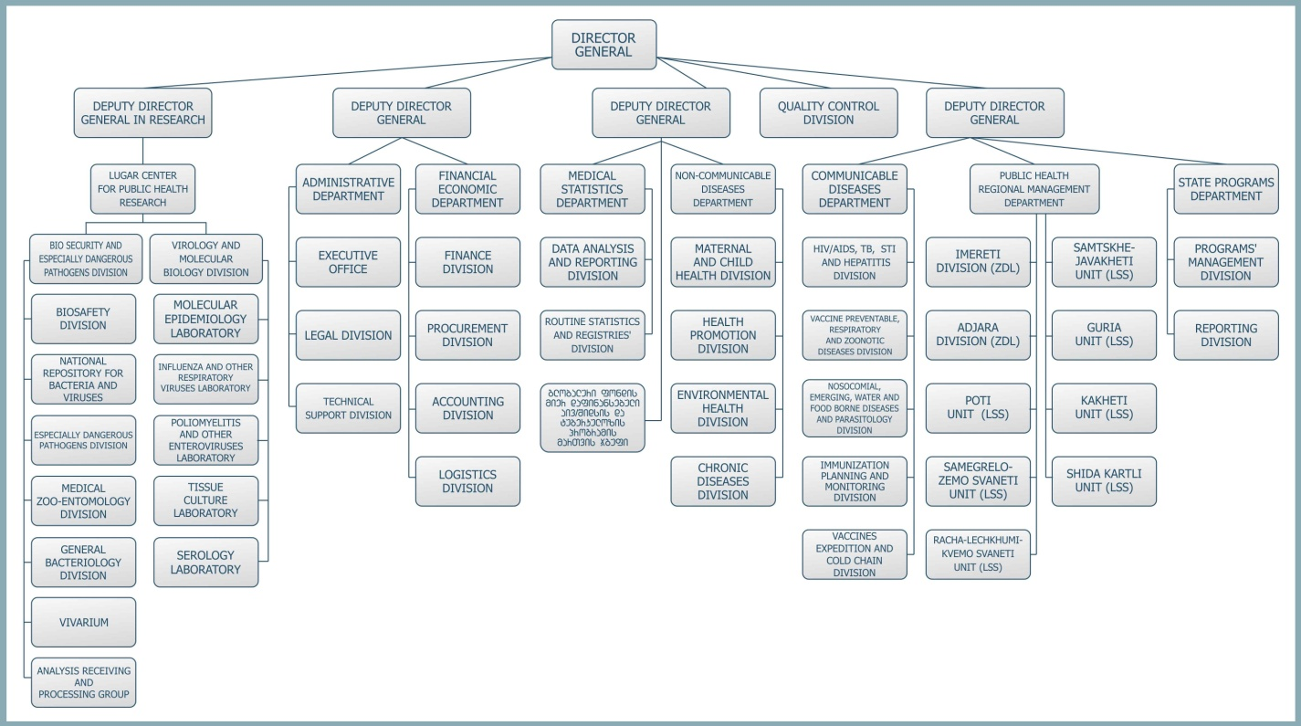

- Number of employees:
436 employees;

- The mandate of the institution:
Protection on public health is a shared responsibility among different partners/agencies both within and outside of the health sector. The NCDC as a state institution has a leadership role in public health and biomedical science. In collaboration with its partners and various government entities the NCDC delivers its broad mandate:
1. Monitoring, assessment and analysis of health status of Georgian population and associated risk factors;
2. Surveillance, control and prevention of communicable diseases;
3. Efficient operation of the unified lab system for detection, surveillance and response to the agents of Especially Dangerous Infections, national referral lab and pathogen collections; Provision and monitoring of bio safety;
4. Prevention and surveillance of non-communicable diseases;
5. Health promotion, education and awareness raising of population;
6. Environmental and human health hazards assessment;
7. Promotion of science and education in the area of public health, epidemiology, micro-biology, immunology, molecular biology and genetics;
8. Contribution to the development of policies, standards and state regulations for public health, bio security and lab operation;
9. Preparedness and response to emergencies and disasters; Implementation of the functions of a focal point for International Health Regulations.

- Number of the staff that could be involved in the project preparation/implementation process:

10 persons

- Background information and justification

A half-page summary of the project idea:

Describe shortly why the project should be supported in the context of the EU-Georgia cooperation agenda and related documents (ENPI AP, future AA including DCFTA, etc.) or in the area and other GoG strategic documents (please indicate clear references to the priorities set out in the documents).

Under the Association Agreement, Georgia undertakes the obligations to bring the national legislation into compliance with the EU Directives. The project will ensure harmonization of the national regulations with the following EU directives:

- Directive 2002/98/EC of the European Parliament and of the Council of 27 January 2003 setting standards of quality and safety for the collection, testing, processing, storage and distribution of human blood and blood components;

- Commission Directive 2004/33/EC of 22 March 2004 implementing Directive 2002/98/EC of the European Parliament and of the Council as regards certain technical requirements for blood and blood components;

- Commission Directive 2005/62/EC of 30 September 2005 implementing Directive 2002/98/EC of the European Parliament and of the Council as regards Community standards and specifications relating to a quality system for blood establishments;

- Commission Directive 2005/61/EC of 30 September 2005 implementing Directive 2002/98/EC of the European Parliament and of the Council as regards traceability requirements and notification of serious adverse reactions and events.

Information regarding the needs of BA and why the project idea is relevant: What are the gaps, the project is to address for the beneficiary’s administrative capacity development? How is it relevant to the particular needs and constraints of the project’s beneficiary?
Ensuring the safety of blood and blood components is an integral part of the health policy of Government of Georgia. The NCDC is the responsible agency for the prevention and control of the spread of infectious diseases in the country, including reduction and elimination of blood transfusion-transmitted diseases. For this purpose, NCDC implements the Safe Blood State Program, which provides (i) screening of blood donors on Hepatitis B and C, HIV and Syphilis; (ii) provision of external quality control; and (iii) popularization of non-remunerated blood donation.
Despite the above mentioned activities implemented by NCDC, introduction of high standards for blood safety, updating of existing outdated legislation and approximation harmonization ? of national regulations with the EU standards, still remains a challenge for NCDC die to the following gaps:
a) In Georgia, blood transfusion service is decentralized. At present, there are 22 blood producing facilities holding state licenses for industrial transfusiology (production of blood and blood components) practice in Georgia. Only 13 of them are engaged in State Safe Blood Program, although blood and blood components produced by all fifteen are used for clinical purposes. In addition, no single management body has been identified at national level to conduct surveillance over blood production/delivery and quality assurance. Therefore, lack of good coordination in blood service at national level creates serious obstacles for the development of effective system of quality and safe blood production and usage;
b) Introduction of the latest technologies and achievements of blood transfusion science and blood production practice requires revision and updating of the relevant legislative and regulatory base Georgia. For prevention of transfusion-transmitted diseases, strict licensing requirements consistent with modern standards of blood products’ production, including testing of donated blood should be set and implemented at all blood establishments;
c) Paid / remunerated donations make up 70% of total donations in Georgia, being a serious challenge in terms of safe blood provision. For prevention of transfusion-transmitted diseases, their gradual, complete replacement with disinterested, regular unpaid donor-based system is of vital importance, prerequisite to which should be an intensive educational and awareness raising campaign;
d) Despite the fact that introduction of quality control mechanisms within the State Safe Blood Program has been set forward, establishment of National Quality Management System according to the vein-to-vein principle remains a serious problem. Improvement of every components of quality control system (including organizational management, low-risk donor identification and selection, blood collection, standardized and valid laboratory testing and proper use) and its introduction in every aspect of blood production and usage is required.
Is it related to ongoing and/or planned activities of other donors and international financial institutions (the World Bank, USAID, etc.)? Please add the list of projects in your institution or in the field of the planned project for last 3 years.

No

In case of the Twinning, are there similar institutions in the EU member states that can be your partners?

Netherland, Ireland, Estonia, Latvia

- Project Purpose

The main purpose of the project is harmonization of blood safety national legislation in accordance to the EU Directives (Directive 2002/98/EC of the European Parliament and of the Council of 27 January 2003, Commission Directive 2004/33/EC of 22 March 2004, Commission Directive 2005/62/EC of 30 September 2005 and Commission Directive 2005/61/EC of 30 September 2005) in order to ensure the establishment of unified national system for safe blood transfusion.

- Expected Results

Expected result 1:
The national legislation is harmonized and brought into compliance with the EU directives.

Expected result 2:
Donor selection and blood testing processes in blood producing facilities are unified.
Expected result 3:
Quality control system for blood production and testing is developed.
Expected result 4:
Mechanisms for implementation of regular non-remunerated donorship institute is developed.

- Key Activities
Task 1.
Revision of relevant legislative acts and bringing into compliance with the EU Directives
Activity 1.1
Revision of existing legislative acts and analysis of distinctions between the current situation in the field and obligations under the Association Agreement.
Activity 1.2
Elaboration of legislative and policy changes and submitting to the Ministry of Labour, Health and Social Affairs of Georgia revised versions of blood safety related normative acts.
Activity 1.3
Supporting implementation of revised normative acts and regulations.
Task 2.
Unification of donor selection and blood testing processes in Blood Producing Facilities
Activity 2.1.
Elaboration of unified standards and criteria of donor selection (rejection/acceptance) and their introduction in all blood facilities through their inclusion in license requirements for industrial transfusiology practice.
Activity 2.2.
Elaboration of blood testing standards for transfusion-transmitted diseases and their introduction in all blood facilities through their inclusion in license requirements for industrial transfusiology practice.
2.2.1. Development of standards for donor blood testing;
2.2.2. Development of guidelines for evaluation and validation of blood screening reagents;
2.2.3. Elaboration of algorithms for blood screening and confirmatory testing;
2.2.4. Organization of trainings for blood service personnel on latest blood production standards.
Task 3.
Elaboration and Implementation of quality control system for blood production and testing
Activity 3.1.
Elaborating quality assurance and management system based on GMP and ISO principles.
Activity 3.2.
Establishment of monitoring and evaluation systems to ensure vein-to-vein traceability of blood and blood components..
Activity 3.3.
Development and implementation of quality control system for blood collection, processing, testing and laboratory reagents.
Activity 3.4.
Development of technical guidelines and standard operating procedures for safe handling, storage and disposal of laboratory reagents/consumables and equipment.
Activity 3.5.
Standardization and introduction of storage condition and cold chain procedures (including calibration and thermography).
Activity 3.6.
Development and implementation of standard operating procedures for blood group serology (typing, antibody screening, Cross-matching).
Activity 3.7.
Revision / updating of blood unit labelling system.
Activity 3.8.
Design and introduction of regular inspection / audit for procedures and equipment compliance to maintenance and calibration requirements in Blood Facilities.

Task 4
Development of the regular non-remunerated donorship institute
Activity 4.1
Development of strategy for attracting and recruitment volunteer unpaid donors and popularization of non-remunerated donation, including:
4.1.1. Implementation of intensive information campaigns;
4.1.2. Integration of thematic courses into the educational curricula – collaboration with the Ministry of Education (advocating inclusion of the adequate curricula in secondary school and higher educational institutions to increase the number of regular non-remunerated donors, since the majority of significant part of regular donors in developed countries are students).
Activity 4.2
Development and implementation of unpaid donor attracting/recruitment system, including creation of respective services for blood establishments.
Activity 4.3
To develop a system of mobile units for blood collection in blood establishments.
Activity 4.4
To create collaboration format with educational institutions and different large organizations, both in Governmental and private sector in order to attract volunteer donors and increase non-remunerated donations.

- Tentative start of the project:
April 1, 2018

- Contact Details
Contact person (official) Responsible for political steering of the project (at Deputy Minister’s level) | Name, Surname: | Nino Berdzuli
 | Position: | Deputy Minister of Labour, Health and Social Affairs of Georgia
 | Address: | 144, Ak. Tsereteli Ave., 0119 Tbilisi, Georgia
 | Tel:
 | E-mail:
Contact person  Technical detail; to ensure the day to day management of the project | Name, Surname:
 | Position:
 | Address:
 | Tel:
 | E-mail:
Date of Application:

