Roadmap for the IT systems that support the Hepatitis C Elimination Program

May – December 2018

Statement:
To support the Hepatitis C Elimination Program, electronic systems, play a critical role in Georgia. Currently, several electronic systems are operational which support and maintain different business processes related to the Hepatitis C program, starting from screening, through patient involvement in treatment process and financial reimbursement for the services health care providers are performing (Schema 1). To achieve the Hepatitis C Elimination goal in Georgia by 2020, the Government of Georgia, with international support, has begun several important steps towards decentralizing services through the simplification of medical service delivery to Georgian citizens. Along with political decisions, information systems are a technical tool for the successful implementation of the program. These systems are in the process of permanent modification to respond to the country’s vision. During the last several months, the functions of the screening system has been expanded to include the HCV viral confirmation test component and the process is ongoing. For treatment, ElimC is used to manage several important components of the current business process (pre-treatment assessment diagnostics; Treatment inclusion clinical committee (Commission); Drug Management, Treatment and Monitoring and Treatment outcomes). The current ElimC system has many limitations (which are described in Annex 1). ElimC cannot support the ambitious goals the MoH has for the decentralization of HCV care and it cannot support the future needs of the Hepatitis C Elimination Program without re-writing the current application. The system should be built with a more modular design approach, which builds in the capacity to change over time and accommodate changes to the program.

Goals achieved from rewrite:
- To support decentralization efforts
- To support future changes needed by Hep C Elimination program
- To support integration with existing IT infrastructure (E-Health SSA & NCDC) where possible
- To decrease inefficiencies (e.g., duplicate entry) and increase data integrity of the system (e.g., validation, drop-down fields, reduction of free-text fields)

Schema 1 - Hepatitis C Ecosystem: As Is
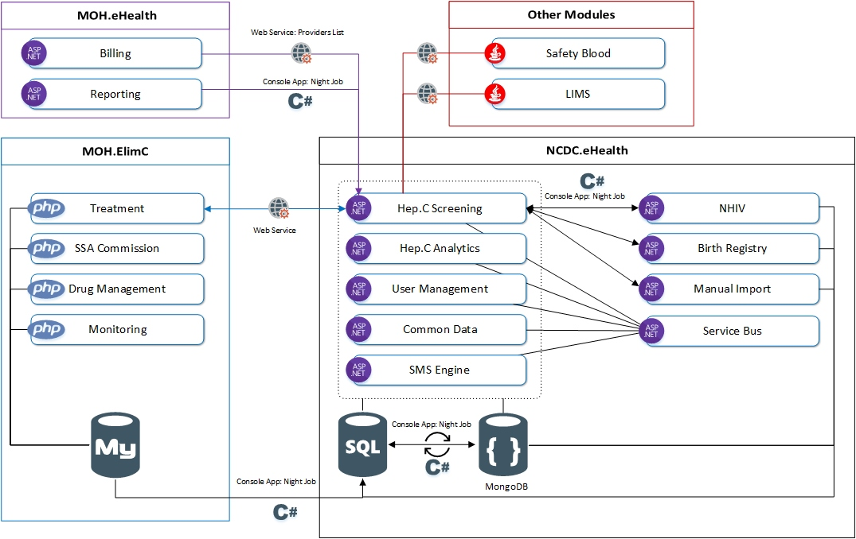

Deliverables:
- The entire architecture of ElimC should be changed. Instead of one monolithic system, which incorporates five tightly coupled components, they should be separate modules for future easy maintenance and modification as seen in Annex 1.
- SSA Commission module of ElimC should be developed separately and integrated into MoH E-Health systems managed by SSA. There are two options available: 1) Use existing Commission component used for Universal Health Care for planned medical services, and if similar, make small modifications to existing Commission component 2) Make a copy of the existing Commission component used by Universal Health Care and modify it for the Hepatitis C Elimination program. An analysis of each option can be done to ensure the best choice for the future of the program. This approach will help the MoH and SSA because the new C commission component could then communicate directly to the whole E-Health system. The functionality of this current module duplicates tasks performed by existing SSA systems, which is redundant. This new approach will help MoH to simplify the current business process by allowing health care facilities to submit all documentations to SSA online and avoids the patient and their guardian having to visit different SSA offices. This will be one additional step for decentralization.
  - Support needed from leadership: A political decision has to be made to do this, allowing the IT technical team (who should rewrite ELIM C) access to MoH SSA systems and permission to incorporate this functionality into existing system(s) together with SSA IT team.
  - Deliverable timeline: Monday, June 4, 2018.

- There is a recognized weakness in the current Treatment and Monitoring modules of the current ElimC system (see Appendix A). This system, as it currently exists, will not be successful at supporting a decentralized elimination program. We recommend a phased approach to achieving a robust, long-term solution for the replacement of ElimC (modules include Drug Management, Monitoring, Treatment).
  - Phase I – write/translate the Treatment and Monitoring modules of ElimC into ASP.Net/Web Forms (because current E Health System is developed using this platform – details in Annex B) so that it can gain some efficiencies in communicating with other systems (E Health Systems managed by SSA & NCDC, like screening, billing etc.). The reason for this also is the urgency with which the MoH would like to start the decentralization process. During this phase, the requirements and needs of decentralization will also be incorporated and included in the system along with changes that have been desired from past IT workshops from clinicians, CDC and other experts.
    - Support needed from leadership: Final decisions around what the decentralization model will be need to be completed as soon as possible. Decrees that mandate the new decentralization model should not be issued until the system is ready to collect the data (there needs to be time provided for system changes from finalization of decisions on model to start of actual decentralization).
    - Deliverable timeline: Monday, July 30, 2018. (this would in effect, also be the first day that that ElimC could be considered for retirement. The scope of requirements for decentralization and the amount of changes desired as decentralization plans begin will have the ability to affect this date. The focus of this development time would be to include the immediate needs of the program to serve decentralization. Additional changes would be incorporated into Phase II development.
  - Phase II – Write/translate the Treatment and Monitoring modules of ElimC into .NET Core 2.1. This allows the modules to be converted into true services with more flexibility in the longer term, over the life of the system. It also allows the IT team to incorporate issues discovered through the decentralization process. Common Data Store and Service Bus components in E-Health system (currently written in ASP.NET) need to be re-written on .NET Core 2.1. This is a prerequisite to the re-write of Treatment and Monitoring modules in .NET Core 2.1. This must be completed so that the new Treatment and Monitoring services will be able to communicate with other modules in the E-Health ecosystem.
New Web Service will need to be written to connect new Commission component in SSA (ASP.Net) ecosystem to new .NET Core Treatment component, completed in Phase II described above.
  - Support needed from leadership: Timely decision related the future concept of decentralization
  - Deliverable timeline: Phase 1 – Monday, July 30, 2018; Phase II - Friday, December 28, 2018.

- The Exact Drug Management schema and mechanism that is needed to support decentralization process for the Hepatitis C Elimination Program is unknown at this point. We do know that the current Drug Module in ElimC is inadequate to serve the needs of the elimination program. The IT team does not know the scope of what is needed to build at present and cannot estimate the exact amount of time that will be needed to build something. The requirements of the drug module are predicated on what the decentralization module looks like (one affects the other). Once the requirements/needs are finalized for decentralization, then discussions should take place about what the needs of the drug module are, and only then can development work be estimated. The scope of this system (a true logistics system) could be quite large, but that is dependent on what is needed.
Based on the identified decentralization model and scope of drug logistics requirements needed to support this model are made, a decision can then be made about what kind of system can serve the needs of the program. To develop a drug module from scratch, in a short time frame (3 -7 months or less) is not realistic. After identified requirements it may be possible to choose some available engine and later modify it to be compatible with treatment component and entire E Health. If the scope of the requirements for the drug distribution model are reasonable and well defined, then there could be a phased approach. Phase 1 – Set the Drug Management Module to meet minimum requirements of decentralization. Import all current stocks and to do Balances of stocks on the level of SSA and Health Care Provider. Phase 2 – Continue working on Drug Management Module, to be compatible with Treatment Component, automatically deduct stock and know balances on the level of patients.
  - Support needed from leadership: To convene meetings with the appropriate stakeholders immediately. The IT team needs to know what the decentralization model will be and have it finalized. Then drug distribution meetings need to take place, where what is needed for decentralization is discussed and agreed upon. “Use cases” are defined and scenarios discussed with their resolutions.
  - Deliverable timeline: Phase 1 – Monday, July 30, 2018; Phase II - February 20, 2019. (caveat: timeline depends on how soon the IT team has the details of the decentralization model and drug distribution model)

Hepatitis C Ecosystem: To Be
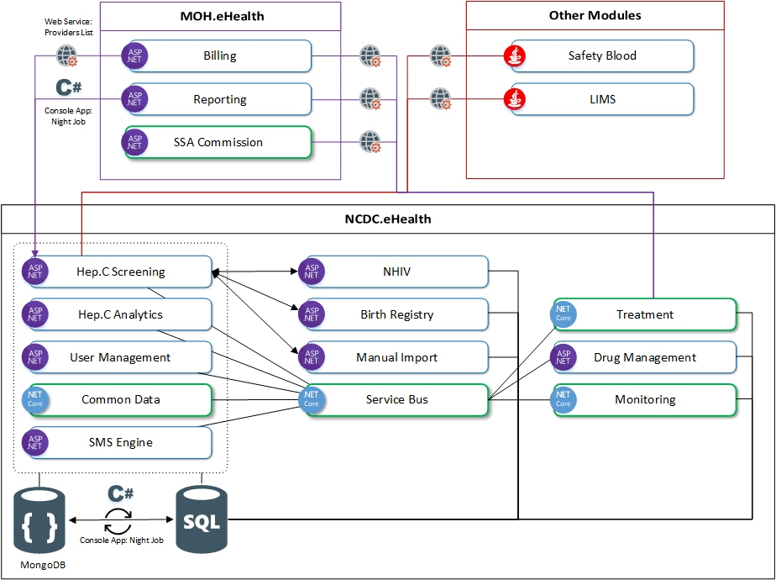

Appendix A: Technical Analysis of ElimC System

- Current ElimC system was built in a hurry (<4 months) with the single intent to quickly replace STOP-C. (STOP-C was based on a modified interferon drug logistic system, developed by the MoH, written in Delphi and later used in the initial stage of the Hepatitis C Elimination Program).
- Current ElimC system was not built with all the stakeholders’ requirements taken into account. Stakeholders’ input was not systematically gathered and included in the system. Therefore, their needs for the system were not captured and included in ElimC. Some of them cannot ever easily be added because the amount of work it would take to build them in would necessitate such a large re-write of the system, its more efficient to just write a new system.
- Current ElimC system is built using MySQL, PHP which was not what the other systems in the MoH ecosystem utilize. In addition, during ElimC system development, the current standards that the MoH’s ecosystem uses was not taken into consideration (common data stores, user management for easy exchange with Georgia E-Health system). This makes it difficult and some cases, impossible to connect to these other needed systems.
  - For example, with the financing system of SSA, double entry is required in both E-Health and ElimC for case registration information, reporting, and financing so that health providers can be paid. Double entry is the source of many mistakes in both systems and has to be reconciled manually.
  - NCDC has had to use the Screening module as the connection between ElimC and other systems using patient ID numbers and this is not an ideal or long term solution to the problem due to the absence of a systematic approach. This causes the Screening system to be modified in ways that it was never intended and over time, it too, may need to be re-written.
- Current ElimC system is built using MySQL, PHP which was not a good choice for the business case/use case for a national Hepatitis C Elimination program system. It is preferred that the system be built on a platform like .NET Core (most current available in the .NET family) and utilize more dynamic tools, software for its various layers.
- Current system was not built with enough controls on data entry such as validation, drop downs (forced choice), checkboxes and date pickers. These controls can help with data quality and integrity in the system by prohibiting users from entering incorrect or insufficient data for analysis later.
- Current ElimC system was built to serve only one data and business process model, which is the current model. It is a highly transactional system designed to efficiently serve just this specific treatment scenario. It did not plan or account for changes to the treatment model and cannot support a decentralized model without re-writing the bulk of the application. The system should be built with a more modular design approach, which builds in the capacity to change over time and accommodate changes to the program. The modules should be something like a User Management module, an Integration API (for connections with other systems), Analytics, Treatment, Drug, and a Commission module. A modular approach takes a little more planning and development up front, but allows changes later to the application without affecting the entire application, just a particular module or area of the application. Right now, even small changes can take hours or days.
- Current system has no test environment, no test database (dB), and no test users. Therefore, the changes and new functionality cannot be tested before having to push changes out into the production environment. IT team has to just make changes and see what breaks in a live production system, which is not good software practices.
- Drug component of ElimC is not serving current model of treatment and cannot serve decentralization. Decentralization is much more complicated and involves logistics for drug tracking. It will take extensive requirements gathering after the process is decided and development time to create a drug module that can serve the needs of the decentralized program.
- Based on stakeholder feedback, more can be done and built in to the system to accommodate the lab information that will need to be entered into the system for the decentralization model. More requirements need to be gathered and decisions made about how to get this into any new system.
- The decentralization of the program will require an increase of thousands of users in the ElimC system. These will be clinicians, laboratorians, and other stakeholders.

Ongoing recognized issues:
Decrees being issued before the IT systems can accommodate changes needed to support the decree. To ensure good software development and a system that can handle future needs of the program, there has to be time allotted to gather requirements, time to build these requirements into the system and test them, and only then a decree made and movement to a new production system made.

Appendix B: Hepatitis C Ecosystem (E Modules)

MOH.ElimC

MOH.ElimC.Treatment (Elimination C Treatment)
- Platform/Language: php
- Database: mysql
- Location: MoLHSA Virtual Machine

MOH.ElimC.Commission (SSA Commission)
- Platform/Language: php
- Database: mysql
- Location: MoLHSA Virtual Machine

MOH.ElimC.Drugs (Drug Management / Stock)
- Platform/Language: php
- Database: mysql
- Location: MoLHSA Virtual Machine

MOH.ElimC.Monitoring (Hepatitis C Monitoring)
- Platform/Language: php
- Database: mysql
- Location: MoLHSA Virtual Machine

NCDC.eHealth

NCDC.eHealth.Screening (Hepatitis C Screening)
- Platform/Language: ASP.NET Web Forms
- Database: Microsoft SQL / MongoDB
- Location: MoLHSA Virtual Machine

NCDC.eHealth.Analytics (Hepatitis C Analytics)
- Platform/Language: ASP.NET Web Forms
- Database: Microsoft SQL
- Location: MoLHSA Virtual Machine

NCDC.eHealth.UM (User Management)
- Platform/Language: ASP.NET Web Forms
- Database: Microsoft SQL
- Authentication: Custom authentication method (similar to oAuth)
- Location: MoLHSA Virtual Machine

NCDC.eHealth.CM (Common Data)
- Platform/Language: ASP.NET Web Forms
- Database: Microsoft SQL
- Location: MoLHSA Virtual Machine

NCDC.eHealth.SMS (SMS engine)
- Platform/Language: ASP.NET Web Forms
- Database: Microsoft SQL
- Location: MoLHSA Virtual Machine

NCDC.eHealth.NHIV (NCDC NHIV Module)
- Platform/Language: ASP.NET Web Forms
- Database: Microsoft SQL
- Location: MoLHSA Virtual Machine

NCDC.eHealth.BR (NCDC Birth Registry)
- Platform/Language: ASP.NET Web Forms
- Database: Microsoft SQL
- Location: MoLHSA Virtual Machine

NCDC.eHealth.SB (Service Bus / Messaging Module)
- Platform/Language: ASP.NET Web Forms
- Database: Microsoft SQL
- Location: MoLHSA Virtual Machine

MOH.eHealth

MOH.eHealth.Billing (Billing Module)
- Platform/Language: ASP.NET Web Forms
- Database: Microsoft SQL
- Location: MoLHSA Virtual Machine

NCDC.eHealth.Reporting (Reporting Module)
  - Platform/Language: ASP.NET Web Forms
  - Database: Microsoft SQL
  - Location: MoLHSA Virtual Machine

Other Modules

Safety Blood
  - Platform/Language: Java
  - Database: N/A
  - Location: N/A

LIMS
  - Platform/Language: Java
  - Database: N/A
  - Location: N/A

Information Flows
- MOH.Elims.mysql – NCDC.eHealth.SQL
  - Method: Console App (C#) / Night Job
  - Data: Only data needed for analytics (24 tables)
  - Period: Every Day
- NCDC.eHealth.MongoDB - NCDC.eHealth.SQL
  - Method: Console App (C#) / Night Job
  - Data: Form and collection data
  - Period: Every Day
- MOH.eHealth.Billing – NCDC.eHealth.Screening
  - Method: Web Service / WCF
  - Data: Providers List
  - Period: Once in 30 minutes
- MOH.eHealth.Reporting – NCDC.eHealth.Screening
  - Method: Console App (C#) / Night Job
  - Data: Form 066 data, where screening event is completed.
  - Period: Every Day
- Other.SafetyBlood – NCDC.eHealth.Screening
  - Method: Web Service / WCF
  - Data: List of the Persons with screening result
  - Period: Every Day (?)
- NCDC.eHealth.BirthRegistry – NCDC.eHealth.Screening
  - Method: Console App (C#) / Night Job
  - Data: List of the Persons with screening result
  - Period: Every Day
- NCDC.eHealth.NHIV – NCDC.eHealth.Screening (Planned)
  - Method: Web Service / WCF
  - Data: Information about laboratory sample
  - Period: Per Request
- MOH.Elim.C - NCDC.eHealth.Screening
  - Method: Web Service / WCF
  - Data: Sends Personal ID / Receives whether screening test is done (Yes/No)
  - Period: Per request
- NCDC.eHealth.Screening - MOH.Elim.C
  - Method: Web Service / WCF
  - Data: Receives Blood sample with confirmation test results
  - Period: Per request

