3rd WHO MISSION TO ABKHAZIA

Scope and purpose

Indicative dates

02-06 November

Background

On 30 January 2020, the WHO Director General declared the 2019-nCoV outbreak to be a public health emergency of international concern (PHEIC) following the recommendations of The Emergency Committee on 2019-nCoV, under the International Health Regulations (IHR 2005). This global pandemic response requires scaling-up support to countries to ensure the health response mechanisms are fully functional.
As of 20 October, since the first case identified on 8 August, there has been 3,036 cases registered in Abkhazia in total, with 31 deaths. 1,267 cases have recovered. 133 new cases and 3 deaths have been reported on 20 October. Considering the size of the population of Abkhazia of 245,000 people, the current scale of the epidemic is alarming. Growing daily incidence suggests significant strain on the designated healthcare facilities and laboratories. Some healthcare facilities have reported high infection prevalence among healthcare workers. Additionally, current positivity rate at almost 30% of all conducted tests indicates insufficiency of testing and raises questions about the contact tracing strategy. Information on non-pharmaceutical measures applied in Abkhazia suggests lack of physical distancing measures and their enforcement.
Previous missions to Abkhazia undertaken by WHO during the early months of the global pandemic, have looked at the preparedness strategy in Abkhazia and provided recommendations on strengthening preparedness to COVID-19, including laboratory capacities, hospital preparedness, infection prevention and control, risk communication and coordination. However, it is important to note that at the time of the previous missions there has been either no registered cases or very few cases of COVID-19 in Abkhazia, therefore it is expected that the local situation has changed and requires review, while technical WHO recommendations would be timely.
Figure 1: General dynamic of COVID-19 epidemic in Abkhazia to date

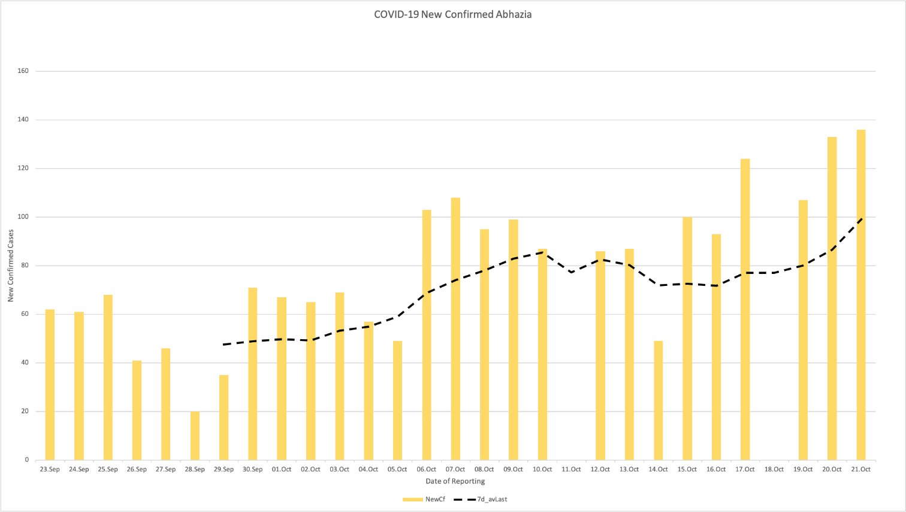
Objectives of the mission:
- Review the current response strategy applied in Abkhazia;
- Understand the standard patient route from the point of suspicion of COVID-19 infection to isolation, testing and treatment facilities;
- Review the current contact tracing strategy and how contact tracing is implemented;
- Understand current case definitions and testing protocols;
- Review current case-reporting/surveillance system for COVID-19 including relevant data flows;
- Understand how epidemiological data is systematically analyzed and is informing the response;
- Review current outbreak/cluster investigation protocols;
- Review current level of preparedness of the designated healthcare facilities for treatment of COVID-19 patients including available clinical protocols, infection prevention and control measures, bed capacities, including through application of the WHO COVID-19 hospital readiness checklist;
- Visit the border with the Russian Federation and understand public health measures that are currently undertaken to limit COVID-19 transmission at the point of entry;
- Evaluate the stringent needs in laboratory, IPC and case management supplies related to COVID-19 response and to essential health service;
- Provide hands-on recommendations on the abovementioned aspects of COVID-19 response;
- Conduct a multisectoral debriefing on the mission findings and discussion on the aspects of response and how public health evidence and advice is informing the response strategy in Abkhazia.

Requested key meetings/visits:
Meetings:
- Meeting with the de facto Chief sanitary doctor of Abkhazia;
- Meeting with the de facto Minister of Health of Abkhazia;
- Multilateral meeting with de facto representatives of the Office of the Head of Administration, Border Control, Interior, etc.;
- In the hospitals visited: meetings with the, or equivalent of, Hospital Director, Chief Nurse, Medical and Nursing Heads of Emergency, ICU, COVID-19 Department, Heads of IPC unit, Pharmacy, Laboratory.

Visits:
- Designated hospitals: Gudauta hospital, infectious disease hospital, republican hospital, hospitals in Gagra, Ochimshiro, Gali
- Office of the Sanitary-Epidemiological Surveillance Authority;
- Point of entry with the Russian Federation;
- Possibly points of testing across the territory of Abkhazia.

