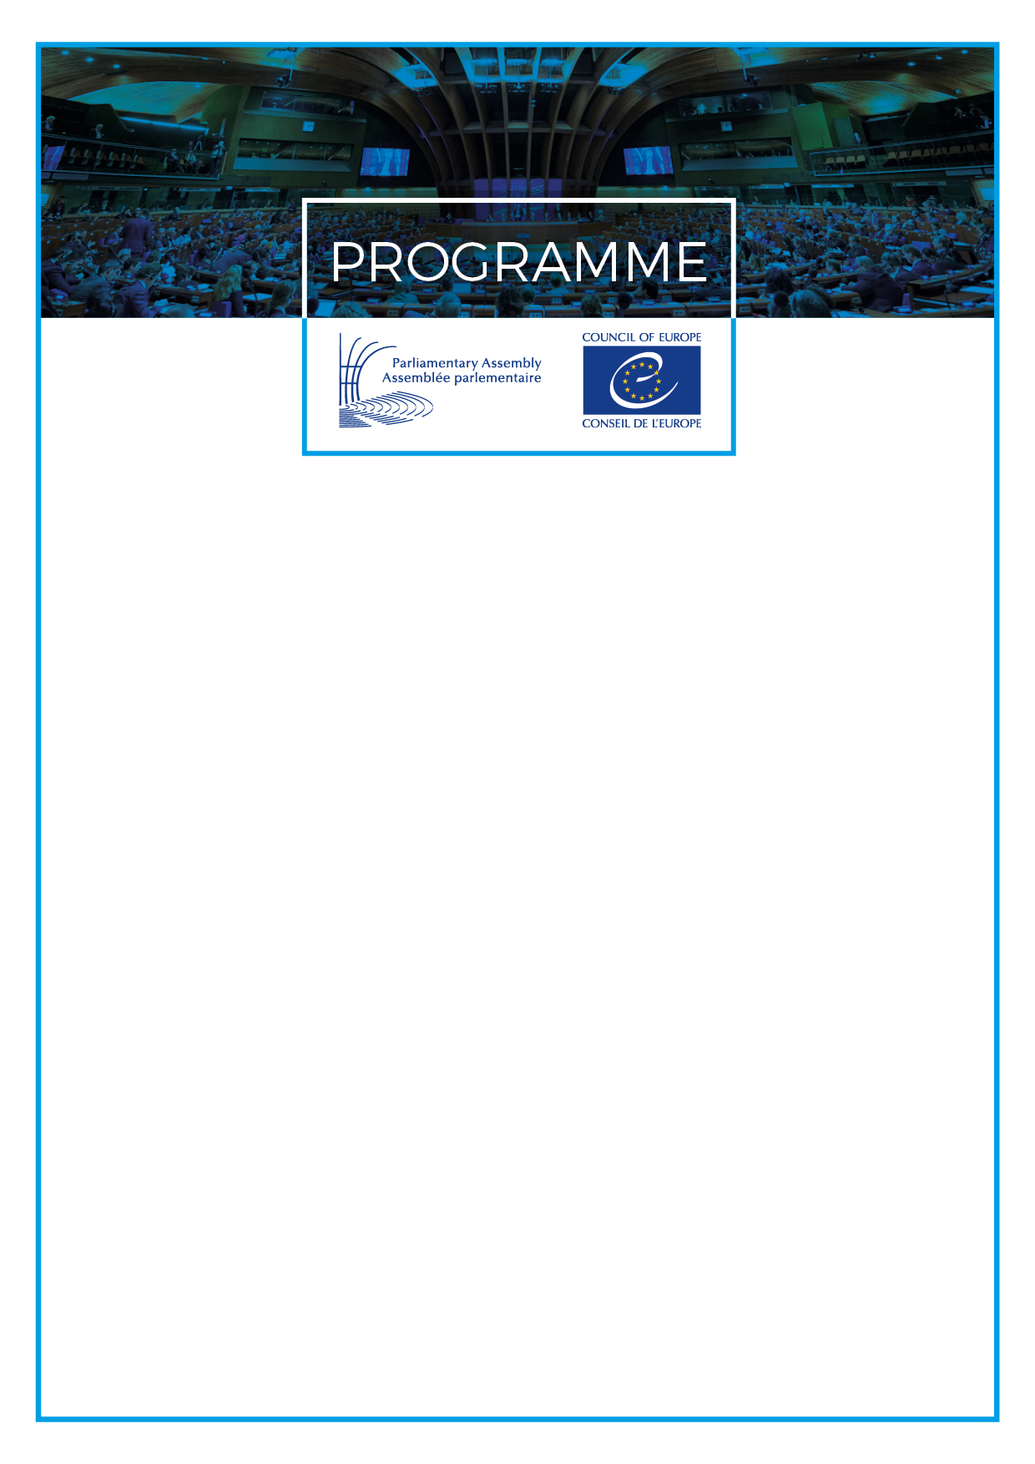

16/10/2018

JOINT MEETING

Sub-Committee on Education, Youth and Sport

Committee on Culture, Science, Education and Media

Sub-Committee on Children

Committee on Social Affairs, Health and Sustainable Development

Wednesday, 17 October 2018
Thursday, 18 October 2018

Parliament of Georgia
Rustaveli Avenue 8, Tbilisi

Co-chaired by:

Mr Georgios Mavrotas (Greece, SOC)
Chairperson of the Sub-Committee on Education, Youth and Sport
Baroness Doreen Massey (United Kingdom, SOC)
Chairperson of the Sub-Committee on Children
Ms Irina Pruidze (Georgia, EC)
Vice-Chairperson of the Sub-Committee on Children

The joint meeting is open to all registered participants of the 15th Council of Europe Conference of Ministers responsible for Sport (16 October 2018) and to all registered representatives of parliaments, governments, inter-parliamentary and intergovernmental organisations,
European institutions, sports movement, athletes, civil society
organisations, academia, sponsors and the media.

Registration and info: linda.mcintosh@coe.int, phone +33 388 41 25 18

Wednesday, 17 October 2018

09:00 Departure for the Parliament

09:10 Registration of participants
Venue: Room “Ilia Chavchavadze”, Entrance C, Parliament of Georgia

10:00 Opening by Mr Georgios Mavrotas, Chairperson of the Sub-Committee on Education, Youth and Sport

Welcoming addresses by the hosts:

- Mr Micheil Kavelashvili, Chairman of the Sports and Youth Affairs Committee, Parliament of Georgia
- Mr Shalva Gogoladze Deputy Minister, Ministry of Education, Science, Culture and Sports, Georgia
- Ms Tamila Barkalaia, Deputy Minister, Ministry of Internally Displaced Persons from the Occupied Territories, Labour, Health and Social Affairs, Georgia

10:45 “Start to talk” – joining forces in the fight against sexual abuse of children in sport

Sport is prone to a high tolerance of physical and psychological stress, unequal power relationships between coaches, officials and athletes and authoritarian leadership. Disclosing experiences of sexual abuse is particularly difficult for young athletes in the environment where one is supposed to be bold and where vulnerability is perceived as weakness. The Council of Europe “Start to talk” campaign calls for action by public authorities, sports organisations, coaches and parents to take concrete measures to prevent and respond to abuse.

What common and individual action should legislators take to make zero tolerance to sexual abuse of children and young people a norm rather than a cliché? What steps have the governments taken since the first groundbreaking revelations and prosecutions, and what still needs to be done? How to best build on synergies for joint action? How has speaking up affected the lives of those who have dared to reveal their stories in public? Has enough been done to protect the athletes who do dare to talk?

Panel discussion with witnesses and experts:

- Ms Karen Leach, Child Protection Advocate, Ireland
- Ms Elda Moreno Villanueva, Head of the Children's Rights and Sport Values Department, Council of Europe
- Mr João Paulo Almeida, Director General, National Olympic Committee of Portugal
- Baroness Doreen Massey, Chair of the Sub-Committee on Children and Member of the United Kingdom Parliament
- Ms Tamar Manjavidze, President, Healthy Gen, Georgia

Moderator: Mr Pieter Hemels, Partner, ftrprf.com – Futureproof, the Netherlands

12:15 Hearing on “Actors or spectators: what role for parliaments in setting the moral compass for sport?”

This public hearing will follow up on the discussions, declarations and resolutions of the 15th Council of Europe Conference of Ministers responsible for Sport, to be held in Tbilisi on the previous day. It will bring together the different viewpoints of public officials, sports movement and experts as regards concrete action to be taken upon these resolutions, with a special focus on defining the key priorities on how national parliaments and inter-parliamentary bodies could help the sports movement and governments to enforce democratic, transparent and accountable governance standards and respect of human rights in all aspects of sport.

Message by Ms Elda Moreno Villanueva, Head of the Children's Rights and Sport Values Department, Council of Europe

Message by Mr Bogdan Wenta, MEP, Vice-Chair of Sport Intergroup, European Parliament (by recorded video message)

12:30 Panel 1: Fighting corruption in sport: scaling up action

The ministerial Resolution “Fighting corruption in sport: scaling up action” sets the guiding lines for European governments in enhancing good governance and deterring corruption in sport. Now is the time to ensure its effective implementation. What are the obstacles and challenges and how to overcome them? Who should set good governance standards and who has the moral and the institutional authority to assess their compliance? Do carrots work better than sticks – recent experience of self-evaluation vs external assessment? Where can legislators make the difference?

- Mr Giorgos Vassiliadis, Deputy Minister of Culture and Sports of Greece
- Mr Akaash Maharaj, CEO, Global Organization of Parliamentarians Against Corruption (GOPAC), Ottawa, Canada
- Mr Francesco Ricci Bitti, President of the Association of Summer Olympic International Federations (ASOIF), Lausanne, Switzerland
- Mr Evan Norris, Counsel, Cravath, Swaine & Moore LLP, former Federal Prosecutor, US Department of Justice, New York, USA
- Mr Arnout Geerhaert, Katholieke Universiteit Leuven, Belgium

Moderator: Mr David Eades, Chief Presenter, BBC World News, United Kingdom

Discussion

14:00 Buffet lunch hosted by the Council of Europe Enlarged Partial Agreement on Sport (EPAS)
Venue: Restaurant “Melograno”, Zakaria Tchichinadze str, Shota Hotel

15:00 Panel 2: Protecting human rights in sport: obligations and shared responsibilities

Jailing and harassment of journalists, abuses of workers’ rights, environmental destruction, forceful evictions, discrimination and abuse based on gender, religion or race all tarnish major sporting events and undermine sport’s capacity as a force for good. The 2017 IOC Charter regards the practice of sport as a human right and the UN Sustainable Development Goals underline the holistic role of sport to that end. Nonetheless, there are increasingly more reports on human rights violations in sport. Is this a sign of heightened awareness or are public authorities and the sports movement failing to guarantee the rights that are supposed to be binding and non-negotiable? This panel will look at how different actors can promote effective approaches across stakeholder lines to prevent, mitigate, monitor and remedy the human rights impacts associated with sport.

- Ms Maja Makovec Brenčič, Special Advisor to the Centre for Sport and Human Rights, former Minister of Education, Science and Sport of Slovenia
- Mons. Melchor Sánchez de Toca y Alameda, Undersecretary of the Pontifical Council for Culture, Holy See
- Mr Stefan Schennach, MP, Chairperson of the PACE Committee on Social Affairs, Health and Sustainable Development, Member of the Austrian Parliament
- Ms Gigi Alford, Coordinator, Sport and Rights Alliance and Head of Sport and Human Rights, World Players Association, UNI Global Union, Switzerland
- Ms Paulina Tomczyk, General Secretary, EU Athletes, Brussels

Discussion

Moderator: Mr David Eades, Chief Presenter, BBC World News, United Kingdom

16:30 Conclusions of the hearing by the Moderator and the Chairperson

17:00 End of the meeting

19:45 Departure for the Restaurant

20:00 Dinner hosted by Mrs Irina Pruidze, Vice-Chairperson of the Sub-Committee on Children of the Committee on Social Affairs, Health and Sustainable Development of PACE, and Mr Mikheil Kavelashvili, Chairperson of the Committee on Sports and Youth Issues of the Parliament of Georgia. (Invitations ONLY)
[Restaurant “Bread House”, 7 Vakhtang Gorgasali str. http://www.mgroup.ge/en/bread-house]

Thursday, 18 October 2018

08:50 Departure for the Parliament

09:00 Registration of participants

09:30 Opening of the meeting by Baroness Doreen Massey, Chair of the Sub-Committee on Children and Ms Irina Pruidze, Vice-Chairperson of the Sub-Committee on Children

09:40 Strengthening parliamentary action for better child protection against sexual violence in sport

Introduction by:
- N.N., Ministry of the Interior, Georgia
- Ms Lia Saralidze, Executive Director, The Public Health Foundation of Georgia
- Mr Rati Ionatamishvili, Deputy Chair of the Human Rights Committee, Parliament of Georgia (tbc)

International legal instruments provide a shared framework for action, and inform policy making in the areas of common concern. Over the past years the PACE has played a key role in promoting the ratification of the Convention on the Protection of Children against Sexual Exploitation and Sexual Abuse (Lanzarote Convention), which is now ratified by all but three Council of Europe member States. In 2018, at the occasion of the “Start to Talk” Campaign the Assembly aims to boost targeted action on sexual abuse against children in sports.

The participants are invited to take stock of the previous discussions and to propose actions to be taken by national parliaments in this area. The discussion will provide an opportunity for sharing good practice from different countries, and will build on the diversity of the participants’ perspectives and experiences. A statement on “Ten Key Parliamentary Actions” will be adopted at the end of this session.

Workshop (in parallel working groups)

11.30 Impact of labour migration on left behind children

Today many people in Europe are compelled to go abroad in search of jobs in order to sustain their families. Parents have to leave their children to their grandparents, to send them to boarding schools or even sometimes to place them in an orphanage due to their employment contracts. Children are therefore deprived of their parents and often find themselves in precarious and vulnerable situations, including moral, physical and sexual abuse. What is being done to address this phenomenon? How successful have these approaches been? What action needs to be taken, both in the short term and in the long-term perspective?

Round table with the participation of:

- Mr Viorel Badea, Member of Parliament, Romania
- Mr Gottfried Hanne, Deputy Head of the UNICEF Office, Georgia
- Ms Gabriela Alexandrescu, Executive Director, Save the Children, Romania
- Ms Anna Arganashvili, Chairperson, NGO Partnership for Human Rights, Georgia

13:00 Conclusions and end of the meeting

13:30 Buffet lunch offered by the Georgian delegation
Venue: Restaurant “Melograno”
Address: Zakaria Tchichinadze str (next to the Parliament building).

14:30 Departure for Tserovani - Study visit in the context of integrating IDP children through sports

16:00 Departure for Mtskheta, Ancient Capital of Georgia - Cultural visit

17:30 Return to the hotels

