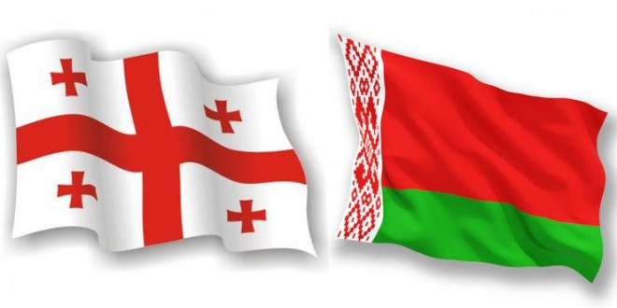

PROGRAMME
VISIT OF Mr. Vasily I. Zharko - Deputy Prime Minister of the Republic of Belarus TO GEORGIA

May 5, Friday
02:50 - Arrival at Tbilisi International Airport (Flight Number – B2735)
03:30 Departure for The Biltmore Hotel Tbilisi

5 May, Friday
11:30 – Departure to the Administration of the Government of Georgia (7 Ingorokva St
Tbilisi 0114, Georgia)
11:50 – Arrival to the Administration of the Government of Georgia
12:00 – Meeting with the Prime Minister of Georgia Mr. Giorgi Kvirikashvili
12:45 – 13:00
14:30 - Departure to the Ministry of Labour, Health, and Social Affairs of Georgia (144 Tsereteli Ave.)
14:50 – Arrival to the Ministry of Labour, Health, and Social Affairs of Georgia
15:00 – Meeting with the Vice Prime Minister, Minister of Education and Science of Georgia Mr. Aleksandre Jejelava and Minister of Labour, Health and Social Affairs of Georgia Mr. David Sergeenko
15:45 – Signing Ceremony of the Memorandum of Understanding on Donation and Cooperation between the Government of the Republic of Belarus and the Government of Georgia and the Contract between the Ministry of Labour, Health and Social Affairs of Georgia and RUP “BELPHARMATSIYA” on donation of pharmaceutical product envisaged under the Memorandum of Understanding between the Government of the Republic of Belarus and the Government of Georgia
16:15 – Group Photo
16:20 - Departure to the Biltmore Hotel Tbilisi
Free Time

6 May, Saturday
01:45 - Departure for Tbilisi International Airport (Flight Number B2736)
END OF THE VISIT

