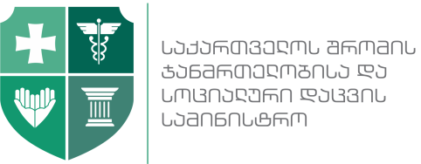 | 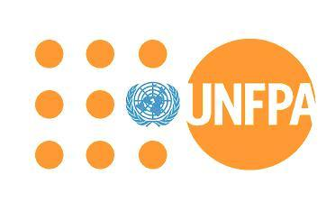 | 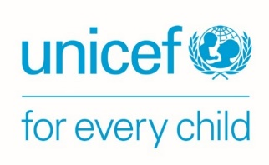

Maternal & Newborn Health and Reproductive Health Priorities in Georgia

Hotel Marriott Tbilisi.
April 7, 2017 10:30-13:00

The presentation of the National Maternal & Newborn Health Strategy (2017-2030) and a 3-year Action Plan (2017-2019) will be held at the Tbilisi Marriott Hotel. The Strategy was developed under the Ministry of Labor, Health & Social Affairs of Georgia (MoLHSA) leadership with technical support provided by the United Nations Population Fund (UNFPA) in collaboration with the United Nations Children's Fund (UNICEF). The overall purpose of this strategy is to give direction and provide guidance for the improvement of Maternal and Newborn Health (MNH) and the related Reproductive Health (RH) fields in Georgia.
The Strategy envisages that by 2030, there will be no preventable deaths of mothers and newborns or stillbirths, every child will be a wanted child, and every unwanted pregnancy will be prevented through appropriate education and full access to high quality integrated services. The Strategy is guided by the internationally accepted principles such as Human Rights, Gender Equality, Life-Course Approach to Reproductive Health, Quality of Care.
The 3-year Action Plan that is developed in light of this Strategy will serve as a general framework for the MNH, RH, and Family Planning areas and as a guide for interventions for the next three years.
Despite the fact that the Maternal Mortality Ratio has decreased for the first time in the past decade, Georgia still significantly lags behind the European countries that prompted the necessity to develop a new strategy. The document provides strategic inputs that will support the development and execution of operating plans at the country level to accelerate the reduction of maternal and neonatal mortality in Georgia by strengthening and expanding policies and programs for the improvement of Maternal and Newborn Health (MNH) within the continuum of care; and gives direction and provides guidance for the fields of Family Planning and Adolescent SRH, as very important determinants of MNH.
This strategy is closely linked to the recent international strategic documents, including the Sustainable Development Goals (2015), the new WHO European Action Plan for Sexual and Reproductive Health (2017-2021) and Every Newborn Action Plan (WHO/UNICEF).
The event will bring together the representatives of the Government agencies - Ministry of Education and Science, Ministry of Sport and Youth Affairs; members of the Parliament, Ms. Alanna Armitage, Regional Director, UNFPA Eastern Europe and Central Asia Regional Office, UN Agencies, Donors, SRH professionals and representatives of the professional associations, academia, civil society organizations.

