Universal Health Care - An important step towards universal access
Introduction
Universal health coverage by 2030 is a priority of the United Nations Sustainable Development Goals. Universal access to services is the opportunity for better health and protection from poverty for hundreds of millions of people, especially for vulnerable groups.
Key Findings
Since 2013, the government has laid the foundation for health policy oriented towards the population health and well-being. This is confirmed by unprecedented increase in state allocations for healthcare sector in the last few years (2012 GEL 450 million - 2017 GEL 986.2 million).
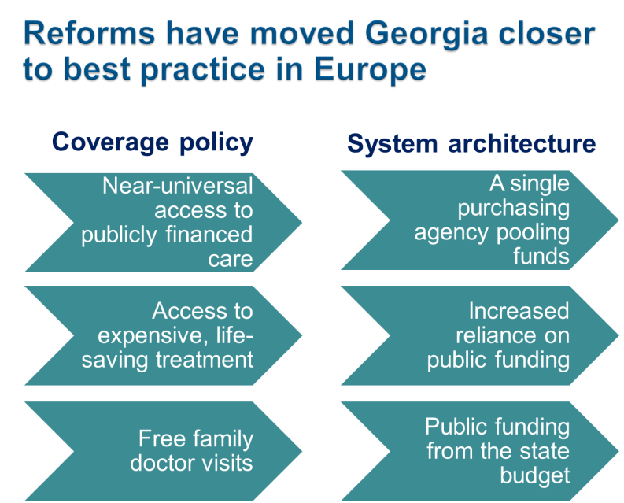
Since 2013 the state universal healthcare program has been enacted creating a mechanism for protection against the catastrophic health expenditure for every citizen, as all citizens without health insurance have become beneficiaries of the program.
Georgia achieved substantial progress in moving towards universal health coverage (WHO European Health report 2015)
In the publication of European Health Report 2015 of World Health Organization's European Bureau, Universal Health Care Program in Georgia has been recognized as one of the successful projects.

The survey carried out by the World Bank, the World Health Organization and the US Agency for International Development showed the main achievements of the Universal Healthcare Program: increased access to medical services, increased utilization of medical services, reduced financial barriers and enhanced coverage.

Recent Key Achievements
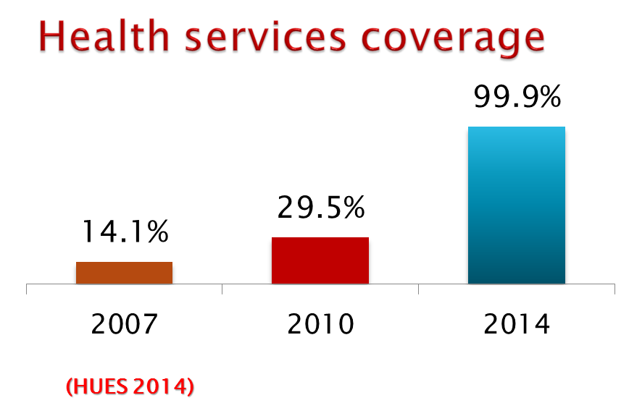
In 2013, after implementation of the Universal Healthcare Program, service coverage has increased significantly and rapidly from 29.5% of the population in 2010, to about 40% by the end of 2012 and up to 99.9% by 2014.
Out-patient service utilization also has increased in 2016 the number of outpatient visits equaled 4.0 (2012 - 2.3), while the hospitalization rate increased from 8.0 (2012) to 13.3 (2016).
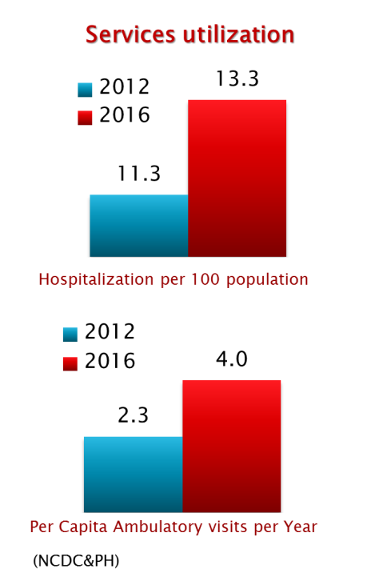
Universal access to health services has significantly reduced the out-of-pocket payments and improved financial protection (2012 - 73% - 2015 - 57%).
According to a survey conducted by the US Agency for International Development in 2014, 80.3% of the surveyed beneficiaries were satisfied with the outpatient service and 96.4% expressed satisfaction with hospital level emergency care within the universal health care program. In addition, according to the survey data, more than 77% of the population notes that by introduction of the universal healthcare program their financial access to outpatient and inpatient services has increased.
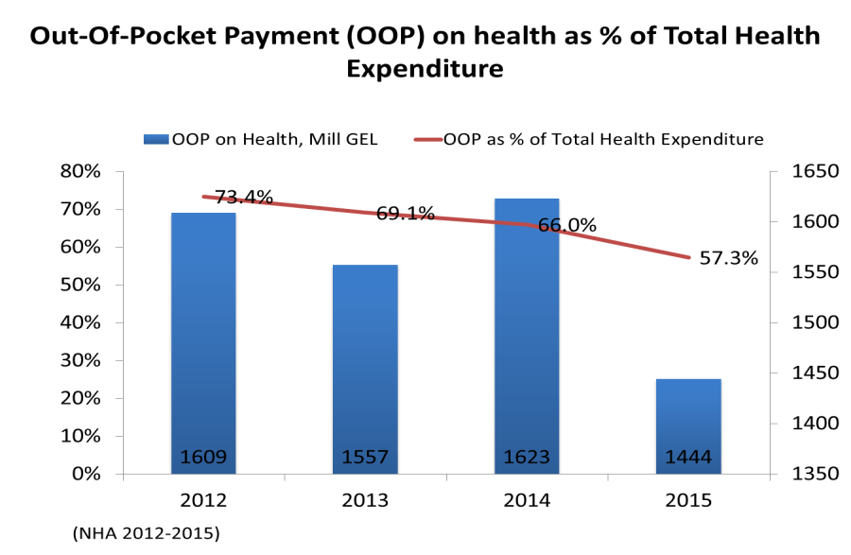
Any healthcare institution may engage in the implementation of the Universal Healthcare Program, if it meets the requirements set by the legislation for this activity, expresses the willingness to participate in the program, agrees with the terms and conditions of the program and confirms the desire to participate in written at the Social Service Agency. At present there are more than 250 hospitals and 300 outpatient institutions involved in the program.
The program beneficiary has the right to choose a healthcare facility throughout Georgia. The program beneficiaries are Georgian citizens, holders of a status-neutral ID, a status-neutral travel document; as well as stateless persons in Georgia, persons with refugee or humanitarian status and asylum-seekers.
From February 28 to July 1, 2013, the first phase of the Universal Healthcare Program was meant to provide the primary healthcare services by the family physician and emergency care at both outpatient and inpatient levels. More than 450 conditions requiring urgent medical care were financed.
The second phase of Universal Healthcare Program has been launched since July 1, 2013 - basic package was introduced for citizens without health insurance, which covers planned outpatient, emergency outpatient and hospital services, planned surgical services, oncological diseases treatment and childbirth. The program also provides funding for essential drugs for target groups of the population.
From May 2017, to further reform the program, elaboration of new criteria for differentiation of beneficiaries (according to beneficiaries' revenue) was considered reasonable for provision of more needs oriented services and development of "social justice" approach.
From July 1, 2017, persons suffering from chronic conditions, who are registered in the unified database of "socially vulnerable families" with the rating score not exceeding 100,000, are eligible for the state program providing drugs for chronic conditions. The program envisages providing patients with selected drugs for chronic CVDs, lung diseases, diabetes (type 2) and thyroid gland conditions.
Since March 1, 2017, selective contracting was introduced for childbirth and caesarean section and neonatal intensive care services, from July - II-III level intensive care, and from January 2018, selective contracting will be used for providers of emergency hospital services.

Challenges
The state continues the strategic reforms in the healthcare sector aimed to reduce negative economic impact on households due to health expenditure, ensuring access to health care and improvement of the populations health. In order to achieve this, the gradual increase of state financing of healthcare sector will be advocated annually based on the analysis of financial area and the programmatic needs in health sector.
Within the framework of the Universal Health Care Program, further emphasis will be made on optimizing the health care package, improving the quality of medical care and access to drugs. Introduction of a universally recognized integrated health financing system is being considered to improve effectiveness of state resources allocated to the health services.

