Universal Health Care - An important step towards universal access
Introduction
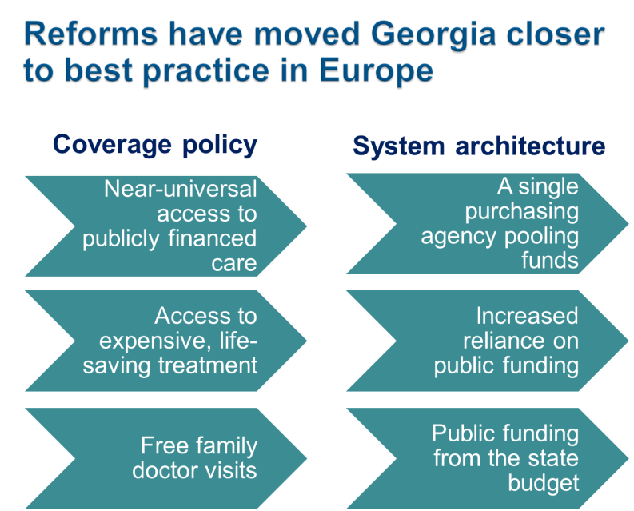
Introducing Universal Health Care system in Georgia in February 2013 aimed at improving the general population’s access to healthcare, has benefited more Georgians, particularly those relatively less well-off, from gaining access to health services when ill and being less prone to impoverishment or catastrophic out-of-pocket spending on healthcare. This was achieved through a strong political commitment and process to create an equitable health financing system.

Key Achievements
- Increasing public health spending
Universal heath care and health policy oriented towards the population health and well-being is confirmed by unprecedented increase in state allocations for healthcare sector in the last few years, from GEL 450 million in 2012 to GEL 986.2 million in 2017. Public health spending as a share of GDP has also increased from 1.7% in 2012 to 2.9% in 2015.
.
Georgia achieved substantial progress in moving towards universal health coverage (WHO European Health report 2015)
.

- Extending entitlement to publicly financed health services to the whole population
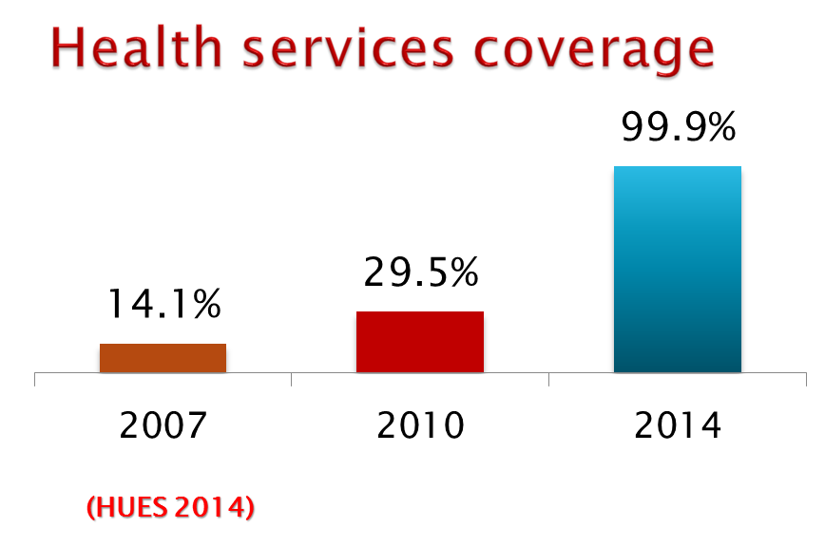
In 2013, after implementation of the Universal Healthcare program, service coverage has increased significantly and rapidly from 29.5% of the population in 2010, to about 40% by the end of 2012 and up to 99.9% by 2014.

- Improving the likelihood of people using health services when sick
On average, there are 4.0 outpatient visits per capita per year in 2016 compared to just 2.3 in 2012, and hospitalization rates have seen a steady increase from 11.3 in 2012 to 13.3 in 2016, which largely is explained by the introduction of UHC program, which offered coverage to a vast number of people in Georgia who were previously uninsured. The largest increase in using health services among those who reported being ill occurred among lower and middle-income household.

- Improving overall financial protection
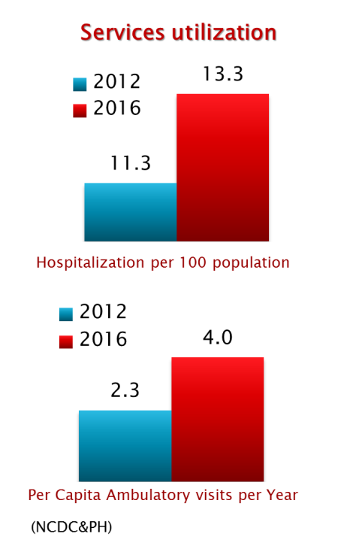
UHC programhas significantly reduced the out-of-pocket payments and improved financial protection of the population. Out-of-pocket spending declined from (73% in 2012 to 57% in 2015).
- Improving user experience of the health system
Survey conducted by the US Agency for International Development in 2014 showed that 80.3% of the surveyed beneficiaries were satisfied with the outpatient service and 96.4% expressed satisfaction with hospital level emergency care within the universal health care program.
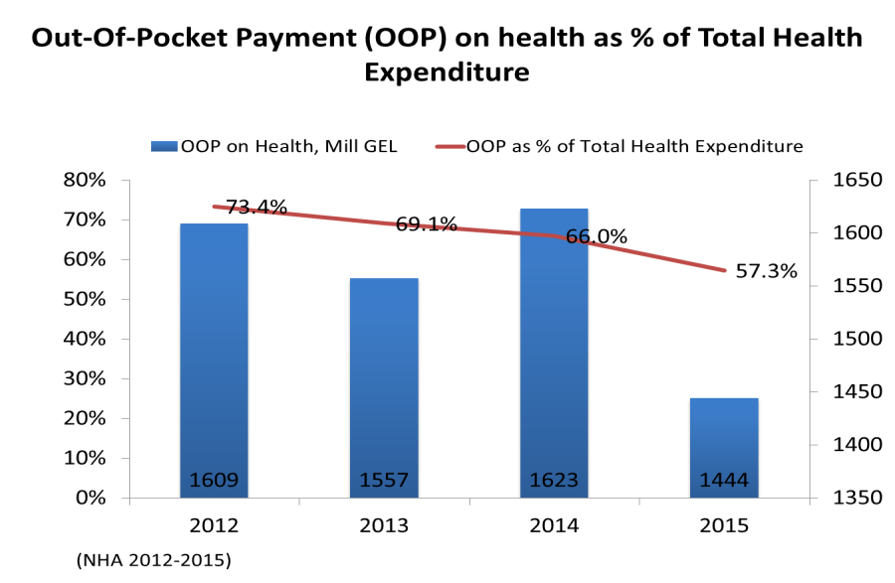
The UHC program beneficiary has the right to choose a healthcare facility throughout Georgia.
From February 28 to July 1, 2013, the first phase of the Universal Health Care Program was meant to provide the primary healthcare services by the family physician and emergency outpatient and inpatient care.
The second phase of Universal Health Care Program was launched in July 1, 2013 extending the services covered and including planned ambulatory care, elective surgery, cr-chemoand hormonotherapy, radiotherapy, obstetrics and cesarean sections, basic drugs for target groups of the population.
In May 2017, to further reform the program, elaboration of new criteria for differentiation of beneficiaries (according to beneficiaries' revenue) has been implemented for provision of more needs oriented services and development of "social justice" approach.
From July 1, 2017, persons suffering from chronic conditions, who are registered in the unified database of "socially vulnerable families" with the rating score not exceeding 100,000, are eligible for the state program providing drugs for chronic conditions. The program envisages providing patients with selected drugs for chronic cardiovascular diseases, chronic obstructive pulmonary disease, diabetes (type 2) and thyroid conditions.

Challenges
The government continues the strategic reforms in the healthcare sector aimed to reduce negative economic impact on households due to health expenditure, ensuring access to health care and improvement of the population’s health. Some of the challenges faced by the health care system include:
- Low public health spending

Despite a substantial increase in the government’s budget allocation to health in recent years, public health spending as a share of GDP is still low. Compared with countries at a similar level of income public health spending is below average and the split between government and out-of-pocket financing is comparable to that of a low-income country.

- High out-of-pocket spending on health

Although the UHC Program has been associated with a reduction in the OOP share of total health spending (73 percent in 2012 to 57 percent in 2015), Georgia still has one of the highest shares of OOP in the region. Pharmaceuticals are a major cost driver. While medicines are provided free of charge to patients for inpatient use, the UHC program has a very limited outpatient drug benefit. The drug benefit for four major chronic conditions introduced in July 2017 offers

- The outpatient visit rate remains very low relative to other countries in the region

- The care seeking behavior in Georgia is skewed towards hospital-based, inpatient care, whereas outpatient services – and in particular primary healthcare – are under-utilized. Strengthening primary health care through improvement of quality and efficiency, including medicines provision, development of an incentive system that enables primary care providers to take more responsibility for patient care, especially for patients with chronic conditions and revision of the system for planning and generation of human resources for primary health care are important policy and program priorities.

Within the framework of the Universal Health Care Program, further emphasis will be also made on strengthening strategic purchasing capacity of the Social Services Agency, and improving the quality of medical care.

