3rd South Caucasus Security Forum (SCSF) 2015

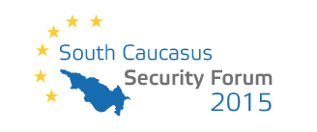



Tbilisi, 26-27 October 2015

Venue: Hotel Holiday Inn Tbilisi, 26 May Square, Tbilisi 0171, Georgia

Official language of the 3rd South Caucasus Security Forum 2015 is English.
#SCSF2015

PRELIMINARY PROGRAM

DAY 1 - MONDAY, 26 OCTOBER 2015

09.00-09.30 REGISTRATION

09.30-10.15 OFFICIAL WELCOME

10.15-10.30 COFFEE BREAK

10.30-12.00 SESSION 1: Euro-Atlantic security: Georgia - a staunch aspirant on
NATO`s eastern edge

12.00-13.30 NETWORKING LUNCH

13.30-15.00 SESSION 2: Information Warfare and its Strategic Consequences

15.00-15.30 COFFEE BREAK

15.30-17.00 SESSION 3: NATO and its Partners before the Warsaw Summit 2016

17.00-17.30 COFFEE BREAK

20.00-22.00 GALA DINNER (upon separate invitations only)

SPECIAL DINNER KEYNOTE SPEECH

DAY 2 - TUESDAY, 27 OCTOBER 2015

09.30-10.00 SCSF KEYNOTE

10.00-11.00 SESSION 4: Hybrid Warfare and its Implications for NATO Members and Partners

11.00-11.30 COFFEE BREAK

11.30-12.30 SESSION 5: Black Sea - Military Balance and Cooperation

12.30-14.00 NETWORKING LUNCH

14.00-15.00 SESSION 6: Changes in the Middle East: ISIS and Beyond

15.00-15.30 COFFEE BREAK

15.30-16.30 SESSION 7: Ukraine Crisis Challenging Europe’s Security
Architecture: Threat of the Domino effect?

16.30-17.00 CLOSING REMARKS AND SUMMARY

17.00-17.30 CLOSED SESSION WITH JOURNALISTS

Speakers:

- Giorgi Margvelashvili, President of Georgia;
- Irakli Garibashvili, Prime Minister of Georgia;
- Tinatin Khidasheli, Minister of Defence of Georgia;
- Davit Bakradze, State Minister of Georgia on European and Euro-Atlantic Integration;
- Giorgi Kvirikashvili, Minister of Foreign Affairs of Georgia ;
- James Appathurai, Deputy Assistant Secretary General;
- Aurel Fondos, State Secretary, MoD Moldova;
- Jakub Kulhánek, Deputy Minister of Foreign Affairs of the Czech Republic;
- Oleksandr Litvinenko, Deputy Secretary of the National Security and Defence Council of Ukraine;
- Marijus Velička, Vice-Minister of National Defence of Lithuania;
- Roman Jakic, Former Minister of Defence of Slovenia;
- Marika Rakviashvili, Deputy State Minister of Georgia on European and Euro-Atlantic integration;
- Róbert Ondrejcsák, Director, CENAA;
- Brooks Tigner, Jane’s Defence Weekly;
- Col. Omar Begoidze, Deputy CHOD, Ministry of Defence of Georgia;
- Kakha Gogolashvili, Director of EU Studies, GFSIS;
- Vasil Sikharulidze, Ambassador, Head of Atlantic Council of Georgia;
- Levan Dolidze, Ambassador, Founder and Director of Centre for Security and Development of Georgia;
- Mikheil Darchiashvili, Former Deputy Minister of Defence, Georgia;
- Amb. Kęstutis Jankauskas, Head of EUMM to Georgia;
- Andreas Peschke, Ambassador, Director for Eastern Europe, the Caucasus and Central Asia, Federal Foreign Office, Federal Republic of Germany;
- Tengiz Pkhaladze, Georgian President Giorgi Margvelashvili's adviser for foreign relations;
- Dr. Ariel Cohen, Senior Fellow, The Atlantic Council and Director, Center for Energy, Natural Resources and Geopolitics at the Institute for the Analysis of Global Security;
- Brigadier General Matt Brand (Ret), former Deputy Chief of Staff Strategic Plans and Policy, NATO Allied Command Transformation;
- Luke Coffey, Margaret Thatcher Fellow; The Davis Institute for National Security and Foreign Policy at The Heritage Foundation;
- Michael Cecire, Associate Scholar, Foreign Policy Research Institute;
- Lincoln Mitchell, Scholar, Arnold A. Saltzman Institute of War and Peace Studies, Columbia;
- Tornike Sharashenidze, GIPA, Georgia;
- Hanna Shelest, Editor in Chief, Ukraine Analytica, Ukraine;
- Richard Giragosian, Director, Regional Studies Center Foundation (RSC), Armenia;
- Sergey Utkin, Head of Department, Centre for Situation Analysis (CSA), Russian Academy of Sciences;
- Iulian Chifu, former advisor to Romanian President;
- Ivars Lasis,
- Liudas Zdanavičius, Lecturer, Military Academy of Latvia;
- Taras Mykhalniuk, Director, Open Ukraine, Arseniy Yatsenyuk Foundation, Ukraine;
- Arkady Moshes, Programme Director, The EUs Eastern Neighbourhood and Russia research programme, The Finish Institute of International Affairs;
- Nodar Kharshiladze, Senior Fellow, GFSIS, Georgia;
- Daniel IONIŢĂ, State Secretary of the Ministry of Foreign Affairs of the Republic of Romania;
- Grigoriy Perepelitsia, Director, Foreign Policy Institute, Ukrainian Diplomatic Academy;
- Hanna Shelest, Editor in Chief, Ukraine Analytica, Ukraine;
- Richard Giragosian, Director, Regional Studies Center Foundation (RSC), Armenia;
- Sergey Utkin, Head of Department, Centre for Situation Analysis (CSA), Russian Academy of Sciences;
- Richard Weitz, Director and Senior Fellow, Center for Political-Military Analysis, Hudson Institute;
- Mate Szalai, Institute for Foreign Affairs and Trade, Hungary;
- Cuneyt Gurer, Chief of Migration Management and Foreigners Service Department of Sivas Provincial Police, Turkey;
- David Chochua, expert on terrorism, Director, Department of Americas, MFA of Georgia;
- Mirek Tóda, Journalist, Denník N .

Organizers

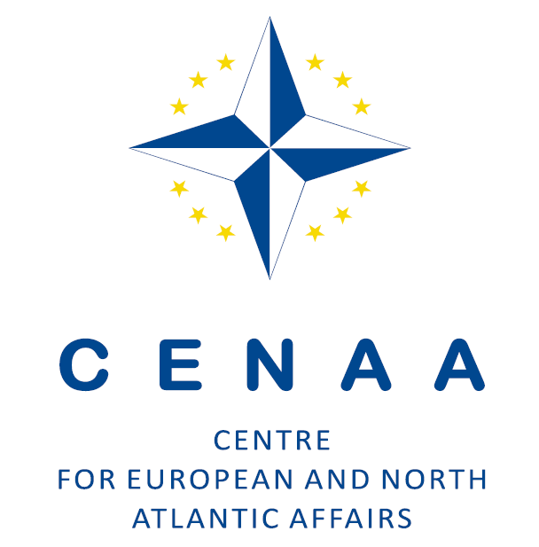
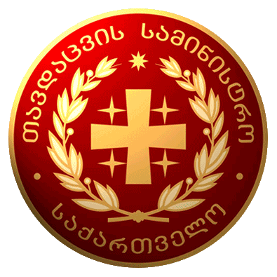


Ministry of Defence of Georgia

Strategic Partners

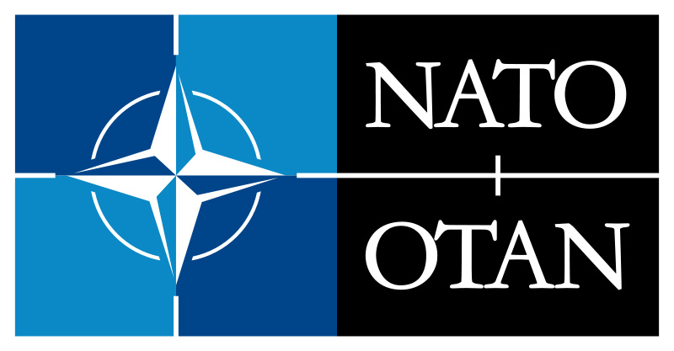

Special Partner



Partners

Faculty of Social Sciences, Charles University Prague, Czech Republic
Antall József Knowledge Centre of Political and Social Sciences, Hungary
The Polish Institute of International Affairs (PISM), Poland
Open Ukraine, Arseniy Yatsenyuk Foundation, Ukraine
Regional Studies Center Foundation (RSC), Armenia
Khazar University, Azerbaijan



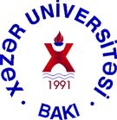
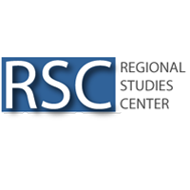







NATO Advanced Research Workshop on Lessons Learned from Small Countries Committing Troops to Operations Abroad

Tbilisi, October 26 - 27, 2015

Program

Organizer:
Centre for European and North Atlantic Affairs (CENAA)
Georgian Foundation for Strategic and International Studies (GFSIS)

Partners:
The NATO Science for Peace and Security Programme

DAY 1 - MONDAY, 26 OCTOBER 2015

10:00- 10:15 KEYNOTE SPEECH
Major General Pavel Macko, Deputy Chief of General Staff of the Armed Forces of Slovak Republic

10:15 – 11:30 Panel Discussion I
Developing Niche Capabilities or Plugging the Holes? Strategies of Small Countries Participating in NATO Contingents Abroad
Henrik Praks, Research Fellow, ICDS, Estonia (confirmed)

MOD Czech Republic

Róbert Ondrejcsák, Director, CENAA

11:30 – 12:30 LUNCH

12:30 – 14:00 Panel Discussion II
Civil-Military Cooperation in the Ground in the Experiences of Small Countries Contingents – How Feasible and How Effective?
Marko Sosic, Institut Alternativa, Montenegro (confirmed)

Gerard Lucius, Senior Consultant to 1 (NL) Civil and Military Interaction
Command as an officer of the Army Reserves (confirmed)
Piotr Lukasiewicz, Former Ambassador of Poland to Afghanistan (confirmed)
Elemír Nečej, Senior Research Fellow, CENAA (confirmed)

DAY 2 - TUESDAY, 27 OCTOBER 2015

10:15 – 12:00 Panel Discussion III
Consequences of Participation Small Countries Military Contingents for Their Strategic Defence Posture – Unnecessary Overstretch or Incentive for Professionalization?
Nodar Kharshiladze, Research Fellow, Georgian Foundation for Strategic and International Studies (confirmed)
Batbayar Baabar, Director, NEPKO, Mongolia (confirmed)
Beata Górka-Winter, Senior Research Fellow, PISM (confirmed)
Nora Vanaga, Researcher, National Defence Academy of Latvia (confirmed)

12:00 – 13:00 Lunch

13:00 – 15:00 Panel Discussion IV
Modern Concept of Hybrid Warfare: Consequences for Small States
Alex Deep, SAIS, United States (confirmed)
James Sherr, Chatham House, United Kingdom
Vivien Pertusot, Head of the Brussels Office, Institut Francais des Relations Internationales (confirmed)
Tornike Sharashenidze, Georgian Institute for Public Affairs (confirmed)
Andras Racz, Research Fellow, Finnish Institute of International Affairs (confirmed)

17:00 – 17:15 Discussion
CLOSING REMARKS AND SUMMARY
Beata Górka-Winter, Senior Research Fellow, PISM (confirmed)
Elemír Nečej, Senior Research Fellow, CENAA (confirmed)
Kakha Gogolashvili, Senior Fellow, Georgian Foundation for Strategic and International Studies

