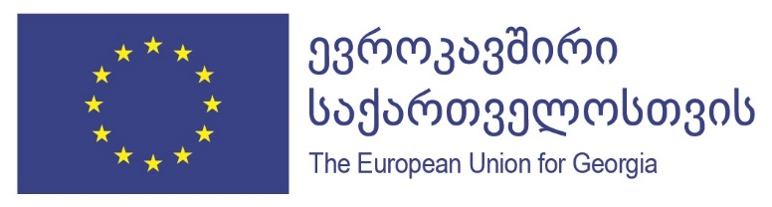

Advancing the Cooperation in the field of Temporary Labor Migration between the Republic of Poland and Georgia

Visit of the Georgian Delegation to Poland

Agenda of the meetings

10 October, Wednesday
06.40 Arrival of the Delegation and transfer to the Hotel
11:00 -11:45 Meeting at the Embassy of Georgia in Poland
12:30 – 13:30
Meeting of the Georgian Delegation with the Deputy Minister Szwed with Mr. the Deputy Minister of Family, Labor and Social Policy of the Republic of Poland;
Discussion around the bilateral cooperation between the countries in the field of the temporary labor migration. Referral during the discussion to the draft bilateral cooperation agreement provided by the Georgian Government prior to the visit.
The Deputy Minister will convey the official invitation to Georgia by the Minister of the Internally Displaced Persons (IDPs) from the Occupied Territories, Labor, Health and Social Affairs (MoLHSA) of the Minister of Family, Labour and Social Policy of Poland to further and finalize the discussions on the bilateral cooperation in the field of temporary (circular) labour Migration between the countries.

13:00-14:30 Lunch
14:45 -15:30 (TBC) Meeting with the Labour Office of Warsaw and discussion terms of cooperation in the field of information provision on employer demands on foreign labour force – skills qualifications and employers contact information etc.).

11 October, Thursday
08:00 Travel to Wroclaw on a minivan
12:30 -13:30 Meeting with the local Labour Office in Wroclaw to discuss the modalities of continued Cooperation;
13:00 -14:00 Lunch and Accommodation in the Hotel
15:30 - 16:30 Meeting with the “BUDWELD” representative Mr. Jakub Jakubiak, employing Georgian Workers/welders in Legnica and Jelz Laskowice

12 October, Friday
10:30 – 11:15 Meeting with Mr. Vladyslav Tarasiuk and Lukasz Dobrowolsky, representatives of the Transportation Agency “LGI”
11:15 Departure to Legnica and /or Jelz-Laskowice and meeting with the Georgian
migrant workers there

13 October, Saturday
15:45 Departure from Wroclaw to Warsaw
22:30 Departure from Warsaw to Tbilisi
Members of the Georgian Delegation:

- Tamila Barkalaia, Deputy Minister of the Internally Displaced Persons (IDPs) from the Occupied Territories, Labor, Health and Social Affairs (MoLHSA)
- Elza Jgerenaia, Head of the Department on Labor and Employment Policy, MoLHSA
- Giorgi Bunturi, Chief Specialist, Division for Promotion of Employment, Department of Labor and Employment Policy
- Natia Kvitsiani, National Programme Officer, IOM Mission to Georgia
- Tsiuri Antadze, Labor Specialist, IOM Mission to Georgia

