Mr. Airis Rikveilis
Defence Counsellor, Latvian Delegation to NATO

The Ministry of Defence of Georgia and the Atlantic Council of the United States would like to invite you to participate in the tenth annual Georgia Defence and Security Conference (GDSC) to be held on May 24-25 in Tbilisi. We would be honored and delighted if you would join us at our conference. Participants will convene at a strategic moment in the run-up to NATO’s Warsaw Summit. This year, GDSC also falls on the 25th anniversary of the Independence of Georgia so you are kindly invited to also join the special celebratory events on May 26.


The past year has witnessed growing geopolitical tension and challenges to European and global security. Moscow’s war in Ukraine and occupation of Georgia continues, as does its broader efforts to overturn the post-Cold War order in Eurasia. The Arab Spring has turned into civil wars in which the most vigorous players represent extremist values. This disorder in the Middle East and North Africa has produced a migrant crisis threatening the unity of the European Union and its liberal values. The Kremlin’s intervention in Syria is now exacerbating that crisis. At the same time, China’s ambitious claims in the South and East China Seas are challenging maritime and resource rights in the Western Pacific. In short, there are proliferating challenges to the global liberal order that the West created after World War II and reinforced after the Cold War. These developments highlight the importance of the transatlantic community as the anchor of liberal values and the key partnership in maintaining a humane world order.

In this difficult security environment, GDSC is bringing together decision-makers, opinion-shapers, and civil society representatives to exchange views and strategize a way forward. The conference will host interactive and thought-provoking plenary sessions and breakout discussions designed to stimulate original and constructive insights about the greatest challenges facing the international order today. Wide-ranging security-related issues will be addressed with a special focus on the road to the 2016 NATO Warsaw Summit.

Please find the registration form and additional administrative information enclosed with this letter. We kindly ask you to confirm your participation by Friday, April 8. Please do not hesitate to contact our administration at gdsc@mod.gov.ge with any further questions.

We look forward to welcoming you to Tbilisi in May.

Sincerely,
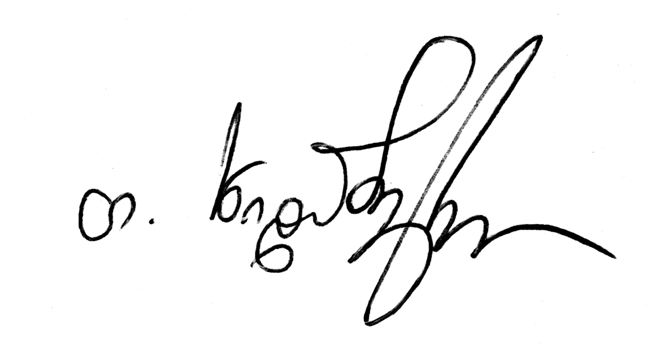
Ms. Tinatin Khidasheli
Minister of Defence of Georgia

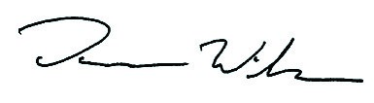
Mr. Damon Wilson
Executive Vice President,
Programs & Strategy,
Atlantic Council

