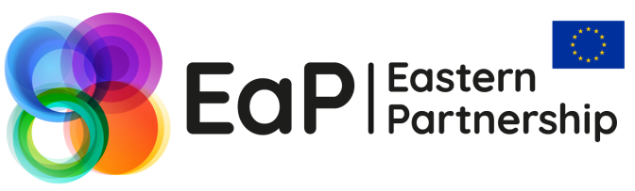

3rd EaP Panel on Harmonisation of Digital Markets
19-20 September 2017
Brussels, Belgium

PRACTICAL INFORMATION FOR SPONSORED PARTICIPANTS
The above event is organised by the European Commission and is financed by DG NEAR, within the framework of the ENI East Instrument. Four participants from each EaP partner country (Armenia, Azerbaijan, Belarus, Georgia, the Republic of Moldova and Ukraine) will be sponsored as well as 2 representatives of the Civil Society Forum and two EU speakers.

Venue & Timing
The event will take place at the Berlaymont hotel EU – Boulevard Charlemagne 11-19, 1000 Brussels, Belgium. The event will start at 09.30 am on 19 September and will finish with a lunch on 20 September 2017. You must have already received the draft agenda by the European Commission or the national HDM coordinator in your country.
A registration desk will be open at the venue, from 08.30 am, on both dates of the meeting. At the registration desk, you will be kindly asked to sign an attendance list.

Hotel arrangements
Your room with breakfast included will be booked and pre-paid at Berlaymont hotel EU – Boulevard Charlemagne 11-19, 1000 Brussels, Belgium, for a maximum of 3 nights, with check-in on 18 September and check-out on 21 September 2017. Participants extending their stay for any reason, including for participation to bilateral meetings, will need to cover their additional costs privately. Any extra costs incurred during your stay (such as mini bar, phone calls, room service, dry cleaning, etc.) will be paid by you privately.

Travel arrangements
A round trip ticket will be booked for you once your participation is confirmed. You will receive a travel proposal from UTS Travel Agency. Once received, please check for convenience and name spelling and then return it to UTS with your approval/confirmation. After your written confirmation, you will receive an electronically issued ticket - no paper ticket.
We would like to remind you that, following the EC rules, if you request an alternative itinerary (i.e. not flying from and back to the same city) or fly at different dates than those proposed by the travel agency, and if this alternative itinerary is more expensive than the one proposed, the price difference between the two itineraries will be covered by you.
Please keep your boarding passes to provide them together with a copy of your passport upon registration at the event venue, in order to receive the daily allowance. In case you need reimbursement for visa issuing costs, please provide the relevant original receipt and a copy of the passport page where your visa appears.

Daily allowance
A daily allowance of 56€ per night (calculated bearing in mind the costs directly covered by the EC) will be provided, with a maximum of three daily allowances. The allowance will be given to you in cash during the meeting.

Local transportation
You are kindly asked to use public transport from the airport to the hotel and vice versa. You will be refunded against your metro, bus or train ticket. After arriving at Zaventem airport, your hotel can be reached by public transport as follows:
- At Zaventem airport take the airport bus no. 12 (except at evenings and weekends when it is no. 21 and not "express"). The bus stops at Schuman Square after 20 minutes ride. Your hotel is a few minutes' walk behind the Berlaymont building.
- At Zaventem airport take the train to "Gare Centrale". From Gare Centrale, take the metro to "Schuman" station. Your hotel is a few minutes' walk behind the Berlaymont building.

Catering
Breakfast is included in the room rate. Coffee breaks and lunch will be offered at the venue of the event and will be financed by the European Commission.

Working Languages
Simultaneous interpretation English - Russian will be provided throughout the event.

Work content
For further information about the content of the event, please contact:
Mr Vassilis Kopanas, DG CONNECT, Email: vassilis.kopanas@ec.europa.eu
Logistics
For further information about the logistics and registration for the event, please contact:
Ms Ludmila Magkaeva, Event Coordinator, Cecoforma, ludmila.magkaeva@cecoforma.com

