1. Project Title
Harmonization of the national legislation on organ transplantation with the EU directives under the Association Agreement between the European Union and Georgia.
2. EU assistance tool
Twinning
3. Beneficiary Administration:
The name of the institution:
Ministry of Labour, Health and Social Affairs of Georgia
General structure:
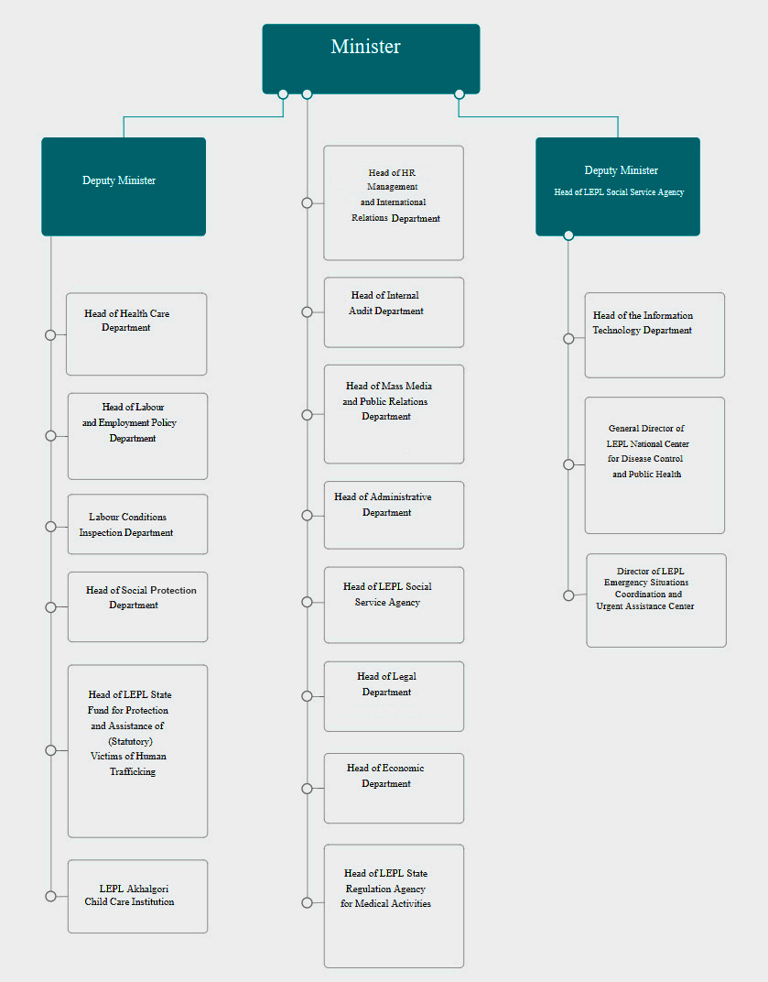

Number of employees:
290 Employees
The mandate of the institution:
The Ministry of Labour, Health and Social Affairs of Georgia is an executive branch of the Government of Georgia, which is responsible to develop and implement the state policy in the fields of labour, health and social protection.
The main activities of the Ministry of Labour, Health and Social Affairs of Georgia include:
- Elaboration of the corresponding legislation in accordance with international standards;
- Elaboration and management of the state labour, health and social programs;
- Coordination of programs implemented by the international and non-governmental organizations in the field of labour, health and social protection;
- Coordination of the sectoral reforms’ implementation.

Number of the staff that could be involved in the project preparation/implementation process:
5 persons
4. Background Information and Justification
Describe shortly why the project should be supported in the context of the EU-Georgia cooperation agenda and related documents (ENPI AP, future AA including DCFTA, etc.) or in the area and other GoG strategic documents (please indicate clear references to the priorities set out in the documents).
Under the Association Agreement, Georgia has the obligation to bring the national legislation into compliance with the following EU Directives:
1. Directive 2004/23/EC of the European Parliament and of the Council of 31 March 2004 on setting standards of quality and safety for the donation, procurement, testing, processing, preservation, storage and distribution of human tissues and cells;
2. Commission Directive 2006/17/EC of 8 February 2006 implementing Directive 2004/23/EC of the European Parliament and of the Council as regards certain technical requirements for the donation, procurement and testing of human tissues and cells;
3. Commission Directive 2006/86/EC of 24 October 2006 implementing Directive 2004/23/EC of the European Parliament and of the Council as regards traceability requirements, notification of serious adverse reactions and events and certain technical requirements for the coding, processing, preservation, storage and distribution of human tissues and cells;
4. Directive 2010/53/EU of the European Parliament and of the Council of 7 July 2010 on standards of quality and safety of human organs intended for transplantation.
Information regarding the needs of BA and why the project idea is relevant: What are the gaps, the project is to address for the beneficiary’s administrative capacity development? How is it relevant to the particular needs and constraints of the project’s beneficiary?
Organ /transplantation services in Georgia have evolved over the past 20 years: the first kidney transplant operation was conducted in 1995, the first liver transplantation - in 2014 and corneal transplantation has been also performed in the country as part of ophthalmologic services. In Georgia, organ transplants from living donors are used, with the exception of corneal transplants, when imported cadaver material is applied. As for the transplants from dead donors, despite the fact that the legislation regulates some aspects of this kind of donation, it is not performed in Georgia due to the lack of respective infrastructure, as well as of the unwillingness on the part of the population.
Since 1995, in total 294 kidney and 28 liver transplantation have been performed. In 2016, - 24 kidney and 13 liver transplantation and in 2017 (first 9 months) were conducted 18 kidnay and 7 liver translplantation. The overall mortality of organ recipients from 1995 to present is 13% for the kidney and - 25% for the liver transplantations. It is noteworthy that since 1995 the results of transplantation operations have been significantly improved, as evidenced by the 5 year life expectancy of renal recipients, which increased from 53% in 1995- 2000 to 98% in 2011-2017.
The Ministry of Labour, Health and Social Affairs of Georgia has launched the program of dialysis development since 1996 and the state program of kidney transplantation - since 1999. At this stage, the state program of dialysis and kidney transplantation ensures the provision of hemodyalisis and peritoneal dialysis services to patients with terminal renal insufficiency, аs well as conduction of renal transplantation operations and provision of post-transplantation immunosuppressive therapy to the persons with kidney transplants.
The number of dialysis program users is increasing: in 1996, 20 patients underwent hemodialysis in three medical facilities, currently 2,200 patients are benefiting from hemodialysis services in 21 medical institutions, 97 patients undergo peritoneal dialysis in 2 medical institutions, and 244 patients with kidney transplants are receiving immunosuppressive therapy under the same program. Liver transplantation is mainly covered by the state program of "Referral Service", in case of patient’s application.
At this stage the renal transplantation services are provided by 4 medical facilities (all in Tbilisi) and liver transplantation services - by 4 medical establishments (1 in Batumi and 3 in Tbilisi). Each institution, performing transplantation services that meets the legal requirements for such service provision and holds a respective permit (hospital permits for "procurement, storage and transplantation of organs and tissues").
In order to be granted the right to work in transplant surgery, general surgeons and urologists are required to complete the sub-specialty program in "transplant surgery" and to hold a subspecialty certificate. At this stage, there are 17 specialists with such subspecialty certificates.
As regards the regulatory framework in the field of organ transplantation, the “The Law of Georgia on Transplantation of Human Organs “ was adopted in 2000, the same year the subordinate legal acts on the charters of the Transplantation Council and Transplantation Bank were enacted and in 2001 and “Rules on Human Organ Export and Import” were approved.
In 2000 Transplantation Council was established at the Ministry of Labour, Health and Social Affairs of Georgia, which is a consultative body of the Ministry. One of the functions of the Council is the preparation of recommendations on the main directions of state policy in the field of transplantation.
Transplantation services have developed since 2000, however, important amendments in the corresponding legislation have not been made. The exception is the charter of the Transplantation Council, updated in 2017 and the revision of the "Rules on Human Organ Export and Import“ in 2016. The requirements for donation, testing, processing, conservation, storage and distribution of human tissues and cells, rules on traceability, undesirable reactions and the standards for the quality and safety of the organs and cells have not been yet established (despite that under the Law of Georgia on Transplantation of Human Organs there is the obligation to approve the standards of organ search, procurement, storage and transplantation, as well as of approving quality standards).
In order to efficiently and timely fulfill obligations undertaken by the Georgia-EU Association Agreement in terms of approximation of organ transplantation legislation with EU standards by 2019 it is highly important to share leading European countries experience and best practices for better health service provision to the population of Georgia.

Is it related to ongoing and/or planned activities of other donors and international financial institutions (the World Bank, USAID, etc.)? Please add the list of projects in your institution or in the field of the planned project for last 3 years.
No

In case of the Twinning, are there similar institutions in the EU member states that can be your partners?
No

5. Project Purpose
The main purpose of the project is approximation of the national legislation on organ transplantation with the respective EU Directives under the Association Agreement between the European Union and Georgia.
6. Expected results
- Bringing into compliance with the EU Directives (DIRECTIVE 2004/23/EC OF THE EUROPEAN PARLIAMENT AND OF THE COUNCIL of 31 March 2004, COMMISSION DIRECTIVE 2006/17/EC of 8 February 2006, COMMISSION DIRECTIVE 2006/86/EC of 24 October 2006, DIRECTIVE 2010/45/EU OF THE EUROPEAN PARLIAMENT AND OF THE COUNCIL of 7 July 2010) of “The Law of Georgia on Organ Transplants”.
- Adoption of the subordinate legal acts, including:
- The requirements for donation, procurement, testing, coding, processing, conservation, storage and distribution of human tissues and cells;
- Quality and safety standards of human organs intended for transplantation;
- Traceability requirements;
- Rules of notification about undesirable reactions and cases;
- Other subordinate acts.

7. Key Activities
1. Formation of a working group in the framework of the Transplantation Council of Georgia in order to ensure harmonization of the national legislation on organ transplantation with the EU Directives;
2. Assessment of the current situation in the field of organ transplantation by the working group and by the experts from EU;
3. Preparation of an action plan in order to ensure the compliance of the national legislation with the respective EU Directives under Association Agreement, based on the assessed situation and agreement of the plan with its main stakeholders;
4. In accordance with the Action Plan:
(a) Elaboration/revision and introduction of the amendments to the “ Law of Georgia on Organ Transplantation”
(b) Drafting and approval of subordinate normative acts.
8. Tentative start of the project
April 1, 2018
9. Contact Details
Contact person (official) Responsible for political steering of the project (at Deputy Minister’s level) | Name, Surname: | Nino Berdzuli
 | Position: | Deputy Minister of Labour, Health and Social Affairs of Georgia
 | Address: | 144, Ak. Tsereteli Ave., 0119 Tbilisi, Georgia
 | Tel:
 | E-mail:
Contact person  Technical detail; to ensure the day to day management of the project | Name, Surname:
 | Position:
 | Address:
 | Tel:
 | E-mail:
Date of Application:

