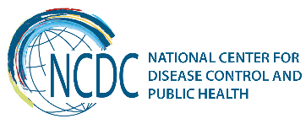
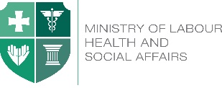

GEORGIA Brief
Implemented Activities Related to the
Antimicrobial Resistance (AMR)

The national AMR strategy was developed by national experts with the participation of the World Health Organization (WHO) consultants. Government of Georgia approved national AMR strategy in January 11, 2017 in line with the One Health approach.

The national AMR strategy is based on the guidelines and recommendations developed and issued by the WHO, CDC, as well as on international scientific literature and the data on the current situation in Georgia with regard to AMR. The national AMR strategy has been developed on the basis of coordination of evaluation activities carried out at the state level, though considering the lessons learned in the process of implementation, it presents the opportunities for further improvement and development.

Key Findings

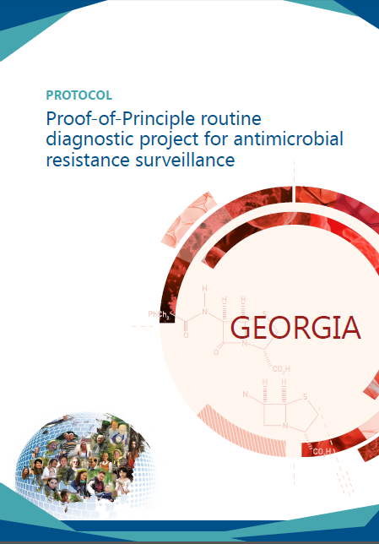

With WHO support had been conducted pilot proof-of-principle (PoP) Study in Georgia.
In the framework of the project, prevalence of blood stream infections (BSIs) has been studied; causal pathogens of BSIs and their antibiotic susceptibility has been determined; the value of clinical microbiology has been demonstrated to clinicians; and AMR Laboratory capacity had been strengthen at the local (hospital) and central (Lugar Center) levels under the PoP activities.
Point Prevalence Survey (PPS) of antimicrobial consumption and resistance was conducted in hospitals.

Recent Key Achievements
In 2016 Georgian AMR data was shared to the Central Asian and Eastern European Surveillance of Antimicrobial Resistance (CAESAR) and Global Antimicrobial Resistance Surveillance System (GLASS).
Georgia is a mamber of CAESAR and enrolled to GLASS since 2016.
Since 2014 nine different laboratories including NCDC are involved in EQA AMR network.
WHO is supporting AMR related activities - workshops, trainings, meetings since 2014, implementation of European Committee on Antimicrobial Susceptibility Testing (EUCAST) standards, renewal of legislation on infection prevention and control (IPC).
- The national AMR committee was created;
- An IPC post-graduation training curricula developed;
- Awareness on Healthcare-associated infections (HCAIs) and AMR increased;
- Knowledge on IPC among healthcare workers improved;
- Assessment and monitoring of IPC is being conducted in health care facilities;
- National IPC guideline is being updated;
- IPC standard operation procedures resistance are under development.

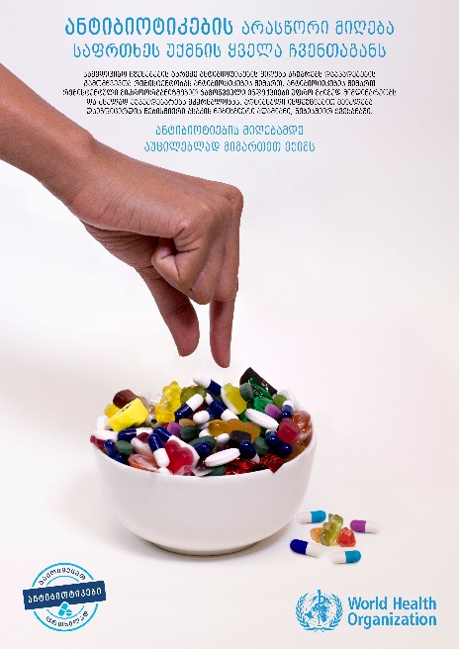
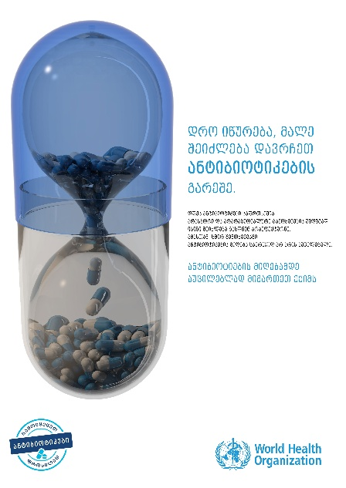

Future steps
- Awareness for AMR and IPC - moving into behavior change
- Promotion of antibiotic stewardship
- Strengthening IPC system at national level, using new guidelines of WHO on core components of infection prevention and control programmes, with following six major components:
1. IPC programmes
2. Evidence-based guidelines
3. Education and training
4. Health care-associated infection (HAI) surveillance
5. Multimodal strategies
6. Monitoring and audit of IPC practices and feedback
- In 2017 there are planed two events with WHO support - World Antibiotic Awareness Week (WAAW) meeting in Tbilisi and Batumi; and, AMR/IPC Workshop covering AMR Data collection and analyzing.
- Strengthening AMR reference laboratory capacity
Challenges
So far no activities have been carried out with regard to the third component of above mentioned new guidelines of WHO on core components of infection prevention and control programmes, which is due to the fact that National Guidelines are still under development.
Once the national guidelines will be completed, will be necessary for its implementation to carry out the appropriate training for all professional categories of healthcare professionals.
________________________________________________________________________________________
  Ministry of Labour, Health and Social Affairs of Georgia  144, A. Tsereteli avenue. Tbilisi, Georgia, 0119  www.moh.gov.ge | 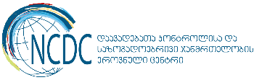  National Center for Disease Control and Public Health  9, M. Asatiani street. Tbilisi, Georgia, 0177  www.ncdc.ge

