Detailed information on the State Health Care Programs of the Ministry of Labour, Health and Social Affairs of Georgia

Healthcare expenditures

- Since 2013, the Government of Georgia has laid the solid foundation in public health and welfare oriented policy. Recent years the state budget allocations for the health sector substantially increased (in 2012 - 450 million GEL; in 2016 - 1067 million GEL);
- The state share of Government expenditure on healthcare from GDP and the state budget has been significantly increased (in 2012 - 1.7%, in 2016 – 3.1%).
- According to the assessment of the World Health Organization and the World Bank, by implementing efficient reforms, the country has improved access to health care and provided better financial protection.
- There was a steady growth of the utilization of medical services, and significantly increased population's satisfaction with regard to the medical services.

Trends of Government Expenditure on Health

Source: MoLHSA, NHA

Government Expenditure on Health per Capita (GEL), Georgia
Source: MoLHSA, NHA

Universal Health Care (UHC) Program

- Since February 2013 Universal Health Care (UHC) program is being implemented, which envisages universal access to healthcare services for all citizens of Georgia;
- According to the WHO European Health Report, 2015, Universal Healthcare Program was recognized as a successful reform.
- According to the World Bank, WHO, USAID survey, an absolute majority of the Universal health Care Program beneficiaries (96.4%) are satisfied or very satisfied with in-patient and/or emergency out-patient services of the UHC program and 80.3% of the surveyed beneficiaries are satisfied with the planned outpatient services.
- According to the World Bank, WHO, USAID survey the main achievements of the Universal Healthcare Program are: increased accessability to the medical services; increased utilization of the medical services; reduced financial barriers and increased coverage.
- Since 2013 utilization of health care services has been increased. in 2016, the number of outpatient visits per capita was 4.0 (in 2012 - 2.3), while the hospitalization rate per 100 population increased from to 8.0 (2012) to 13.3 (2016).
- Universal Health Care Program covers – planned ambulatory care, emergency outpatient-inpatient care, elective surgery, cardio surgery, chemo-radio-hormone therapy, Delivery and C-section, infectious diseases
- UHC program beneficiaries are: persons holding identity card of Georgia, neutral identity card, neutral travel document, also persons without citizenship having stateless status in Georgia, asylum seekers in Georgia, refugees and persons with humanitarian status.
- In order to ensure health service quality, from March 1, 2017 has been started selective contracting of service providers for deliveries and ceasearian sections as well as neonatal intensive care; from July – 2nd and 3rd level intensive treatment/care providers and from January 2018 – selection of emergency in-patient care and antenatal services service providers has been started.
- In May 2017 has been started the further stage of the reform - elaboration of new criteria for differentiation of beneficiaries (according to beneficiaries' revenue) has been implemented for provision of more needs oriented services and development of "social equity" approach.
- By the end of 2017, more than 3, 5 million cases were reported in the Universal Health Care Program.

Annual outpatient visits per capita (2012-2016)

Source: NCDC&PH

Hospitalization Rate per person (2012-2016)
Source: NCDC&PH

Universal health care State Program Expenditure

Source: State Treasury

State program for providing medicines for chronic diseases

- From July 1, 2017, persons suffering from chronic conditions, who are registered in the unified database of "socially vulnerable families" with the rating score not exceeding 100,000, are eligible for the state program providing drugs for chronic conditions. The program provides patients with selected drugs for chronic cardiovascular diseases, chronic obstructive pulmonary disease, diabetes (type 2) and thyroid conditions.
- During the year 2017, the program benefited 13 010 persons.

Hepataitis C Elimination Program

- Memorandum of Understanding between the Government of Georgia and US pharmaceutical company Gilead Science Inc. was signed on April 21, 2015. As a result, Georgia started unprecedented Hepatitis C Elimination Program in the World.
- In April 2016, The Government of Georgia and the company "Gilead" signed a long-term agreement on the continuous provision for 0 price of the new generation of hepatitis C medicines by Gilead Science Inc., until the elimination of hepatitis C in Georgia.
- In August 2016, a long-term strategy for elimination of hepatitis C (2016-2020) was developed to achieve the ultimate goal of eliminating the hepatitis C. Strategy sets forth the following targets, to be reached by 2020:
- 90% of HCV infected persons have been tested for their infection
- 95% of people with chronic infection have received treatment, and
- 95% of persons who receive treatment are cured of their HCV.
- In the initial phase of the program in 2015, program beneficiaries were patients with severe liver disease. From June 10, 2016, the inclusion criteria were removed. Services are provided to the citizens of Georgia as well as persons with neutral IDs living in occupied territories, and for convicts placed in penitentiary system.
- Throughout the country, 32 service centers are providing diagnostic and treatment services to the elimination program beneficiaries. Since the launch of the program in 2015 through April, 2018 more than 45 462 beneficiaries have been registered in the program. More than 41 580 patients completed the treatment. SVR was achieved in 98%, in case of medicine “Harvoni”.
- In order to increase identification of hepatitis C virus screening activities has been significantly scaled up. The Hepatitis C screening protocol was developed and approved. Routine screening is provided for pregnant women and hospitalized patients. More than 700 sites, including primary health care centers, hospitals, penitentiary system, pharmacies and Georgian Harm Reduction Network (GHRN) centers, municipal public health centers. etc., provide HCV screening across the country.

From December 2017, confirmative test necessary for the program enrollment is fully funded within the HCV Elimination Program. On November 1, 2017, at the World Hepatitis Summit in Sao Paulo, Brazil, Georgia was awarded the title of NOhep Visionary for the European Region status for contribution to the process of elimination of hepatitis C.

State Program of Referral Service

- The State Program of Referral Service aims to improve the health of the population by increasing the financial and geographical accessibility.
- The Program beneficiaries together with Georgia citizens are stateless persons permanently residing in Autonomous Republic of Abkhazia, Tskhinvali Region and based on Ceasefire Agreement on August 12, 2008, population.
- In 2012-2017, more than 74,000 people benefited from the program.

Herceptin

- Since 2016, the Ministry of Labour, Health and Social Affairs of Georgia provides expensive drug Trastuzumab (Herceptin) treatment for HER2 + Receptor positive Women with breast cancer.
- The aim of the program is to conduct an innovative, targeted therapy and increase financial access to treatment for the citizens of Georgia (women) with HER2-reciprocate early breast cancer.
- The total beneficiaries of the program were 182 patients

Other state health programs

- Public Health Programs include the prevention of communicable and non-communicable disease, immunization of population, early detection and screening of diseases, TB, malaria, viral hepatitis, HIV/AIDS, sexually transmitted infections and health promotion among the entire population of Georgia.
- Health care service provision to the population of Georgia in priority areas is ensured by geographical accessibility to the following health care services/programs: mental health, diabetes management, children's onco-hemology services, dialysis and kidney transplantation, palliative care of incurable patients, patients with rare diseases and patients undergoing permanent replacement treatment, ambulance and emergency care and rural doctors.

Rural doctors program

- In order to strengthen the role of the rural doctor, in the first quarter of 2014, the government took the responsibility to manage of the "Rural Doctor" program.
- Salary of doctors and nurses increased by 30% from May 2014 (the doctor's salary was 500 GEL and became 650 GEL; the salary of the nurses was GEL 300 and became 455 GEL).
- The centralized procurement of medical documents and "doctor's bag" (the doctor's bag contains medicines, antiseptic means, single-handed goods and instruments) was made for rural doctors.
- Distribution of medical personnel in rural areas is underway based on data from the 2014 census conducted by the Statistics Department of Georgia and taking into account the new form of divided municipalities into administrative units.

TB Management Program

- The Government of Georgia significantly increased the state funding of TB management program (the program budget in 2015 - 11 629 100 GEL, in 2016 - 14 000 000 GEL, 2017 - 15 400 000 GEL).
- The trilateral Memorandum of Understanding was signed between the Ministry of Labour, Health and Social Affairs of Georgia, the National Center for Tuberculosis and Lung Diseases and MSF-France in September 2014, which aims to provide new generation drugs (Bedaquiline and Delamanid) to the patients with multiresistant tuberculosis.
- In order to improve enrolment of patients with Sensitive and Resistant Tuberculosis in the programe, the financial incentives for the resistant form of tuberculosis have been started since 2015.
- From 2015 the State ensures TB patients with the first-line antiretroviral (ARV) and Anti-TB drugs and from 2017 - 25 % of second-line drugs.
- Within the state program, the piloting project of Gene expert testing started in 15 medical facilities.
- The prevalence and incidence of tuberculosis in Georgia is gradually decreasing by the assessment of the World Health Organization.

TB incidence per 100000 population, Georgia
Source: NCDC&PH

HIV/AIDS Management Program

- From 2015 the State ensures HIV patients with the first-line antiretroviral drugs (ARV) and from 2017 - 25 % of second-line of ARV drugs.
- For the first time in 2017 the reduction of HIV incidence (new cases revealed) by 12% has been occurred despite increasing detection of new HIV infection cases in 2015-2016.

Number of HIV/AIDS new cases, Georgia

Source: NCDC&PH

State Program of Rare Diseases

- In 2014-2015, 4 new medicines, 7 new nosologies and physiotherapy services of hemophilic infections has been added to the State Program of Rare Diseases.
- Since 1st June, 2017 the Ministry of Labour, Health and Social Affairs of Georgia within the Referral Service State Program provides patients suffering from one of the severe disease - Idiopathic Pulmonary Fibrosis with medicine Pirfenidone (Esbriet).

Mental Health State Program

- In 2018, the State budget of the Mental Health Program has been increased by 5 million and comprised 21 million in total.
- Financing of community-based services has been increased. In particular, 54% of the budget resources has been directed to community-based services. The budget of the community-based mental health services was determined in accordance with the number of population in bounded area and throughout the country 11 community-based mobile teams will be financed (last year only 3 mobile teams were financed). The budget for each mobile team is also increased and as a result, more beneficiaries will be able to use the mental health services in Tbilisi and in the regions as well.
- Under the new financial conditions, balance between the community and hospital services is 40-60%, which is defined by the Strategic Development Plan for Mental Health 2015-2020.

Source: SSA

State Program for the Treatment of Drug Abuse

The state program for treatment of drug addicted patients abuse has been carried out since 2005, which includes hospital detoxification and primary rehabilitation, as well as replacement therapy with methadone and suboxone.
- Within the program the amount of co-payment by the patient was GEL 110 in 2013. From July 1, 2017, the state fully covers replacement program, which previously was funded by the Global Fund and in parallel all beneficiaries are fully released from co-payment.
- The services are provided in Tbilisi and in the regions of Georgia
- The upper limit of patients’ acceptance is being canceled.
- The release of beneficiaries from co-payment resulted in significant increase of the number of patients’ first and repeated enrolment in the program.

Maternal and Child Health

- Georgia managed to reduce under–five mortality rate to 10.2 per 1000 live births by 2015 thus accomplishing the Millennium Development Goal #4 (MDG) set at the 2000 Millennium Summit: Reduce by two-thirds, between 1990 and 2015, the under-five mortality rate.
- In 2015 perinatal care regionalization project has started to improve health outcomes and decrease maternal and infant morbidity and mortality through provision of risk-appropriate care. Within the project, all facilities providing maternal and new born care services are divided by levels of care according to their capacity. each mother and new born is delivered and cared in a facility appropriate for their healthcare needs. In 2016, the lowest mortality rate of maternal mortality has been observed in recent years - 22.9 /100 000 livebirth.
- In 2017, a comprehensive long-term (2017-2030) Maternal and Newborn Health Care Strategy has been approved, which defines next 14 years’ state policy of maternal and new born health, family planning, sexual and reproductive health.
- From June 2014, all pregnant women, before the 13th week of pregnancy, are provided with folic acid and iron supplements in case of iron deficiency. Newborns (6-23 months) are provided with food supplements containing microelements.
- In 2016, the specific treatment of pregnant women with syphilis has started.
- From 2018, pregnant womens registered within the Antenatal Care Program are provided with 8 visits instead of 4. Also, selective contracting of antenatal care providers has been started.

Maternal Mortality Rate by different sources of information, Georgia, 2000-2016
Official Statistics
Source: NCDC&PH

Immunization

- In accordance with the national calendar, the state provides 13 disease prevention.
- Five new vaccines were successfully introduced in the National Immunization Calendar: rotavirus vaccine (Since 2013, the share of rotaviral diarea from 40 5 dicreased to 12% (2016); Pneumococcal vaccine; Polliomielitis vaccine (switch from Penta to Hexavalent vaccine); Bivalent Oral Polio Vaccine (bOPV); Human Papillomavirus (HPV) vaccine in the four territorial areas of the country (Tbilisi, Kutaisi, Adjara AR, Abkhazia AR).
- Vitizens are provided with anti-rabies vaccine for free of charge.
- In order to ensure high quality, uninterrupted supply and balanced prices of vaccines, all vaccinations included into the National Vaccination Calendar are prequalified by the World Health Organization and their procurement (except hexavalent) is carried out through the United Nations Children's Fund Purchase Mechanism.
- Hepatitis B and flu vaccination was introduced in state immunization program for persons diagnosis with Hepatitis C. Also, the vaccination of HIV infected patients continued with these vaccinations under the obligations govement tooked form Global Fund.
- In order to prepare for the 2017-2018 flu season, 27,000 doses of seasonal flu vaccines were purchased.
- In order to renew the "cold chain" inventory across the country, electrodesmotors, freezing indicators, room refrigerator and temperature sensors have been purchased.

Budget of Immunization State Program, 2012-2018
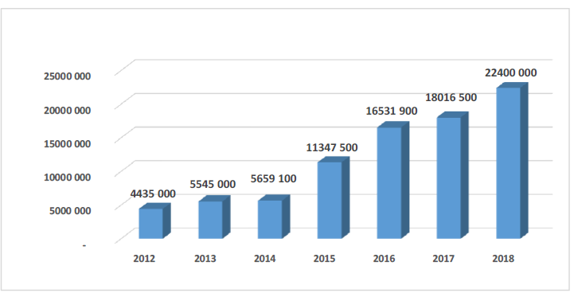
Source: NCDC&PH

Immunization Coverage (%), Georgia 2016
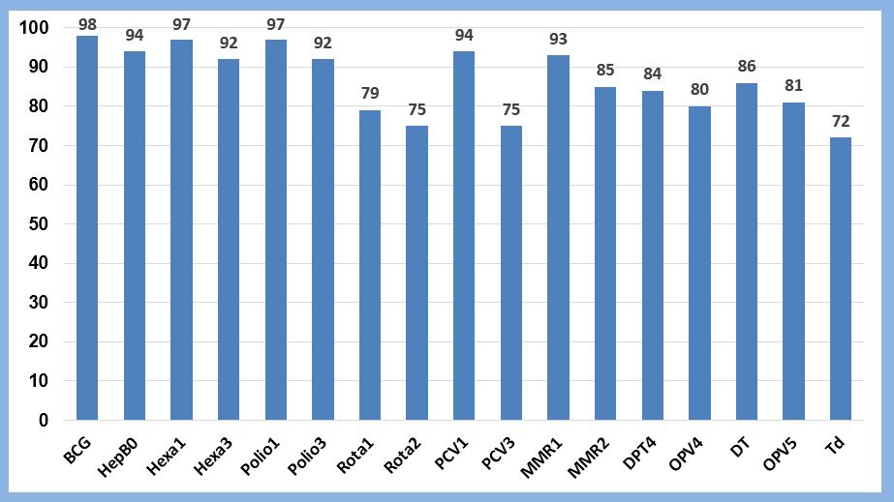
Source: NCDC&PH

Programs funded by the Global Fund: HIV/AIDS, TB

- In order to endure the sustainability of programs on the background of the reduction of funding of the Global Fund and the gradual transition to state funding, the Plan for Stability and Transition Period of Global Fund Programs for 2017-2019 was elaborated.
- From the Global Fund, more than 55 million US dollars have been mobilized in 2014-2019. In 2019-2022, the grant amount provided by the Global Fund to the country has been reduced twice and is USD 15.4 million.
- The State has been obliged to purchase the first line (full) and second-order medication (25%) of TB and AIDS.
- Reduction of Global Fund financing is in proportion with increasing share of state funds on these programs to ensure continuity of services. The percentage share of state programs financing in 2014-2016 has significantly increased in the volume of financing of HIV infection and TB management programs and exceeded 70%.
- HIV prevention and screening measures for high risk groups with HIV infection increased significantly; the geographical coverage of these populations was expanded by the introducing of mobile outpatient services. (The 8 mobile outpatient car was purchased).
- The Georgian Antiretroviral therapy (ART) program was recognized by the international experts as one of the best in the region due to universal access to HIV treatment, high coverage of target populations and improved quality of the program interventions. As of December 1, 2017, there were 4033 patients on ART treatment.
- Georgia one of the first in the region started implementation of WHO “Treat ALL” strategy from December 2015, offering ART to all registered PLHIV (People Living with HIV/AIDS) despite their CD4 count.
- The latest diagnostic methods recognized by the World Health Organization are implemented in the country: Cultural studies on hard and liquid soils, rapid diagnostic methods of tuberculosis and multi-drug resistant tuberculosis and the sensitivity tests of the drug.
- A new DOT outpatient center has been constructed and one more project is planned to replace existing amortized facilities.
- In order to improve geographical access to medical care for patients with TB, 3 mobile outpatients have been purchased in 2016.
- Form July, 2016 Video Observed Therapy (VOT) pilot program was initiated in the capital city. Patients with resistant tuberculosis in the stage of outpatient treatment, if desired, can take the drugs are during the video call that the nurse supervises through the skype.
- Since 2017, the ECHO model has been introduced, which implies the use of teleconference technology to discuss patients' condition.

