Company: Drug Center Pharmacy
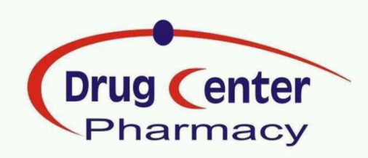
Drug Center Pharmacy is a chain retail pharmacy consisting of 10 branches distributed all over Amman, the Capital of Jordan.
The company’s mission is to provide its customers with medicines, cosmetics, medical devices, and everything related to the body care at any life stage whether it is from local or international vendors.
The company’s vision is to be one of the best pharmacies in Jordan by providing high quality products and services in competitive prices and to continue spreading by opening more branches.
In addition to the ten branches, the company has a specialized department to follow up all of the issues related to the agencies that it has, including the distribution issues to other pharmacies in Jordan.

- Founded: July 2005
- Organization: Privately held
- Branches:10
- Employees: 100+
- Annual Sale: 7,500,000 €
*Till the end of 2014
General Manager (Founder)
- Dr. Ra’afat Abdulghani

Executive Manager
- Ehab Abdulghani

Certificates
- ISO 9001:2015
Links
- http://www.drugcenterjo.net
Agencies
- Dalton for cosmetics (Germany).
- Medical Disposable (USA).
- Drammock for beauty formula (France).
- Martini SPA for massage products (Italy).
- Profoot for foot care products (UK).
Why we are special?
- Our branches are distributed very well and occupy vital places in Amman which guarantees the easy accessibility for all customers.

- Regarding the dispensing of the drugs we provide an excellent service by dealing with customers in a professional kind way and by giving the time and the consultation needed for every customer. To improve this service we have incorporated an isolated consultation room in some of our branches to give the maximum benefit and privacy to our customers.

- The prices of babies and mothers’ needs at our pharmacies are competitive, and we have beauty advisors who provide customers with free medical cosmetic consultations.

- Our pharmacists are well trained and prepared to hold their positions professionally. We applied a continuous training programs either internally or from external parts like the well-known pharmaceutical companies.

- We are socially active, our social activities are wide and diverse like visiting schools to give medical lectures to students, visiting doctors, and building good relations with the biggest institutions from different working fields.

- We issue a magazine called Drug Center Newsletter which contains advertising, introducing offers, discounts or gifts on the products. It has a good influence on customers and was spreadable and successful in raising the percentage of sales for its products since 2008.

- Our departments are well organized and specialized, we have an IT department, a well-developed accounting department which uses the most updated technology to ease dealing with vendors like sending massages to vendors once their checks are issued.

- We have a well-established marketing department that deals with any activity related to the promotion of the company name and its pharmacies’ products.

