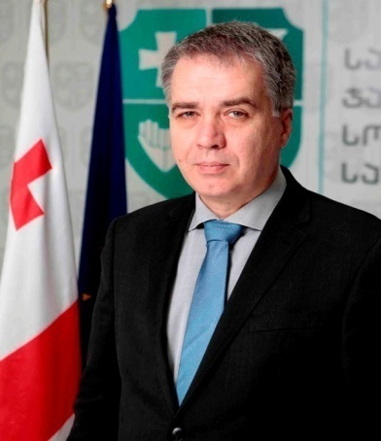
Mr. David Sergeenko was appointed as a Minister of Labour, Health and Social Affairs of Georgia in 2012. Mr. Sergeenko manages the biggest budget among the ministries in Georgia.
2013 Mr. Sergeenko introduced Universal Health Care System in Georgia. This program had a big impact on Georgian citizens: twice as many people were able to receive medical care, and it significantly decreased out of pocket spending of citizens on healthcare.
2015 Mr. Sergeenko in partnership with CDC and GILEAD Sciences Inc. launched an ambitious program – Elimination of Hepatitis C in Georgia. The program includes diagnosis, treatment and monitoring of the patients infected with Hepatitis C. In order to implement elimination program and prevent spread of the virus, the Ministry has introduced various control mechanisms and regulations. This program continues to be one of the first most successful public private partnerships of its scale.
In 2015 with the leadership of Minister Sergeenko the Ministry has introduced labour inspection in Georgia that supports work safety throughout the country.
Under Mr. Sergeenko’s management special emphasis has been made on promotion and development of family support services and alternatives to institutionalization in Georgia. In 2014 the Ministry has introduced an innovative special program for children living and working on the streets.
Mr. Sergeenko graduated from Tbilisi State Medical University from faculty of pediatrics. He continued his education in Intensive Care Medicine at Berlin Heart Institute and received training in Pediatric Cardiac Intensive Care at Boston’s Children’s Hospital, Harvard Medical School. After returning to Georgia, he practiced neonatology and later served in the Georgian Armed Forces as a physician for an air force regiment. In 1995 he was appointed as a chief of medical service at the State Department of Sports. He worked as an anesthesiologist -intensive care unit doctor at the Cardiac Surgery JoAnn Medical Clinic in Tbilisi from 1997 to 2006 and as a medical service manager at the MediClub-Georgia clinic from 2002 to 2006. In 2006, he became general director of Sachkhere Medical Center.

Minister Sergeenko is a member of World Health Organization’s (WHO) Executive Board and a member of Ministerial Health Leadership Network at Harvard University. In 2015 was awarded with St George’s Order of Victory, which comes second in rank to the Order of National Hero in Georgia.

