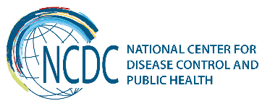


GEORGIA Brief
Diseases Under Elimination

In order to embody international demands and modern challenges, diseases of the elimination concern have been managed in accordance with relevant standards.
EMTCT:
Mother-to-child transmission of HIV and Syphilis - Amendments were made to the National Program for supporting the elimination of mother-to-child transmission. Specifically, if testing of pregnant women was held once in the past, nowadays government covers two-time testing for 2 infectious (HIV and Syphilis) + hepatitis B& C. Our goal is to be ready to proceed verification elimination of mother-to-child transmission of HIV and Syphilis in two years.

Measles, Rubella, Congenital Rubella:
Country had 2 big outbreaks of measles in 2004 and 2013; measles - rubella immunization campaign was failed in 2008 - only 50% of target population was immunized. Because of unsuccessful campaign experience, in 2013 country decided to vaccinate non-immunized adults within the National Program. Today more then 181 000 previously non-immunized adults are vaccinated against measles-rubella-mumps and this process is still ongoing.
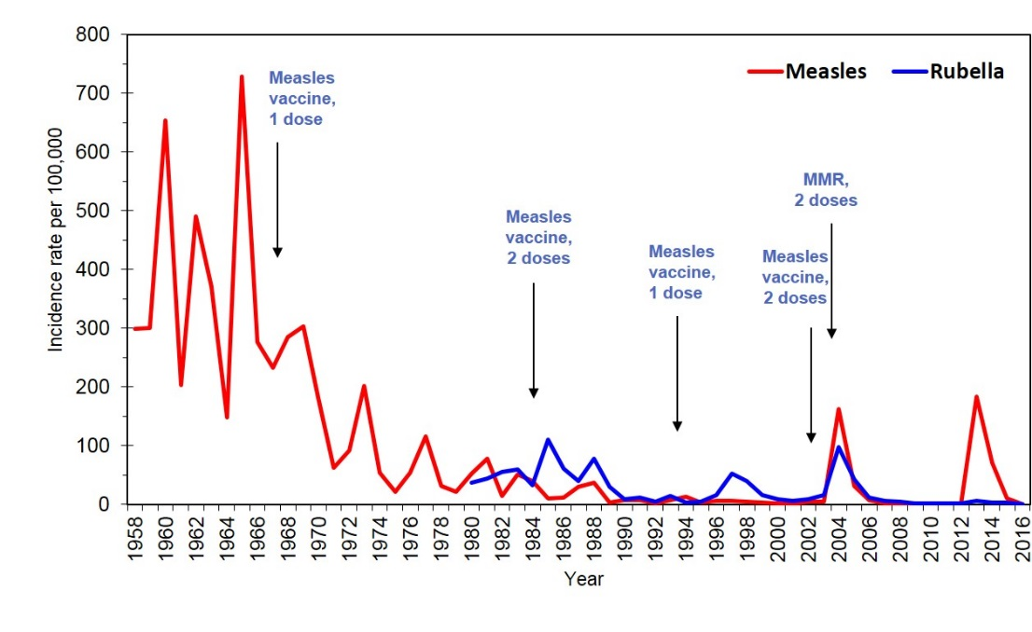
* Incidence of Measles and Rubella 1958-2016
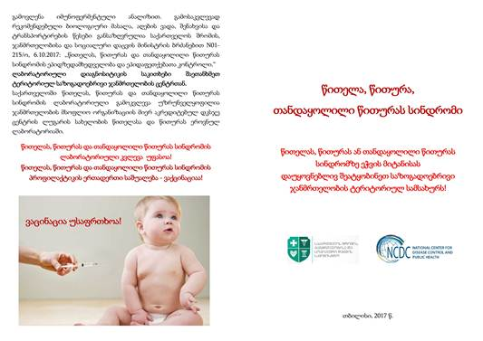
* Brochure on Measles, Rubella, Congenital Rubella Syndrome
Poliomyelitis:
- Georgia is certified as a country free from the wild poliomyelitis virus in 2002.
- IPV and OPV vaccination was introduced in country timely and successfully.
- Surveillance on acute flaccid paralysis cases was actively implemented.
- Vaccination of travelers from high risk countries, defined by WHO is being conducted on the border.
- Since 2000, surveillance on environment is carried out under which laboratory research of wastewater is being conducted to reveal poliovirus. The results of surveillance of environment together with the results of the surveillance on AFP/poliomyelitis confirms the absence of polyvirus circulation in country.
*Incidence of poliomyelitis 1989-2016 (per 100 000)
AFP
Poliomyelitis
Incidence of AFP 1997-2016 (per 100 000, 0-14 age group)

Malaria:
- The natural conditions for malaria transmission occur on 51.6% of Georgian territory.
- 80% of Georgian territories are populated, and 93% of Georgian population lives on these territories.
- Since 2005 to date 136 malaria foci were recovered in Georgia.
- From 2013, no local (endemic) cases of malaria was recorded in Georgia. Since 2016, the surveillance system has identified 32 suspicious cases, of which 11 cases have been confirmed (all of them were imported from the endemic countries).
- In 2017, totally 9 000 000 m² outdoor and indoor territory was processed for vector control by Ministry of Agriculture and Ministry of Labour Health and Social Affairs.

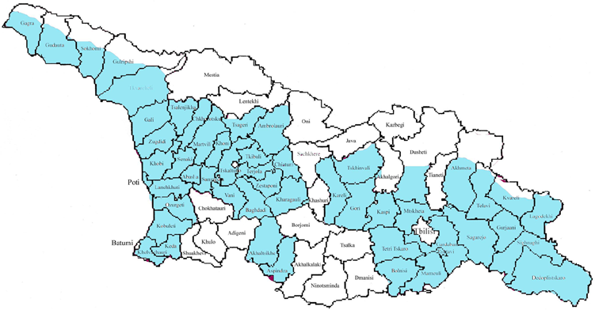
* Risk Areas in Georgia

* Distribution of autochthonous malaria cases by years

In order to support elimination of diseases, it is necessary to have strong episurveillance and sustainable laboratory system. Polio and Measles/Rubella laboratories at Lugar Center are accredited by WHO.

Rabies
Since 2015 there were no human rabies cases registered in Georgia, which was achieved by implementing following measures by the Ministry of Labour Health and Social Affairs and Ministry of Agriculture:

- Appropriate rabies post exposure treatment.
- Increased universal accessibility to anti-rabies immunoglobulin and vaccine.
- Raised awareness in population on response after exposure to animal suspected of having rabies.
- Herd immunity in domestic animals.

________________________________________________________________________________________
  Ministry of Labour, Health and Social Affairs of Georgia  144, A. Tsereteli avenue. Tbilisi, Georgia, 0119  www.moh.gov.ge | 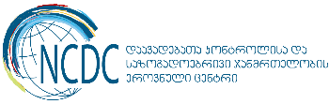  National Center for Disease Control and Public Health  9, M. Asatiani street. Tbilisi, Georgia, 0177  www.ncdc.ge

