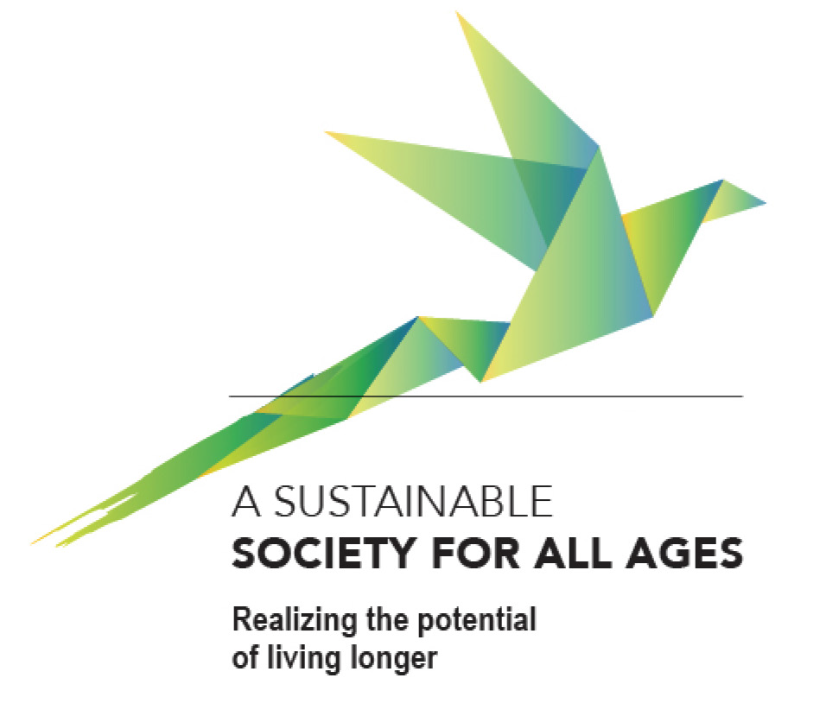


UNECE Ministerial Conference on Ageing 2017
Lisbon, from the 20th to 22nd of September

2017 MINISTERIAL DECLARATION
“A Sustainable Society for All Ages: Realizing the potential of living longer”
Declaration Drafting Group
(including suggestions from the two rounds of official consultations)
15 August 2017
Final Draft

2017 MINISTERIAL DECLARATION
4th UNECE Ministerial Conference on Ageing
“A Sustainable Society for All Ages: Realizing the potential of living longer”

Preamble
- We, the representatives of the member States of the United Nations Economic Commission for Europe (UNECE), gathered at the fourth Ministerial Conference on Ageing from 21 to 22 September 2017 in Lisbon, Portugal, reaffirm our commitment made in the Berlin Ministerial Declaration in 2002 and subsequently confirmed by the León (2007) and Vienna (2012) Ministerial Declarations to fulfil the Regional Implementation Strategy (RIS) of the Madrid International Plan of Action on Ageing (MIPAA) and to safeguard older persons’ enjoyment of all human rights as laid down in the relevant international and regional instruments.
- We note with satisfaction that life expectancy has increased for both women and men in the UNECE member States, although this increase in longevity is not always accompanied by good health. We particularly appreciate the richness of life experience and knowledge of older persons and their contributions for the benefit of our societies and their own personal fulfilment.
- We recognize that the ongoing demographic changes present opportunities and challenges for policymaking and for individuals in our countries, and acknowledge a need for gender equality and intergenerational solidarity.
- We appreciate that older persons are not a homogenous group, but diverse in their needs, preferences, and opportunities throughout their life course.
- We acknowledge the significant progress made by many member States, either at the national or local level, in fulfilling the ten commitments of the UNECE RIS/MIPAA during the third five-year cycle. At the same time, we are aware that the implementation of the UNECE RIS/MIPAA during the past five years has occurred in an environment of economic stagnation, pressures on social spending, rising migration and technological transformation. Notable achievements in implementation in the region include, among others, the following:
  - increasing attention of policymakers, social partners, media, civil society and the general public to the issues of individual and population ageing, including the observance of older persons’ dignity and enjoyment of all human rights, and recognition of their contributions to economic performance and society as well as to strengthening inter- and intragenerational solidarity
  - advancing active ageing as the central concept and operational approach of national and regional policies on ageing
  - setting up measures to adapt national social protection systems and labour markets to the consequences of demographic changes
  - growing involvement of civil society, in particular organizations of older persons, in the development of policies addressing the rights, needs and fulfilment of the potential of older women and men
  - wider use of innovative approaches in providing services related to education and training, employment, culture, leisure and social tourism, rehabilitation, health and social care, including technological and organizational innovations, as well as promoting stronger cross-sectoral multi-stakeholder involvement in developing such services.
- We note that some UNECE member States have still to develop more comprehensive policy responses to the individual and societal needs of ageing populations, while other member States need to secure or enhance the existing access of older persons to adequate social protection and well-functioning systems of health and long-term care including access to advanced treatments offered by medical progress.
- We are also cognizant that policies on health and welfare of older persons in many member States need to be complemented with measures aimed at empowering older persons, particularly older women, safeguarding their dignity and preventing all forms of discrimination, abuse, violence and neglect.
- We realize that the contribution of growing numbers of older persons - as both consumers and producers - to economic and social innovation and development is not universally recognized. Likewise, the role of social and health service sectors supporting older persons calls for better appreciation not only as important and growing labour market, but also as contributing factor to the economy and social cohesion as well as healthy ageing.
- We see a need to strengthen social cohesion in our societies by recognizing the potential of older persons and promoting opportunities for them to participate in society and the economy.
- To foster the implementation of UNECE RIS/MIPAA during the fourth cycle from 2017 to 2021, we stress the importance of further mainstreaming ageing into relevant policy areas and combating ageism in its many forms. We stand together in reaffirming the commitment to designing and implementing integrated policies for active and healthy ageing, where older persons are continuously recognized as an asset for a sustainable and inclusive society for all ages.
- We aspire to realize the potential of living longer and we are determined to work towards achieving the following policy goals by 2021:
    - Recognizing the potential of older persons by
- empowering individuals to realize their potential for physical, mental and social well-being throughout their lives and to participate in and contribute to society according to their capacities, needs, and desires
- developing and implementing socially responsible and future-oriented economic and financial strategies that encompass the needs, capacities and expectations of current and future generations, while valuing the potential of older persons, their life experience, their responsibility and support for all generations and for society
- fostering effective consultations with, and involvement of, older persons and their representatives at the national, regional and local levels in designing policies, strategies and measures that directly or indirectly influence their lives, taking into account the diversity of older persons and their needs
- promoting a positive image of older persons, acknowledging their contributions to society and strengthening multigenerational discourse and intergenerational learning by all stakeholders, cultivating a life-course perspective in education, the media and other areas to promote better understanding of individual and societal ageing and the opportunities it presents
- fostering work and volunteering of younger and older persons in intergenerational settings to help them understand how important and rewarding communication, exchange of experiences, cooperation and intergenerational solidarity are in all areas of life, within and outside the family
- encouraging businesses, non-profit organizations and public enterprises to involve older persons as consumers in the planning and design of goods and services to match their needs and preferences, and to engage them in monitoring the quality of such goods and services
- ensuring that older persons can attain and maintain their highest possible level of health and functional capacity by supporting the development of age-friendly environments and housing, and adapting health and social care systems to provide integrated, prevention- and person-oriented services, including in deprived urban, rural and remote areas.
    - Encouraging longer working life and ability to work by
- recognizing the potential embedded in the employment of older workers and developing labour market strategies to promote maximum participation opportunities for workers of all ages
- fostering access to and promoting lifelong learning opportunities and development of skills as a prerequisite of an active and fulfilling life at all ages
- developing strategies to fight unemployment at all ages, reducing financial inequalities and poverty, taking up measures to reduce the gender pay gap as well as other gender inequalities, and preventing age-related discrimination in employment
- encouraging employers to value the experience of, and to retain and hire, older workers, promoting age management in both the public and private sectors, and supporting age-adapted, safe, health-promoting, and flexible working conditions throughout the entire working life
- providing incentives for longer working life opportunities and more flexible retirement choices and fostering alternatives to early retirement including, but not limited to, rehabilitation, reintegration into work and flexible employment options to retain older workers
- planning and implementing pension reforms, as far as not yet done, that take into account the increasing longevity and the extension of working lives, to ensure intergenerational fairness as well as the sustainability and adequacy of pension systems
- facilitating the reconciliation of employment and care work, providing access to flexible working arrangements and appropriate care services, and promoting an equal division of care work between women and men, while considering a possibility to account for the time spent on tasks of family care in the calculation of the old-age pension.
Ensuring ageing with dignity by
- protecting older persons’ enjoyment of all human rights and dignity, promoting their autonomy, self-determination and participation in society, and making sure that no law, policy or programme leaves room for discrimination of any kind
- supporting the necessary infrastructure and assistance to prevent all types of abuse and violence against older persons, ensuring their economic, physical, and psychological safety
- fostering the development of innovative methods and services as well as user- and age-friendly technology and products for reliable, accessible and affordable support and care suited to the varied and changing needs of older persons, allowing older persons to maintain social connections and stay in their preferred living environment for as long as possible
- raising quality standards for integrated social and long-term care and health services, as appropriate, and continuously adapting the status, training and working conditions of professional care workers, including migrant care workers, to the growing need for culturally-sensitive care and health services, thus alleviating the strain on family and informal caregivers while also recognizing and supporting them in their fundamental role of providing care
- supporting research on individual and population ageing processes to better address emerging needs in ageing societies, with special attention to the situation of persons with dementia or mental and behavioural disorders, and their families
- promoting the participation of both persons with dementia or mental and behavioural disorders and their informal carers in social and community life, and ensuring integrated care on a local basis with treatment, care, and support after diagnosis as needed, especially through community-based services
- respecting the self-determination, independence and dignity of older women and men, especially, but not limited to, towards the end of life, through patient-centred medical and social care, including access to appropriate palliative care and aspiring to facilitate where possible the preferences of older couples to be cared for together.

Final remarks
- We emphasize that policies on ageing and their implementation are to be seen as a shared responsibility of all major actors in society. Consequently, there is a need for intergenerational dialogue and for effective collaboration among governments, policymakers, the private sector, social partners, researchers and non-governmental organizations, especially organizations of and for older persons, including migrant organizations, and older men and women themselves.
- We underline the importance of monitoring and evaluating ageing-related policies on the basis of research and improved data collection, as specified in the UNECE Recommendations on Ageing-related Statistics, involving older persons and their organizations throughout this process.
- We recognize the relationship between population ageing and societal development and uphold our commitment to the United Nations 2030 Agenda and its Sustainable Development Goals, including ending poverty in all its forms everywhere, ensuring healthy lives and promoting well-being at all ages, achieving gender equality, promoting full and productive employment and decent work for all as well as access to lifelong learning opportunities, and making cities and human settlements inclusive, safe, resilient and sustainable for persons of all ages.
- We acknowledge recent international initiatives that highlight the importance of a life-cycle approach in mitigating entrenched inequities by implementing comprehensive, multisectoral policies that can deliver stronger growth, greater inclusiveness, and more intergenerational mobility.
- We endorse the Global Strategy and Action Plan on Ageing and Health adopted by the World Health Assembly in May 2016 which calls for combatting ageism, developing age-friendly environments, aligning health systems to the needs of older populations and developing sustainable and equitable systems for providing long-term care (at home, in communities, and in institutions).
- We acknowledge that the UNECE Working Group on Ageing has proven its added value as an intergovernmental body that provides an institutional framework for the exchange of information and good practice and for engaging stakeholders, including civil society and the scientific community, in ageing-related policymaking. We are committed to continue to actively participate in the Working Group for the implementation of the UNECE RIS/MIPAA and will contribute to its activities.
- We appreciate the role of the UNECE secretariat and other stakeholders in assisting member States in implementing the UNECE RIS/MIPAA and the goals of the Ministerial Declaration 2017 through, inter alia, the support provided for developing national capacities on ageing.
- We thank Portugal for hosting the fourth UNECE Ministerial Conference on Ageing in September 2017.

