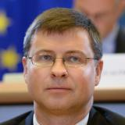
VICE-PRESIDENT for the Euro and Social Dialogue, also in charge of Financial Stability, Financial Services and Capital Markets Union, Valdis Dombrovskis

Recommendation: Cooperation could be established on issues related to the social dialogue, in line with the commitments of the Association Agreement and Association Agenda

Possible directions of cooperation could be:
- Enhancing the convergence of economic, fiscal and labour market policies between EU countries (European Semester).
- Promoting social dialogue; engaging with social partners.

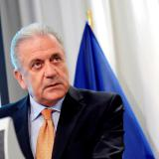
Commissioner for Migration, Home Affairs and Citizenship, Dimitris Avramopoulos
Georgia established close cooperation with the Commissioner Avramopulos and DG Home Affairs during the VLAP implementation process. He largely contributed to the successful finalization of the assessment process and timely initiated legislative procedures on Georgia’s visa liberalization.

Possible sphere of cooperation could be dealing with irregular migration, including by ensuring smooth return, in cooperation with non-EU Member States.

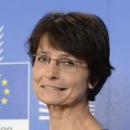
Commissioner for Employment, Social Affairs, Skills and Labour Mobility, Marianne Thyssen

Possible spheres/directions of cooperation are as follows:

- Ensuring that employment and social policy are at the centre of the European Semester for economic policy coordination by working in full partnership with EU countries and social partners to create good jobs, and modernize labour markets and social protection systems
- Promoting the free movement of workers so that people can take up vacant jobs in other EU countries and employers can adequately fill vacancies, while supporting national authorities to resolve abuses or fraudulent claims
- Ensuring decent and safe working conditions and equal opportunities for all on the labour market
- Ensuring that all Commission proposals and activities take the impact on employment and social issues fully into account and contribute to a deeper and fairer Economic and Monetary Union

