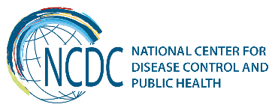
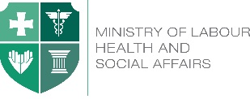

GEORGIA Brief
Environment and Health

Similar to many other countries in the world, burden of disease caused by adverse environmental impacts is quite high (17%) in Georgia. In order to reduce and prevent the environmentally-related diseases’ burden and reduce people's exposure to ecological risks, the National Environmental and Health Action Plan has been developed based on requirements set by the Association Agreement between Georgia and the EU.

Country has initiated the implementation of the commitments set in the National Action Plans through utilization of the twinning mechanism supported by the EU.

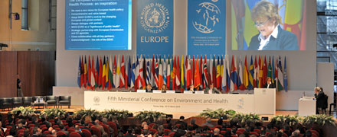

In order to assist Georgia to elaborate the National Environmental and Health Action Plan (NEHAP) WHO European Centre for Environment and Health (ECEH), Bonn, Germany conducted 3 missions in 2015-2016 in Georgia.
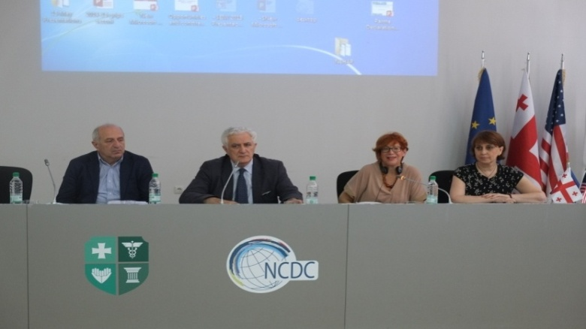

Key Findings and Recent Achievements

7 Strategic objectives and Interventions are set forth in the newly elaborated NEHAP:
- Ensure public health through improvement of access to safe and sustainable water supply and sanitation. Ensure access of each child to safe water supply and sanitation by2021.
- Improved children accessibility to healthy and safe environments and settings of daily life, promoting their increased physical activity by 2021
- The impact of ambient and indoor air pollution on human health assessed and implemented measures to reduce the harmful effects
- Prevention of morbidity caused by exposure to chemical substances.
- Integration of health issues in climate change adaptation and mitigation policies.
- Improving Governance of existing "Environment and Health “System in Georgia.
- Reduced risks from physical agents of the environment by 2021

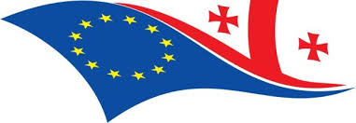
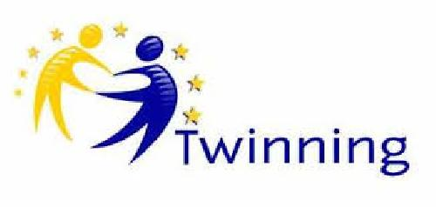
The project Twining-GE22-"Strengthening Environmental Health System in Georgia” carried out by consortium of Italy, Poland and the UK, support by EU was started in 2017. The project objectives are to develop National Action Plan on Environment and Health, harmonizing of relevant legislation with EU-legislation, strengthening of the Environment and health existing system capacity and twinning with the EU's relevant public agencies.

Chemical Safety - In the framework of German Federal Ministry for Environment, Nature Conservation, Building and Nuclear Safety Advisory Assistance Programme (AAP), a project "Development of a framework for the collection and sharing of information on Chemicals", was carried out in 2015-2017.

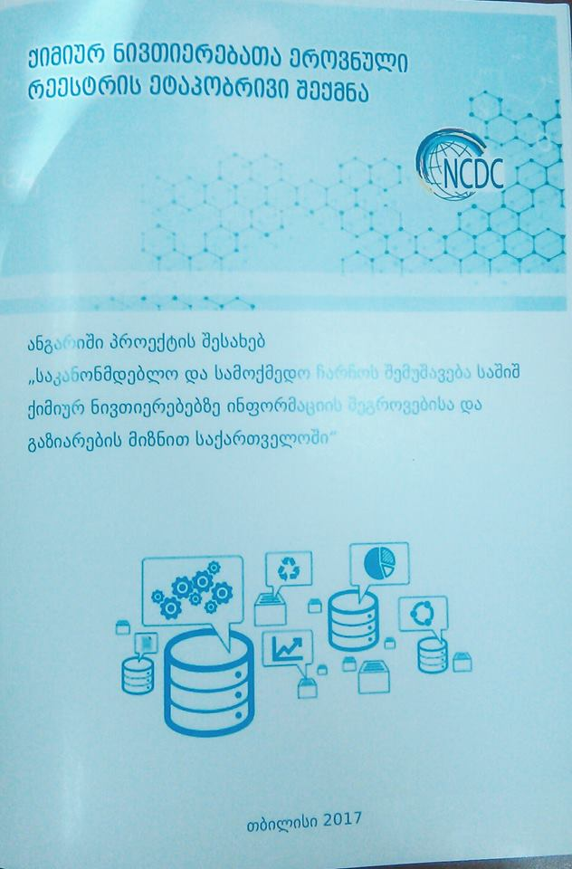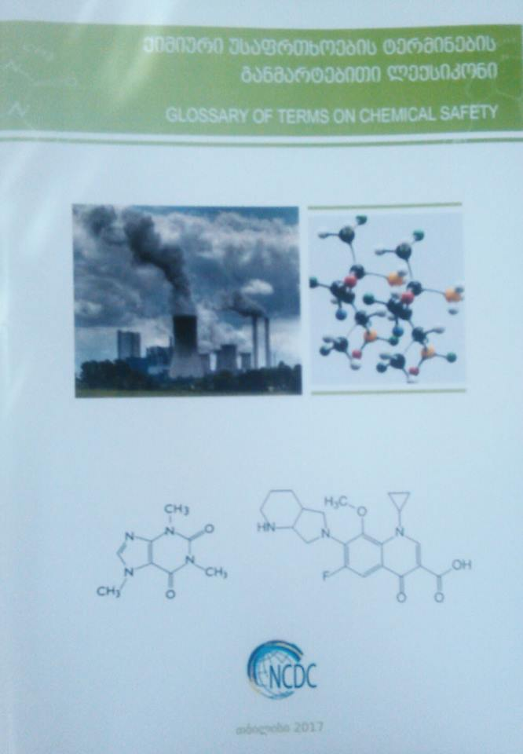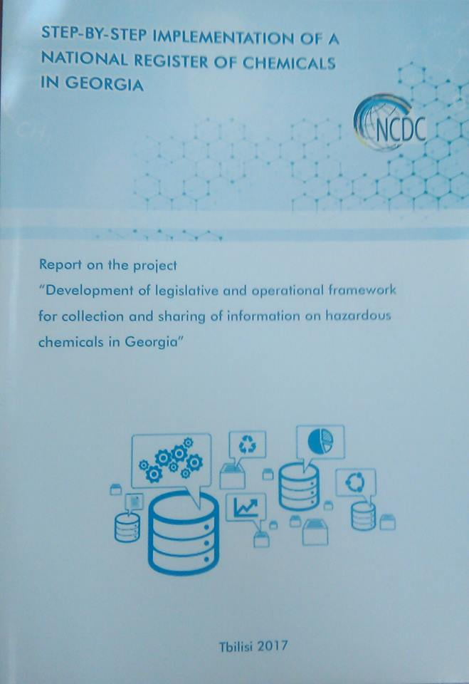

The project aims at the development of the legislative and operational framework for collecting and sharing information on hazardous chemicals, creating a model-inventory and testing its applicability.

The register model of hazardous chemicals, its demo-version and operational framework have been developed by national experts in cooperation with the international project manager and international experts.

WASH activity - Georgia Co-leader with Hungary - Georgia is involved in strengthening Water, Sanitation and Hygiene (WASH) in Schools in European Region.

At the Third Meeting of the Parties of the Protocol on "Water and Health" (Oslo, 2013) adopted the 2014-2016 programme of work. For the first time this programme includes a priority area concerned with improving and strengthening WASH in schools. Hungary and Georgia lead to coordinate these activities. WHO/Euro organized a meeting on advancing WASH in schools (Bonn, September 2014) and in Hungary on 16-17 May.

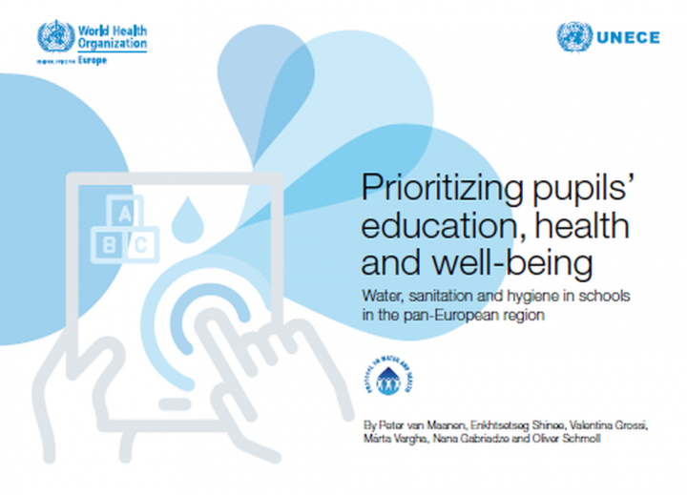

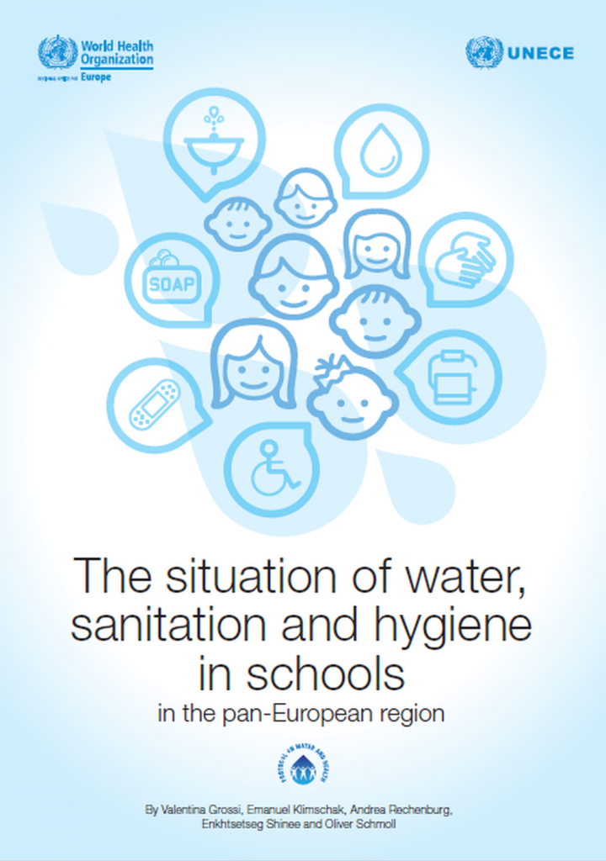

NCDC is actively involved in drafting process of WHO recommendations and strategies for the improving water sanitation and hygienic in schools in European Region.

Challenges

- Development of national portfolios for action, implementation of the Ostrava Declaration commitments
- Implementation of the National Environment and Health Action Plan NEHAP-2.
- Strengthening Environmental Health System in Georgia according EC TWINING Project.
- Implementation of the UBA, Germany and WHO Euro joint project-“Establishment of key elements of national systems for a sound management of chemicals in Georgia”.

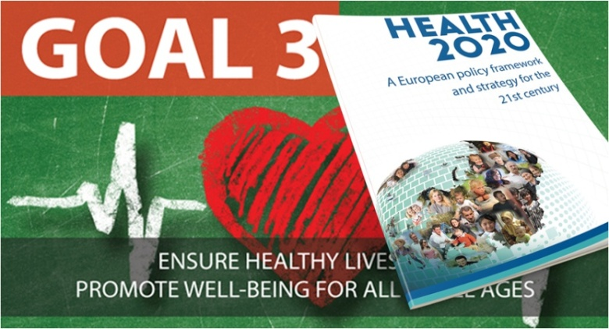

_________________________________________________________________________________________
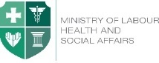  Ministry of Labour, Health and Social Affairs of Georgia  144, A. Tsereteli avenue. Tbilisi, Georgia, 0119  www.moh.gov.ge | 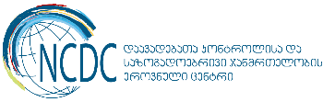  National Center for Disease Control and Public Health  9, M. Asatiani street. Tbilisi, Georgia, 0177  www.ncdc.ge

