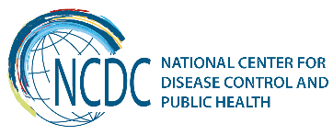
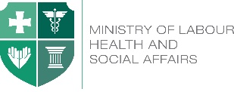

GEORGIA Brief
Hepatitis C

Based on available data, Georgia is among the countries with high hepatitis C (HCV) Prevalence, however, the reasons of the high burden of the disease has not been studied sufficiently. Collapse of the health care system in 1990s, sub-optimal quality standards of health services had negative influence on safe injection practices, infection control and blood safety in health care settings over the years. All these conditions along with the widespread practice of needle sharing among people who inject drugs (PWID) contributed to the spread of HCV in the general population.
According to the Latest population-based seroprevalence survey, conducted by the National Center for Disease Control and Public Health (NCDC) and US Centers for Disease Control and Prevention (CDC) between May-August, 2015, estimated national seroprevalence of hepatitis C is 7.7% and the prevalence of active disease is 5.4%.
Characteristic | n | Weighted % | Estimated number of adults >18
Anti-HCV+ | 425 | 7.7% | 215,000
HCV RNA+ | 311 | 5.4% | 150,300

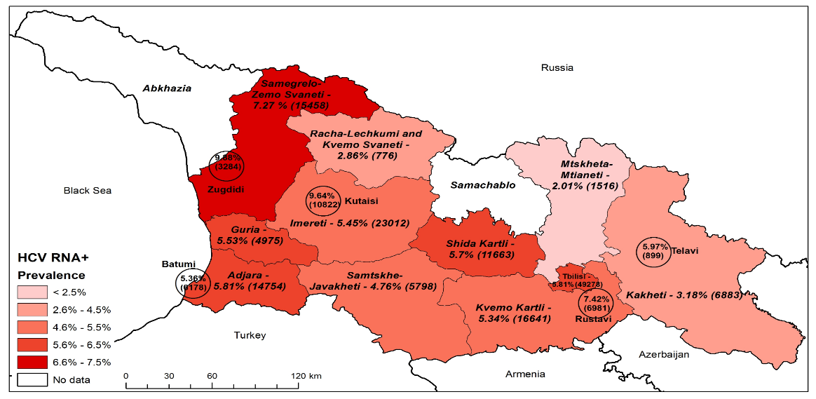
Prevalence and Estimated Number of HCV RNA+ Individuals by Regions and Cities

9,88%
3284
9,64%
10822
Tbilisi
5,81%
49278
5,97%
899
5,36%
6178
7,42%
6981

Progress towards elimination
- The Government of Georgia, with strong support from US CDC and other international partners, declared intention to eliminate hepatitis C in Georgia. The national Hepatitis C elimination program became operational in 2015.
- Over the past several years the Government of Georgia substantially stepped up its efforts against hepatitis C by implementing national programs such as free of charge hepatitis C treatment for HIV/HCV co-infected patients (funded under the Global Fund HIV Program since 2011); Free of charge hepatitis C treatment at the penitentiary system and 60% price reduction on combination of pegilated interferon and ribavirin for the general population.
- In February 2014, MoLHSA (Minister Dr. David Sergeenko) initiated discussion regarding strengthening Hepatitis C response in the country with US partners.
- In 2014, the Georgian Government started negotiation with pharmaceutical company Gilead which is one of the global leaders in research and manufacturing of potent DAAs, including Sofosbuvir and fixed-dose combination of Ledipasvir/Sofosbuvir regarding possible elimination of HCV in Georgia.
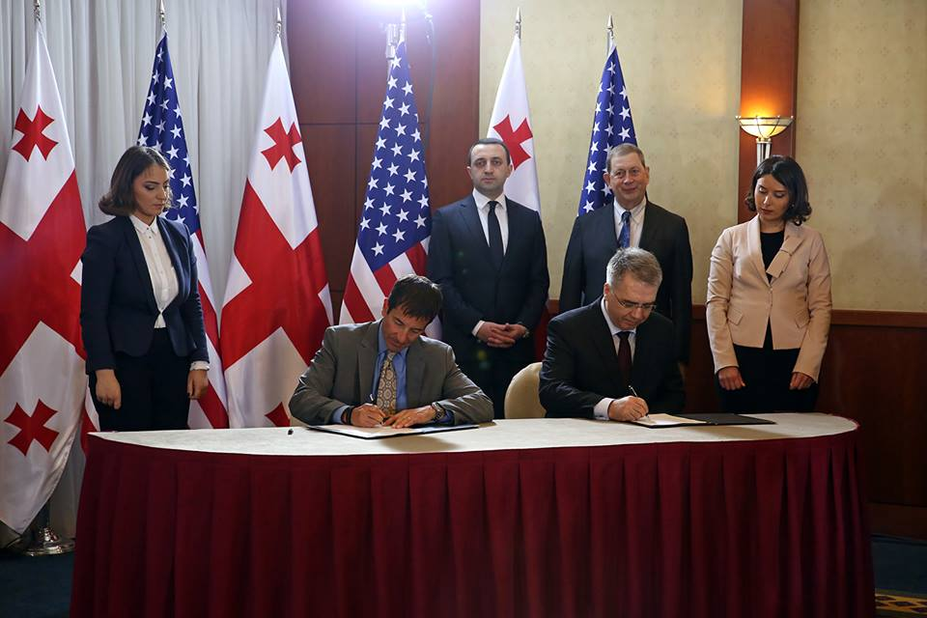
- Under the MoLHSA, a special commission on HCV was established that is in charge of overall coordination of national HCV elimination movement. In addition, a working group of experts was created to elaborate national strategy and action plan for HCV elimination. National Program for Short-term/urgent Measures of Hepatitis C Elimination Action Plan for Georgia has been developed.
- Memorandum of Understanding between the Government of Georgia and US pharmaceutical company Gilead was prepared and officially signed on April 21, 2015.
Official signing of Memorandum of Understanding, April 21, 2015
- Population-based HCV seroprevalence survey was conducted in May-August, 2015. It aimed to estimate the prevalence of HCV infection in the general population, to assess risk factors for HCV infection in Georgia, to describe HCV circulating genotypes and identify knowledge and perceptions towards hepatitis and its prevention and treatment. The survey estimated that 7.7% of population are anti-HCV positive and 5.4% are HCV RNA positive. Injection drug use and history of blood transfusion were identified as man risk-factors.
- Long-term elimination strategy for 2016-2020 was developed together with CDC based on WHO guidelines. Georgian government approved the document on August 18, 2016. Strategy sets forth the following targets, to be reached by 2020:
- 90% of HCV infected persons have been tested for their infection
- 95% of people with chronic infection have received treatment, and
- 95% of persons who receive treatment are cured of their HCV.
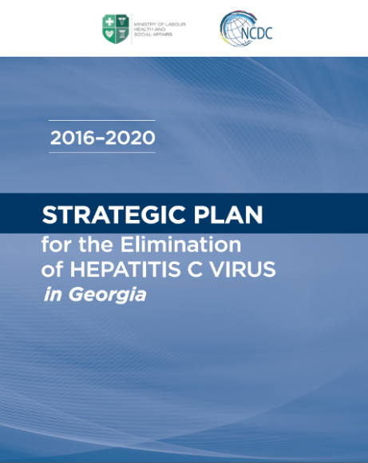
Strategy includes six main directions:
Georgia has increased efforts to strengthen each direction of the strategy:
- NCDC has started massive awareness campaigns. Short text messages (SMS) are regularly sent to invite population to the HCV screening. HCV Hotline was established at NCDC.
- Infection control and prevention monitoring and evaluation system has been established in medical and non-medical facilities. PWID and their sexual partners receive Regular screening services. Unified Blood Donor Electronic Database was developed.
- Georgian government scaled up screening activities. More than 600 sites, including inpatient and outpatient facilities, prisons, Georgian Harm Reduction Network (GHRN) centers, pharmacies, etc., provide HCV screening across the country. A unified electronic screening registry was created which captures data from all national and local HCV screening programs throughout Georgia. Data from the screening and treatment programs are linked by a unique identification number. As of November 2017, more than 1.2 million screenings were registered in the database, among which ~750,000 were unique individuals with positivity rate 10.2%.

- NCDC referral laboratory – Richard Lugar Center for Public Health Research – conducts research activities for the simplification of HCV diagnostics, including studies on HCV cAg and various PCR approaches. External quality assessment system has been introduced.
- Starting with 4 service providers in 2015, currently 32 centers in different cities (including 1 center in penitentiary system) are providing diagnostic and treatment services to the elimination program beneficiaries. Since the launch of the program in 2015 through October 31, 2017, 36,012 patients completed the treatment.
HCV elimination program care cascade
* Of 32,835 patients eligible for SVR assessment, 24,930 were tested, 24,481 (98.2%) achieved SVR, 7,505 (24%) missing data

- Surveillance has been strengthened through efforts for microelimination among persons who have hemophilia and dialysis patients. Study for identification and characterization of HCV-attributable hepatocellular carcinoma (in collaboration with US CDC) is underway. NCDC plans to conduct a survey to find the barriers to enrolling into the HCV treatment program.
- To facilitate the process of elaboration of the strategy, NCDC, in collaboration with its partners, organizes annual meetings dedicated to the hepatitis C elimination. Since 2014, National HCV Elimination Workshops are conducted every year, during the spring period. In 2015, the Technical Advisory Group (TAG) composed of 12 international experts was established with support of the CDC. Every year, TAG discusses the progress towards elimination, monitors and evaluates indicators and provides recommendations on long-term elimination strategy.
- Since 2014, special side meetings are organized on annual meetings of European Association for the Study of the Liver (EASL) to discuss the progress towards HCV elimination in Georgia.
- In August, 2016 the Clinical and Scientific Committees were established with the aim of providing the volunteer leadership for the transparency and coordination of the research activities within Hepatitis C Elimination Program in Georgia. In total, 39 proposals were reviewed and 31 were approved by the Scientific Committee by the end of October. Clinical guideline for management of hepatitis C infection was elaborated by the Clinical Committee.
- Georgia was awarded the title of NOhep Visionary for the European Region at the World Hepatitis Summit in Sao Paulo, Brazil, on November 1st, 2017. The NOhep Visionaries Programme is a global campaign which engages governments to scale-up successful approaches to elimination and share key learnings, accelerating progress towards eliminating viral hepatitis by 2030.
________________________________________________________________________________________
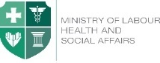  Ministry of Labour, Health and Social Affairs of Georgia  144, A. Tsereteli avenue. Tbilisi, Georgia, 0119  www.moh.gov.ge | 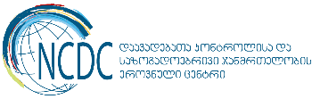  National Center for Disease Control and Public Health  9, M. Asatiani street. Tbilisi, Georgia, 0177  www.ncdc.ge

