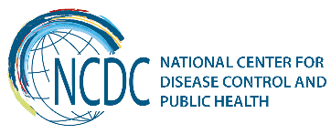
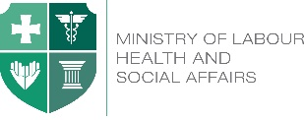

GEORGIA Brief
HIV/AIDS

Georgia faces low level HIV epidemic with concentration of HIV cases among KAP groups (PWIDs, FSWs and MSM). The national level HIV prevalence among adult population was 0.4 in 2016. The Number of registered HIV cases was 6131, out of them 1205 have died. Estimated number of adult PLHIV for the same year was 9600. Annual number of newly registered cas0es during the last five years was varying between 500 and 719.
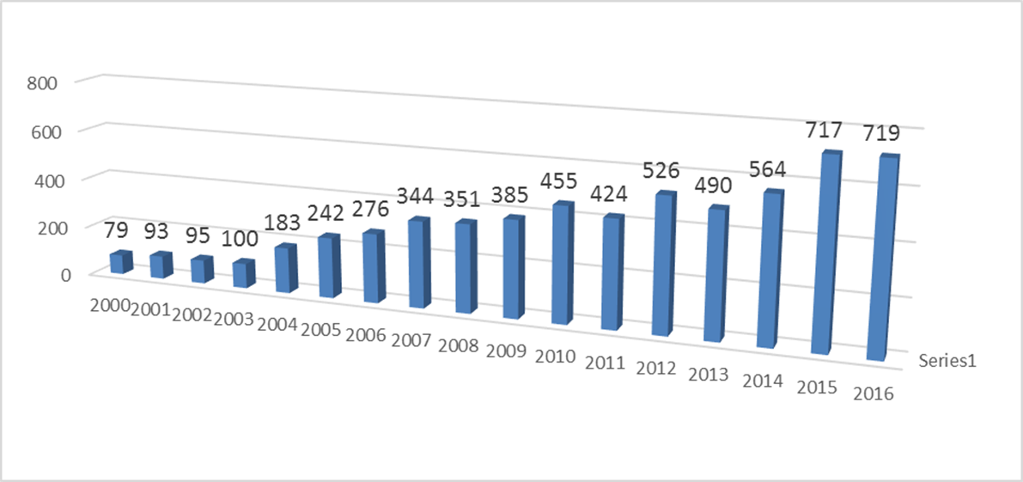
According to the last IBBSS data HIV epidemic is controlled in all KAPs except of MSM. IBBSS of 2013 and 2015 have revealed that HIV epidemic is growing fast among MSM in Georgia. According to the study the prevalence of HIV has increased from 17% to 25% in two large cities of Georgia (Tbilisi and Batumi).

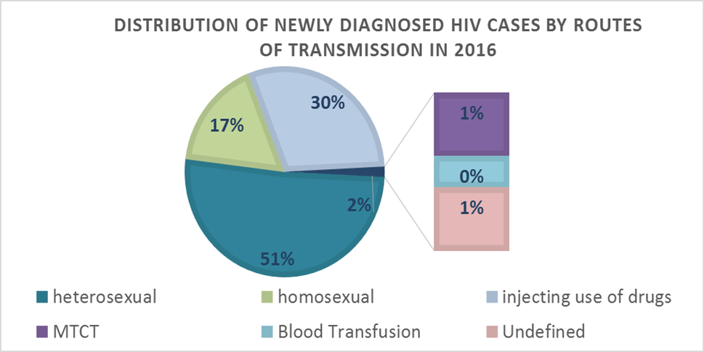
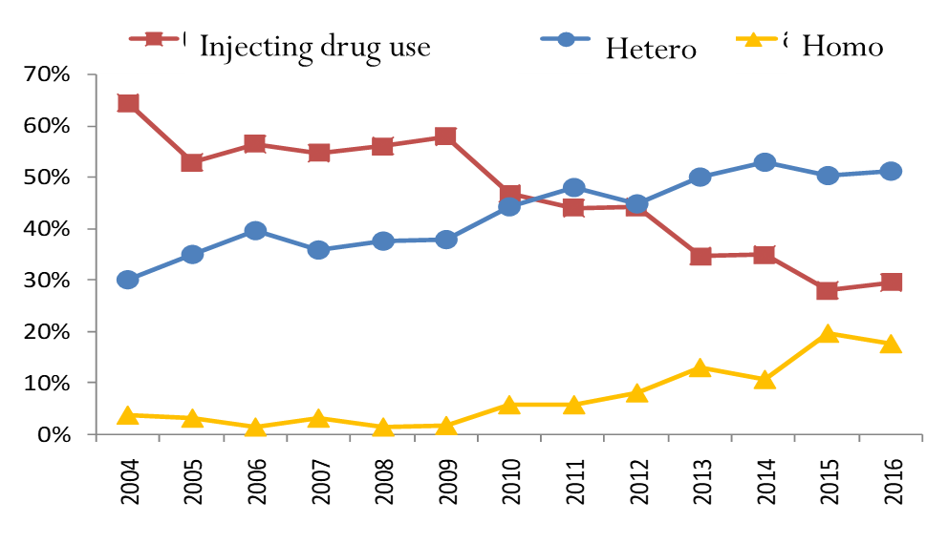
Data Source: National AIDS Center & NCDC Center

HIV Transmission - If during 1990-2010 the main route of HIV transmission was injecting use of drugs, from 2011 the number and share of the cases attributed to sexual transmission of HIV has been increased in Georgia. In 2016 among newly registered HIV cases 51% was attributed to unprotected heterosexual contacts and 17% to homosexual contacts.

Data Source: National AIDS Center
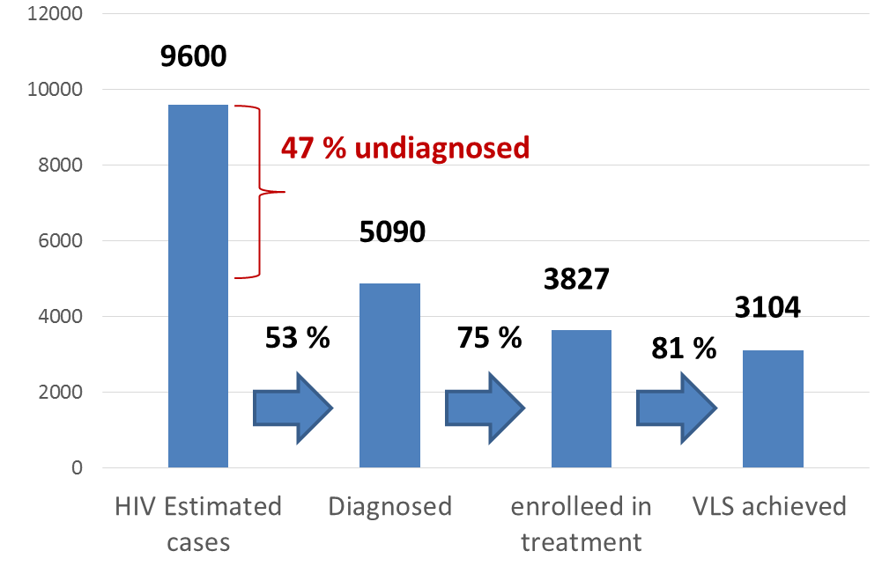
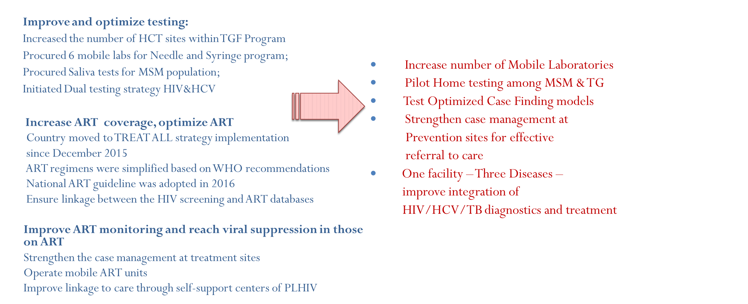
For the UNAIDS 90-90-90 Fast Track targets Georgia is well positioned for last two, but is behind for the first 90. By the end of 2016 only 53% of estimated PLHIV knew their status, while 75% of them were enrolled in ART and in 81% the VL suppression was achieved. Georgia has achieved important progress in HIV, TB and Malaria programs. The Georgian Antiretroviral therapy (ART) program was recognized by the international experts as one of the best in the region due to universal access to HIV treatment, high coverage of target populations and improved quality of the program interventions. Also, Georgia one of the first in the region started implementation of WHO “Treat ALL” strategy from December 2015. However the detection rate of new HIV infection cases remains a main challenge for the National HIV Program. NCDC works closely with KAPs through National AIDS Center, NGO and CBO networks to increase the coverage of key affected groups and test new approaches of integrated screening of HIV, TB and hepatitis C, implementing mobile outreach services, etc. Georgia one of the first counties in the region has started pilot PrEP program among MSM in (9) 2017.

PMTCT
HIV testing coverage: 93 % (51287/54874)
PMTCT ART coverage 100 % for registered cases (45)
73 % for estimated cases
Country is moving towards dual HIV & syphilis EMTCT by 2020
Co-infections
TB/HIV - 22% ; 90 active TB cases registered in 2016
*HIV/HCV co-infections - 34% (1099)
*HIV/HCV patients treated for HCV – 21% (697)

*Chkhartishvili N. at all, IAS2017 Abstract #MOAB0301

National Efforts towards reaching three 90s

Collaboration with WHO

WHO is a leading partner of Georgia is the area of HIV and TB since 1990th when the country has started elaboration of the National HIV and TB Strategies. During these years WHO was playing a critical role in the HIV and TB program assessments and review of the National Strategies ensuring that National goals are aligned with the MDGs and later with SDGs and well responding to the local epidemic trends. WHO’s epidemic modelling tool SPECTRUM was helping Georgia to assess the magnitude of HIV epidemic in the country. In 2017 WHO has tested STI SPECTRUM in Georgia as in one of the pilot countries for a new modelling tool. In 2018 WHO will support the country in elaboration of the new HIV Strategic Plan for the period of 2019-2021.
- National HIV Strategic Plan (NSP) of Action 2016 -2018 was endorsed by the Government in July, 2017. The Plan is supported with relevant M&E framework.
- NSP for 2019-2021 will be developed in 2018
- WHO SPECTRUM modelling tool has been applied for estimation of HIV and STI burdens in Georgia
- WHO is assisting Georgia in planning for elimination of mother to child transmission of HIV and syphilis by 2020

Planning for Sustainability and Transition of donor funded programs
Despite the important positive developments and significant progress achieved in HIV and TB control, Georgia continues to face a number of serious challenges and the priority issue would be the sustainability of the GF supported programs. The GF support to Georgia is decreasing considerably (by 50%) for the next three year funding cycle (till 2022). During the same period the Government of Georgia needs to mobilize substantial additional internal resources in health care for scaling up of programs in response to the growing epidemics.
- In 2016 the country has developed TGF programs’ Sustainability and Transition Plan for 2017 - 2021 to ensure smooth and effective transition from the TGF funding to the domestic funding of HIV program activities by 2022.
For the HIV program, starting 2015, the Government is paying for the first line ARV. In 2017 it will buy 25% of Second Line medicines as well with State Funds. Just recently (June 2017) Georgia has fully transitioned the funding of the OST programs in the state budget and not only that, we started free OST programs with no need of the co-payment from the side of beneficiaries, which is a revolutionary change in support of the Government for the harm reduction program. During the coming two years the country will increasingly take responsibility of procurement of diagnostic test-systems, including the viral load and CD4 testing.
Sustainability of HIV prevention programs remains especially critical for us. We know that the State will need to start investing in HIV prevention programs from 2020. With support of EHRN and UNFPA, we started the initial preparatory work. Namely, we started development of the National NSP, OST standards as well as prevention intervention standards for FSWs and MSM with cost estimations. The draft documents are developed that will be reviewed by the relevant field experts and approved by the CCM and the National Guideline Approval Committee. This will prepare a ground for starting investing the state funds in HIV detection and linkage to care activities for Key Affected Populations. The state may start investing in the procurement of means for prevention, like syringes, condoms, etc. starting from 2019.

________________________________________________________________________________________
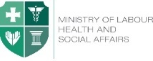  Ministry of Labour, Health and Social Affairs of Georgia  144, A. Tsereteli avenue. Tbilisi, Georgia, 0119  www.moh.gov.ge | 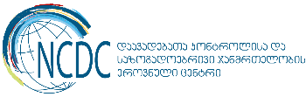  National Center for Disease Control and Public Health  9, M. Asatiani street. Tbilisi, Georgia, 0177  www.ncdc.ge

