From: Warwick Geneva [mailto:resa.geneva@warwickhotels.com]
Sent: Tuesday, May 1, 2018 11:32 AM
To: Tea Tatishvili
Subject: Your reservation at Warwick Geneva 20 May 2018 / Number: 7122658

If this email is not displaying correctly, please click here.

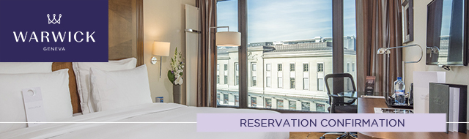

Become A Member / Login

Dear Mr Sergeenko,
Thank you for choosing Warwick Geneva for your forthcoming visit to Geneva. We are pleased to confirm your reservation – please see your confirmation details below. . We look forward to welcoming you to our hotel and if there is anything we can do to make your upcoming stay more enjoyable please do not hesitate to let us know.
Warmest regards
The Reservations Team
Phone: +41 22 716 8157
Email: resa.geneva@warwickhotels.com

Confirmation number: |  | 7122658
Guest name: |  | Mr David Sergeenko
Arrival Date: |  | 20 May 2018
Departure Date: |  | 23 May 2018
Number of nights: |  | 3
Number of persons: |  | 1 Adult
Room Type: |  | 1 Superior Room
Rate per room per night: |  | CHF 290.00
Rate Description: |  | United Nations
Guarantee: |  | Your reservation is guaranteed by a company.
Special Requests: |  | Package including free Video On Demand, one Mineral Water and one piece of dry cleaning a day  - Guaranteed
Breakfast: |  | Buffet Breakfast Included served at Teseo restaurant.
Taxes: |  | VAT of 3.7% is included in the room price
City Tax: |  | CHF 4.00 per person and per night
Total Amount: |  | CHF 882.00
Check in / Check out: |  | 3:00pm / 12:00 noon
Wi-Fi: |  | Included

Please note that a credit card will be required at check-in to guarantee extras during your stay.

Cancellation Policy

In the event of a no-show or cancellation after 4PM CEST 24 hours prior to arrival, the hotel will charge a fee equivalent to the first night’s room and tax.




Warwick Geneva
Rue de Lausanne 14 – 1201 Geneva, Switzerland
Reservations: +41 22 716 8157 ​ Fax: +41 22 716 8001
Email: info.geneva@warwickhotels.com
www.warwickhotels.com

