From: "Warwick Geneva" <resa.geneva@warwickhotels.com>
Date: April 25, 2018 at 5:18:45 PM GMT+2
To: ttatishvili@mfa.gov.ge
Subject: Your reservation at Warwick Geneva 28 May 2018 / Number: 7121632
If this email is not displaying correctly, please click here.

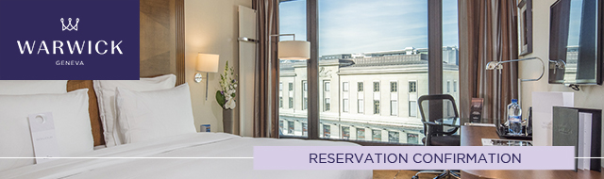

Become A Member / Login

Dear Mr Sergeenko,
Thank you for choosing Warwick Geneva for your forthcoming visit to Geneva. We are pleased to confirm your reservation – please see your confirmation details below. . We look forward to welcoming you to our hotel and if there is anything we can do to make your upcoming stay more enjoyable please do not hesitate to let us know.
Warmest regards
The Reservations Team
Phone: +41 22 716 8157
Email: resa.geneva@warwickhotels.com

Confirmation number: |  | 7121632
Guest name: |  | Mr David Sergeenko
Arrival Date: |  | 28 May 2018
Departure Date: |  | 30 May 2018
Number of nights: |  | 2
Number of persons: |  | 1 Adult
Room Type: |  | 1 Classic Room
Rate per room per night: |  | CHF 670.00
Rate Description: |  | Mission de Georgie
Guarantee: |  | Your reservation is guaranteed by the Mission.
Breakfast: |  | Buffet Breakfast Included served at Teseo restaurant.
Taxes: |  | VAT of 3.7% is included in the room price
City Tax: |  | CHF 4.00 per person and per night
Total Amount: |  | CHF 1,348.00
Check in / Check out: |  | 3:00pm / 12:00 noon
Wi-Fi: |  | Included

Please note that a credit card will be required at check-in to guarantee extras during your stay.

Cancellation Policy

In the event of a no-show or cancellation after 4PM CEST 24 hours prior to arrival, the hotel will charge a fee equivalent to the first night’s room and tax.




Warwick Geneva
Rue de Lausanne 14 – 1201 Geneva, Switzerland
Reservations: +41 22 716 8157 ​ Fax: +41 22 716 8001
Email: info.geneva@warwickhotels.com
www.warwickhotels.com

