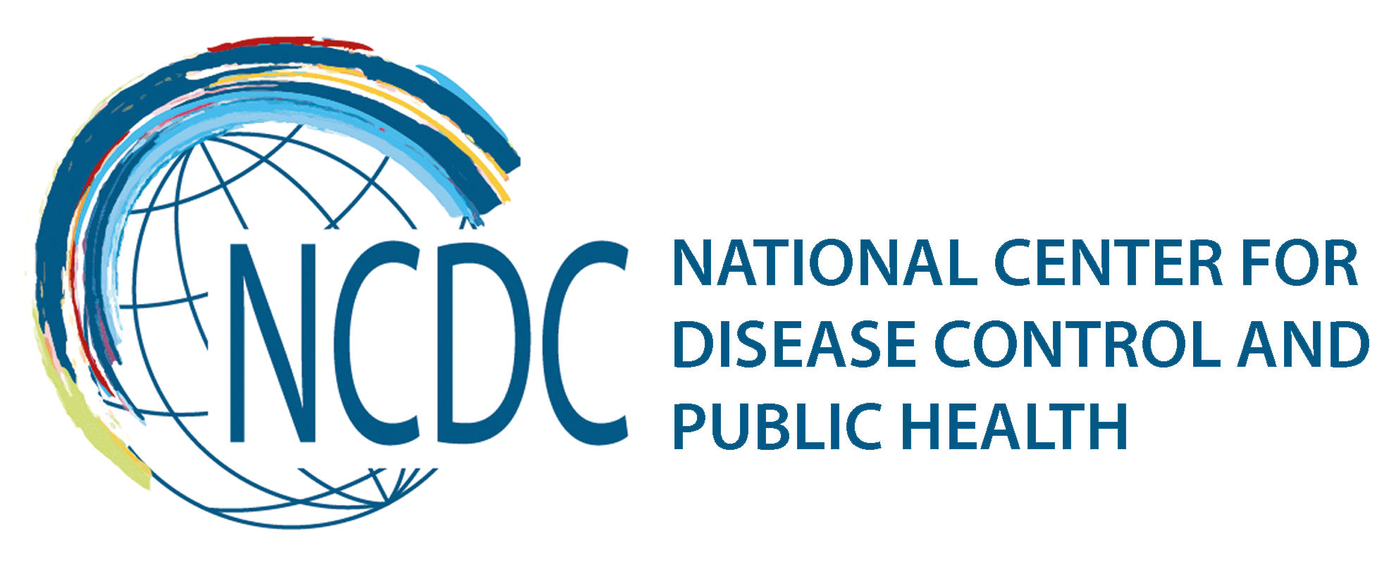
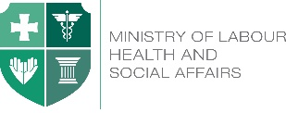

GEORGIA Brief

International Health Regulations and Global Health Security Agenda

The International Health Regulations (IHR) are the foundation of the Global Health Security as they provide the framework to address public health threats that have the potential to spread internationally. The successful implementation of the IHR requires a national public health system with capacity to respond to public health emergencies of national and/or international concern. Georgia reached the full compliance with the core IHR requirements by the June 2012 deadline set by the World Health Organization (WHO).
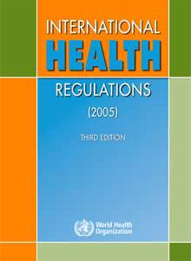
Only 16% of countries reported reaching full compliance with the core IHR requirements by the June 2012 first deadline set by the World Health Organization (WHO) and Georgia was among them.
Georgia is actively implementing the IHR into the existing national system. The National Center for Disease Control and Public Health (NCDC) is designated as the National Focal Point (NFP). NCDC is accessible at all times for communications with the WHO IHR Contact Point, has a 24/7 duty officer system, is able to receive notifications from national surveillance system and from other stakeholders, conduct risk assessment and notify WHO contact point of IHR within 48 hours.

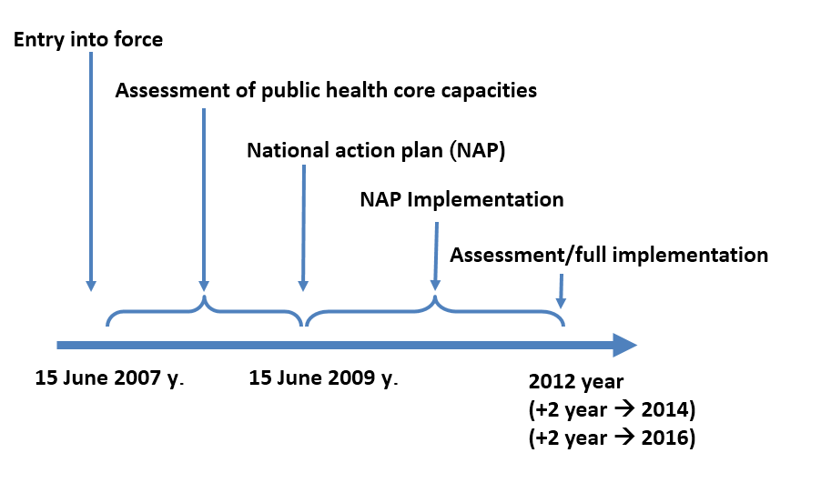

The Global Health Security Agenda (GHSA) was launched in February 2014 to advance a world safe and secure from infectious disease threats, to bring together nations from all over the world to make new, concrete commitments, and to elevate global health security as a national leaders-level priority. GHSA has become a new vision for Georgia since it’s launch, when first external assessment of baseline GHSA capabilities was conducted and since Georgia took a path to contribute to Zoonotic Disease and National Laboratory System Action Packages and lead an Action Package of Real-Time Surveillance.
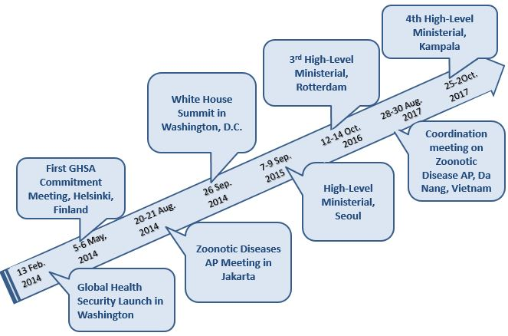
Georgian delegation had the honor to participate in significant meetings in the frames of Global Health Security Agenda.

Information exchange for GHSA is considered to be the proxy indicator for controlling and managing communicable diseases. In this regard, Bio-surveillance Network of the Silk Road (BNSR) as a regional partnership, which consists of Human and Animal Health professionals from, Georgia, Azerbaijan, Kazakhstan, and Ukraine, works to create sustainable, integrated disease surveillance network, thereby contributing to One Health perspective and supporting the implementation of global health security agenda within the region.

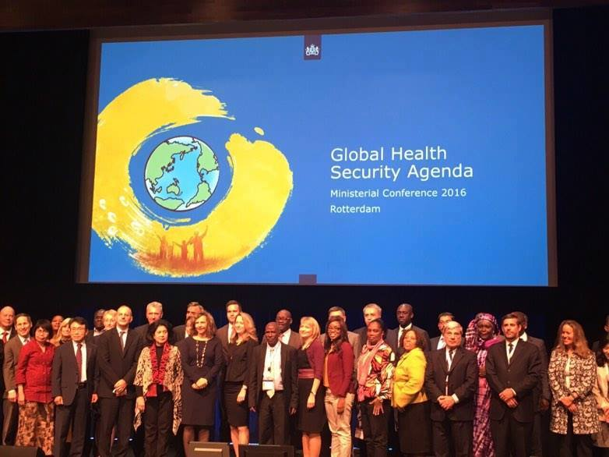
Challenges and Further Activities
In order to be prepared and be able to respond to the Public Health Emergencies effectively, it is vital to establish Public Health Emergency Operations Center (EOC), in accordance with GHSA and IHR core capacities.
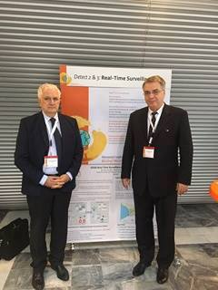
For successful implementation of IHR (2005) multisectoral collaboration is a key. Raising awareness among non-health sectors regarding the IHR and what is stand for, is defined as one of the priorities.
Since Georgia has the responsibility to lead the Real Time Surveillance Action Package, it is planned to host a meeting to unite all partner countries and organizations under the mission to strengthen efforts towards capacities to prevent, detect and respond to infectious disease threats and support the continuum of building the capacity under International Health Regulations (IHR).

___________________________________________________________________________________
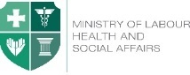  Ministry of Labour, Health and Social Affairs of Georgia  144, A. Tsereteli avenue. Tbilisi, Georgia, 0119  www.moh.gov.ge | 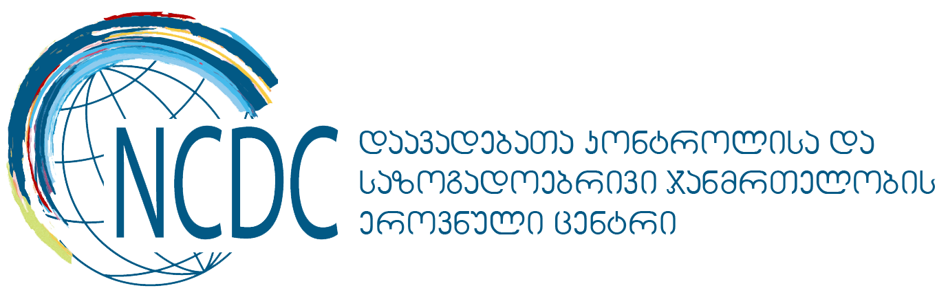  National Center for Disease Control and Public Health  9, M. Asatiani street. Tbilisi, Georgia, 0177  www.ncdc.ge

