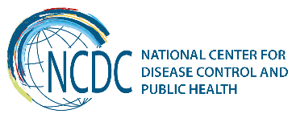
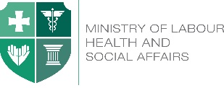

GEORGIA Brief
Surveillance on Influenza and Other Respiratory Viruses

In Georgia, historic data on influenza surveillance is available since 1960. Over the decades, influenza system has changed several times, and from 2011 - it took a form of Influenza-Like Illness and Severe Acute Respiratory Infection (ILI/SARI) Sentinel Surveillance system. Transition from the old influenza surveillance system to the new one has begun in 2006, in the frame of CDC Cooperative Agreement, and with technical assistance of WHO, which was widely provided for NCDC staff. (e.g. WHO course for National Influenza Centres on Principles of PCR assays development and validation; WHO course for National Influenza Centres on Influenza virus bioinformatics; Genetic Analyses of Influenza Viruses; Quality implementation in influenza laboratory; Transport of Infectious Substances; Workshop on pandemic preparedness and etc.). Government of Georgia has been increasingly interested in this issue. Its involvement and support will be discussed further below.

Key Findings

Surveillance and laboratory capacities
  - In 2006, influenza laboratory diagnostics has been established at the NCDC within the cooperative agreement, which was recognized by WHO as the National Influenza Center (NIC) in the next year;

  - During last ten years, the national preparedness plan for influenza has been adopted within World Bank project. The plan was developed and reviewed by public health and representatives from other relevant sectors of the government. Portions of the plan have been tested through table top exercises. The preparedness plan was utilized during the 2009 H1N1 pandemic;

  - The influenza sentinel surveillance system has been established throughout the country (5 sites for SARI, 1 site for ILI, 3 sites for virological surveillance);

- The ILI incidence and SARI admission rates are being routinely uploaded to NCDC’s web-site (Figure #1), which is available to public;

  - Epidemiological and virological data are submitted to the ECDC’s European Surveillance System - TESSY on a regular basis;

  - Influenza surveillance system has been enhanced by conducting number of annual rounds of surveillance system monitoring and trainings of epidemiologists and clinicians all around the country on influenza epidemiology, surveillance, early detection and notification. These efforts resulted in health care personnel raised knowledge and improved registration, notification and reporting.

Figure 1: ILI incidence, SARI admission rates, and number of influenza positive cases by weeks
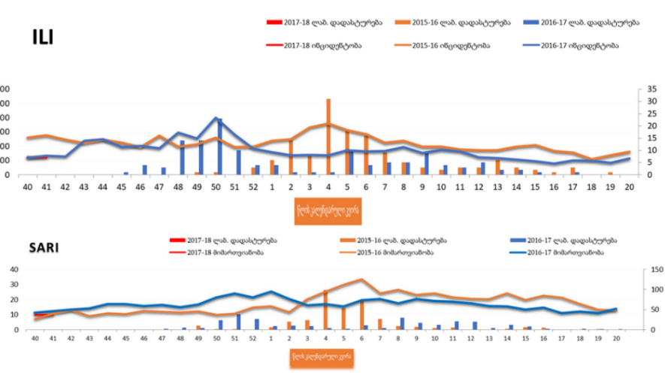

Quality assessment and assurance

The key stakeholders involved in influenza preparedness and response in Georgia participated in the review conducted by CDC experts in 2008, 2010 and 2012. For the review the National Inventory of Core Capabilities for Pandemic Influenza Preparedness and Response (called the M&E) tool developed by CDC was used. After the 2008 M&E review, the influenza project team chose to focus on 5 capabilities in an effort to improve scores in those areas. The five areas selected were: country planning, laboratory capability, routine influenza surveillance, national respiratory disease surveillance and reporting, and health sector pandemic preparedness. A comparison of the scores in those areas showed that the project team was able to work with relevant partners to strengthen capacity in these areas resulting in meaningful increases in each of the focus areas (Table 1);

Table 1. M&E Review results 2008/2012
 | Country  Planning | Laboratory  Capability | Routine Influenza Surveillance | Disease Surveillance and Reporting | Health Sector Pandemic Response
2008 Scores | 1.00 | 1.50 | 1.75 | 2.00 | 0.88
2010 Scores | 2.88 | 2.50 | 3.00 | 3.00 | 3.00
2012 Scores | 2.75 | 2.00 | 3.00 | 3.00 | 2.25

Quality assurance measures have been developed and implemented in the laboratory and at the surveillance sites. Equipment procured in the frame of CDC project contributed in enhanced influenza diagnostic capacity of NIC. Staff qualification was improved by means of international training in virus isolation, PCR detection, sequence and immunofluorescence techniques. The NIC participates in the WHO external quality assurance proficiency testing, typically conducted twice per year. Influenza virus specimens/isolates are sent to the WHO Collaborating Center in London for inclusion of Georgia specimens in the vaccine strain selection process. In 2015, A/H3N2/Georgia/532/2015 was selected as reference strain for season 2015-2016 by WHO CC London.

In spite of progress made in influenza surveillance capacity building, a few measures and activities have been conducted in the area of seasonal influenza vaccination. Recommendations for seasonal influenza vaccination were developed by NCDC Georgia and included in Pandemic Preparedness Plan in 2009. Before 2013 seasonal influenza vaccine were available only commercially and since 2013 Georgia government made a decision to add influenza vaccination in National Immunization Schedule recommendations for particular risk groups based on WHO recommendations. Additionally, pre-determined number of seasonal influenza vaccines have been procured and offered free of charge to some of the risk groups.
In order to provide recommendations on immunization policy, rules and practices, and consultative and technical support to the State and other interested institutions the National Technical Council of Immunization Experts (NTCIE) has been established in Georgia by recommendation of the World Health Organization. The National Technical Council of Immunization Experts technically functions as NITAG. The main authority for project implementation is L. Sakvarelidze National Center for Disease Control and Public Health, which is the State Entity of Public law under Ministry of Health, Labour and Social Affairs of Georgia responsible for disease surveillance in the country.
Recent Key Achievements
Governmental support
In the beginning of implementation of the cooperative agreement, it was anticipated that eventually the Government of Georgia would take over and maintain the activities of the surveillance system and provide funding through state budget. At present, ILI sentinel site is run by governmental funding. Importantly, the number of vaccines procured through state program keeps increasing - since 2016 from 20 000 doses to 27 000 in 2017, which proves that surveillance and prevention of ILI/SARI is becoming a bigger priority for the country. (Figure #2).

Figure 2: Number of influenza vaccines procured through state program by influenza seasons
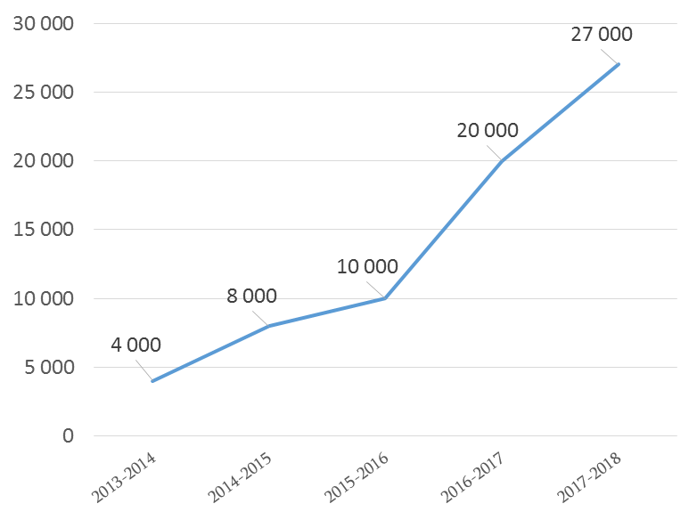

It should be noted that besides the above-mentioned increase in the state procurement, annually the private sector purchases approximately 12,000 doses of Influenza vaccine.

Since 2014, in order to further increase the country’s capacity to detect respiratory pathogens, and strengthen preparedness and response capabilities, a new project “Respiratory Disease Surveillance” was introduced under CDC’s Global Disease Detection Cooperative agreement. It was built upon an already established ILI/SARI surveillance system, and it helped establish routine surveillance on other respiratory pathogens, including Respiratory Syncytial Virus, Human Adenovirus, Metapneumovirus, and Rhinovirus by implementing Multiplex PCR testing methods. The results of laboratory testing are also being uploaded to NCDC’s web-site on a weekly basis. One of the key findings of this project is that it shows the burden of not only influenza virus, but other respiratory viruses too (Figure #3). The Government of Georgia has shown interest in maintaining project’s activities. For this purpose, state funds have been used for procuring Multiplex PCR diagnostic kits (for 2017-2018 season, 10 kits have been purchased).

Figure #3. Circulation of respiratory pathogens by weeks.
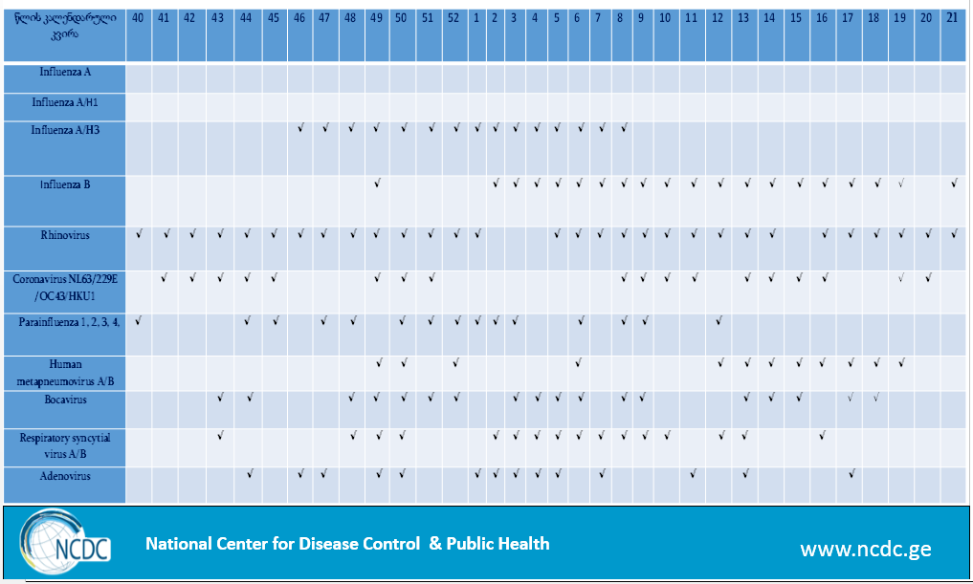

Challenges
In spite of the country’s significant achievements in these areas during previous years, it is critical that these capacities continue to be sustained and strengthened to ensure an effective global detection and response to respiratory threats. It is crucial to sustain the functions of the system to monitor trends and circulating types and subtypes of viruses throughout the country including areas of extreme risk for the spread of Highly Pathogenic Avian Influenza, and also to be the country providing data for TESSY and specimens to the WHO Collaborating Centers. Thus, it is extremely important to keep and maintain the existing influenza surveillance system and NIC capacity to have data during the influenza season, in order to be able to detect and respond to pandemic influenza and other respiratory pathogens, in case of their emergence.

________________________________________________________________________________________
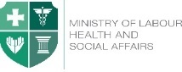  Ministry of Labour, Health and Social Affairs of Georgia  144, A. Tsereteli avenue. Tbilisi, Georgia, 0119  www.moh.gov.ge | 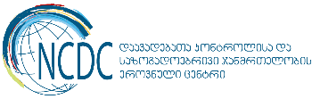  National Center for Disease Control and Public Health  9, M. Asatiani street. Tbilisi, Georgia, 0177  www.ncdc.ge

