World Health Organization  Regional Office for Europe  Weltgesundheitsorganisation  Regionalbüro füR Europa |  | Organisation Mondiale de la SantÉ  Bureau RÉgional de l'Europe  ВсемирнаЯ организациЯ здравоохранениЯ  Европейское региональное бюро

Joint ECDC-WHO/Europe Meeting
of the ARHAI Networks
UN City, Copenhagen, Denmark | 12 March 2018
11-15 June 2018

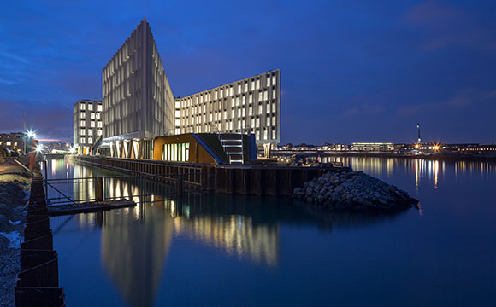

INFORMATION CIRCULAR

Dear participant,

We are pleased to provide you with the following information regarding the practical arrangements for the above meeting.

1. Site of the meeting
Address: UN City, Marmorvej 51, 2100 Copenhagen O, Denmark
Telephone: +45 45 33 50 00

2. Language
The meeting will be held in English and Russian and simultaneous interpretation will be provided.

_____________________________________________________________________

3. Registration, opening session and closure
Registration of participants will take place at the reception area of the UN City between 12.00-13.00 hours on Monday 11 June 2018 and the meeting will begin at 13.30. It is expected that the meeting will close not later than 12.00 hours on Friday 15 June 2018.

4. Documentation
Documentation concerning the meeting will be available electronically prior to the meeting.

5. Accommodation and meals
Rooms have been provisionally reserved from 10 to 16 June 2018 at the:

Hotel Cabinn City
Address: Mitchellsgade 14, 1568 Copenhagen K
Telephone: (+45) 33 46 16 16
Fax: (+45) 33 46 17 17
E-mail and Web site: city@cabinn.com – www.cabinn.com

at the following prices including breakfast, service charges and taxes:

Standard single room: DKK736 per night Standard twin room: DKK857 per night

To confirm a reservation in your name, please complete the enclosed Booking Form as soon as possible and send it to the hotel with copy to taksoevesterk@who.int . We cannot guarantee that there will be any rooms available after 10 April 2018.

Please settle your bill directly with the hotel for your room and for any other charges (laundry, room service, bar bills, telephone calls etc.). The hotel accepts credit cards.

Lunches will be provided at the UN City during the entire meeting.
A reception will be hosted by WHO at the UN City in the evening of Wednesday 13 June.
A dinner will be hosted by ECDC at Tivoli Gardens in the evening of Thursday 14 June.

6. Travel tickets and subsistence allowance (for participants attending the meeting at the expense of WHO)
We shall instruct our travel agent to issue your tickets. Whenever possible, your ticket will be an e-ticket; alternatively, you will be contacted by their local agent who will issue your ticket. If, exceptionally, you are purchasing your own ticket, the agreed amount will be paid together with your subsistence allowance.
Subsistence allowances are paid directly to your bank account (the details of which should be provided to the organizer).

______________________________________________________________________

7. Visa
Please check whether a visa is required for your travel to the meeting. If so, kindly apply for one as soon as possible. The letter of invitation to participate in the meeting should facilitate the issuance of your visa.

8. Banks/exchange facilities
A cash dispenser is located at the reception area of the UN City.

9. Transport to the venue
Please see the attachment: General information for meeting participants and other visitors to the UN City of Copenhagen.

10. Climate
At this time of the year the climate is generally mild between +15°C to +20°C, but changeable.

We hope we have covered all the administrative points you need to know in connection with the meeting. Should you have any queries however, please do not hesitate to contact
Ms Karen Taksøe-Vester, Programme Assistant/AMR: taksoevesterk@who.int

