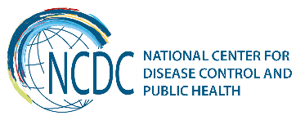
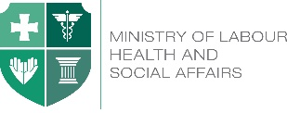

GEORGIA Brief
Richard Lugar Center of Public Health Research

R. Lugar Center for Public Health Research is a brand new facility under the National Center for Disease Control and Public Health (NCDC), which became operational in August 2013. The Lugar Center is top-tiered institution in NCDC’s system. Establishment of the Lugar Center took start in 2004, after USA – Georgia Agreements were signed (in 1997 and in 2002) on cooperation in the area of prevention of proliferation of technology, pathogens and expertise related to the development of biological weapons.

During the last 13 years, based on those agreements, USA provided significant financial and technical assistance in the area of Human and Animal Health and Biosafety. Cooperative Biological Engagement Program (CBEP), implemented by the US Defense Threat Reduction Agency (DTRA) supported renovation laboratory networks with modern biosafety features, for detection of Human and Animal pathogens. Significant resources were invested into personnel training as well.

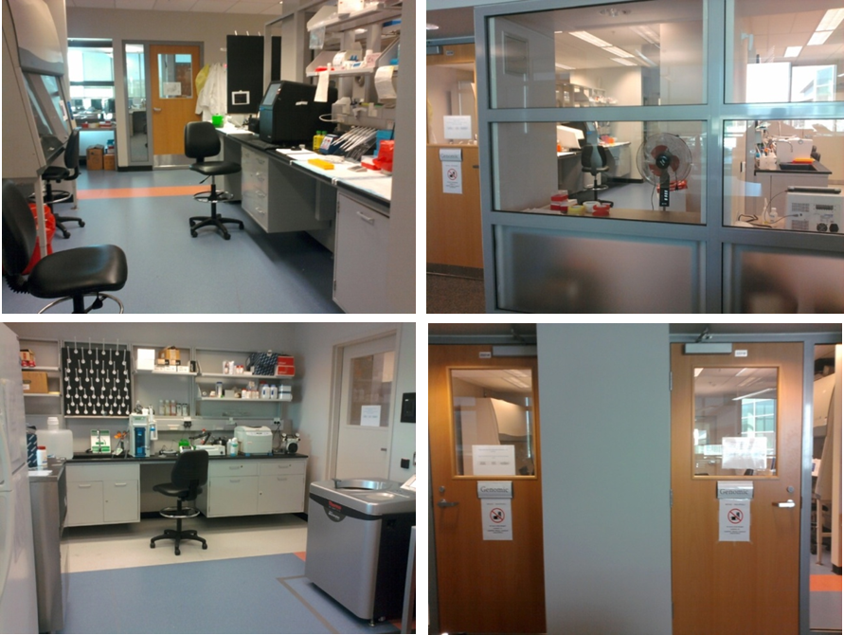
Key findings
The Lugar Center consists of modern BSL-2 and BSL-3 laboratories, with emphasis to timely detection and identification of human and animal pathogens based on the One Health concept.
This Biosafety Level 3 (BSL-3) facility houses bacteriology and virology laboratories, and the National Repository of human and animal especially dangerous pathogens (EDPs).

The BSL-3 facility is unique not only to Georgia but the entire Caucasus and Central Asia Region. Strains of infectious disease causative agents, including EDPs, are stored at NCDC’s Bacterial and Viral National Repository. The history of the repository has begun since the ‘60s of the last century when the live “culture museum” of the Georgian APS received two strains of V. cholerae asiatica (OGAWA).

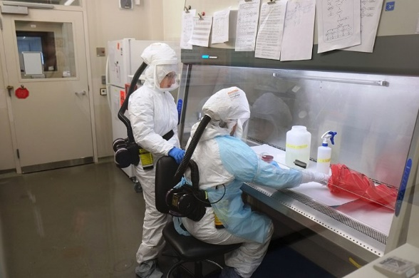

The Biosafety Level 2 (BSL-2) space encompasses several laboratories: Bacteriology, Virology, Serology, Molecular Biology / Genomics, Cell Culture, Parasitology, and Entomology.

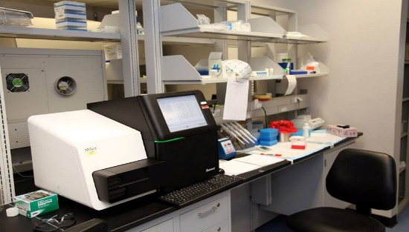

The Center also includes the well-equipped genomic center which makes the center a unique sequencing facility in the region.

There are several laboratories at the Lugar Center which are accredited by international organizations. These laboratories regularly participate in evaluations of professional competence. The quality control activities of NCDC’s Polio, Influenza and Measles/Rubella Laboratories are accredited by the World Health Organization (WHO). Four Labs are connected to WHO Lab Network: Rota, Invasive Meningitis, Malaria, Salmonelosis. Participation on WHO Laboratory Networks
- 2001 - Participation on Global Salmonella Network, Salmonella Global Investigation External Quality Assessment Program.
- 2002 - Measles/Rubella National Laboratory Participation in WHO Europe Network
- 2003 - Laboratory of poliomyelitis and other enteroviruses is fully accredited by WHO and has been a part of the WHO Global Polio Laboratory Network
- 2006 - Rotavirus group became the member of the WHO/EURO Rotavirus Laboratory Network
- 2007 - recognition of National Influenza Center (NIC) by the WHO
- 2010 - Integration into the WHO Invasive Meningitis Network and participation in EQA Program 2014 – Join to CAESAR AMR network
Currently the Lugar Center is in the process in obtaining the status of WHO Collaborating Center in AMR.
Recent Key Achievements
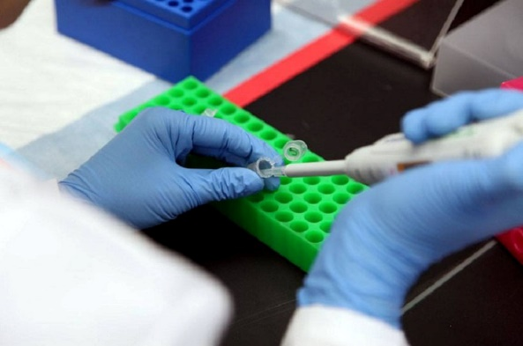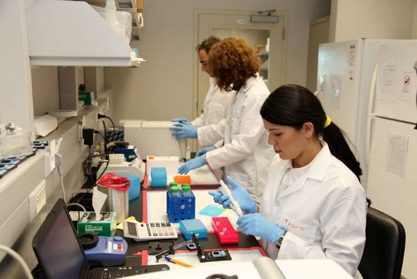

At present NCDC / Lugar Center has implemented more than 160 international scientific and public health projects within ~ 36 000 000 USD.
On the basis of the Lugar Center the following scientific achievements were made the first time in the World:

- new species of Orthopox virus discovered (so called Akhmeta virus);
- brucellosis and leptospirosis pathogens were found in bats;
- bartonella taylorii was detected as a human pathogen in patients with HIV / AIDS; Janibacter hoylei PVAS-1 was separated from endocarditis clinical sample.

And the first time in Georgia:
- Cowpox detected in Samegrelo
- The Results of the suspected but unconfirmed samples 41% of Anthrax turned out to be caused by the viral infection of Parapox
- Information on AMR was processed and published on the CAESAR network
- Gram-negative bacteria was detected as high resistant (ESBL)
- First time it was introduced bacterial isolates of carbapenem for monitoring
- The mechanism of resistance was developed and resistant strains of Neisseria gonorrhea
- Viral pneumonia cases, bacterial research / molecular method found to be positive for bacterial etiology on Streptococcus pneumonia
- Anthrax in soil active foci detection increased to 15% (10% historically). Correspondently, increased the risk of disease, as in animals, as well as in humans
- Tularemia new foci was detected in Kvemo Kartli
- Cl. Dificille was isolated from clinical samples
- Leptospirosis species were identified in the country
- Escherichia coli (STEC) toxical markers (stx1/stx2/eae/Ehly) were identified
- Salmonella spp., Shigellosis spp. And inner toxins were identified producing Escherichia coli (STEC) of the genetic profiles of the pulsing field gel electrophoresis (PFGE), which is the source of an outbreak detection and identification
- Sequencing of measles / rubella was introduced. Cases revealed measles genotype - D8
- New serotypes of salmonella found in shigella
- Through GARP (Genetic Algorithm for Rule-set Production) it became possible to forecast and ecologically model of vectors; GIS database started to be developed
NCDC was awarded “Quality Management System” (in the area of laboratory examinations) International Standard ISO 9001:2008 certification in 2015.

Right now Lugar Center is in the process of obtaining Clinical Laboratory accreditation standard ISO 15189.

Lugar Centre is a Regional Training and Resource Center (RTRC) in biosafety, biosecurity and Laboratory management in the South Caucasus. Lugar Center is ready to provide trainings for our international partners from former Soviet Countries as well as other countries of the region. There were training sessions for Kyrgyz and Turkish scientist within collaborative projects.
As the country’s NPHRL, Lugar Center established a National EQA Program. In 2017 Lugar Center launched national EQA program by sending PT panels and required documents to all laboratories listed in the Hepatitis C registry.

Challenges and Future Steps
The Lugar Center will serve as the main reference laboratory for public health in Georgia and Provide subject matter expertise in a broad range of disciplines such as, but not limited to, pathogen research methods and technologies, clinical infectious diseases, clinical research methods, bio surveillance, biosecurity, biosafety, medical product development, grant writing training, facility operations, equipment and facility maintenance, and research marketing.
  Ministry of Labour, Health and Social Affairs of Georgia  144, A. Tsereteli avenue. Tbilisi, Georgia, 0119  www.moh.gov.ge | 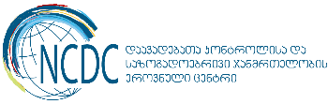  National Center for Disease Control and Public Health  9, M. Asatiani street. Tbilisi, Georgia, 0177  www.ncdc.ge
___________________________________________________________________________________________

