- Global Strategy for Women’s, Children’s and Adolescents’ Health (2016–2030) early childhood development
Georgian experience
MNH Status in Georgia: Georgia has achieved remarkable progress in reducing under–five and neonatal mortality rates to 10.2 and 6.1 per 1000 live births respectively by 2015 thus accomplishing the Millennium Development Goal #4 (MDG) set at the 2000 Millennium Summit: Reduce by two-thirds, between 1990 and 2015, the under-five mortality rate.
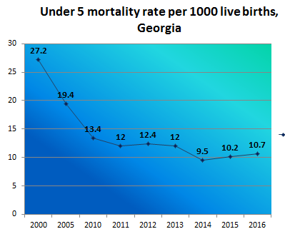
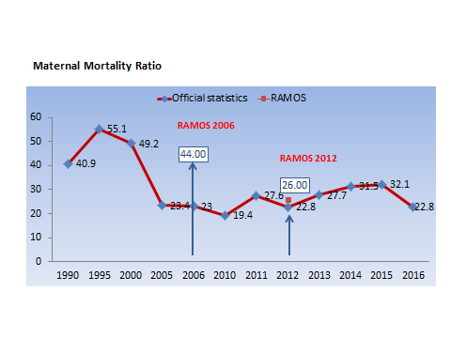
While significant progress has been made in reducing child/infant mortality rates, more efforts are needed to improve maternal mortality figures. Maternal Mortality Ratio in Georgia has fluctuated widely over the past decades. In 2015 it was 32.1 per 100 000 live birth, which is higher than average rate both for European region and the CIS. The rate decreased to 22.9 per 100 000 livebirth in 2016.

National MNH Strategy: 2017-2030 with related short term Action Plan (2017-2019) is developed and approved by the government with the aim to provide long-term guidance and coherent plan of action for the improvement of maternal and new born health in Georgia.

Perinatal Care Regionalization - “gold” model of maternal and new born service organization
Aim: to improve the health outcomes and decrease maternal and infant morbidity and mortality through provision of risk-appropriate care.

Principle: each mother and new born is delivered and cared for in a facility appropriate for his or her healthcare needs.

Process: all facilities providing maternal and new born care services are divided by levels of care according to their capacity.

The initiative of starting the perinatal care regionalization process from May 2015 is a significant step forward in strengthening the maternal and newborn health care system, which considers defining the levels of perinatal service providers and their role and responsibilities in order to provide the correct timing of the correct patient to a correct medical institution and, if necessary, effective referral. Regionalization was be completed in 2017.

105 facilities assessed, 83 facilities have designated level of care. All 83 facilities strengthened their capacity for infrastructure/equipment and competencies of service providers according to the level requirements.

Birth Registry: In 2016, MoLHSA in alliance with NCDC launched the nationwide electronic registry “Mother’s and neonate’s health surveillance system”, so called “Georgian Birth Registry” (GBR). The system tracks information on all cases of pregnancy, delivery, postpartum, neonatal care and abortion.
The GBR provides an opportunity:
- to get comprehensive knowledge on a wide array of indicators, related to the maternal and newborn health, morbidity and mortality along with the quality of antenatal, obstetric and neonatal care
- to make evidence-based policy decisions.
The GBR also allows monitoring the regionalization of perinatal care services through providing data on selected maternal and neonatal health indicators.
The coverage of pregnancy and childbirth by GBR increased from 47% in 2016 to 96 % in 2017.

Selective Contracting: In March, 2017 MoLHSA initiated a selective contracting of facilities providing perinatal care services. Social Service Agency contracts only facilities which demonstrate required compliance with pre-defined quality criteria. Currently 30 facilities, providing perinatal care services from three largest cities of Georgia (Tbilisi, Kutaisi and Batumi) are involved in selective contracting process. The existed contract includes 10 quality indicators, covering the critical issues related to obstetric and neonatal care in Georgia.

Clinical Audit: The routine clinical audit of cases of stillbirth and maternal and neonatal mortality has been introduced by the MoLSHA in 2017 with aim to advance practice of obstetrics and neonatal care and improve the quality of services through detailed clinical analysis of selected mortality cases. The comprehensive audit process allows identification of root causes of gaps and deficiencies in existing practices and in the health system and planning the corrective policy and practice measures at the local and national level.

Elimination of mother-to-child transmission of HIV and syphilis: Georgia maintains a strong commitment to prevent mother-to-child transmission of HIV and syphilis (EMTCT) and integrated EMTCT into the National MNH Strategy. The specific plan for meeting elimination targets has been developed by the national elimination committee. EMTCT interventions are part of the national maternal and child health care programs and are offered to the population free-of-charge.

