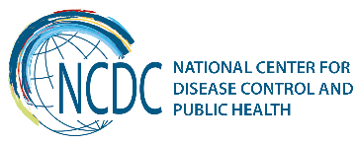
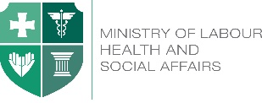

GEORGIA Brief
Public Health State Programs

The National Center for Disease Control and Public Health is implementing following public health programs in the country:

- State Program on Early Disease Detection and Screening
The aim of the program is early detection and prevention of the spread of diseases; and establishing a healthy lifestyle in the population. The program provides: breast, cervical and colorectal cancer screening and prostate cancer management; organized screening of cervical cancer in Gurjaani region; prevention of mild and medium mental development retardation in children of 1-6 years; diagnostics and supervision of epilepsy; piloting of retinopathy in prematurely born infants throughout Tbilisi.
- State Immunization Program
The aim of the program is protection of population from vaccine-preventable infections; providing population with rabies vaccine and immunoglobulin, creating strategic stockpiles of specific vaccines and serums, distribution of vaccines, serums and consumables to the regional/district administrative units, in compliance with cold chain requirements; according to the “Strategy of global elimination and prevention of spread of measles” conducting unplanned immunization of the unimmunized or incompletely immunized population, according to the rules agreed with the the Ministry of Labour Health and Social Affairs of Georgia.
- State Program on Epidemiological Surveillance

The aim of the program is epidemiological surveillance of communicable and non-communicable diseases in the country; ensuring early detection and prevention of diseases as well as adequate response through proper functioning of the surveillance and laboratory service-based system. The program envisages: monitoring/management of the activities carried out for surveillance, immunization and managing medical statistics, through the public health centers on regional and municipal level; measures for improvement of prevention and control of Malaria and other transmissible diseases; Surveillance of nosocomial infections; investigation of viral diarrheas; maintaining the sustainability of the epidemiological surveillance network for flu and responding to seasonal/pandemic flu (including sentinel services).
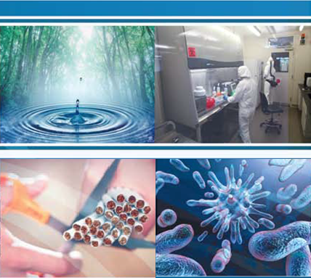
- TB Management State Program

The program aims to reduce TB morbidity, mortality and spread of infection in society, prevention of resistance to TB medicines. In the frames of the State program NCDC undertakes the following activities: surveillance; laboratory control and sputum logistics; regional management and monitoring of TB program; purchasing of the first and second line (up to 25% of total cost) TB medicines; monetary incentives (up to 225 patients per month) - in order to improve the treatment adherence of patients with sensitive and resistant forms of tuberculosis.
- State Program on HIV/AIDS Management
The aim of the program is timely detection of HIV/AIDS new cases, fight with the spread of disease and ensuring access to the treatment of the HIV/AIDS patients. In the frames of the State program NCDC undertakes the following activities: voluntary counseling and screening on HIV; purchasing test systems and consumables for screening on HIV, confirmational investigation of positive cases; purchasing of the first and second line (up to 25% of total cost) ARV medicines.
            - Safe Blood State Program

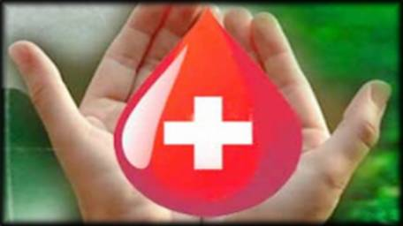
The program aims at prevention of transfusion- transmissible Infections and ensures equal blood safety standards throughout the country; step-by-step replacement of a paid donorship with a voluntary, non-remunerated regular blood donation. Following activities are carried out under the program: HBV, HCV, HIV and Syphilis testing of the donor blood; ensuring external quality control and monitoring (including administration of the unified national donors database); implementation of a national campaign supporting and attracting voluntary regular donors.
- State Program on Prevention of Occupational Diseases
The aim of the program is to protect the health of the employed population through the prevention of professional and occupational diseases and promotion of safe working environment.

- Maternal and Child Health State Program

The aim of the program is to reduce maternal and child mortality, decrease the number of premature deliveries and congenital abnomalites through effective patronage of pregnant women and improving geographical and financial accessibility to highly qualified medical aid and to the medicines. In the frames of the program, NCDC undertakes following activities: providing tests and consumables for testing Hepatitis B, C, HIV/AIDS and syphilis in pregnant women (as well as - immunoglobulin against Hepatitis B to the children of HBV infected mothers); confirmational testing of positive cases of screening; newborn hearing screening in Tbilisi.


- State Program on Health Promotion
The aim of the program is education and awareness raising of population on health issues; and creating a health-friendly environment that enables better control and improvement of health determinants. Program envisages: Strengthening of tobacco control; awareness raising about alcohol consumption; education on healthy eating; promotion of physical activity; hepatitis C prevention and promotion of education of the population; mental health promotion and prevention of substance abuse; popularization and strengthening of health promotion measures.

- State Program on Hepatitis C Management

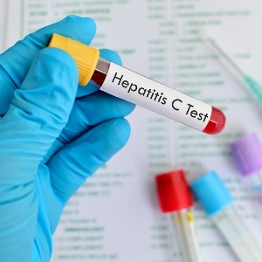
The aim of the program is to reduce morbidity, mortality and the spread of infection caused by HCV by ensuring access to the prevention, diagnosis and treatment of the disease. Within the State program, the center provides hepatitis C screening in accordance with the geographical accessibility; purchasing and distribution of the tests and consumables for HCV screaning of the ambulatory patients in the provider institutions.

Recent Key Achievements
Budget of the public health programs 2012-2017
State Program budget administered by the NCDC has been almost tripled from 2012 to 2017 and equaled to 29 089 GEL. As a result, transition of obligations from the international organizations (Gavi Alliance, GFTAM, US CDC) to the state, regarding vaccination, TB and AIDS first and the second line medicines, medical supplies and reagents, as well as introduction of different activities within the State Health Care programs (Influenza surveillance, introduction of new vaccines, and the new types of services etc.) became possible.

NCDC undertaking the administration of public health programs – 2011-2012
Since 2011, the NCDC’s role has significantly increased in terms of health prevention programs administration. State programs, such as Early Disease Detection and Screening, Safe Blood, Prevention of Occupational Diseases, TB Management, HIV/AIDS, and Maternal and Child Health have been delegated to the Center. In addition, Health Promotion State Program and Screening Component of Hepatitis C Management State Program have been launched in 2015-2016.
Introduction of external quality control systems within the Safe Blood State Program – 2011-2015

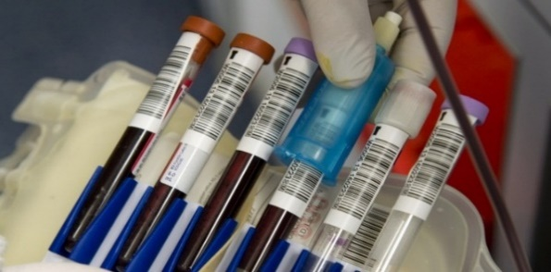
Since 2011, Center provides routine external quality control for blood banks participating in the state program through re-testing of randomly selected blood samples extracted from banks. Since 2015, a proficiency testing of blood samples by internationally accredited reference-laboratories has been introduced in the blood banks by the Center.

Under the Safe blood State Program Modernization of Unified Blood Donor Electronic Base has been performed and became obligatory
Existing modules of the blood donor electronic base have been updated; new informative abstracts have been added. For proper operation of modernized bases special trainings were held for employees and specialists of blood banks and medical institutions. Additionally, since August 15, 2017 the notice is regulated and includes information on transfusion by means of registration in Unified Blood Donor Electronic Base.
Launching cervical cancer organized screening pilot within the State Program on Disease Early Detection and Screening - 2014

Within the frames of the State Program on Early Disease Detection and Screening, in close collaboration with UNFPA, a pilot program on cervical cancer organized screening was introduced in Gurjaani municipality in 2014. The goal of the program is to expand positive results from the pilot across the country and ultimately, to increase screening coverage rate. The pilot provides rural doctor’s counseling to target population (women aged 25 to 60 years) about cervical cancer screening and their referral to service provider clinic. In 2015, equipment for
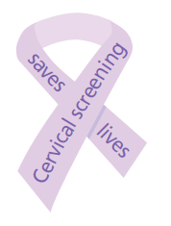
cervical cancer screening was purchased by the state budget. Since 2016, rural doctors are given the opportunity to take over the PaP testing and make referral to service provider clinic.

Introduction of newborn retinopathy screening Within the Early Detection of Disease and Screening State Program
Under the Decree No. 638 of December 30, 2016 of the Government of Georgia on "Approval of State Programs for Health Care 2017", Since 2017, to the Early Detection and Screening State Program has been added new activity - the pilot of premature neonatal retinopathy screening in Tbilisi medical institutions, which includes examination of newborns for diagnosis of retinopathy, according to retinopathy national protocol of premiums, in accordance with screening criteria.
Introduction of pregnant women HCV screening within the Maternal and Child Health State Program -2015
Within the conditions set forth in the Hepatitis C Elimination Strategy for Georgia, screening of pregnant women for Hepatitis C (along with testing for Hepatitis B, HIV and syphilis already implemented by the previous program design) and provision of medical facilities with the four-component test systems have been added to the Maternal and Child Health State program since 2015.
Enlargement of newborn hearing screening within Maternal and Child health State Program
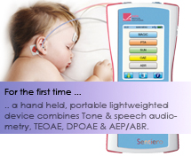

Coverage of newborn hearing screening has been expanded from capital city to 8 additional regions (Kakheti, Shida Kartli, Kvemo Kartli, Imereti, Samtskhe-Djavakheti, Guria, Samegrelo-Zemo Svaneti, Adjaria) through the equipping of 14 regional maternal houses which improved early detection of hearing loss and increased access to the screening services. In addition, newborn hearing screening programs funded by local municipalities (Ajara Region) and other donor programs (Imereti, Samegralo-Zemo Svaneti, Guria Regions) have been supported and coordinated by the State Programs.
Based on the order, No.01-59/n of 13.09.2017, introducing amendments to the order of the Minister of Labour, Health and Social Affairs of Georgia “on Approval of Criteria for Registration of Perinatal Services and Patient Referral”, from 01.03.2018 universal access to newborn screening will be provided at all maternity houses.
An introduction of postal referral within TB Management State Program – 2013

The pilot introducing a new scheme of sputum specimen transportation from TB centers to laboratories was introduced by NCDC in three regions of Georgia in 2013 and was expanded across the country since March, 2016.
Under this scheme, LTD Georgian Post carries out the
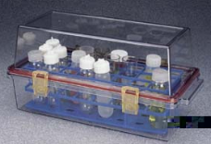

specimen transportation in accordance with biosafety norms. The new mechanism of specimen referral resulted in the: 1. Reduction in the time required for patient diagnosis (both for bacterioscopy and mycobacterial culturing methods); 2. Improvement of treatment initiation timing; 3. Increase in quality of laboratory analyses through achieving proportional workload of laboratory capacities; 4. Decrease of specimen transportation costs.
WHO acknowledged Georgian new transportation mechanism as the best practice and published it as a guidance for other countries.
Introduction of new mechanism for contact tracing of TB patients within TB Management State Program – 2014
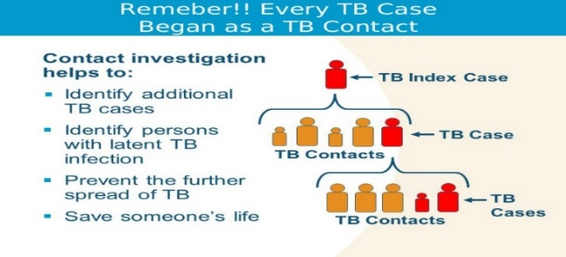
Since 2012, National Center for Disease Control and Public Health bears the responsibility for contact tracing of TB patient. In this direction, a new methodology for epidemiological surveillance of TB patient contacts has been introduced since 2014, which implies epidemiological investigation of TB patient contacts with specially designed questionnaire and their referral to the specialized medical facilities through providing appropriate informational and educational work.
Upgrading of Cold Chain infrastructure within the Immunization State Program – 2013-2014
In 2014, on the basis of Resolution of the Government of Georgia No.1799 (dated 30 September 2014), for the first time in the history of independent Georgia, a Cold Chain equipment recommended by WHO was purchased with the budgetary funds within the frames of Immunization State Program, through UNICEF procurement mechanism. As a result, approx. 30% of country’s Cold Chain infrastructure has been updated.
Vaccines and injection materials continuity supply within the Immunization State Program
From 2013 all routine immunization vaccines (except Hexavalent) are procured through UNICEF flexible procurement mechanism and all vaccines procured for routine vaccination are WHO prequalified. On November 21-25, 2016, the UNICEF experts evaluated the procurement system of vaccines in Georgia. As a result of assessment, procurement process was evaluated as effective, open and transparent, and the process of vaccines predicting, budgeting was evaluated as exemplary.
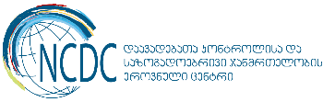
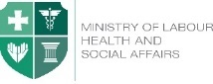
______________________________________________________________________________________
Ministry of Labour, Health and Social Affairs of Georgia  144, A. Tsereteli avenue. Tbilisi, Georgia, 0119  www.moh.gov.ge | National Center for Disease Control and Public Health  9, M. Asatiani street. Tbilisi, Georgia, 0177  www.ncdc.ge

