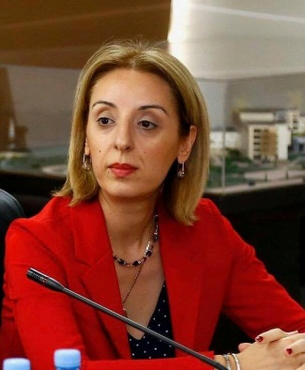

Nino Berdzuli
- Birth date: 25 November, 1973
- Birth plase: Kutaisi, Georgia

Education:
- 1990-1996 - Tbilisi State Medical University, Medicine faculty
- 1996-1997 - Tbilisi State Medical University, internship in obstetrics and gynecology
- 2002-2004 - Master of Public Health - Emory University, Atlanta, USA,
- Edmund Mask's American State Department Scholarship
- 2014-2016 - Doctor of Public Health, Candidate - Oslo University, Norway

Professional development:

- 1999 - Public Health and Primary Health Care Management and Leadership, Lund University, Sweden
- 2003 – Advanced Life Support in Obstetrics (ALSO), Certificate
- 2003 - Principles of Sexually Transmitted Diseases / HIV Infection, University of Washington, Seattle, USA
- 2004 - Organizing Perinatal Services and Referral System, Department of Obstetrics-gynecology and Perinatal Medicine, Emory University, Atlanta, USA
- 2011 - Accreditation of health care services and medical institutions, Joint Commission International, Chicago, USA
- 2013 - Improvement of healthcare services, Harvard Community Health School, Harvard University, Boston, USA
- Working Experience:
- 19.11.2015 - Till today; Deputy Minister of Labour, Health and social affairs of Georgia
- 2013-2015 - USAID Maternal and Child Health and Reproductive Health Program - Director, “JSI” Institute for Research and Teaching, Tbilisi, Georgia
- 2009-2013 - JSI Research and Training Institute, Senior Technical Advisor, Washington, USA
- 2006-2009 - USAID European and Eurasian Regional Reproductive Health Program - Director, Washington, USA
- 2004-2006 - JSI Research and Training Institute, Director's Advisor, Women's Health Program, Tbilisi, Georgia
- 2003-2004- Centers for Disease Control and Prevention, Scientist, USA Atlanta
- 1997-2002-Maternity house, Obstetrician gynecologist. Kutaisi. Georgia
- Awards and Publications:
- is the owner of the Delta-Omega Order of Emory University, for best academic achievements and the introduction of public health principles and contributing. Emmor University, USA, 2004
- Her 12 scientific articles, monographs and other scientific writings have been published. Is a reporter and expert on more than 50 international conferences and congresses.
- Languages:
- Georgian, English, Russian.
- Marital status:
- She has a husband and a child.

