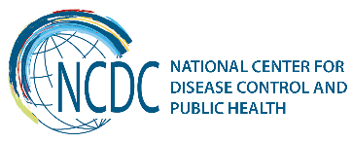
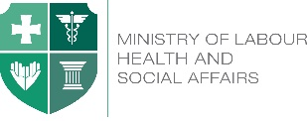

GEORGIA Brief
Public Health System Management

The National Center for Disease Control and Public Health (NCDC) – under the state control of the Ministry of Labour, Health and Social Affairs of Georgia was created in 2007, after a merger of the Public Health Department and the Center for National Disease Control and Medical Statistics. NCDC is responsible for the public health of the entire population, including security and monitoring of epidemiological situation in the country, immunization, surveillance, disease prevention and timely response to public health emergencies, health promotion, information support, Prevention of environmental hazards and behavioral risk-factors, Development of applied and fundamental bio-medical scientific researches in Public health the laboratory system for health and coordinates the public health lab services based on the “One Health” principle together with the Ministry of Agriculture.

Public health system in Georgia is arranged by the following structures:
- The National Center for Disease Control and Public Health
- 9 regional branches of the NCDC
- PH centers in 61 municipalities.

While the first two structures are strongly connected and the work is coordinated centrally by the NCDC, the municipality centers are under local authorities; the NCDC provides also some funding to them (i.e. certain surveillance, outbreaks etc.). Public health laboratories belong also to the NCDC.

The main objective of the municipal centers is to support the health of the population of the particular municipality area by promoting state public health programs and to prevent diseases, in close cooperation with primary health care centers as well as other medical institutions (hospitals, diagnostic laboratories, medical centers), governmental and international organizations.

In cooperation with primary healthcare centers
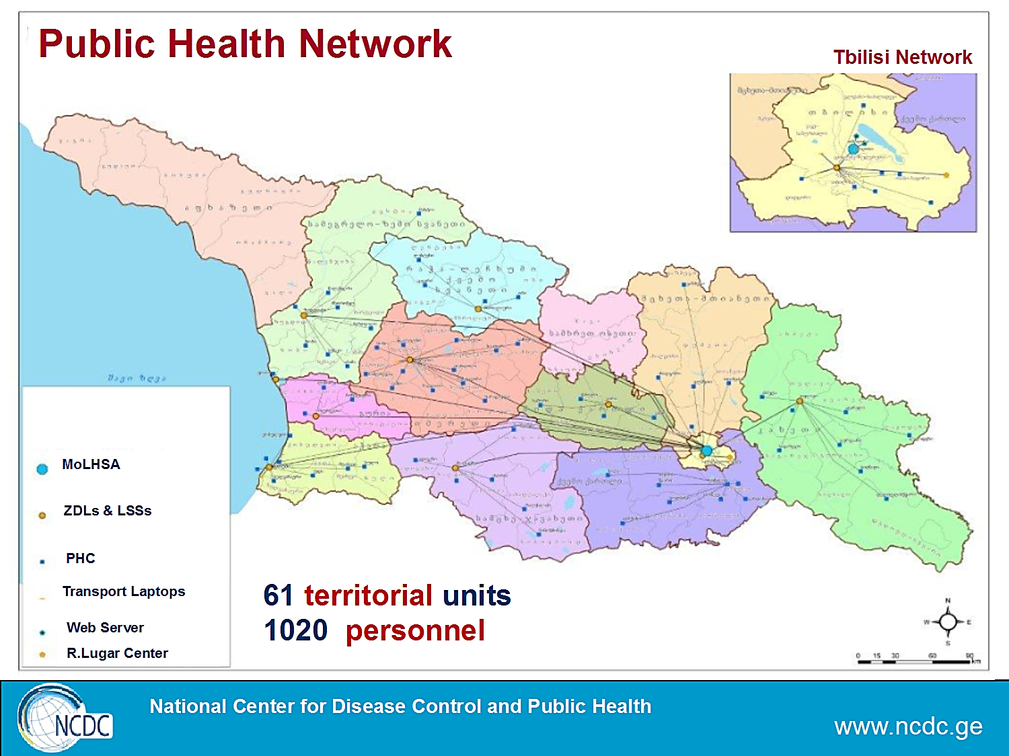

Municipal PHCs implement:
- State Immunization program
- Epidemiological surveillance and control of communicable and non-communicable diseases
- Timely respond to the reportable/notifiable diseases and data management
- Primary detection of TB patients and their referral to the TB cabinets, monitoring, supply with anti-TB drugs of diagnosed patients, surveillance
- Planning and implementing of preventive healthcare activities on the territory of municipality
- Participation in the State Hepatitis C program, reporting
Public Health Regional Management Department at the NCDC plays an important role in coordinating activities of local (61) municipal public health centers (PHCs) of self-governing cities and districts in compliance with requirements of state programs that aims at fulfillment of its obligations in the field of public health.

Key Findings
Public Health Law has been endorsed in 2007. Several legislative acts were adopted in past 5 years to ensure better infection control in Georgia including rules and conditions of issuing permits and licensing for conducting medical activities, on accomplishment of better medical and prophylactic disinfection services, on medical waste collection, storage and neutralization, on sanitary norms of conducting activities on biological pathogens, on surveillance, prevention and control of nosocomial infections, on transfusion, on infection control while conducting esthetic and cosmetic activities in publicly important institutions/facilities, on disinfection and sterilization norms in medical, public health and public facilities etc. Decree of Government of Georgia “on Adoption of the National Strategic Plan 2017-2020 on Fighting Antimicrobial Resistance” was adopted in 11.01.2017.
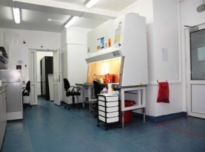
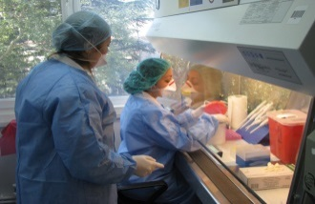
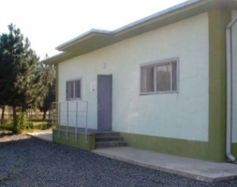
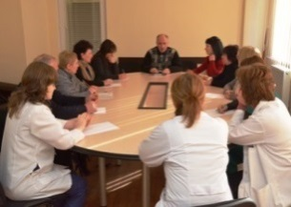

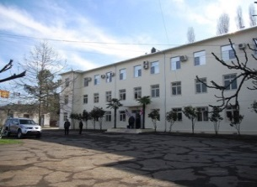
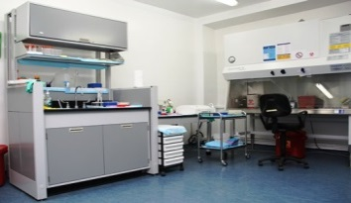
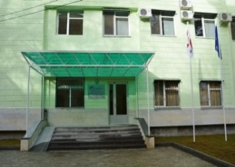
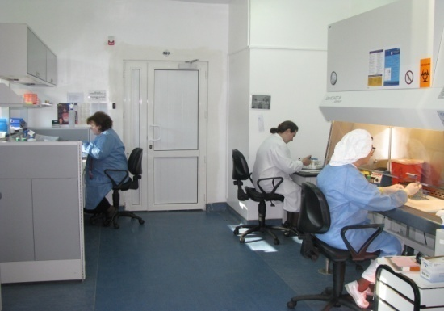

WHO Regional Office for Europe conducted the Public Health Services Expert Mission to Georgia on May 8-10, 2017. Objectives of the mission were to study and evaluate current public health services in Georgia; to support the discussion and Brain-storm the vision of long-term development of public health in Georgia; and to find integrated solutions with the aim to strengthen public health services and capacities. In particular, Expert Mission aimed to assess the human resource capacity for public health, including education of public health professionals; Find the ways where and how to introduce changes in order to fully implement national strategies/programmes at the municipality level; Define institutions, procedures and mechanisms for enforcing key public health legislation etc.

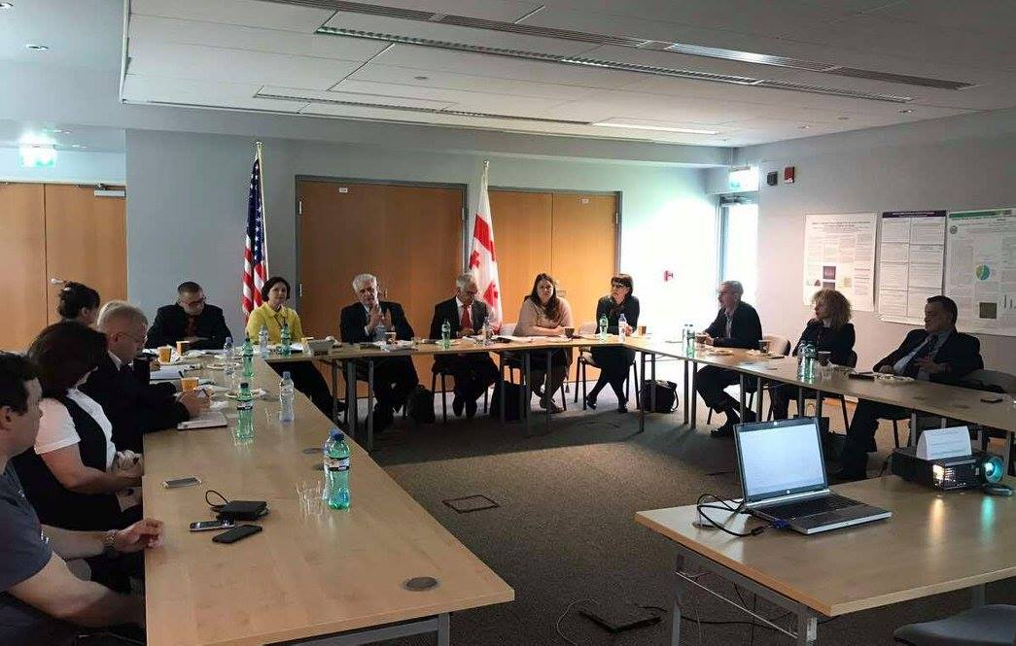
Expert mission covered a vast technical area: studied arrangement of Georgian Public Health System and principles of its functioning, became acquainted with the procedures and mechanisms for drafting the public health legislation, discussed the human resource development issues etc. and identified recommendations for possible next steps: A paradigm shift towards prevention and health promotion was suggested at all levels of the health system. Establishing strong accountability structures and legislative mandate for public health outcomes (governance, finance & legislation), enabling cross- sector leadership and stake-
holder engagement towards improved public health outcomes, building capacity of modern public health competencies in the health workforce, review the existing funding arrangements, learning more about the options to establishment of a modern public health system, with appropriate authority at local level; and conducting the study tour (in order to examine governance, finance & legislation for public health outcomes) in the country with a strong track record on this - was considered a good starting point.

Recent Key Achievements
Based on the needs of local population, the list of possible municipal programs and the methodology for their elaboration and implementation have been developed. According to the new requirements, Public Health National Recommendation (Guideline) for further functioning of municipal PHCs, typical methodic provisions and job descriptions for public health workforce have been updated and approved on 20.07.2017 by the Order of the Minister of Labour, Health and Social Affairs of Georgia #01-163/o on Functioning Public Health Municipal Services”.

Order defines the responsibilities of the municipal PHCs: supervision of sanitary and hygienic norms in educational and other facilities of public importance (including esthetic and cosmetic salons); organization of preventive measures and other needed activities for infection control; implementing activities set forth in the Order of the Minister of Labour, Health and Social Affairs of Georgia for maintaining and proper distribution of vaccines and consumables to service provider medical centers in accordance with the immunization calendar; epidemiological surveillance and primary investigation at the territory of municipality; implementation of preventive and epidemiological control activities in emergency situations etc.

According to the Order, budget of the local municipalities envisages funds for elaborating and implementing the municipal PH programs according to the local needs, which should be based on epidemiological analysis in given municipality. These programs together with the State Healthcare programs should serve for improving the health of local population and has to be elaborated according to the 10 essential public health operations (EPHO), recommended by WHO Regional Office for Europe.

The list of the possible municipal programs was identified: Ensuring Detection and prevention of tobacco consumption and other habits - harmful to the health (alcohol, drug abuse etc.); promotion of healthy development of children (prevention of mental health disorders); education of adolescents on medical/preventive issues; identifying risk-factors which causes communicable and/or non-communicable diseases; prevention of cardio-vascular diseases at family environment; prevention of traumatism; screening and monitoring of preschool and school children’s health status (on helminthiasis, physical development etc.); awareness raising of local population on healthy diet and physical activity, preventive measures to avoid diseases caused by the deficiency of iodine and other microelements, immunization, family planning methods, STDs, early marriages and accompanying possible complications, socially dangerous diseases; informing local medical personnel on the methods of processing obligatory medical/statistical data and local population - employed in the institutions of public importance about the mandatory sanitary norms; investigation and prevention of psycho-social problems in adolescents; elaboration of recommendations for local municipalities, local population and educational institutions, etc.

Draft of the concept for further development of public health has been developed based on EPHO 1-10. In January, 30-31 2017, Georgia participated in the “Coalition of Partners Expert Meeting on Strengthening Public Health Capacities and Services in Europe” organized by the WHO Regional Office for Europe where presented the framework of the planned actions for the development of the public health system in Georgia, which envisages consistent and coordinated strengthening of the public health services in the country, focused on four enabling functions – human and financial resources for public health, organization and governance of public health services, and public health legislation.
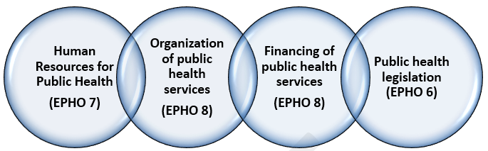Source: WHO EURO

Challenges and Future Steps
Implementing unified, effective and coordinated disease control and public health system in Georgia that will be based on European and global experience:
- Introduction of modern technologies according to EPHOs 1–4 to improve public health activities, in terms of multidisciplinary and multisectoral perspectives with improving quality of monitoring and evaluation.
- Discussing and approval of the Public Health Strategy and Action Plan with the participation of all stakeholders and decision-makers
- Developing strategy for infrastructure arrangement of regional and district PHCs
- Review and improvement of the legislative framework in cooperation with WHO, governmental structures, parliament, and international partners; harmonization with the EU Acquis and other international standards for ensuring implementation of unified policy
- Increasing effectiveness and efficiency of organization and management of public health services
- Strengthening the coordinating role of public health specialists in solving local health care problems;
- Recognition of public health workforce as a profession within the framework of current legislation; Organizing continuous education system for public health system workforce
- Increasing the sustainability of the regional laboratory network by expanding commercial research areas
- Increasing integration of public health programs into primary health care programs; increasing integration of preventive measures in universal health care and private insurance packages.
In order to meet the public health needs, WHO contributions may be spread on the following areas and relevant actions:
- Identifying the core competencies of public health professionals – evaluation of the professional level of public health workforce;
- Creating a curriculum for continuous professional development (short-term course curriculum) for public health workforce; Developing roadmap towards professionalization of the public health workforce, compendium of case studies;
- Creating and developing licensing and accreditation systems; developing template public health workforce development plan;
- Organizing public health capacity building workshops;
- Reviewing the public health legislation to identify shortcomings and extent of relevance of national legislation with 10 EPHOs. Studying the best practices in this field;
- Reviewing and comparison of legislation framework, testing the methodology in other countries with different public health structures.
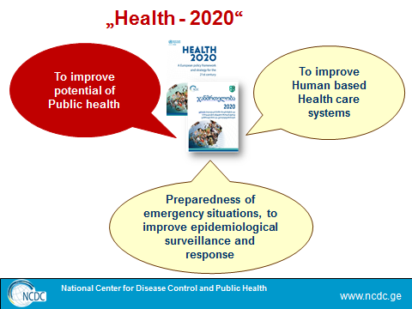
Source: WHO EURO
________________________________________________________________________________________
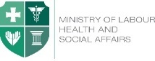  Ministry of Labour, Health and Social Affairs of Georgia  144, A. Tsereteli avenue. Tbilisi, Georgia, 0119  www.moh.gov.ge | 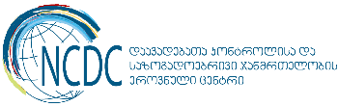  National Center for Disease Control and Public Health  9, M. Asatiani street. Tbilisi, Georgia, 0177  www.ncdc.ge

