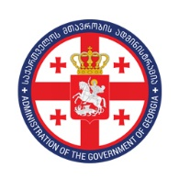
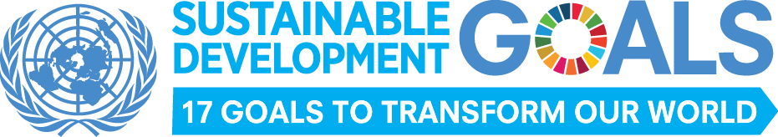

Sustainable Development Goals (SDG) Council
Plenary Meeting N1
24 October, 2017
Hotel “Radisson Blu Iveria”
16:00 - 16:15 Opening Remarks
Maia Tskitishvili, Head of Administration of Government of Georgia
Niels Scott, UN Resident Coordinator
16:15 - 16:25 Structure of SDGs Council – Arrangement of Working groups
Nationalisation Process of SDGs in Georgia – Overview of Last Two Years
Nino Sarishvili, Head of Government Planning Unit, Secretary of the SDGs Council
16:25 - 16:35 Presentation of National Targets and Indicators (Data)
Ana Kvernadze, SDGs National Coordinator, Secretariat of the SDGs Council
16:35 - 16:50 Discussion
16:50 - 17:20 Integration of Country Internal Policies and SDGs:
- Education (Goal 4)
- Social Welfare (Goals 1 and 3)
- Agriculture (Goal 2)
- Environment (Goals 11,12,13,14,15)
- OGP and Anti-corruption policy (goal 16)
- Economic Growth (Goals 8 and9)
17:20 - 17:30 GEOSTAT - Insight, Data interpretation and Challenges
17:35 - 17:40 Presenting Results of SDG 16 Pilot Project (UNDP Georgia/IDFI)
17:40 - 17:50 Discussion
17:50 - 18:00 Wrap-up
18:00 - 19:00 Reception – UN Day Celebration

