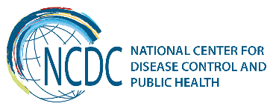


GEORGIA Brief
Non-communicable Diseases Surveillance

Non-communicable diseases make the greatest proportion of the total burden of disease and injuries in Georgia affecting the most productive years of life. According to WHO 2014 Health Report, non-communicable diseases account for nearly 94% of all deaths, among them 69% due to CVDs, 14% - cancer, 1% - diabetes, 4% - chronic respiratory diseases; they make influence not only on health but also on sustainable development of the country.
For the effective prevention and control of NCDs it is essential to have timely access to precise and reliable information, to monitor and interpret health indicators, to monitor and evaluate the impact of interventions. For the effective NCD surveillance Georgia implemented The WHO STEPwise approach; 2 rounds of STEPS surveys have been conducted in 2010 and 2016 with technical and financial assistance of the WHO-Euro and WHO-HQ and giving us the unique possibility to compare the data not only with other countries but to monitor and evaluate patterns and trends of NCDs and risk-factors in Georgia. These are the first steps to contribute to building sustainable surveillance systems, which improved national capacity and provided the better health information and thus better opportunities necessary for effective NCD prevention and control to improve the health of our citizens.
Goals and objectives of the STEPS 2016
The overall goal: Strengthening the surveillance system of major NCDs and risk-factors for improvement of NCDs prevention and control including healthcare management in Georgia.
The specific goal: Assessment of the prevalence and variation of major NCD behavioral, biological risk factors and their determinants among 18-69 years old population of Georgia, and changes with respect to 2010 survey
Objective 1: Estimate NCDs risk-factors prevalence among 18-69 years old population of Georgia by age groups, regions, and by urban and rural residence
Objective 2: Increase institutional capacity for ensuring effective and sustainable NCDs risk-factors surveillance system development in the future, including national monitoring and reporting of globally agreed NCD indicators on risk factors
Objective 3: Ensure that study outcomes are efficiently promoted to be used for supporting a significant decrease of the burden of NCDs in the country

STEPS country board includes representatives from the National Center for Disease Control and Public Health (NCDC), Ministry of Labor, Health and Social Affairs (MoLHSA), National Statistics Office of Georgia (GeoStat), academic medical institutions, and professional associations.
Georgia conducted all three different levels of "steps" of risk-factor assessment:
"Steps" of risk-factor assessment

Step 1- Questionnaire-based assessment (Social-demographic indicators, behavioral risk-factors (tobacco, alcohol, unhealthy diet, physical inactivity, etc.)

Step 2- Simple physical measurements (height, weight, waist circumference, pulse and blood pressure)

Step 3- Biochemical Measurements (blood glucose, blood lipids, HDL cholesterol, urinary sodium and creatinine, urinary cotinine)

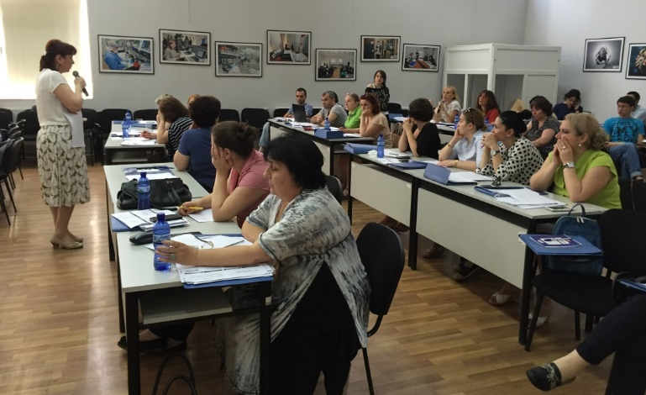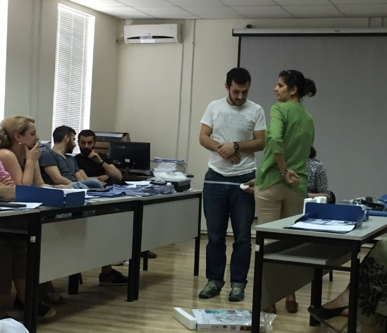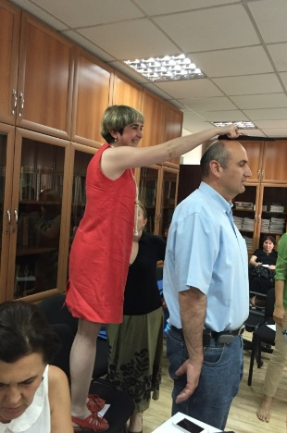
"steps" of risk-factor assessment

Final sample size – 5554

Representation of urban/rural and 4 age groups (1-29, 30-44, 45-59, 60-69)

Response rate – 76%

Several indicators, STEPS 2016
 | Both Sexes | Males | Females
Percentage aged 40-69 years with a 10-year CVD risk ≥ 30%, or with existing CVD | 28.8% | 30.8% | 27.1%
Percentage who engage in heavy episodic drinking (6 or more drinks on any occasion in the past 30 days) | 18.30% | 35.30% | 2.60%
Percentage of women aged 30-49 years who have ever had a screening test for cervical cancer |  |  | 23.90%
Mean systolic blood pressure – SBP (mmHg), including those currently on medication for raised BP | 129.4 | 132.6 | 126.5
Mean diastolic blood pressure – DBP (mmHg), including those currently on medication for raised BP | 82.2 | 83 | 81.4
Mean intake of salt per day (in grams) | 8.5 | 9.7 | 7.4

Recent Key Achievements
- Based on the information provided by the STEPS surveys the multisectoral state council on NCDs prevention and control is established
- National Strategy of NCDs Prevention and Control and 4-year AP are endorsed
- Essential drugs for major NCDs for Georgia – IHD and stroke, asthma and COPD, Diabetes type 2 and thyroid gland dysfunction for the most vulnerable populations are arranged into the Universal Healthcare Program
- For the effective NCD surveillance Georgia implemented The WHO STEPwise approach is implemented
- With the assistance of the WHO-Euro and other international organizations Georgia uses all possibilities to obtain the information on NCDs and their risk-factors through the surveys such as GYTS, RHS, Migrant Health Survey, Hep C survey, HBSC, COSI, National Iodine Survey, cancer registry, birth registry, and etc.
Challenges and Future Steps
- On the basis of the NCDs and risk-factors surveillance to orientate not only the primary but also secondary prevention, disease screening and management
- To ensure the regularity of the STEPS Survey every 3-5 years in order to establish a sustainable surveillance system to estimate existing tendencies and provide sustainable networking for information exchange and evaluation
- To disseminate the Survey results among the Insurance Companies as well as other governmental and non-governmental, national and international health stakeholders in the country to undertake an in-depth analysis, oriented at win-win solutions, in view of increasing capacities/coverage offered by the State Health Insurance Policy with regards to NCDs management and treatment
- Any further research would be valuable – e.g. intervention research with implementation of NCD prevention measures and evaluation of health insurance/allowance impact for NCD drugs on NCD treatment compliance, etc. such information can inform policy makers and other partners/donors on the needs
- To disseminate the survey results to communicate the needs of population to frontline stakeholders such as policy/decision makers, INGO and NGO sector, community leaders, etc. through different types of media sources
- Capacity building of primary health care personnel with a special emphasis on NCDs and health promotion among PHC
- To elaborate Information, Education and Communication (IEC) materials to ensure accessibility and explicitness of health-related information intended for diverse population groups as well as general population.
Ministry of Labour, Health and Social Affairs of Georgia  144, A. Tsereteli avenue. Tbilisi, Georgia, 0119  www.moh.gov.ge | National Center for Disease Control and Public Health  9, M. Asatiani street. Tbilisi, Georgia, 0177  www.ncdc.ge




