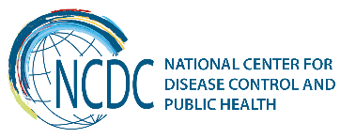
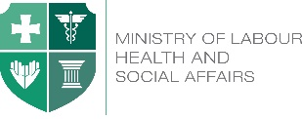

GEORGIA Brief
Medical Statistics

National Center for Disease Control and Public Health has the leading role in the field of health information in Georgia. The Department of Medical Statistics is a part of the NCDC since 2003, main functions of which are: data collection from the medical establishments, data management (control, classification, validation), data analyses and data presentation through publications and a variety of materials, ensure databases management.

Key Findings
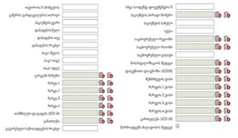
Development of the health information systems (HIS) in the country is based on the principals of the modern healthcare practice, supported by electronic processes and communication (eHealth). Following these principals, in 2014, a new case-based electronic hospital discharge reporting system was developed. Implementation of the system, enables a deeper data analysis and presentation, creating a basis for evidence-based decisions. Content of the records allows distribution of data by geographic location, diagnosis, hospitalization outcome, conducted surgeries and procedures, and personalized features (sex, age, education, etc.). Statisticians from all countrywide in-patient health institutions have been trained by the Medical Statistics Department staff of NCDC.

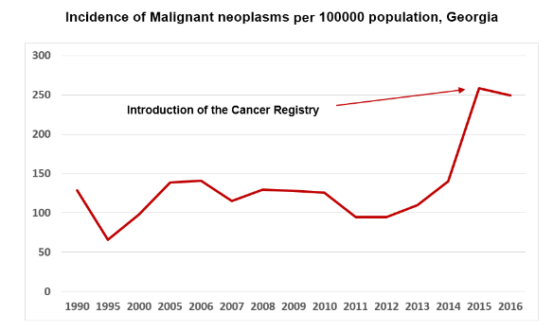
In 2016, a similar case-based electronic reporting system for primary health care institutions was implemented throughout the country. The system also created a basis for a detailed data analysis (by gender, age, diagnosis, geographical location, etc.). Statisticians from all outpatient health institutions were trained by Medical Statistics Department staff.

Georgian HIS is shifting from one rooted in regular data collection to one that focuses on better managing chronic disease conditions and improving registration of the overall health status of the population. Helping to fuel this transition is the emergence of new models of data collection - registries.

In 2015, Population-based Cancer Registry, which is an organized system for collecting, storing, analyzing, interpreting and presenting the cancer data, was implemented. The Registry plays a significant role in terms of gathering qualitative data of cancer incidence and prevalence. Using this type of registry is important for cancer control programs’ assessment, for the defining and planning priority interventions, for cancer screening and for proper implementation other preventive measures, as well as for evaluation of the service effectiveness to determine the oncological patients’ medical care dynamic observation. After the introduction of cancer registry, the registered incidence of malignant neoplasms almost doubled.
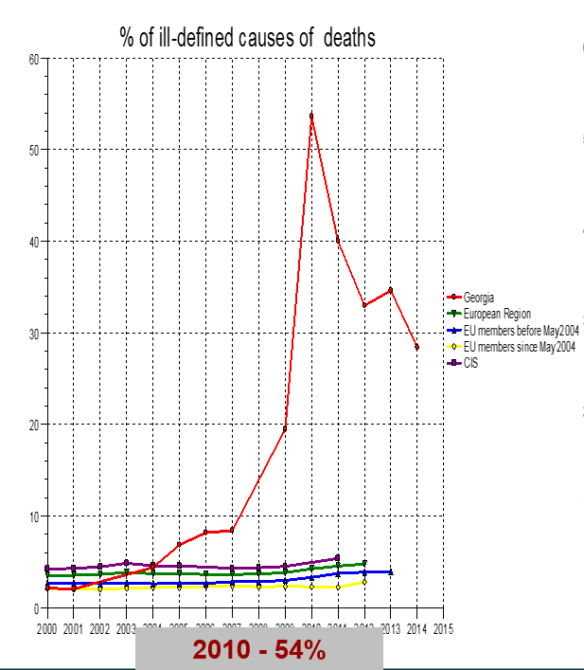
Since Georgia introduced electronic data collection of births and deaths, coverage of the birth and death registration reached more than 95% in recent years. Although the large share of ill-defined causes remains a serious problem. A decision to implement additional efforts to determine the underline cause of death was made to improve the situation. District public health centers were involved in the process and their staff was trained in implementing verbal autopsy technology. As a result, the share of ill-defined causes significantly reduced.

Introduction of electronic system for antenatal and obstetric services, so called “Georgian Birth Registry”, which provides continuous monitoring of pregnant women from the first antenatal visit until childbirth in 2016, was an important step forward. The system also registers data about the newborn’s health at birth.
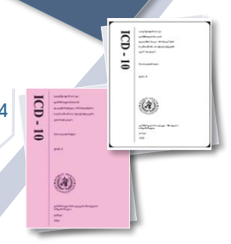
A rapid development of the health information system in the country was supported by the World Health Organization, which plays an important role in this process. An important milestone of the collaboration was the implementation of the 10th Revision of the International Statistical Classification of Diseases and Related Health Problems throughout the whole country. A lot of cascade trainings for different target groups have been conducted to study the morbidity and mortality registration. The trainers’ potential has been developed at regional level. In addition, all materials are translated into Georgian language. NCDC translates published volumes of ICD-10 with updates and lists of changes.

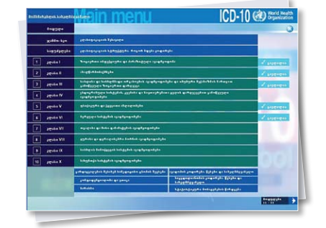
Georgia was the first country in the European region, having translated The World Health Organization’s Web-based interactive training package for coding morbidity and mortality. In 2011-2012, it was translated into Georgian language and was uploaded on the Center’s web-site:
http://apps.who.int/classifications/apps/icd/icd10training/.

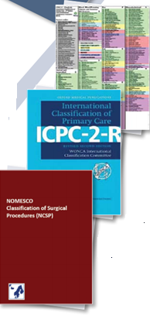
Implementation of the unique classifications of health interventions and services was an important step for reinforcing the data standardization in Georgia. Classifications of outpatient and in-patient interventions, suitable for Georgia, have been chosen for adequately managing and registration of a great volume of data: NOMESCO Classification of Surgical Procedures (NCSP) for in-patient, and the International Classification of Primary Care (ICPC) for outpatient care. The classifications have been implemented since 2011. Classifications are available on-line:
http://classifications.moh.gov.ge/Classifications/Pages/ViewICD10.aspx.

In 2013, a capacity building process in ICD10 implementation started. Trainings of trainers (ToT) and following trainings of Public health (PH) specialists in proper use of ICD10 were conducted countrywide.
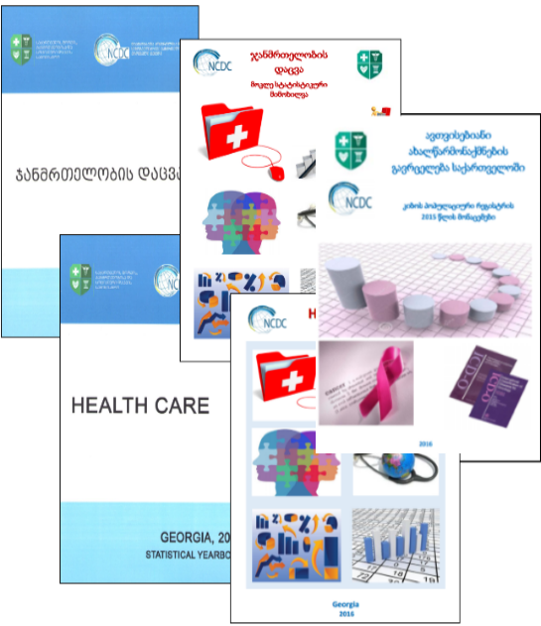
Data popularization and presentation are among the main goals of the Medical Statistics Department of NCDC. In 1996, the first statistical yearbook “Health Care in Georgia” was published. Since that time, this has been the annual publication. The statistical yearbook “Health Care in Georgia” represents the edition comprising the basic statistical indicators related to public health and health care resources of the country. The indicators provided by the yearbooks are calculated using the WHO recommended methodologies. The latter makes possible to compare the respective data from Georgia to the data from other parts of the world. Since 2012, an edition named “Highlights of health care” has been published annually. The edition is a shorter version of the statistical yearbook prepared faster and published earlier than the main publication.

Since 2008, statistical publications have been available on-line: http://ncdc.ge/en-US/Statistics/DiseaseStatistics.

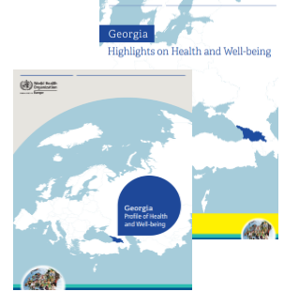
Recent Key Achievements
Collaboration with the WHO continues to be the most fruitful and beneficial for the country. In 2017, “Georgia, Profile of health and well-being” and shorter version “Georgia, Highlights on health and well-being” were developed in collaboration with the WHO Regional Office for Europe. These publications give an overview of a country’s health status, describing data on mortality, morbidity and exposure to key risk factors along with trends over time. Georgia was one of the first among the Member States to develop these publications. The data in the report are drawn from the European Health for All database of the WHO Regional Office for Europe.
In 2017, birth and death registration electronic system was transferred under the NCDC supervision. After migration of the birth and death registration electronic modules to the NCDC, further measures to improve the data quality are taken. In 2017, capacity building process of improvement of identification of causes of death using Verbal Autopsy was continued. The district public health centers (63 PHC) are involved in the implementation of verbal autopsy and medical records revision. All involved staff was provided with trainings and appropriate instructions and materials.
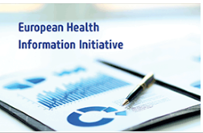
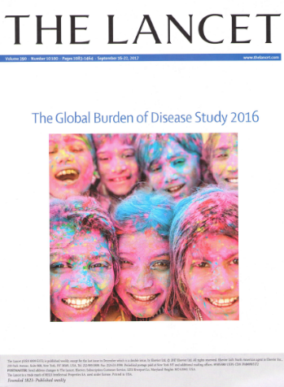
International collaboration is essential for getting good statistics. Institute for Health Metrics and Evaluation (IHME) is a global research center at the University of Washington that provides independent, rigorous, and comparable measurement of the world’s most important health problems and evaluates the strategies used to address them. IHME and the NCDC aim at improving estimates of the burden of diseases, injuries, and risk factors for Georgia, using methods consistent to the overall Global Burden of Disease Study (GBD), administered by IHME. For this to happen, the two institutions collaborate to share data, knowledge, and expertise. The collaboration produces estimates on the burden of diseases, injuries, and risk factors at the national and sub-national level. During 2015-2016, in six articles published in the Lancet the NCDC medical statistics staff has been a co-author.
Georgia is a member of the European Health Information Initiative (EHII), which is a WHO network committed to improving the information that underpins health policies. It fosters international cooperation to support the exchange of expertise, build capacity and harmonize processes in data collection and reporting. The NCDC staff actively participates in conduction of regular steering committees.
Challenges and Future Steps

Future development of the Health Information System (HIS) includes:
- Full electronic data collection (including cancer registry, and annual forms).
- Development and implementation of new registries.
- Implementation of a new system for supervision of under-5 children.
- Regular updating of implemented medical classifications.
- Introducing of modern analytical tools and data presentation methods.
- Data Quality improvement.
- Strengthening Human Resources.
- Continuous education of the involved health personnel.

For further development of the HIS all types of assistance (financial, technical, and methodological) is needed. For effective monitoring and quality evaluation of the implemented modules and registries is recommended to conduct surveys. For this a participation of international experts is necessary to implement a standard technology, data collection tools, and for representative sampling. Results of such surveys will give internationally recognized estimates of incidence and prevalence of diseases, specific groups of mortality (maternal, child, neonatal, etc.), and real distribution of causes of death (mortality structure).
________________________________________________________________________________________
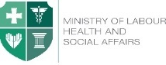  Ministry of Labour, Health and Social Affairs of Georgia  144, A. Tsereteli avenue. Tbilisi, Georgia, 0119  www.moh.gov.ge | 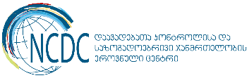  National Center for Disease Control and Public Health  9, M. Asatiani street. Tbilisi, Georgia, 0177  www.ncdc.ge

