Tuberculosis
Hewlett-Packard Company | [Pick the date] | [Edition 1, Volume 1]

TB epidemic status

Georgia has achieved remarkable progress in fight against Tuberculosis. During the last several years TB case notification has been decreasing on average by 9% annually and based on a robust and sustainable surveillance system, this trend seems to reflect a genuine reduction in incidence. According to the NTP notifications data, a total of 3,332 TB cases, all forms, were registered in the country in 2016 (including penitentiary sector), or 89.6 per 100,000 population; out of these, 2,465 were new cases (66.3 per 100,000).

Notified TB Cases (2005-2016)
DR-TB prevalence in Georgia (2005-2016)
From 2016 Georgia is not listed among the high MDR TB burden countries; however, according to the WHO Euro surveillance report (2017) the estimated number of all forms of incident cases in 2015 amounted to 99 per 100,000 population, which is the top third estimated incidence in the WHO European Region, exceeding European average almost three times and thus, Georgia is considered a high-priority country.

National efforts towards reaching End TB Strategy goals

Main Challenges

Significant share of multi-drug resistant (MDR) TB and high loss to follow up rate are the key challenges for the national TB program and the main obstacle for effective TB control in the country. As a response to these challenges, the country elaborated and has started implementation a national strategy to stop the spread of TB in Georgia and reduce the burden of MDR and especially extensively drug resistant (XDR) TB. The strategy covers a comprehensive spectrum of interventions including updating TB management guidelines and offering individual treatment adherence support package.

The country met MDG 6c and the Stop TB Partnership 2015 targets of reducing the prevalence and mortality rates of TB by 50% compared to 1990 and demonstrated commitment to achieve the milestone of further reducing TB incidence as part of the End TB strategy.

4000
3611
Notified
Enrolled in treatment
90%
89%
Successfully treated
2862
89%
3200
Estimated TB Cases
TB Care Cascade in Georgia (2015)

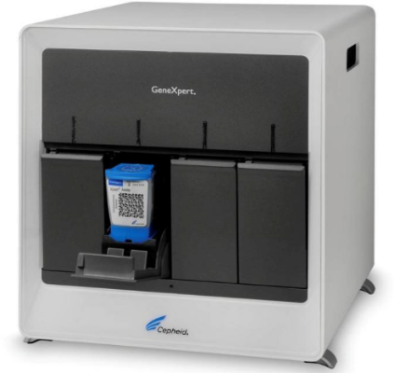
- The country introduced modern diagnostic methods approved by the WHO: culture on solid and liquid media, GeneXpert MTB/RIF systems for rapid diagnosis of TB and MDR-TB.
- FAST strategy was successfully piloted and rolled out to promote early detection and prevent disease transmission in general healthcare facilities.
- Georgia was one of the first countries to ensure programmatic use of the new TB drugs.
- Diverse approaches are used to strengthen PHC provider engagement in TB control countrywide.

Expanding the scope and reach of interventions with a focus on high-impact, integrated and patient-centered approaches.

GeneXpert Machine

- National TB program in Georgia represents a model public-private collaboration enabling universal access to TB care and leading to improved case detection and treatment success rates.
- National Strategic Plan for Tuberculosis Control in Georgia 2016-2020 and Transition Plan developed through multilateral dialogue are endorsed by the government.
- NCDC as a Principal Recipient of GF grants and implementer of state TB program has established an integrated supply chain management system to make use of global supply mechanisms through Global Drug Facility and ensure efficient delivery of quality drugs and consumables.
- Within the frames of TB EECA project on strengthening health systems for TB control (TB-Rep) Georgia has established strong collaboration with international partners and local stakeholders to ensure TB program effectiveness and sustainability.
Eliciting full benefits of health and development policies and systems through engaging a much wider set of collaborators across government, communities and the private sector.


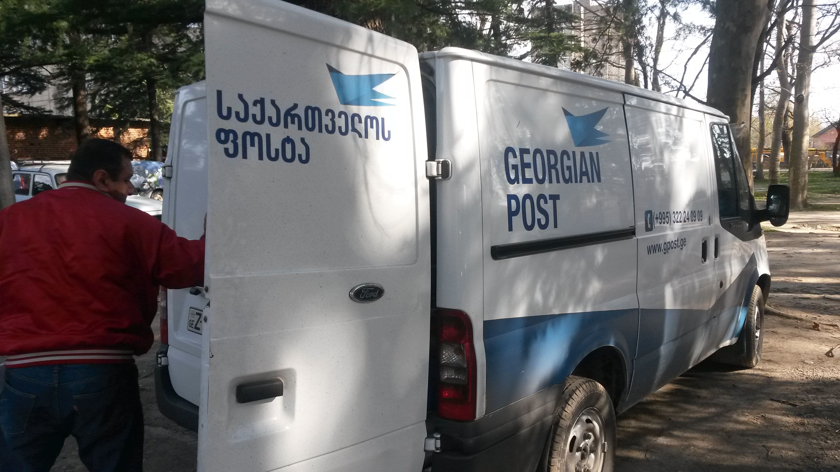
Sputum Sample Transportation through Georgian Post
Video Observed Treatment
Pursuing new scientific knowledge and innovations that can dramatically change TB prevention and care.
- Georgia has been part of multi-central research projects such as: FIND, EXPAND TB, STREAM, STAND, END-TB, Nix-TB.
- Innovative technologies: real-time and reliable eHealth module, tablet-based software for surveillance and patient education, and mobile based application for Video Observed Therapy, novel approaches to transportation, procurement and supply chain management and civil-society engagement have been developed and implemented within NTP.
- The country is piloting integrated HCV-HIV-TB screening, diagnosis and treatment approach to enable comprehensive care delivery at PHC level and promote health outcomes.
- Results Based Financing model is under development.


Mobile Ambulatories

________________________________________________________________________________________
  Ministry of Labour, Health and Social Affairs of Georgia  144, A. Tsereteli avenue. Tbilisi, Georgia, 0119  www.moh.gov.ge | 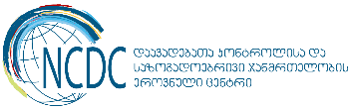  National Center for Disease Control and Public Health  9, M. Asatiani street. Tbilisi, Georgia, 0177  www.ncdc.ge

