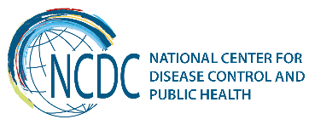

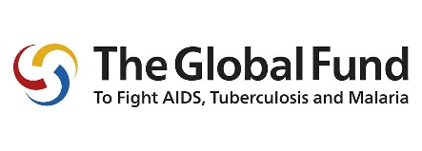
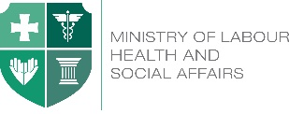

GEORGIA Brief
Global Fund to Fight AIDS, TB and Malaria (GFATM) Programs in Georgia
Georgia is implementing GFTAM supported programs since 2003 when the first request for funding was approved for HIV Program. Since then, the country has received over 119,2 million USD investment support for implementation of HIV, TB and Malaria programs (74.1 million for HIV Program, 41,9 million for TB and 3,5 million for malaria Program). The GFTAM support was instrumental for elimination of malaria (no local case of malaria has been detected since 2010) and for development and implementation of effective HIV and TB responses allowing the country to avoid the wide scale epidemics. Only with GFATM support Georgia was able to start the lifesaving antiretroviral treatment for PLHIV and implement effective anti-TB treatment for both, sensitive and MDR TB patients. By the end October this year 4018 (3317 FL and 701 SL regimens) patients were on ART and more than 20,000 patients received anti TB treatment with the support of the GF.

Components | Signed | Committed | Disbursed
HIV | US$84,351,026 | US$78,187,522 | US$74,066,047
TB | US$50,585,396 | US$46,354,378 | US$41,889,518
Malaria | US$3,500,710 | US$3,500,710 | US$3,500,710
TOTAL | US$138,437,132 | US$128,042,610 | US$119,456,275

Programmatic Achievements
Since 2005 the universal access to ART is guaranteed for all PLHIV living in Georgia including patients living in Abkhazia (conflict zone). The Georgian ART Program is recognised as one of the best in EECA region due to high coverage, good retention data and high quality of the services provided to PLHIV countrywide. Georgia has moved to implementation of the WHO Treat All strategy as early as in December, 2015 offering ART to all registered PLHIV despite their CD4 count.
Georgia was one of the first also to start OST program in the region in 2005, including two long term methadone detoxification programs in prisons.
With GFATM support the country was able to largely scale up the Needle and Syringe Program coverage through operation of 14 drop-in Centres and 8 mobile ambulatories covering up to 55 cities of Georgia. FSWs and MSM have access to HIV prevention and HCT services in 5 the most affected cities of the country through intensive outreach work and community resource centers. Also, from September 2017 Georgia the first in the region has started a pilot PrEP among MSM community with a plan to expand the program geographically and involve other KAPs in the future.
The main challenge of the HIV Program is low HIV case detection rate and the late diagnosis of PLHIV which needs acceleration of HCT services among KAPs that is largely supported through the GFATM HIV Program.

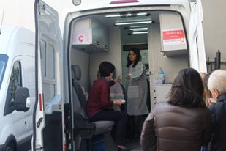

The Georgian national TB program has achieved remarkable successes in the uptake and implementation of contemporary international strategies and guidance in TB control. Visible improvements have been documented during the recent years in relation to TB burden, proven by the decreasing number of TB cases and TB rates. The universal access is ensured to diagnosis and treatment of all forms of TB, including M/XDR-TB. The use of novel rapid diagnostic methods for TB and DR-TB, as well as that of newly developed drugs is being scaled up. As of July, 2017, overall 370 patients were enrolled in New Treatment Regimens, in parallel active drug safety monitoring system was introduced. In order to improve geographical access for out-patient treatment the Video Observed Therapy (VOT) pilot program was initiated in the capital city.

Georgia is one of the countries supported by the Tuberculosis Regional Eastern Europe and Central Asia Project (TB-REP) that aims the strengthening health systems for effective tuberculosis and drug-resistant tuberculosis control. Georgia supports the framework articulated in the blueprint, “a people-centered model of TB care” developed by the TB-REP project.

The hepatitis C elimination program has created a unique momentum for scale up of detection of HIV, HCV and TB cases in Georgia. This year with GFATM support Georgia has started a novel pilot project in one of the regions of Georgia (Samegrelo-Zemo Svaneti) to test the potential integration of HIV, TB and HCV screening services at the regional level with the increasing role of primary care (ambulatory centers and family doctors) in the detection and management of all three diseases under the “one umbrella”. The regional steering committee will advocate and lead the implementation of the program with support of the MoLHSA of Georgia, NCDC and National TB and AIDS Centers. Based on the results coming from the pilot project, later the program might be expanded to other regions of the country.
Within the GFATM TB program Georgia is starting implementation of Zero TB Initiative in Adjara region of Georgia. This initiative is by the Stop TB partnership and the purpose of the initiative is to create ‘islands of elimination’ that will contribute to lowering rates of TB through supporting a coalition of the local government, businesses, and civil society. The specific objectives of the project in Adjara region are: to strengthen TB case detection / ‘finding the missing TB cases’; Improve patient outcomes through comprehensive TB case management and addressing the special needs of mobile populations through cross-border activities.
Sustainability of the GF grant programs in Georgia
Since 2016 Georgia is implementing the New Funding Model grants (18,4 million USD for HIV and 11,9 million for TB) for which the Government has fully met the co-funding requirements. For both the HIV and TB programs the Government’s share of funding for the last three years has exceed 60% of the total funding for the Programs.

For the next funding period the Country is eligible for 15.8 million additional funding, which is twice less than the current Grants amounts. The country aims to submit the continuation funding requests for both programs during August’s window of 2018 to cover the programs needs till end of 2022.
The Georgian Sustainability and Transition Plan (STP) was developed for the period of 2017-2019 that addresses the immediate and short-term key challenges of the transitioning of the GFATM programs.
As GF support to Georgia is decreasing considerably (by 50%) for the next three year funding cycle the Government of Georgia needs to mobilize substantial additional internal resources in health care for scaling up of programs in response to the growing epidemics.
Starting from 2015 the Government of Georgia is paying for the first line ARV and anti- TB medicines. This year 25% of Second Line medicines will be procured with the State Funds as well. From July 2017 the OST Program was fully transitioned to the state funding, and not only that, but the state has abolished the co-payment scheme for OST Program and all PWIDs enrolled have now free of charge access to methadone treatment.
During the coming two years the country will increasingly take responsibility of procurement of diagnostic test-systems, including the viral load and CD4 testing. It is expected that a substantial portion of the products needed for the universal coverage of the diagnosis and treatment of TB in Georgia will be covered through the state funds by 2019. It worth mentioning that procurement of first and second line drugs through the state funds is done using the Pooled Procurement Mechanism of the GFATM and GDF, ensuring the same high quality products from both, the GFATM and the State funding channels.
Sustainability of HIV prevention programs remains especially critical. The State will need to start investing in HIV prevention programs from 2020. With support of the GFATM, EHRN and UNFPA initial step for preparation of the transition was made with development of the National NSP, OST standards as well as prevention intervention standards for FSWs and MSM with relevant costing that will allow the Government to make an informed decision regarding the funding of the particular components of the HIV Prevention Programs.
The success of the STP implementation will largely depend of the external TA that the Country will be able to mobilize. With this regard the support of WHO and other technical partners will be critical for development of relevant strategic documents and testing the novel interventions recommended by the international technical advisory groups.
_________________________________________________________________________________
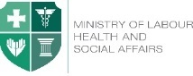  Ministry of Labour, Health and Social Affairs of Georgia  144, A. Tsereteli avenue. Tbilisi, Georgia, 0119  www.moh.gov.ge | 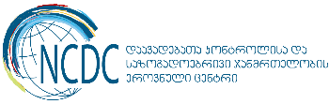  National Center for Disease Control and Public Health  9, M. Asatiani street. Tbilisi, Georgia, 0177  www.ncdc.ge

