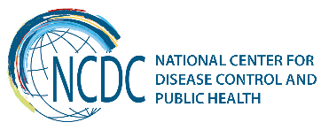
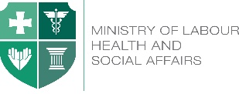

GEORGIA Brief
Tobacco Control in Georgia
Georgia is a party to the WHO Framework Convention on Tobacco Control since 2006 and, thus, is committed to implement comprehensive tobacco control measures, including some of the time-bound WHO FCTC articles, the implementation deadline of which has been already breached.

Tobacco control is an important aspect for Georgia’s EU integration process. One of the obligations under the EU Association Agreement signed in 2014, is effective implementation of the international agreements in the field of health, that are recognized by the parties, namely, the International Health Regulations and the WHO FCTC.
Georgia has one of the highest smoking prevalence among the countries of World Health Organization European Region. According to the STEPS 2010 and 2016 results smoking prevalence has increasing trend; 33% of Georgian adult population are current smokers; among them about 57% are men and 7% are women. According to the urine cotinine test the real prevalence of female smoking in Georgia is 12.2%.

*results of cotinine testing; STEPS 2017
There are approximately 1.1 million tobacco users of whom about 40% want to stop. Cigarette smoking is almost the exclusive form of smoking tobacco; use of smokeless tobacco is very low and does not have any significant public health impact at the moment.
According to the Global Youth Tobacco Surveys (GYTS 2014-2017) smoking prevalence is also increasing among 13-15 year olds; GYTS 2017 shows that 12% of 13-15 years teenagers consume tobacco (17% boys, 8% girls), in 60% of smokers tried to stop last year.
TOBACCO USE
- 15.4% of students, 20.6% of boys, and 9.6% of girls currently used any tobacco products.
- 12.6% of students, 16.9% of boys, and 7.6% of girls currently smoked tobacco.
- 8.4% of students, 12.3% of boys, and 4.4% of girls currently smoked cigarettes.
- 4.4% of students, 5.0% of boys, and 3.2% of girls currently used smokeless tobacco.

SECONDHAND SMOKE
- 43.2% of students were exposed to tobacco smoke at home.
- 58.6% of students were exposed to tobacco smoke inside enclosed public places.
ELECTRONIC CIGARETTES
- 13.2% of students, 17.3% of boys, and 7.7% of girls currently used electronic cigarettes.

European School Survey Project on Alcohol and Other Drugs (ESPAD) survey conducted in 16 years old adolescents showed higher figures of current smoking (26% in boys, 9% in girls, 18% overall.)

Cigarette smoking alone kills 8000 to 11 000 (22% of all death cases) people per year in Georgia, and is a leading cause of cardiovascular disease, cancer and respiratory disease.

Key Achievements
In 2013 in order to address the devastating health and economic burden of the growing tobacco epidemic in the country, the Government of Georgia created the State Tobacco Control Committee. The Committee is chaired by the Prime Minister of Georgia. The goal of the Committee was to develop and advocate new tobacco control policies, which is in line with the World Health Organization (WHO) Framework Convention on Tobacco Control (FCTC) and with the standards of the European Union. As a result of the work of the Committee National Tobacco Control National Strategy Committee (Government Decree #196, 2013), a 5 year Action Plan (Government Decree #304, 2013) and amendments to 5 related laws in March 2013 were prepared and approved by the Government of Georgia.
Georgia has undergone the WHO FCTC Joint Needs Assessment Mission in 2013. As a result, the comprehensive set of recommendations was produced. The latter was followed with post-needs assessment assistance provided to the country based on the immediate needs.
On May 30, 2017 the amendments to the Tobacco Control bills have been adopted by the Parliament and signed by the President of Georgia. Amendments were made in the following laws of Georgia: "On Tobacco Control", "On Advertising", "On Organizing Lotteries, Games of Chance and Other Prize Games", "On Broadcasting" and in the Administrative Offenses Code of Georgia.
Important issues of tobacco control regulations
- Ban of smoking (including e-cigarettes and hookah) in all public transport and buildings, except of private homes, prisons, casinos and taxis. Ban of smoking on open areas of educational, health facilities and mass activities of youth. Violation is not only smoking but also presence of smoke, butt, ashes and hookah within building. Ban of smoking in enclosed public places enters into force from May 2018
- Ban of all forms of advertisement, sponsorship and promotion of tobacco, its accessories and devices for its use, including ban of display at points of sales and restriction of demonstration of smoking in movies and massive performances. Part of regulations enters into force from May 2018
- Increasing size of health warnings to 65% and obligatory pictorial warnings on front side of the packages of smoking tobacco
- Introducing standardized cigarette packaging (plain packaging). Enters into force from January 2022
- Ban of direct or indirect participation of industry in decision making on health issues
- Ban of "drive tobacco"
- Updated model of administration of the law - burden of responsibility for smoking ban on organizations and its owners, increasing amount of fines for violations, no court decision needed

The National Center for Disease Control and Public Health (NCDC) is implementing the State Program on Health Promotion, the largest component of which is tobacco control, including media campaign, training of Quitline staff and PHC providers, monitoring of enforcement of smoke-free legislation in public premises, developing a tobacco cessation mobile application and school educational materials. In order to meet all the objectives of the tobacco control component, of the state program needs to be increased according to National Action Plan.
With the support of the WHO FCTC Secretariat and the International Union against Tuberculosis and Lung Diseases (The Union), Georgia initiated training of PHC staff in handling brief tobacco cessation interventions in-line with the WHO methodologies. The said effort was further supported by the WHO European Regional Office and these trainings are now expanded throughout the country. NCDC is a main partner of Georgian Respiratory Association who is implementing a Pfizer Independent Grants Project to fully address implementation gap of the article 14 of the WHO FCTC.
With the support of the Union and within the scope of the Bloomberg Philanthropies Grant the NCDC in close collaboration with the Ministry of Finance implemented a project targeting at development of a supportive environment for a tobacco tax increase in the country; and the comprehensive, country-specific and evidence based tobacco products taxation policy document was elaborated and shared with all interested stakeholders to reach consensus on adoption of policy document.
The project “Supporting endorsement and enforcement of strengthened legislation on tobacco demand reduction in Georgia in order to meet WHO FCTC requirements” aims to focus its efforts on continuing collaboration with decision makers to facilitate and enhance implementation of WHO FCTC articles.
With the support of the Union, North America ‘Tobacco Victims’ Media Campaign” was implemented including production and placement of Public Service Announcements (PSAs) and outdoor posters.
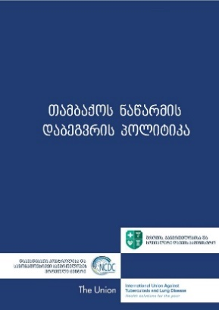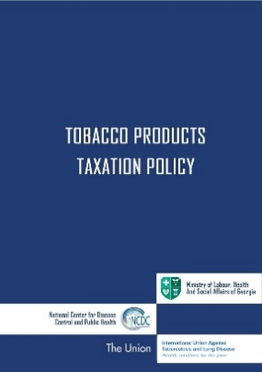
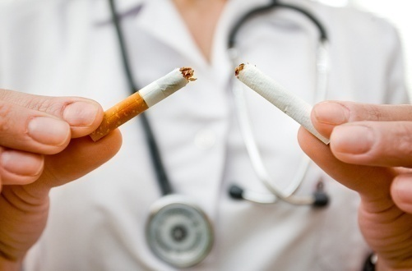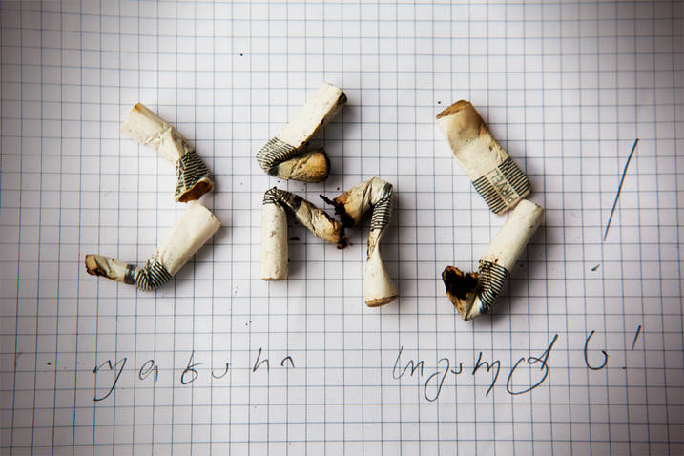
Georgia has been selected as a FCTC2030 project Partner Party among other 14 countries. This project is a new initiative of the WHO FCTC Secretariat to directly help countries to scale up tobacco control measures. Georgia is the only country being selected from the European region. One of the selection criteria was the motivation of the country to advance tobacco control and demonstration of some significant achievements in this regard.
Challenges
Despite the efforts of strives of the Georgian Government to combat the wide-spread tobacco epidemics in the country, almost one third of adult population in Georgia are active smokers and tobacco industry interference in law implementation remains a big challenge.
Given this situation, some of the vitally important tobacco control policies are being prioritized among which are:
- Implementation of FCTC Article 5 obligations
- Strengthening implementation of timebound articles of the WHO FCTC
  - Total ban of smoking in all enclosed public/work places and specific outdoor areas designated for youth and hazardous materials
  - Total ban of tobacco advertisement, sponsorship and promotion
  - At least 65% of pictorial health warnings on the surface of tobacco packages
- Strengthening tobacco control law enforcement/administration
- Strengthening of tobacco taxation
Abovementioned tobacco control measures will contribute to full implementation of the WHO Framework Convention on Tobacco Control, thus also advancing the achievement of SDG targets related to tobacco control. There are opportunities for Georgia such as the High level political commitment, National focal point of tobacco control within MoLHSA, high level public support, active CSOs and strong legislative measures. However, the findings of the needs assessment for the implementation of WHO FCTC in Georgia indicate that the tobacco control activities need to be further strengthened and existing Tobacco Control National Strategy and Action Plan need to be properly revised and implemented.

_______________________________________________________________________________________
  Ministry of Labour, Health and Social Affairs of Georgia  144, A. Tsereteli avenue. Tbilisi, Georgia, 0119  www.moh.gov.ge | 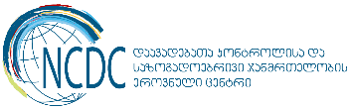  National Center for Disease Control and Public Health  9, M. Asatiani street. Tbilisi, Georgia, 0177  www.ncdc.ge

