Good Practices on
Implementation of the Action Plan for the Health Sector Response to HIV in the WHO European Region
Submission Form
Dear Colleague,
Thank you for your active involvement in adopting and initiating implementation of the Action plan for the health sector response to HIV in the WHO European Region. (http://www.euro.who.int/__data/assets/pdf_file/0010/315649/66wd09e_HIVActionPlan_160560.pdf )
WHO Regional Office for Europe is soliciting its Member States, partners and communities to share their good practices with the purpose of building a Compendium of Good Practices of HIV interventions in our Region. The Compendium would be shared at the 22nd International AIDS Conference in Amsterdam, 23-27 July 2018. The practices need to be submitted through the below form. A multi-stakeholder selection committee will review and evaluate submissions against the following criteria: relevance, sustainability, efficiency, and ethical appropriateness, plus any one or more of the additional criteria detailed in Annex 1 below.
Please answer the following questions as in detail as possible, and send the form to the WHO Regional Office for Europe at eurohiv@who.int; with a copy to our Technical Officers Dr Elena Vovc at vovce@who.int, Ms Annemarie Stengaard bollerupa@who.int and our consultant Ms Vittoria Gemelli gemelliv@who.int .
The deadline for submission is 28 February 2018. If you have any questions please do not hesitate and contact us.
- Contact details for further communication:

Name of the submitting author Tengiz Tsertsvadze
Country Georgia
Organization Infectious Diseases, AIDS and Clinical Immunology Research Center
E-mail tengizt@gol.ge
Phone (995 32) 2399922

- What area(s) of the Action Plan for the Health Sector Response to HIV does the practice address?

Information for focused action

☒Strengthening the collection and analysis of high–quality granular data on the HIV response (e.g. data disaggregated by sex, age, population, location etc.)
☐Strengthening strategic information on key populations
☐Implementing linked/ integrated HIV strategic information systems with broader health information systems, including those focusing on coinfections/comorbidities (TB)
☐Expanding cross-border sharing of information to ensure service continuity for migrants and mobile populations
☐Implementing ARV drug resistance surveillance and/or monitoring of early warning indicators
☐Other areas related to HIV surveillance or HIV strategic information including but not limited to: using unique patient identifiers for person-centered HIV patient monitoring and case surveillance.

Interventions for impact

☐Implementing needle and syringe exchange programmes
☐Implementing opioid substitution therapy programmes
☐Implementing pre-exposure prophylaxis (PrEP) for populations at substantial risk of HIV
☐Improving male and/or female condom lubricant programmes, sexuality education and behaviour change communication
☐Improving prevention of mother to child transmission of HIV and syphilis
☐Implementing early infant diagnosis of HIV and immediate HIV treatment
☐Scaling up HIV testing of key populations
☐Implementing rapid HIV testing
☐Implementing HIV self-testing
☐Simplifying the national HIV testing algorithm
☐Introducing HIV testing in facilities for TB, STI’s, drug dependency, emergency departments, in closed settings etc.
☐Providing HIV testing through community/outreach services and/or by trained lay providers
☐Increasing linkage from HIV testing to treatment and/or increasing retention in care
☒Scaling up ART coverage and implementing the ’treat all’ approach
☐Improving viral load monitoring of treatment outcomes
☐Other interventions for impact, including but not limited to: Improving blood safety programmes; implementing assisted partner notification; innovative HIV testing and laboratory services transitioning to new ARV drugs in HIV programmes; providing psychological and social support to PLHIV; quality of life interventions for PLHIV.
Delivering for equity
☐Delivering HIV services under a model of universal health coverage framework
☒Implementing people-centred, integrated care by linking health services (e.g. HIV services integrated with TB and/or drug dependency/OST programmes or SRH or viral hepatitis or other diseases or a combination)
☐Implementing services for key populations, incl. providing services outside the formal health system
☐Implementing differentiated care models
☐Implementing policy changes and/or legislation changes related to HIV
☐Including civil society in the implementation and coordination of the national HIV programme
☐Other interventions that promotes equity in the delivery of services, including but not limited to: Decentralising ART provision/refill; decreasing stigma and discrimination of key populations, incl. PLHIV; providing HIV services in prisons/penitentiary system; implementing quality improvement and quality assurance programmes.

Financing for sustainability
☐Reducing financial barriers and eliminating out-of-pocket expenses for the individual
☐Health systems strengthening, including well-aligned financing mechanisms and human resources (incl. task shifting)
☐Increasing cost-effectiveness of HIV service delivery models
☐Procurement of affordable HIV medicines and diagnostics, incl. collective international and regional procurement
☐Amendments of pricing policies and/or leverage cost reductions through TRIPS etc.
☐Transition models from external funding of the HIV response to increased domestic funding
☐Other interventions aimed at increasing financial sustainability, including but not limited to: monitoring of health expenses; effective advocacy for sustained financing; adopting the WHO Health Accounts Country Platform Approach.

Innovation for acceleration
☐Innovative HIV service delivery models that effectively reaches key populations
☐Innovative partnerships and models of collaboration in the HIV response
☐Innovative technology in the HIV response
☐Innovative financing in the HIV response
☐Research to optimize implementation and impact, and promote innovation
☐Other innovative interventions

- When was the practice implemented? (month/year)

Start date 09 / 2015

End date (if any) /

- Is the practice financially supported by an international partner?
No
Yes (please, list) The Global Fund to Fight AIDS, Tuberculosis and Malaria

- Please describe the good practice in your country/project as in detail as possible according to the following structure (minimum word count is 500 and maximum - 2000 words).
Title
Progress towards ART and viral suppression targets through implementing treat all policy in the country of Georgia
Names and affiliations of all contributing authors
Tengiz Tsertsvadze, Infectious Diseases, AIDS and Clinical Immunology Research Center
Nikoloz Chkhartishvili, Infectious Diseases, AIDS and Clinical Immunology Research Center
Akaki Abutidze, Infectious Diseases, AIDS and Clinical Immunology Research Center
Otar Chokoshvili, Infectious Diseases, AIDS and Clinical Immunology Research Center
Lali Sharvadze, Infectious Diseases, AIDS and Clinical Immunology Research Center
Pati Gabunia, Infectious Diseases, AIDS and Clinical Immunology Research Center
Background (e.g. epidemiological information) and description of the specific problem/situation/key population related to HIV in your country/project that the good practice addresses

The first case of HIV infection in Georgia was diagnosed in 1989. By the end of 2017, a total of 5090 persons were diagnosed and living in the country. Similar to other Eastern European countries, the HIV epidemic in Georgia for many years was driven by injection drug use (IDU), accounting for around 60% of new diagnosis annually. However, recent trends indicate decrease in the proportion of IDU-related cases with respective increase in sexually acquired infections both through heterosexual contact and sex between men. Currently heterosexual contact accounts for 48% of diagnosed infections, followed by IDU - 36%, and sex between men – 13% of all reported cases. Notably, there was 5-fold increase in new diagnosis among men who have sex with men (MSM) between 2010 and 2017. Bio-behavioral surveys conducted during the same period show that HIV prevalence is maintained below 5% among people who inject drugs (PWID), and has increased to 21% among MSM (Country reports for Global AIDS Monitoring, data available from http://aidsinfo.unaids.org/).

Antiretroviral therapy (ART) in Georgia was introduced in 1990s, but with very limited access. Since 2004, through the support from the Global Fund to Fight AIDS, Tuberculosis and Malaria, Georgia ensures universal access to ART in accordance with existing guidelines, translating into dramatic decline in AIDS related mortality. Annual Global AIDS Monitoring (GAM) reports show that over the last decade Georgia has the highest ART coverage in the Eastern Europe and Central Asia.
Description of the good practice in HIV intervention (what was implemented and how?)

Georgia has made remarkable progress in HIV treatment and care. The National AIDS Treatment program became operational in 1995, which was substantially strengthened after arrival of the Global Fund support in 2004. The Georgian model of service delivery builds on principles of equity and human rights towards ensuring universal access to HIV treatment and care for all.

Georgia has been moving toward earlier ART initiation in line with WHO recommendations, introducing CD4 <350 cells/mm³ criteria in 2011, followed by CD4 <500 cells/mm³ in 2013 and Treat All in September 2015. The country had been preparing for Treat All policy for several years, initially inspired by results of landmark treatment as prevention trial (HPTN 052, Cohen MS, et al. N Engl J Med 2011;365:493-505), and further supported by evidence from TEMPRANO and START trials (The TEMPRANO ANRS 12136 Study Group. N Engl J Med 2015;373:808-822; The INSIGHT START Study Group. N Engl J Med. 2015;373:795-807). The early-release guideline on when to start ART published by WHO in September 2015 gave the green light for the country to remove all limitations for ART eligibility and recommend lifesaving therapy to all persons living with HIV in Georgia regardless of CD4 cell count. The new recommendations were rapidly disseminated and by the end of 2015 the new policy was in place countrywide.

With the implementation of Treat All policy, Georgia continued to maintain public health approach to ART. Standard first line regimens are provided and viral load is prioritized for treatment monitoring.
If the good practice engaged more than one of the specified areas of Action plan for the health sector response to HIV in the WHO European (listed in Annex 1). Please, explain what benefit the practice has brought about

In 2011 Georgia launched National AIDS Health Information System (AIDS HIS), which is secure web-based system connecting all HIV care providers in the country. The system ensures real-time collection of case-based information, which includes detailed demographic, epidemiological, clinical and laboratory data. Each person is identified using unique national ID numbers in the system and this effectively prevents duplications. This unique system incorporates both surveillance and clinical information, allowing for high-quality analysis of granular data to inform both public health action and clinical practice.

Equitable access to ART has been prioritized since the scale up of ART in country in 2004. All persons receive quality care regardless of risk behavior, gender or ethnicity. Moreover, special efforts are made to ensure greater engagement of key populations, such as PWID. There is strong linkages with addiction services providing free harm reduction services to all eligible HIV positive persons, including opioid substation treatment.

Strong collaboration between HIV and tuberculosis services ensures effective management of TB/HIV co-infected patients, with Georgia showing highest in the region for ART coverage among person with known TB/HIV status (http://www.who.int/tb/country/data/profiles/en/).

Hepatitis care has been fully integrated in HIV care. All persons are screened for viral hepatitis. HIV/HBV co-infected persons are started on Tenfovir containing regimens. For HIV/HCV co-infected persons free HCV treatment is universally available since 2011. During the period of 2011-2015, the Global Fund supported treatment with pegylated interferon and ribavirin. In 2015 with the support of U.S. CDC and a private pharmaceutical manufacturer, Georgia launched the world’s first hepatitis C elimination, and from that point all HIV/HCV co-infected persons now receive direct acting antivirals for free.

The comprehensive package of care in Georgia also includes support services provided both by healthcare workers and by lay professionals, including community-based organizations. These support services include adherence monitoring and support, psychological counselling and peer-driven interventions.
Evidence of impact/ efficacy (including diagrams, tables, photos and videos)
Expansion of treatment initiation criteria along with provision of comprehensive care package ensures high engagement of HIV positive person in the continuum of HIV clinical services. Presented analysis focused on this right side of cascade that is Georgia’s progress towards reaching ART and viral suppression targets of 90-90-90 strategy. Guidance for Global AIDS Monitoring 2018 (http://www.unaids.org/en/resources/documents/2018/Global-AIDS-Monitoring) was used for indicator definitions.

By the end of 2017, of 5090 HIV positive persons diagnosed and living in Georgia, 4144 (81%) were on ART. This falls short from 90% target, but overall progress is visible and commendable. The number of people on ART in Georgia more than doubled over the last 5-year period from 2013 to 2017, with proportion of diagnosed persons on treatment increasing from 57% to 81% (Figure 1). There was respective increase in the number and proportion of persons with viral suppression, with 71% of the total diagnosed population being virally suppressed in 2017. 90% target of viral suppression was nearly reached among persons on ART – overall 87% (3598/4144) had viral load <1000 at the last measurement in 2017 (Table 1).

Figure 1. HIV care cascade among diagnosed persons in Georgia, 2013-2017

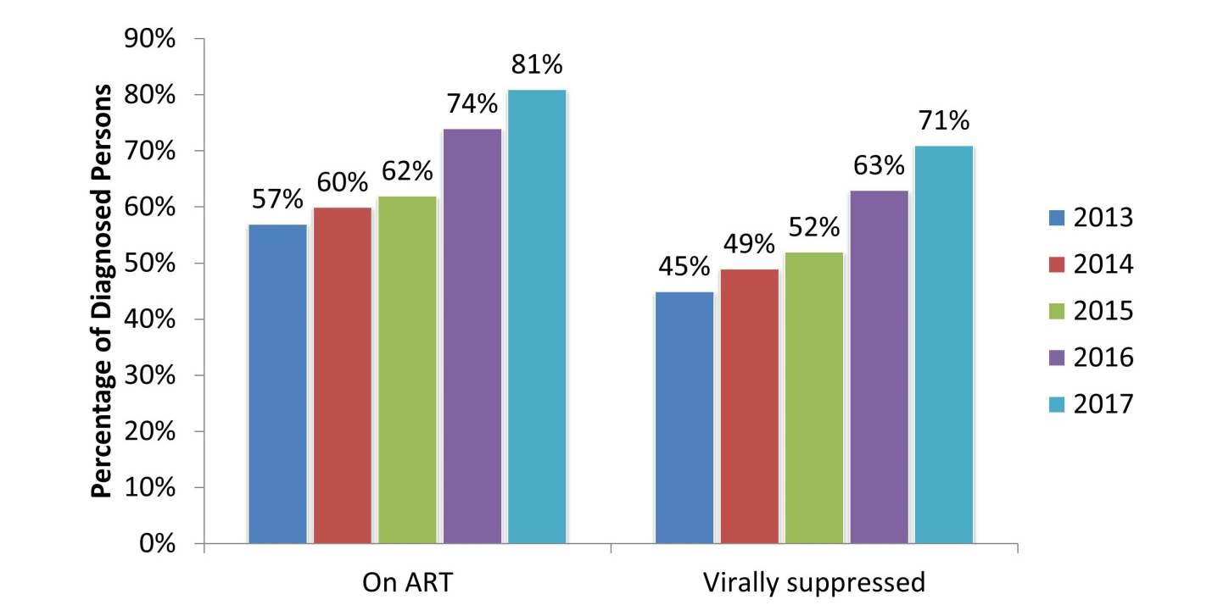

Stratified analysis by transmission category showed that heterosexually infected women already reached 90% target for ART and viral suppression, and this is significant success (Table 1). The lowest ART coverage was seen among MSM, while viral suppression was lowest among PWID (Table 1).

Table 1. Achievement of ART and Viral suppression targets of the 90-90-90

 | % of diagnosed HIV persons, who are on ART | % of persons on ART, who are virally suppressed
All PLHIV | 81% (4144/5090) | 87% (3598/4144)
People who inject drugs | 78% (1435/1843) | 84% (1205/1435)
Men who have sex with men | 75% (479/640) | 88% (422/479)
Heterosexually infected men | 78% (894/1150) | 87% (774/894)
Heterosexually infected women | 92% (1219/1328) | 90% (1102/1219)

Although all persons are offered treatment, not all of them initiate and some of them are lost from care. We conducted additional analysis to explore reasons for loss between diagnosis and treatment initiation. For this purpose we constructed one additional stage in HIV continuum between diagnosis and ART initiation – retention in care, defined as at least one measurement of CD4 cell count or viral load in 2017. This analysis showed that among PWID and heterosexually infected men, loss occurs both between diagnosis and retention and ART initiation. With regard to MSM, 97% are retained in care after diagnosis with major loss occurring between retention and ART initiation. Further analysis revealed that these persons are relatively newly diagnosed with high CD4 cell count, who potentially decline therapy because of perceived well-being.

Two years of implementation of Treat All approach in Georgia shows that achieving 90% targets for ART coverage and viral suppression is feasible. The country has made substantial progress in scaling-up ART and the targets are within sight. 90% ART coverage and viral suppression are already reached among heterosexually infected women and this can be done in other populations as gaps are clearly identified and filled.

Roll-out of ART since 2004 has already resulted in significant decline in AIDS related mortality. Further expansion of treatment is expected to save more lives and improve quality of life. Spectrum projection models suggest that the estimated number of new infections in Georgia have been declining over the last several years coinciding with implementation of earlier ART initiation recommendations.
Figure 2. Estimated number of new HIV infections, ART initiation criteria and number of persons on ART
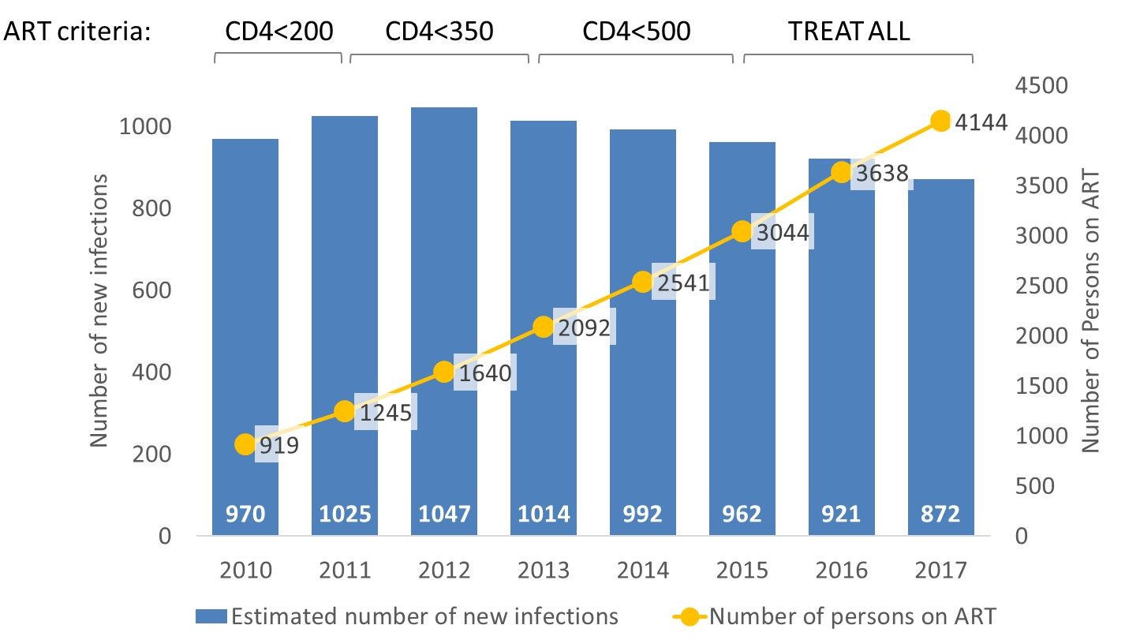

Did the good practice result in any further positive impact beyond what than expected? Please, describe (if any)

Success of the ART program in Georgia stimulated movement to end the epidemic in the country. On December 1, 2017 the national AIDS conference adopted declaration entitled “test all, treat all, end the AIDS epidemic in Georgia”.

While the country is steadily moving to meet the global targets for ART coverage and viral suppression, however achieving target of diagnosing 90% of PLHIV remains serious challenge. Currently only 48% of estimated 10500 persons living with HIV area aware of their status and this significant gap prevents the country from deriving maximum individual and public health benefits of ART. Improvement in HIV diagnosis can place the country on the path to achieving the visionary goal of ending the epidemic.

Sustainability of the practice How will this practice (including policy decisions) be maintained over a long period of time without requiring any massive injection of additional resources?

Georgia’s commitment to universal healthcare coverage to ensure equitable access to basic health services for all people living in the country. In 2013 the Ministry of health launched universal healthcare program, which among others prioritizes response to communicable diseases such as HIV, hepatitis C and tuberculosis. This commitment along with public health approach to ART delivery provide basis for sustainability of presented good practice and its impact.

The national ART program procures WHO prequalified generic drugs, ensuring low-cost of treatment. In 2017 Georgia started procuring generic formulation of a new integrase inhibitor, which along with low cost has other important strengths such as high potency, a high genetic barrier to HIV drug resistance and low toxicity. Given these circumstances, 2018 revision of national guidelines recommends combination of tenofovir/emtricitabine + dolutegravir as preferred first line ART regimen at the price of <120 US dollars per person per year.

Initially supported by the Global Fund, national ART program is now in the process of transitioning to domestic allocations. The Government of Georgia has been strictly fulfilling its obligations through increasing budget of national AIDS programs. The Government already covers 100% costs related to first line drugs and 50% of costs associated with second-line treatment. By 2020 the funding will be fully transitioned to domestic source, covering all aspects of treatment and care. Transition to domestic funding for HIV has been an integral part of national policy towards universal ehalth coverage, Government of Georgia substantially increased public spending on health, which more than doubled between 2012 and 2015 (National Health Accounts 2011-2015), after implementation of universal health program and the national health budget continues to increase annually. AIDS related spending increased from 4.5 million USD to 8.6 million USD over the last several years, with national spending accounting for 70% of total AIDS expenditures.

WHO EURO

Technical Review

Zachary Gavry, Antons Mozalevskis | gavryz@who.int | +45 45 33 71 80

Areas for Improvement:
- Suggestion to remove Gilead as the pharmaceutical company involved in partnership- phrase as pharmaceutical sector so Member States know public-private partnerships are an attractive option;
- Please include more information regarding the transition from international to domestic funding- how exactly has the Government been able to raise the funds and engage national level monetary support? These details will be relevant for other Member States moving forward;
- Mention alignment with relevant WHO guidelines;

Strengths:
- Epidemiological information and data are of high quality;
- Transitioning to domestic funding from international donor, financial and programmatic sustainability;
- Treat all approach, following the three principles of the HIV Action plan, relevance;
- Strong English, coherency, and grammar almost directly ready for the compendium;
Recommendations:
- Please fill in the details in response to comments listed in text by providing a reply in the boxes;
- Remove Gilead sciences name;
- Include more details concerning financial shift from international to domestic resources;
- Strategic Direction Recommendation: 3

Thank you very much for the submission of this practice! With a few minor adjustments, it is ready for publication in the Good HIV Practice Compendium for submission at the 22nd International AIDS Conference in Amsterdam this July, 2018! – WHO, EUROHIV

Annex 1
Selection criteria for the good practice in implementation of the Action plan for the health sector response to HIV in the WHO European Region
A good practice can be any practice that works to achieve the targets Action plan for the health sector response to HIV in the WHO European Region, or is otherwise working in your country for the prevention and care of HIV and HIV co-infections, and can be useful in providing lessons learned to other countries. The examples of good practice should address:
Information for focused action
- Strengthening the collection and analysis of high–quality granular data on the HIV response (e.g. data disaggregated by sex, age, population, location etc.)
- Strengthening strategic information on key populations
- Implementing linked/ integrated HIV strategic information systems with broader health information systems, including those focusing on coinfections/comorbidities (TB)
- Expanding cross-border sharing of information to ensure service continuity for migrants and mobile populations
- Implementing ARV drug resistance surveillance and/or monitoring of early warning indicators
- Other areas related to HIV surveillance or HIV strategic information including but not limited to: using unique patient identifiers for person-centered HIV patient monitoring and case surveillance.

Interventions for impact

- Implementing needle and syringe exchange programmes
- Implementing opioid substitution therapy programmes
- Implementing pre-exposure prophylaxis (PrEP) for populations at substantial risk of HIV
- Improving male and/or female condom lubricant programmes, sexuality education and behaviour change communication
- Improving prevention of mother to child transmission of HIV and syphilis
- Implementing early infant diagnosis of HIV and immediate HIV treatment
- Scaling up HIV testing of key populations
- Implementing rapid HIV testing
- Implementing HIV self-testing
- Simplifying the national HIV testing algorithm
- Introducing HIV testing in facilities for TB, STI’s, drug dependency, emergency departments, in closed settings etc.
- Providing HIV testing through community/outreach services and/or by trained lay providers
- Increasing linkage from HIV testing to treatment and/or increasing retention in care
- Scaling up ART coverage and implementing the ’treat all’ approach
- Improving viral load monitoring of treatment outcomes
- Other interventions for impact, including but not limited to: Improving blood safety programmes; implementing assisted partner notification; innovative HIV testing and laboratory services transitioning to new ARV drugs in HIV programmes; providing psychological and social support to PLHIV; quality of life interventions for PLHIV.

Delivering for equity
- Delivering HIV services under a model of universal health coverage framework
- Implementing people-centred, integrated care by linking health services (e.g. HIV services integrated with TB and/or drug dependency/OST programmes or SRH or viral hepatitis or other diseases or a combination)
- Implementing services for key populations, incl. providing services outside the formal health system
- Implementing differentiated care models
- Implementing policy changes and/or legislation changes related to HIV
- Including civil society in the implementation and coordination of the national HIV programme
- Other interventions that promotes equity in the delivery of services, including but not limited to: Decentralising ART provision/refill; decreasing stigma and discrimination of key populations, incl. PLHIV; providing HIV services in prisons/penitentiary system; implementing quality improvement and quality assurance programmes.

Financing for sustainability
- Reducing financial barriers and eliminating out-of-pocket expenses for the individual
- Health systems strengthening, including well-aligned financing mechanisms and human resources (incl. task shifting)
- Increasing cost-effectiveness of HIV service delivery models
- Procurement of affordable HIV medicines and diagnostics, incl. collective international and regional procurement
- Amendments of pricing policies and/or leverage cost reductions through TRIPS etc.
- Transition models from external funding of the HIV response to increased domestic funding
- Other interventions aimed at increasing financial sustainability, including but not limited to: monitoring of health expenses; effective advocacy for sustained financing; adopting the WHO Health Accounts Country Platform Approach.

Innovation for acceleration
- Innovative HIV service delivery models that effectively reaches key populations
- Innovative partnerships and models of collaboration in the HIV response
- Innovative technology in the HIV response
- Innovative financing in the HIV response
- Research to optimize implementation and impact, and promote innovation
- Other innovative interventions
A good practice will be evaluated against the following criteria: relevance, sustainability, efficiency, and ethical appropriateness, plus any one or more of the additional criteria detailed below.
*Relevance: | Must address one of the targets or areas of intervention of the  Action Plan for the health sector response to HIV in the WHO European Region as outlined above.
*Sustainability: | Implementable or able to be maintained over a long period of time (including policy decisions) without any massive injection of additional resources
*Efficiency: | Must produce results with a reasonable level of resources and time
*Ethical appropriateness: | Must respect the current rules of ethics for dealing with human populations
Equity/ Gender: | Addresses the needs of key populations and/ or gender in an equitable manner
Effectiveness: | Must work and achieve results that have been measured
Possibility for scale-up: | Can be scaled-up to a larger population
Partnership: | Involves satisfactory collaboration between several stakeholders
Community involvement: | Involves participation from the affected communities
Political commitment: | Has support from the relevant national or local authorities
*Required

