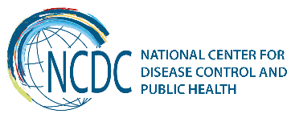



GEORGIA Brief
Universal Salt Iodization in Georgia
Success Story

Iodine deficiency has been identified as a global public health problem and as the main cause of preventable mental retardation, with over a billion people at risk worldwide.
Iodine deficiency disorders are endemic in Georgia. They are caused by low iodine levels in water and soil and, therefore, in locally produced food products. In 1990, with the onset of the socio-economic crisis in Georgia, the system of iodized salt import and distribution was completely disrupted. The effects were soon apparent. A survey conducted in 1998 showed various degrees of iodine deficiency in 55-58% of the population.
The most effective method of eliminating ID disorders (IDD) is promoting the widespread consumption of adequately iodized salt with the target of more than 90% of households consuming adequately iodized salt.
In 2005 the new law on “Prevention of Disorders Caused by Iodine, Micronutrients and Vitamins Deficiency” was adopted by the Georgian Parliament mandating universal salt iodization (USI) - to ban the import and trade of non-iodized salt. The law is the result of joint efforts by the Government of Georgia and UNICEF. The salt standard of 40±15mg iodine/kg salt was set.
To provide information on coverage of population with iodized salt in Georgia nationwide, and on adequacy of iodine content in salt on the household level though quantitative measurement of iodine concentration in salt, to determine status of iodine nutrition of the population in Georgia nationwide by measuring UIC and total body weight in school aged children (SAC), to assess status of iodine nutrition in pregnant women (PW) by collecting urine samples on the 1st trimester of pregnancy in clinics nationwide and measuring UIC, to develop recommendations for revision of present normative values of iodine in salt, as well approaches to use of iodine nutritional supplements among SAC and PW the national survey of iodized salt use and status of iodine nutrition has been conducted by the NCDC in collaboration with the UNICEF-Georgia.
Results
- Over 90% of households in Georgia consume adequately iodized salt both in General and Mountain stratum.
- Quality of iodized salt was remarkably good for all major brands of salt imported from various countries.
- Adjusted median UIC in SAC nationwide (298µg/L) was within the range (100-299µg/L) for optimum iodine nutrition of population, albeit close to the upper limit.
- Median UIC findings in all the SAC groups are clearly above the threshold for population iodine deficiency.
- Percent UIC values less than 100µg/L in the 3 groups were 0.6%, 2.2% and 3.1% of SAC in urban, rural and mountainous areas, respectively.
- The median iodine intake estimate in SAC was 227µg/day. The analysis shows that the iodine intake of Mountain SAC is lower by 19% than of SAC in the General stratum.
- The median UIC in the 634 PW was 211µg/L. This finding suggests optimal iodine status of PW in Georgia as the level is conveniently in the middle of the normative 150-250µg/L range.

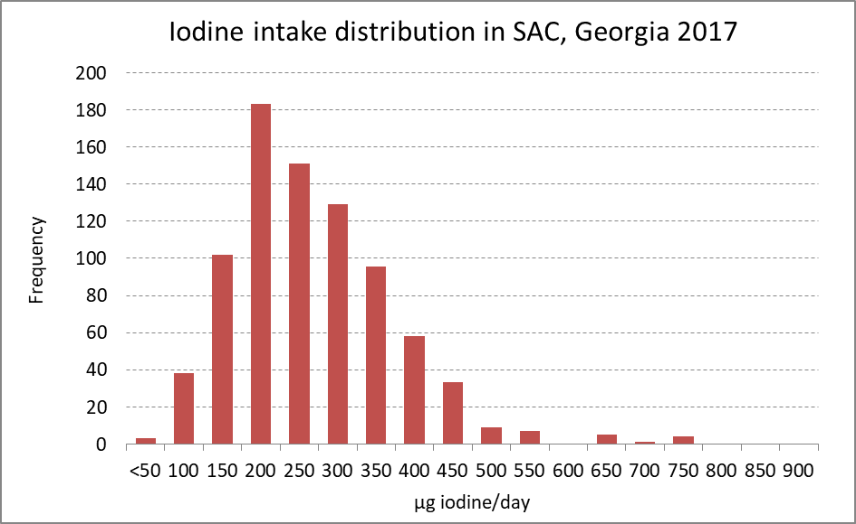

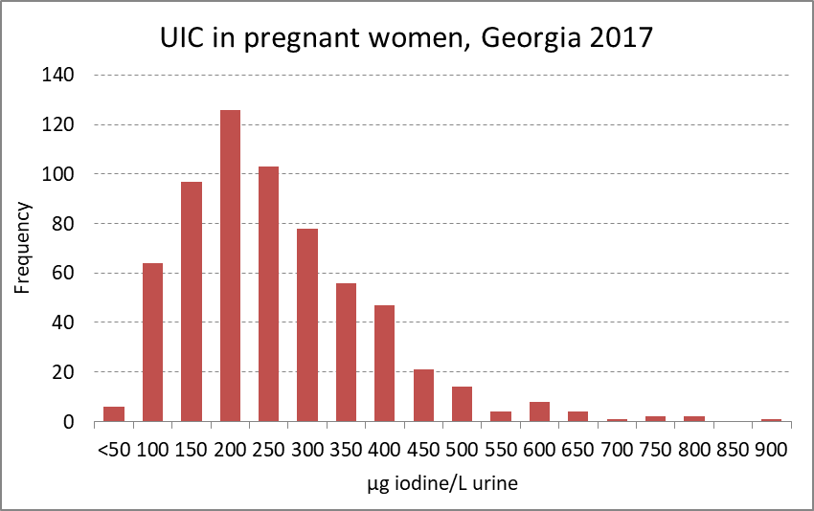

Conclusions
- The results of the survey confirmed that Georgia has a sustained, effective USI program with more than 90% coverage of the population with quality iodized salt.
- Optimal iodine nutrition status has been achieved and sustained for the general population (based on assessments of SAC) and PW.
- While median UIC in SAC countrywide is close to upper limit, there is no urgent need to alter or reduce current normative levels of salt iodization (40±15mg/kg).
- Analysis of iodine intakes in SAC showed no evidence of excess iodine consumption in any group (urban, rural, mountain).
- Iodine nutrition in PW is perfectly normal with median UIC (211µg/L) conveniently in the middle of recommended values.

Recommendations
- Monitoring of iodine nutrition of population, coverage and quality of iodized salt should be continued and strengthened.
- GNMSS (Georgia Nutrition Monitoring and Surveillance System) should continue to monitor iodine nutrition as well as status of other micronutrients on annual basis.
- Health professionals (endocrinologists, OBG, pediatricians, general practitioner, etc.) should be discouraged to recommend iodine supplement to PW and SAC without strong suspicion of inadequate iodine intake (such as veganism or extremely low salt consumption for medical or behavioral reasons).
- Further monitoring of iodized salt use and iodine nutrition is recommended to assure permanent IDD elimination and optimal iodine nutrition in Georgia.

________________________________________________________________________________________
  Ministry of Labour, Health and Social Affairs of Georgia  144, A. Tsereteli avenue. Tbilisi, Georgia, 0119  www.moh.gov.ge | 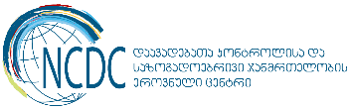  National Center for Disease Control and Public Health  9, M. Asatiani street. Tbilisi, Georgia, 0177  www.ncdc.ge

