1. Project Title
Harmonization of Medical Devices National Regulations with the EU Legislation under the Association Agreement between the European Union and Georgia.
2. EU assistance tool
Twinning
3. Beneficiary Administration:
The name of the institution:
Ministry of Labour, Health and Social Affairs of Georgia
General structure:
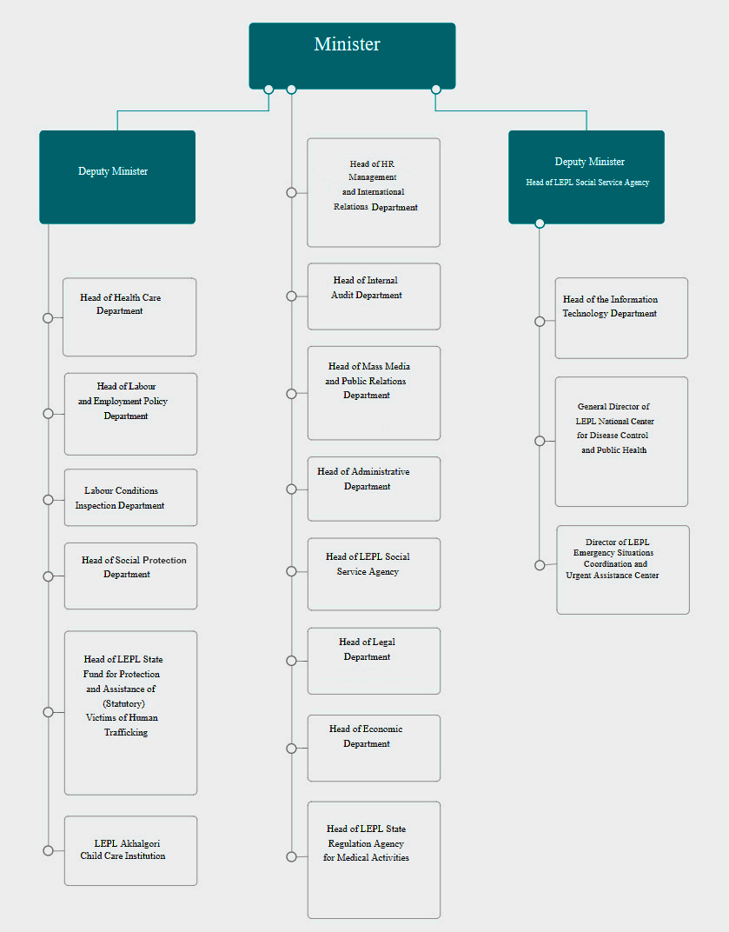

Number of employees:
290 Employees
The mandate of the institution:
The Ministry of Labour, Health and Social Affairs of Georgia is an executive branch of the Government of Georgia, which is responsible to develop and implement the state policy in the fields of labour, health and social protection.
The main activities of the Ministry of Labour, Health and Social Affairs of Georgia include:
- Elaboration of the corresponding legislation in accordance with international standards;
- Elaboration and management of the state labour, health and social programs;
- Coordination of programs implemented by the international and non-governmental organizations in the field of labour, health and social protection;
- Coordination of the sectoral reforms’ implementation.

Number of the staff that could be involved in the project preparation/implementation process:
10 persons
4. Background Information and Justification
Describe shortly why the project should be supported in the context of the EU-Georgia cooperation agenda and related documents (ENPI AP, future AA including DCFTA, etc.) or in the area and other GoG strategic documents (please indicate clear references to the priorities set out in the documents).
In order to meet the obligations under the Deep and Comprehensive Free Trade Area Agreement (DCFTA) between Georgia and the European Union, it is necessary to establish a market surveillance system, relevant to the EU best experience. The project will ensure harmonization of the national regulations with the following EU directives:
93/42 / EEC medical devices;
90/385 / EEC actively implantable medical devices;
98/79 /EC in-vitro diagnostic medical devices.
Information regarding the needs of BA and why the project idea is relevant: What are the gaps, the project is to address for the beneficiary’s administrative capacity development? How is it relevant to the particular needs and constraints of the project’s beneficiary?
For more than a decade in Georgia there have been no mechanisms for the regulation of medical devices. The only existing requirement of the current legislation regarding medical devices (licensing requirements for medical practices and hospital permits) refers to the device release date: medical devices should not be issued before 1998. Placement on the market, registration, assessment of conformity and survillance of the medical devices are currently out of state regulation and accordingly, there is no competent body/authority responsible for the regulation of medical devices.
In order to meet the obligations under the Deep and Comprehensive Free Trade Area Agreement (DCFTA) between Georgia and the European Union, it is necessary to establish a market surveillance system, relevant to the EU best experience. To achieve this goal, with the EU technical assistance, the project on the “Support of the Technical and Construction Surveillance Agency for the improvement of the national market surveillance system, consistent with the EU best practices” has been carried out, within which, alongside other activities, the drawbacks and needs of the general market surveillance system were identified and long term action plan on the “Market surveillance of industrial and consumer products” was developed (Government Ordinance of December 30, 2016 №641). According to this plan, under the sectoral principle of the institutional arrangement of product market supervision, the surveillance of the Ministry of Labour, Health and Social Affairs of Georgia covers the implementation of the following EU directives: 93/42/EEC medical devices; 90/385/EEC actively implantable medical devices; 98/79/EC in-vitro diagnostic medical devices. Along with the above mentioned, the obligation of the Ministry is to ensure by 2019 the development of technical regulations, in accordance with the above mentioned directives. It is worth mentioning that the Georgian Law “On Medical Devices", drafted in 2014 by the Ministry with the involvement of experts from the EU, in turn, requires an expert assessment, which is currently not feasible in Georgia.
Under the new EU Medical Devices and In Vitro Diagnostic Medical Devices regulations (EU Directives 2017/745, 2017/46), the Georgian draft law “On Medical Devices" requires further revision (05.04.2017) (under DCFTA Georgia has a commitment of dynamic approximation (Association Agreement, Article 418)). Additionally, the establishment of an effective supervision system of the medical device market, envisaged by the draft law, requires the development of subordinate legal acts by the Ministry.
Is it related to ongoing and/or planned activities of other donors and international financial institutions (the World Bank, USAID, etc.)? Please add the list of projects in your institution or in the field of the planned project for last 3 years.
No
In case of the Twinning, are there similar institutions in the EU member states that can be your partners?
No
5. Project Purpose
Establishment of a medical device supervision system in accordance with the Deep and Comprehensive Free Trade Area Agreement (DCFTA) between Georgia and the European Union.
6. Expected Results
- Approximation of the Law of Georgia “On Medical Devices” with the EU directives and its introduction to the parliament of Georgia;
- Adoption of the subordinate normative acts, including:
- Technical regulation on the safety assessment of medical devices (in vitro diagnostics, actively implantable medical equipment);
- The rules on medical device registration;
- The rules of recognition of the institutions/establishments for conducting conformity assessment;
- The rules on the import of medical devices on the territory of Georgia;
- The rules on conducting clinical research on medical devices;
- The rules on clinical assessment of medical devices;
- The rules on the medical devices supervision system;
- The procedures for performing regular inspections;
- The procedures for performing unplanned inspections;
- The rules on maintenance medical equipment registry maintenance;
- Other subordinate acts.
7. Key Activities
- Establishment at the Ministry of a working group with the involvement of stakeholders for harmonization of the current legislation with the EU directives;
- Development by the Working Group, in collaboration with the experts from EU, of an action plan and agreement of it with the main stakeholders;
- According to the action plan:
- Drafting/revision of the law of Georgia “on Medical Devices”, organization of the discussions with stakeholders and introduction of the law to the Parliament;
- Drafting/revision of the subordinate normative acts.
8. Tentative start of the project
April 1, 2018
9. Contact Details
Contact person (official) Responsible for political steering of the project (at Deputy Minister’s level) | Name, Surname: | Nino Berdzuli
 | Position: | Deputy Minister of Labour, Health and Social Affairs of Georgia
 | Address: | 144, Ak. Tsereteli Ave., 0119 Tbilisi, Georgia
 | Tel:
 | E-mail:
Contact person  Technical detail; to ensure the day to day management of the project | Name, Surname:
 | Position:
 | Address:
 | Tel:
 | E-mail:
Date of Application:

