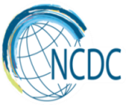

GEORGIA BRIEF
Maternal and Newborn Health

MNH Status in Georgia
Georgia has achieved remarkable progress in reducing under–five and neonatal mortality rates to 10.2 and 6.1 per 1000 live births respectively by 2015 thus accomplishing the Millennium Development Goal #4 (MDG) set at the 2000 Millennium Summit: Reduce by two-thirds, between 1990 and 2015, the under-five mortality rate.

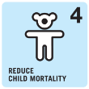
Millenium Development Goal 4 met!

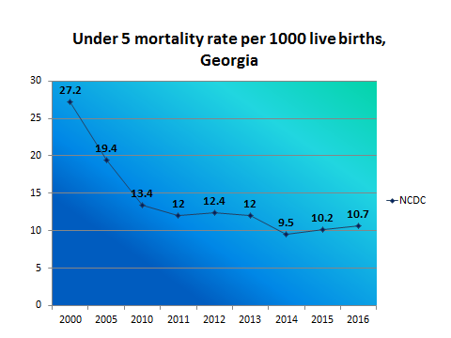

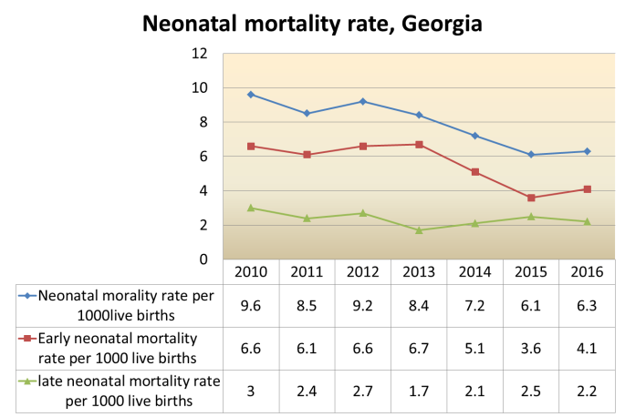

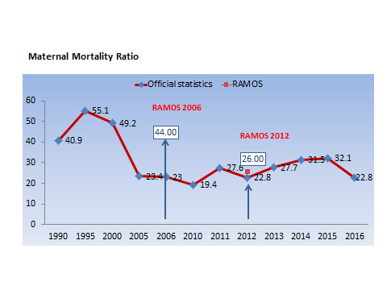

While significant progress has been made in reducing child/infant mortality rates, more efforts are needed to improve maternal mortality figures. Maternal Mortality Ratio in Georgia has fluctuated widely over the past decades. In 2015 it was 32.1 per 100 000 live birth, which is higher than average rate both for European region and the CIS. The rate decreased to 22.9 per 100 000 livebirth in 2016.

Strategies to improve MNH in Georgia
National MNH Strategy 2017-2030 with related short term Action Plan (2017-2019) is developed and approved by the government with the aim to provide long-term guidance and coherent plan of action for the improvement of maternal and newborn health in Georgia.

Key constituents of the strategy:

Perinatal Care Regionalization - “gold” model of maternal and newborn service organization

Aim: to improve the health outcomes and decrease maternal and infant morbidity and mortality through provision of risk-appropriate care.

Principle: each mother and newborn is delivered and cared for in a facility appropriate for his or her healthcare needs.
Right Patient

Right Time

Right Place

Process: all facilities providing maternal and newborn care services are divided by levels of care according to their capacity.

Subspecialized Care

LEVEL III

Specialized Care
LEVEL II
LEVEL I

Basic Care

105 facilities assessed, 82 facilities have designated level of care. All 82 facilities strengthened their capacity for infrastructure/equipment and competencies of service providers according to the level requirements.

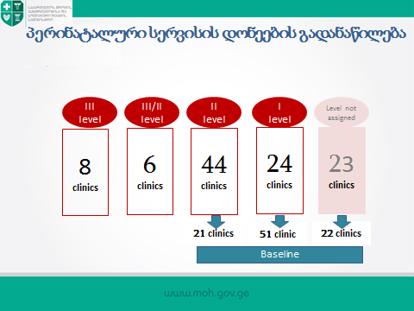

Birth Registry

In 2016, MoLHSA in alliance with NCDC launched the nationwide electronic registry “Mother’s and neonate’s health surveillance system”, so called “Georgian Birth Registry” (GBR). The system tracks information on all cases of pregnancy, delivery, postpartum, neonatal care and abortion.
The GBR provides an opportunity:
- to get comprehensive knowledge on a wide array of indicators, related to the maternal and newborn health, morbidity and mortality along with the quality of antenatal, obstetric and neonatal care
- to make evidence-based policy decisions.
The GBR also allows monitoring the regionalization of perinatal care services through providing data on selected maternal and neonatal healthindicators.
The coverage of pregnancy and childbirth by GBR increased from 47% in 2016 to 96 % in 2017.

Selective Contracting

In March, 2017 MoLHSA initiated a selective contracting of facilities providing perinatal care services. Social Service Agency contracts only facilities which demonstrate required compliance with pre-defined quality criteria. Currently 30 facilities, providing perinatal care services from three largest cities of Georgia (Tbilisi, Kutaisi and Batumi) are involved in selective contracting process. The existed contract includes 10 quality indicators, covering the critical issues related to obstetric and neonatal care in Georgia.
Clinical Audit

The routine clinical audit of cases of stillbirth and maternal and neonatal mortality has been introduced by the MoLSHA in 2017 with aim to advance practice of obstetrics and neonatal care and improve the quality of services through detailed clinical analysis of selected mortality cases. The comprehensive audit process allows identification of root causes of gaps and deficiencies in existing practices and in the health system and planning the corrective policy and practice measures at the local and national level.

Elimination of mother-to-child transmission of HIV and syphilis

Georgia maintains a strong commitment to prevent mother-to-child transmission of HIV and syphilis (EMTCT) and integrated EMTCT into the National MNH Strategy. The specific plan for meeting elimination targets has been developed by the national elimination committee. EMTCT interventions are part of the national maternal and child health care programs and are offered to the population free-of-charge.

  Ministry of Labour, Health and Social Affairs of Georgia  144, A. Tsereteli avenue. Tbilisi, Georgia,0119  www.moh.gov.ge | 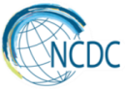  National Center for Disease Control and Public Health  9, M.Asatiani Street. Tbilisi, Georgia, 0177  www.ncdc.ge

