Health
Maternal and child health and sexual and reproductive right
According to official data, the under-5 mortality rate per 1,000 livebirths was 10.7 in 2016. Almost 60% of all deaths in children aged under-5 occurred during the neonatal period. Georgia has achieved remarkable progress in reducing under–five and neonatal mortality rates to 10.2 and 6.1 per 1000 live births respectively by 2015 thus accomplishing the Millennium Development Goal #4 (MDG) set at the 2000 Millennium Summit: Reduce by two-thirds, between 1990 and 2015, the under-five mortality rate.
For better monitoring of maternal and child mortality cases emergency notification system has been started in February 1, 2013, which ensures urgent provision of information on maternal mortality, 0-5 year’s child mortality and stillbirth cases. Each medical organization is obliged to notify MoLHSA by phone call within an hour in case of maternal or 0-5 child mortality and stillbirths and in the next 24 hours confirm the call by the written notification.
The initiative of starting the perinatal care regionalization process from May 2015 is a significant step forward in strengthening the maternal and newborn health care system, which considers defining the levels of perinatal service providers and their role and responsibilities in order to provide the correct timing of the correct patient to a correct medical institution and, if necessary, effective referral. Regionalization was be completed in 2017. 105 facilities assessed, 82 facilities have designated level of care. All 82 facilities strengthened their capacity for infrastructure/equipment and competencies of service providers according to the level requirements.
In 2016, MoLHSA in alliance with NCDC launched the nationwide electronic registry “Mother’s and neonate’s health surveillance system”, so called “Georgian Birth Registry” (GBR). The system tracks information on all cases of pregnancy, delivery, postpartum, neonatal care and abortion.
National MNH Strategy 2017-2030 with related short term Action Plan (2017-2019) is developed and approved by the government with the aim to provide long-term guidance and coherent plan of action for the improvement of maternal and new born health in Georgia.
The principle of protecting the universal rights of Georgian population has been achieved in healthcare sector from 2013s the whole population of Georgia is insured for basic medical service under state Universal Health Care program. Children under 0-5 and 5-18 are covered planned ambulatory care, emergency out-patient and in patient services, elective surgery, Chemo-hormone- and radiotherapy, delivery and C-section.
In order to decrease number of mortality of mothers and children, also number of perinatal death from iron deficiency anemia, and number of early delivery and inborn anomalies, from June 2014 all pregnant population is provided with folic acid up to 13th week of pregnancy and in case of iron deficiency anemia – with, iron deficiency anemia medication from 26th week of pregnancy. From 2018 under Maternal and child heath state program Government covers 8 antenatal visits by WHO new guidelines.
Maternal and child health state program includes:
- Antennal screening for HIV / AIDS, H & C and hepatitis and syphilis
- Screening for genetic pathologies
- Prevention of hepatitis B, HIV / AIDS and syphilis in pregnant women and transmission of hepatitis to mother from mother
- New-born and child screening on hypothyroidism, phenylketonuria, hyperphenylalaninemia and mucosididase
- Screening for newborn hearing screening
In March, 2017 MoLHSA initiated a selective contracting of facilities providing perinatal care services. Social Service Agency contracts only facilities which demonstrate required compliance with pre-defined quality criteria. Currently 30 facilities, providing perinatal care services from three largest cities of Georgia (Tbilisi, Kutaisi and Batumi) are involved in selective contracting process. The existed contract includes 10 quality indicators, covering the critical issues related to obstetric and neonatal care in Georgia.
The routine clinical audit of cases of stillbirth and maternal and neonatal mortality has been introduced by the MoLSHA in 2017 with aim to advance practice of obstetrics and neonatal care and improve the quality of services through detailed clinical analysis of selected mortality cases. The comprehensive audit process allows identification of root causes of gaps and deficiencies in existing practices and in the health system and planning the corrective policy and practice measures at the local and national level.
In 2016, 28720 abortions have been registered (511.7 per 1000 live births), of which, induced abortions constituted 74%. Compared with the previous year, the total number of abortions decreased by 11% (in 2015 - 555.0 per 1000 LB) (Figure 4.5). It is important that the share of abortions in women aged under-20 has decreased and equales 3.2% of the total number of abortions (in 2013 – 5%).

Total fertility rate (TFR), Georgia
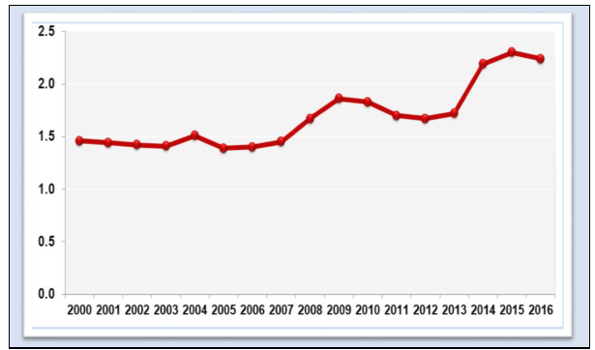
NCDC&PH
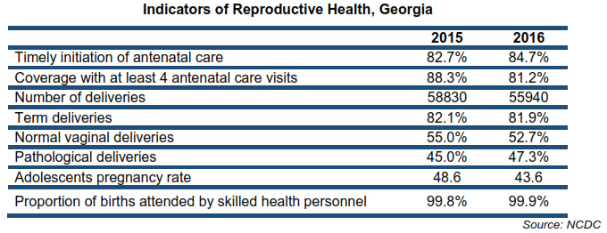
Rate of childbirth in health centers, assisted by qualified medical personnel (%),
Georgia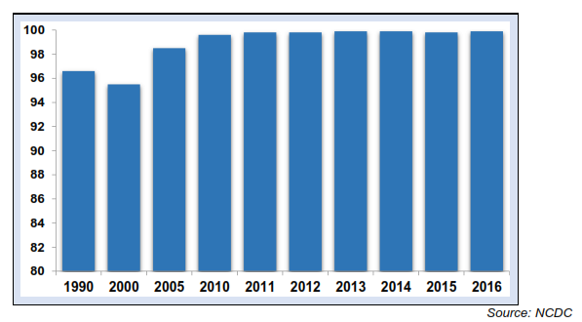
Induced abortion ratio per 1000 live births
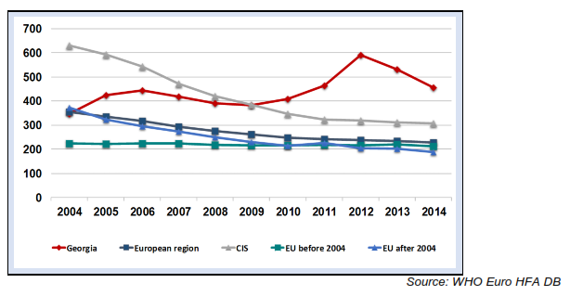

Maternal mortality ratio per 100000 live births, Georgia
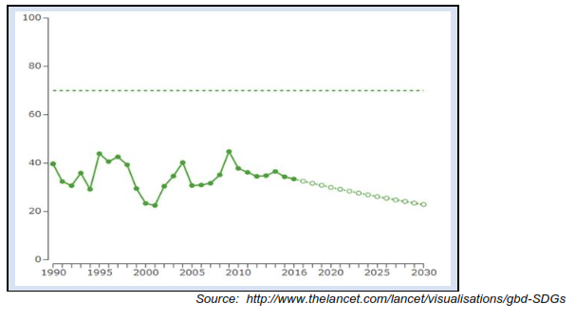

Under-5 mortality rate per 1000 live births, Georgia
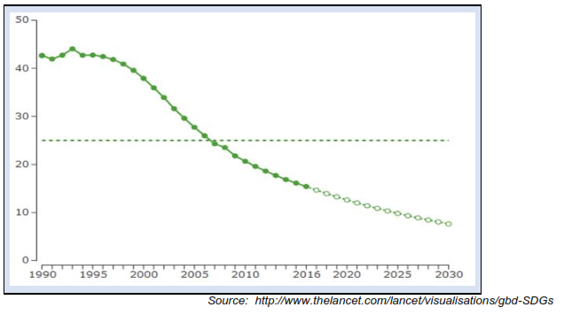

Universal health care
Introducing Universal Health Care in Georgia in February 2013 aimed at improving the general population’s access to healthcare, has benefited more Georgians, particularly those relatively less well-off, from gaining access to health services when ill and being less prone to impoverishment or catastrophic out-of-pocket spending on healthcare. This was achieved through a strong political commitment and process to create an equitable health financing system.
Universal heath care and health policy oriented towards the population health and well-being is confirmed by unprecedented increase in state allocations for healthcare sector in the last few years, from GEL 450 million in 2012 to GEL 986.2 million in 2017. Public health spending as a share of GDP has also increased from 1.7% in 2012 to 3% in 2016.
In 2013, after implementation of the UHC program, service coverage has increased significantly and rapidly from 29.5% of the population in 2010, to about 40% by the end of 2012 and up to 99.9% by 2014.
On average, there are 4.0 outpatient visits per capita per year in 2016 compared to just 2.3 in 2012, and hospitalization rates have seen a steady increase from 11.3 in 2012 to 13.3 in 2016, which largely is explained by the introduction of UHC program, which offered coverage to a vast number of people in Georgia who were previously uninsured. The largest increase in using health services among those who reported being ill occurred among lower and middle-income household.
UHC program has significantly reduced the out-of-pocket payments and improved financial protection of the population. Out-of-pocket spending declined from73% in 2012 to 57% in 2015.
Survey conducted by the US Agency for International Development in 2014 showed that 80.3% of the surveyed beneficiaries were satisfied with the outpatient service and 96.4% expressed satisfaction with hospital level emergency care within the universal health care program.

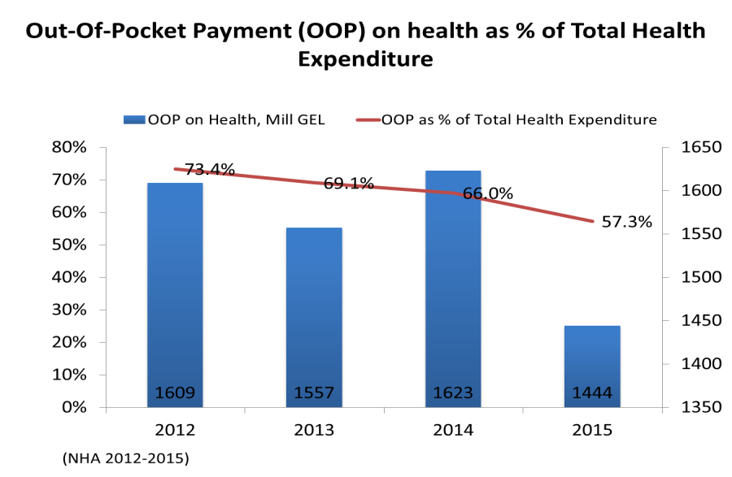

HIV infection
Georgia faces low level HIV epidemic with concentration of HIV cases among KAP groups (PWIDs, FSWs and MSM). The national level HIV prevalence among adult population was 0.4 in 2016. The Number of registered HIV cases was 6131, out of them 1205 have died. Estimated number of adult PLHIV for the same year was 9600. Annual number of newly registered cas0es during the last five years was varying between 500 and 719.
HIV Transmission - If during 1990-2010 the main route of HIV transmission was injecting use of drugs, from 2011 the number and share of the cases attributed to sexual transmission of HIV has been increased in Georgia. In 2016 among newly registered HIV cases 51% was attributed to unprotected heterosexual contacts and 17% to homosexual contacts.
For the UNAIDS 90-90-90 Fast Track targets Georgia is well positioned for last two, but is behind for the first 90. By the end of 2016 only 53% of estimated PLHIV knew their status, while 75% of them were enrolled in ART and in 81% the VL suppression was achieved. Georgia has achieved important progress in HIV, TB and Malaria programs. The Georgian Antiretroviral therapy (ART) program was recognized by the international experts as one of the best in the region due to universal access to HIV treatment, high coverage of target populations and improved quality of the program interventions. Also, Georgia one of the first in the region started implementation of WHO “Treat ALL” strategy from December 2015. However the detection rate of new HIV infection cases remains a main challenge for the National HIV Program. NCDC works closely with KAPs through National AIDS Center, NGO and CBO networks to increase the coverage of key affected groups and test new approaches of integrated screening of HIV, TB and hepatitis C, implementing mobile outreach services, etc. Georgia one of the first counties in the region has started pilot PrEP program among MSM in 2017.
