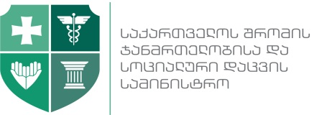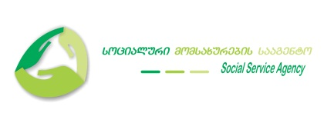

The Amendment to the

MEMORANDUM OF UNDERSTANDING signed on 14th January 2016, BETWEEN MINISTRY OF LABOUR, HEALTH AND SOCIAL AFFAIRS OF GEORGIA, LEPL SOCIAL SERVICE AGENCY AND UNICEF

- The amendment to the Memorandum of Understanding signed on 14th January 2016, Between Ministry of Labour, Health And Social Affairs Of Georgia, LEPL Social Service Agency And UNICEF to be defined as follows:
“3.7. The MOU is valid until June 21th 2020”.
- The current amendment represents integral part of the MOU.
- The amendment is effective from the date of signing from all participants.
Ministry of Labour, Health and Social Affairs of Georgia  Address: 144 Tsereteli Ave. 0119, Tbilisi, Georgia  Tel: (+995 32) 2 510 047; 2 510 048; 2 510 049  Minister | David Sergeenko
LEPL “Social Service Agency”  Address: 144 Tsereteli Ave. 0119, Tbilisi, Georgia  Tel: (+995 32) 2 510 047; 2 510 048; 2 510 049  Director | Zaza Sopromadze
UNICEF Georgia  Address: 9, Eristavi St., 0179 Tbilisi, Georgia  Tel: (+995 32) 2 23 23 88  Representative | Laila O Gad

