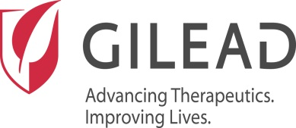

Memo

To: MoH Georgia
From: Standards and Collaborations, Drug Safety & Public Health
Date: 12-Apr-2016
Subject: Updated Forms: Gilead Adverse Event/Special Situation Reporting form and Reconciliation Report Form

Please find enclosed for your immediate use, an updated Solicited Program Adverse Event/Special Situation Report Form and Reconciliation Report Form. Please use these forms going forward to report AE, SSR data to Gilead and to provide the reconciliation summary as per your previous training.

Below is a summary of the changes made to each form to streamline safety information reporting and tracking for both the vendor and Gilead.

The updates to the Solicited Program Adverse Event/Special Situation Report Form (GF-21045H.04) include:

Program Details Section:

Checkboxes to identify the type of program your organization has been commissioned for, e.g. Market Research, Patient Assistance Program, Patient Support Program, or other type of GSI sponsored program. Gilead DSPH has pre-populated this for you to ensure that all safety information reports generated from the program are classified in the same manner. Please do not make any changes to the pre-populated information, as this is for internal use by Gilead.

A respondent/case reference number row was added to allow your organization to provide either the project number for market research projects, or an internal case reference number given to safety information reports submitted to Gilead. This field is optional and can be left blank if there is no project number, or if your organization does not assign a reference number to safety reports submitted to Gilead.

The updates to the Solicited Program Reconciliation Report Form (GF-21045E.05) include:

Reported Safety Information Section:

A column for the respondent/case number was added to allow your organization to provide either the project number for market research projects, or an internal case reference number given to safety reports submitted to Gilead. This field is optional and can be left blank if there is no project number or if your organization does not assign a reference number to safety reports submitted to Gilead. Please do not make any changes to the pre-populated information, as this is for internal use by Gilead.

If you have any questions regarding these updates please email sandcollaborationsds@gilead.com

Please confirm receipt of this communication and new forms to sandcollaborations@gilead.com
Sincerely,
Standards and Collaborations, Drug Safety & Public Health

