Progress Towards Hepatitis C Elimination — Georgia, 2015–2016

Lia Gvinjilia, MD, PhD¹, Muazzam Nasrullah MD, PhD² , David Sergeenko, MD³; Tengiz Tsertsvadze, MD, PhD⁴; George Kamkamidze, MD, PhD⁵; Amiran Gamkrelidze, MD, PhD⁶; Paata Imnadze, MD, PhD^{6;} Valeri Kvaratskhelia³; Nikoloz Chkhartishvili, MD, PhD⁴; Lali Sharvadze, MD, PhD⁷; Jan Drobeniuc, MD, PhD²; Liesl Hagan MPH²; John Ward, MD²; Francisco Averhoff, MD²

(Author affiliations at end of text)
¹CDC Foundation
²Division of Viral Hepatitis, National Center for HIV, Hepatitis, STD and TB Prevention, Centers for Disease Control and Prevention, Atlanta, Georgia (Corresponding author: Muazzam Nasrullah, snasrullah@cdc.gov , 404-639-3271)
³Ministry of Labor Health and Social Affairs of Georgia
⁴Infection Diseases, AIDS, and Clinical Immunology Research Center, Tbilisi, Georgia
⁵Neolab, Tbilisi, Georgia
⁶National Center for Disease Control and Public Health of Georgia
⁷Joint Georgian-French Hepatology Clinic Hepa, Tbilisi, Georgia

Total Words: 1486/1400; References: 4/10; Tables/Figures: 3/3

The country of Georgia has a large burden of hepatitis C virus (HCV) infection, with particularly high rates of infection among persons who inject drugs (PWID), incarcerated persons, and persons infected with HIV (1). In April 2015, in collaboration with Centers for Disease Control and Prevention (CDC) and other partners, Georgia embarked on a program to eliminate HCV infection, subsequently defined as achieving 90% reduction in prevalence by 2020. The initial phase of the program focused on treatment of persons who had advanced liver disease. Through April 2016, a total of 27,392 persons had registered for the program, which provides persons with evidence of HCV infection free treatment with curative, direct-acting antivirals (DAAs). By April 28, 5,850 patients (21.4%) with laboratory evidence of HCV infection had completed treatment and 2,398 of those treated had received testing to determine virologic cure, of which 1,980 (82.6%) had achieved a sustained virologic response (SVR). The first of its kind, Georgia’s HCV Elimination Program will help pave the way for other countries experiencing high rates of HCV desiring to undertake a similar initiative to eliminate HCV.

Georgia, a country with a population of 3.7 million (2) bordering the Black Sea, Russia, Turkey, Armenia, and Azerbaijan has an HCV prevalence of >5% (Georgia Ministry of Labor, Health, and Social Affairs [MoLHSA], unpublished data, 2016). With strong political will, a partnership with and technical assistance from CDC, and commitment from Gilead Sciences to donate DAA medications, the country of Georgia embarked on the world’s first elimination program in April 2015 (1). Initially, four treatment centers located in Georgia’s capital city of Tbilisi provided HCV treatment to program participants. By April 28, 2016, this number had increased to 17 centers located throughout the country, including 95 physicians, either infectious-disease specialists or gastroenterologists, authorized to provide HCV treatment services (Figure 1). All the HCV treatment centers provide point-of-care and laboratory-based anti-HCV testing and have capacity to conduct viral load determination and genotyping.

A sliding-scale approach was used for HCV testing, with patients paying for their own HCV testing based on ability to pay and the local government or MoLHSA paying for the remaining balance. All program participants received sofosbuvir-based treatment regimens, provided to patients free of charge by Gilead Sciences; the Georgian government purchased additional medications (i.e. pegylated interferon and ribavirin) and provided them at no cost to patients for whom such treatment was indicated.

From the start of the program through April 28, 2016, a total of 27,392 persons with a positive test for anti-HCV had enrolled; number of enrollees peaked during the first month of the program and has generally declined over time (Figure 2). Most of those enrolled (99.1%; 27,155) have initiated diagnostic work-up to determine eligibility for treatment. Among these, 9,615 (36.3%) completed diagnostic work-up, and 8,448 (87.9%) initiated treatment for HCV (Figure 3). Because patients with advanced liver disease were prioritized to receive treatment during the first year of the program, most enrollees (92.1%) had F3 or F4 METAVIR fibrosis score by ultrasound elastography) (3). The most commonly used regimen consisted of sofosbuvir in combination with pegylated interferon and ribavirin, the drug combination most effective for patients with advanced liver disease.

Outcome data for patients treated through April, 2016 with sofosbuvir based treatment showed that of 2398 people eligible for an SVR determination 12 weeks following completion of treatment and tested for the presence of HCV RNA (SVR12), levels of HCV RNA were undetectable in 1980 (82.6%) of those tested, indicating a virologic cure. Among those completing their treatment course, cure rates were lowest (72.6%; 724/997) among genotype 1 patients, intermediate among those infected with genotype 2, (84.7%; 421/497), and highest among those with genotype 3 patients (92.4%; 834/903).

In mid-February 2016, Gilead Sciences began providing program participants with the newer ledipasvir/sofosbuvir DAA regimen (also free of charge). Among those who initiated treatment in the first year, the total number includes 162 persons who restarted treatment with ledipasvir/sofosbuvir, following introduction of this combination DAA, for a variety of reasons, primarily failure to achieve viral clearance after initial treatment course (n=155); no treatment outcome data are available for patients receiving this combination therapy.

Discussion
Georgia, the first country in the world to take on the challenge of HCV elimination, has made remarkable progress in the year since embarking on this goal. Even before the official start of the HCV elimination program in April 2015, Georgia had been providing HCV treatment to some high risk populations, including incarcerated persons and persons co-infected with HIV (2). Since the launch of the program in April 2015, >27,000 persons have been enrolled and 8,000 have initiated treatment, representing a >400% increase in the number treated over the total treated in the country in the previous 4 years combined (1). Persons with advanced liver disease, who are at highest risk for morbidity and mortality, were prioritized for treatment during the first year, and >90% of those treated met this criteria as determined by ultrasound elastography. Rate of virologic cure was > 80% among this difficult-to-treat population, in a “real world” setting.

Georgia has taken a collaborative, informed approach to eliminating HCV. Together with CDC, the World Health Organization (WHO), and other international partners, Georgia’s MoLHSA developed a technical advisory group (TAG), which convened its first meeting in November 2015. To help Georgia reach its proposed elimination goals, TAG recommended that MoLHSA address gaps in advocacy and awareness, surveillance, prevention of transmission (including harm reduction, blood safety, infection control in health- and non-health-care settings, and evidence-based screening and linkage to care (4). Several strategies were proposed, including assessing Georgia’s burden of disease and risk factors for transmission; implementing measures to prevent transmission; identifying all persons living with HCV infection; and providing patients with access to high-quality diagnostics and free treatment with DAA medications. TAG also applauded Georgia’s ongoing efforts to develop a comprehensive elimination plan to address key challenges and outline steps and strategies for achieving elimination goals; this plan is currently being developed, as is a system to enable thorough monitoring and evaluation of the program.

Despite notable progress made over the last year, significant challenges persist. To ensure high quality screening and monitoring, as the program expands, a laboratory quality assurance and quality control (QA/QC) system covering all treatment centers is needed. To monitor progress towards elimination goals, surveillance systems capable of capturing data from key populations and those with acute disease are needed, allowing for monitoring of trends and risk factors for infection. Collection of quality and timely treatment data is important to monitor the progress of the care and treatment program. These gaps will be addressed in Georgia’s comprehensive elimination plan, which is currently under development. As the treatment program continues to expand and the number of providers and sites that provide HCV care and treatment services grows, the capacity of the information system will need to be increased. The MoLHSA is anticipating this growth and is working with partners to ensure the system is upgraded to handle additional demand.

In its first year, Georgia’s HCV elimination program primarily served patients who already knew their infection status, voluntarily presented to participating clinics, and enrolled in the program. However, most persons living with HCV infection in the country currently are not participating in the program and have yet to be screened for HCV, remaining unaware of their infection and failing to receive lifesaving care and treatment. Moving forward, Georgia must develop a comprehensive screening program that ensures more patients are tested, informed of their test results, provided with confirmatory testing, and linked to care and treatment services if found to be infected. As more Georgians are tested for HCV, the demand for treatment will increase. Primary-care providers and settings serving high-risk populations (e.g., harm-reduction centers) must be prepared to provide HCV treatment, because demand for therapy is anticipated to exceed the capacity of providers currently offering treatment (i.e., infectious-disease specialists and gastroenterologists).

In many low-to-middle income countries facing the highest burden of HCV infection, access to advanced diagnostics is limited. Specific models of care and treatment that use simplified testing and patient management are needed to demonstrate feasibility of HCV care and treatment in resource-limited settings like Georgia. Fortunately, in the near future, Georgians will likely have access to a newer DAA associated with high rates of virologic cure regardless of HCV genotype, suggesting that genotype testing may not be a pre-requisite for treatment. Use of these antivirals is expected to simplify HCV diagnostics in Georgia, allowing more patients to receive treatment in a timely manner. Georgia’s model elimination program will provide invaluable lessons for future efforts to control HCV infection worldwide, particularly as testing is simplified, treatment becomes more affordable, and more countries seek to address the growing HCV burden.

References
1. Mitruka K, Tsertsvadze T, Butsashvili M, Gamkrelidze A, Sabelashvili P, Adamia E, et al. Launch of a Nationwide Hepatitis C Elimination Program--Georgia, April 2015. MMWR Morb Mortal Wkly Rep. 2015; 64: 753-7.
2. National Statistics Office of Georgia. Population. 2015 [cited 2016 June 15]; Available from: http://geostat.ge/index.php?action=page&p_id=152&lang=eng.
3. Talwalkar JA, Kurtz DM, Schoenleber SJ, West CP, Montori VM. Ultrasound-based transient elastography for the detection of hepatic fibrosis: systematic review and meta-analysis. Clin Gastroenterol Hepatol. 2007; 5: 1214-20.
4. Ministry of Labour Health and Social Affairs of Georgia. Hepatitis Technical Advisory Group (TAG) recommendations for achieving the 2020 goals towards eliminating hepatitis C infection in the country of Georgia. 2015 [cited 2016 June 10]; Available from: http://www.moh.gov.ge/files//2016/Failebi/09.06.16-1.pdf.

Figure 1: Hepatitis C treatment sites and specialized physicians for HCV treatment as of April 28, 2016, nationwide hepatitis C elimination program—Georgia, 2015-2016
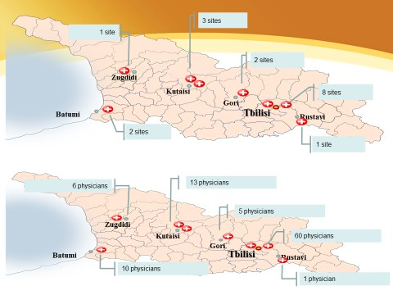
Figure 2: Number of persons with positive HCV results presenting to clinical site by month during April, 2015-April, 2016, nationwide hepatitis C elimination program—Georgia, 2015-2016 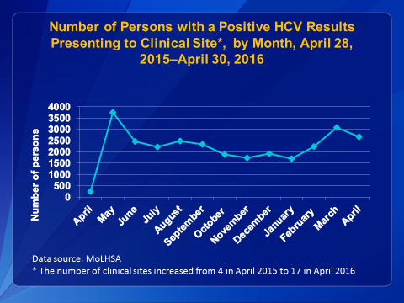

Figure 3: Care cascade during April 28, 2015-April 28, 2016, nationwide hepatitis C elimination program—Georgia, 2015-2016

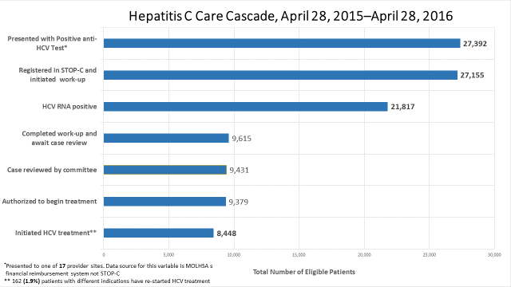

Sustained Virologic Response (SVR) is defined as undetectable (or below the lower limit of quantification) HCV RNA at 12–24 weeks after cessation of treatment (Wedemeyer H et al., 2012)

