Hepatitis C Virus Elimination in Georgia—Progress and Challenges

Muazzam Nasrullah MD, PhD¹ ; David Sergeenko, MD²; Lia Gvinjilia, MD, PhD³, Amiran Gamkrelidze, MD, PhD⁴; Tengiz Tsertsvadze, MD, PhD⁵; Maia Butsashvili, MD, PhD⁶; David Metreveli, MD, PhD⁷; Maia Alkhazashvili, MD⁴; Shaun Shadaker, MPH³; John W. Ward, MD¹; Juliette Morgan, MD⁸; Francisco Averhoff, MD¹

(Author affiliations at end of text)
¹Division of Viral Hepatitis, National Center for HIV/AIDS, Viral Hepatitis, STD and TB Prevention, Centers for Disease Control and Prevention, Atlanta, Georgia (Corresponding author: Muazzam Nasrullah, snasrullah@cdc.gov , 404-639-3271)
²Ministry of Labor Health and Social Affairs of Georgia
³CDC Foundation
⁴National Center for Disease Control and Public Health of Georgia
⁵Infection Diseases, AIDS, and Clinical Immunology Research Center, Tbilisi, Georgia
⁶Neolab, Tbilisi, Georgia
⁷Mrcheveli, Tbilisi, Georgia
⁸Global Disease Detection, Division of Global Health Protection, South Caucasus CDC Office, Tbilisi, Georgia.

Total Words: 1905/1400; References: 7/10; Tables/Figures: 3/3

Summary Box

What is already known on the topic?
The country of Georgia has a large burden of hepatitis C virus (HCV) infection globally. In April 2015, in collaboration with CDC and other partners, Georgia embarked on a program to eliminate HCV infection that included HCV screening and provision of curative direct acting antivirals (DAAs) at no cost for infected persons.

What is added by this report?
During April 28, 2015-December 31, 2016, a total of 29,985 HCV infected persons were enrolled (persons who test positive for HCV RNA, and completed diagnostic workup) for the treatment program, of which 27,595 (92.0%) started treatment, and 19,778 (66.0%) patients completed their course of treatment. Of those who completed treatment and were tested to determine treatment response 84.1% were cured of their HCV infection. Recent data has found that the numbers enrolling are decreasing, suggesting persons who were aware of their infection and sought care are exhausting, highlighting the need to step up HCV screening and linkage to care.

What are the implications for public health practice?
The Georgia HCV Elimination Program has made significant progress since it was launched in April 2015, and the country has demonstrated the ability for rapidly scale up of care and treatment services. Georgia’s HCV elimination program model provides important lessons for other countries considering HCV elimination efforts. The lessons will continue to evolve as diagnostics and treatment options continue to improve and become more affordable globally.

The country of Georgia has a large burden of hepatitis C virus (HCV) infection. In April 2015, Georgia embarked on an ambitious HCV elimination program with strong support from CDC and other partners, subsequently defined as achieving a 90% reduction in HCV prevalence by 2020 [1, 2]. Initially, the focus of the program was on treatment of patients with advanced liver disease, followed by a liberalized eligibility criteria to allow treatment of all HCV infected persons regardless of disease severity. Additional efforts to achieve elimination included the development a comprehensive Strategic Plan that addresses surveillance, prevention, and laboratory diagnostics quality, in addition to screening and linkage to care and treatment. During April 28, 2015-December 31, 2016, a total of 29,985 HCV infected persons were enrolled in the treatment program, of which 27,595 (92.0%) started treatment, and 19,778 (66.0%) completed their course of treatment. Of those who completed treatment, 6,366 received polymerase chain reaction (PCR) testing for HCV at least 12 weeks after completion of treatment, among these patients, 5,356 (84.1%) had no detectable virus, indicative of a sustained virologic response (SVR), i.e., were cured of their infection. Enrollment in the program peaked in August 2016 (n=4543), following the liberalization of eligibility in June 2016, but declined steadily September through December. The implementation of the Strategic Plan, with an emphasis on increasing enrollment in the treatment program, is needed to reach the elimination goals. Lessons from Georgia’s model program on HCV elimination can help guide other countries with a high burden of HCV infection to undertake similar initiatives.

Globally there are an estimated 71 million people living with chronic HCV infection of which an estimated 720,000 die annually, primarily due to the sequelae of chronic infection, cirrhosis and hepatocellular carcinoma [3]. Most new infections result from unsafe health-care practices and injection drug use [3]. Georgia, a middle-income country at the cross-roads of Europe and Asia, has a high prevalence of HCV infection (7.7% anti-HCV+, and 5.4% RNA positive) [4]. Georgia with strong stakeholder support, including partnership and technical assistance from the CDC, and commitment from Gilead Sciences to donate direct acting antivirals (DAAs) free of charge, launched the world’s first HCV Elimination Program on April 28, 2015 [1, 2]. The initial phase of the program was focused on providing HCV treatment to infected persons with advanced liver disease (F3 or F4 by METAVIR fibrosis score) that were at highest risk for HCV-associated morbidity and mortality [1, 2], followed by treatment for all HCV infected persons regardless of the disease severity beginning June, 2016.

Initially, only four treatment centers located in Georgia’s capital Tbilisi were providing HCV care and treatment through the program. By December 31, 2016, the number of treatment centers had increased to 27 located throughout the country. Services provided to the patients include diagnostic, disease staging, and treatment. Non-invasive tests including FIB-4 score, and ultrasound or transient elastography are used to determine the degree of hepatic fibrosis. A sliding-scale approach is used for diagnostics and clinical monitoring, with patients charged based on their ability to pay and the local government or Ministry of Labour, Health, and Social Affairs (MoLHSA) paying the balance [2]. All program participants initially received sofosbuvir-based treatment regimens, followed by sofosbuvir/ ledipasvir based regimens beginning in March of 2016 provided free-of-charge by Gilead Sciences; the Georgian government purchases additional medications (i.e., pegylated interferon and ribavirin), if indicated and provides them at no cost to patients [2]. In addition to the treatment program, Georgia has also initiated several key activities necessary to reach their elimination goals (Table 1).

During April 28, 2015–December 31, 2016, a total of 58,223 patients with evidence of HCV infection (positive HCV antibody test results) were referred for enrollment in the program. Of those referred, 38,113 (65.5%) initiated diagnostic workup, including confirmation of active HCV infection and genotype, assessment of hepatic fibrosis, and other testing to determine eligibility for treatment. Among those who initiated diagnostic workup, 29,985 (78.7%) enrolled in the program (persons who test positive for HCV RNA, and completed diagnostic workup), of which 27,595 (92.0%) initiated treatment for HCV. More than triple the number of patients initiated treatment with sofosbuvir/ledipasvir-based treatment regimens (n=20,402) during March-December, 2016 as compared to sofosbuvir-based treatment regimens (n=6,585) during May, 2015-February, 2016 (Figure 1). Among the 27,595 who initiated treatment, 537 (1.9%), did not complete the treatment course; the leading causes for discontinuation included 371 (69.1%) who died during treatment, and 83 (15.4%) who discontinued treatment because of an adverse event. During the first 14 months of the program until June 30, the majority of patients enrolled in the treatment program, 11,175 (86.5%) had advanced liver disease criteria (≥F3 METAVIR fibrosis score), while from July 1 to December 31, most, 14,813 (85.7%) enrolled patients had less severe liver disease (<F3 METAVIR fibrosis score).

As of December 31, 2016, of 6,366 persons who completed treatment and were tested for HCV at least 12 weeks after completion of treatment, HCV RNA was undetectable in 5,356 (84.1%), indicating a virologic cure i.e. SVR. Of those who received sofosbuvir-based treatment regimens (n=4,774), overall 3,793 (79.5%) achieved and SVR, which varied by genotype: 67.8% for Genotype 1, 80.4% for Genotype 2, and 89.6% for Genotype 3. Among those who received sofosbuvir/ledipasvir-based treatment regimens (n=1,592), 1,563 (98.2%) achieved an SVR with little variation by genotype (data not shown). A total of 799 patients have been retreated with sofosbuvir/ledipasvir since its introduction in March who failed sofosbuvir-based treatment. Of those who are eligible (n=167) and completed SVR testing (n=46), 97.8% (n=45) achieved SVR.

A larger proportion of HCV-infected individuals enrolled in the HCV treatment program were from the regions of Racha-Lechkhumi-Kvemo-Svaneti, and Tbilisi as compared to other regions of the country (Figure 2). The enrollment of patients in HCV treatment program, after peaking in August 2016, with 4,543 enrolling, declined steadily from September (3538) to December 2016 (1696), paralleling the number of patients per month who initiated HCV treatment (Figure 1).

Screening for HCV infected persons has been greatly expanded in Georgia since 2015. Screening is conducted at several sites and programs throughout the country including the National Centers for Disease Control and Public Health (NCDC) headquarters and NCDC regional centers, blood banks, antenatal clinics, hospitals (offering screening to all inpatients), Georgian Harm Reduction Network sites, screening centers operated by the City of Tbilisi, prisons, military enlistment centers, and MoLHSA run HCV centers in Tbilisi and one soon to open in Zugdidi. These screening programs conduct HCV screening with a rapid test and are free of charge to the public. As of December 31, 2016 472,890 rapid HCV tests have been recorded, and 50,962 (10.8%) were reported as positive for HCV antibody. Data on individuals testing positive through the screening programs being linked to the treatment program are not currently available.

DISCUSSION

The Georgia HCV Elimination Program has made significant progress since it was launched in April 2015. Notably, with the expansion of treatment sites throughout the country and liberalization of the enrollment criteria, now all HCV infected Georgians are eligible for treatment regardless of disease severity. The introduction of sofosbuvir/ledipasvir has improved the effectiveness of the treatment program by curing >98% of those completed treatment and tested for RNA. The development of a comprehensive Strategic Plan for Elimination of Hepatitis C was another important achievement. The 2015 serosurvey identified injection drug use and receipt of blood products as risk factors associated with HCV infection [4], informing the Strategic Plan. This has highlighted the need to address interventions for PWID, such as enhanced screening and linkage to care at harm reduction centers i.e. centers providing services such as opioid substitution therapy and needle and syringe provision to people who inject drugs, and launched an initiative to improve blood safety by Georgian health authorities. The Strategic Plan for Elimination addresses not only prevention and treatment, but diagnostics, awareness and education, information systems, and screening and linkage to care [5]. The Strategic Plan provides a roadmap for reaching HCV elimination in Georgia, and the country is serving as a model for other countries embarking on HCV elimination. The HCV Elimination program has also served as a catalyst to improve health systems and services throughout the country, demonstrating that HCV elimination efforts can have benefits beyond controlling viral hepatitis.

Data presented in this report showed that enrollment of patients in the treatment program has declined during the last three months of 2016. Through 2016, the treatment program enrolled around 20% of the estimated 150,000 persons living with HCV in the country. To reach the 2020 elimination goal of 90% reduction in prevalence, there is a need for major efforts in identifying infected persons and linking them into the treatment program. The current report also showed the major shift in enrollment, where previously most patients enrolling had severe liver disease to now where most enrolling patients have milder liver disease; patients with mild liver disease are more likely to be asymptomatic and may not be aware of their infection, thus difficult to identify and link them to care. Data from the 2015 seroprevalence survey provides data that clearly identifies regions with higher infection rates, and characteristics of persons, including age (30–59 years) and sex (males), at highest risk of being HCV infected [4]. These data can guide future screening and linkage to care efforts.

Robust information systems that provide high quality and timely treatment data have been critical in monitoring progress and identifying challenges. Currently efforts are underway to enhance information systems for the screening programs, and eventually link these systems to the treatment program, which could improve efficiency and effectiveness of the program. Efforts to realize these improvements in information systems are ongoing and are supported by international partners who are providing technical assistance and resources to the effort.

The world is looking at the Georgia program to determine whether HCV elimination is feasible and cost-effective. The Georgia HCV Elimination Program has some advantages, including relatively small population, high burden of disease, highly motivated government and civil society, donation of DAAs from Gilead Sciences, and technical assistance from CDC, in addition to support from partners including the Georgian Harm Reduction Network, World Health Organization, Extension for Community Healthcare Outcomes (ECHO), and Liver Institute and Foundation for Education and Research (LIFER), Foundation for Innovative Diagnostics (FIND), Médecins du Monde, among others. Nonetheless, lessons learned from this comprehensive model program can inform similar initiatives in other low- and middle-income countries, especially those countries in the region that may have a high burden of disease and an interest in eliminating HCV. Pan-genotypic DAAs that are associated with high rates of virologic cure regardless of HCV genotype [6] may be soon available to Georgians, and other countries, providing an opportunity to simplify diagnostics, treatment, and monitoring, thus greatly reducing the burden on the health system and related costs. Georgia’s HCV elimination program provides important lessons for other countries considering HCV elimination efforts. The lessons will continue to evolve as diagnostics and treatment options continue to improve and become more affordable globally.

References
1. Mitruka K, Tsertsvadze T, Butsashvili M, Gamkrelidze A, Sabelashvili P, Adamia E, et al. Launch of a Nationwide Hepatitis C Elimination Program--Georgia, April 2015. MMWR Morb Mortal Wkly Rep. 2015; 64: 753-7.
2. Gvinjilia L, Nasrullah M, Sergeenko D, Tsertsvadze T, Kamkamidze G, Butsashvili M, et al. National Progress Toward Hepatitis C Elimination - Georgia, 2015-2016. MMWR Morb Mortal Wkly Rep. 2016; 65: 1132-1135.
3. World Health Organization. Global Hepatitis Report 2017. Geneva: World Health Organization. 2017 [cited 2017 May 1]; Available from: http://apps.who.int/iris/bitstream/10665/255016/1/9789241565455-eng.pdf?ua=1.
4. Hagan L, Kasradze A, Salyer SJ, Gamkrelidze A, Alkhazashvili M, Chanturia G, et al. Hepatitis C Virus Seroprevalence Survey in the Country of Georgia. American Association for the Study of Liver Diseases; Boston, Massachusetts, USA, Nov 11-15. 2016.
5. Ministry of Labour Health and Social Affairs of Georgia. Strategic plan for the elimination of hepatitis C virus in Georgia, 2016-2020. 2017.
6. U.S. Food and Drug Administration. FDA approves Epclusa for treatment of chronic Hepatitis C virus infection: First regimen to treat all six major HCV genotypes. 2016 [cited 2017 May 5]; Available from: https://www.fda.gov/newsevents/newsroom/pressannouncements/ucm508915.htm.
7. World Health Organization. Laboratory assessment tool. 2012 [cited 2016 May 28]; Available from: http://apps.who.int/iris/bitstream/10665/70874/3/WHO_HSE_GCR_LYO_2012.2_eng.pdf?ua=1&ua=1.

Figure 1: Number of patients (n=27,595) with positive hepatitis C virus (HCV) results who initiated HCV treatment, by month — nationwide HCV elimination program, Georgia, April 28, 2015 - December 31, 2016
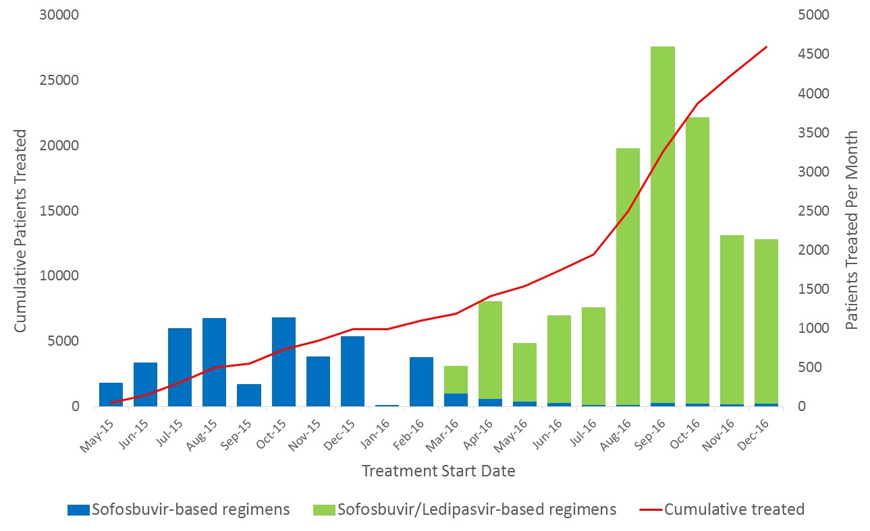

Figure 2: Percentage of hepatitis C virus (HCV)-infected patients who were enrolled† in treatment program by region — nationwide HCV elimination program, Georgia, April 28, 2015–December 31, 2016

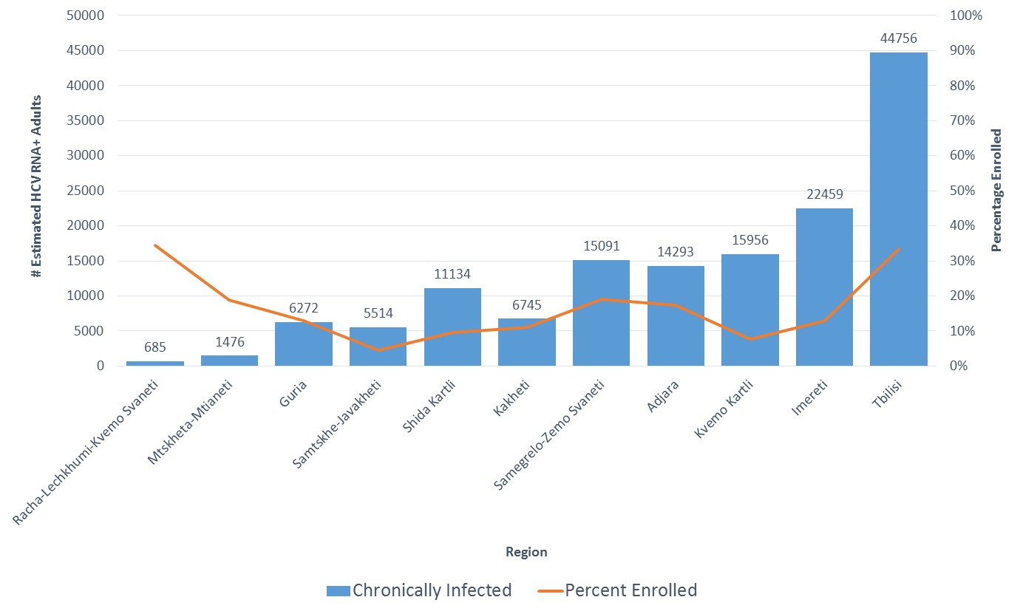
†Persons who test positive for HCV RNA and completed diagnostic workup

Table 1: Key activities for a nationwide hepatitis C elimination program — Georgia
Activities | Time period | Details | Status
Estimating hepatitis C virus (HCV) disease burden | 2015 | National seroprevalence survey | Completed
Information systems | 2015-present | Development of STOP-C national treatment database | Completed
Information systems | 2015-present | Development of ELIMINATION-C national treatment database launched since June 2016 | Completed*
Information systems | 2015-present | Development of national HCV screening database | Ongoing
Strategic plan for the elimination of HCV in Georgia, 2016 - 2020 | 2015-2017 | Components of the plan include:  (1) Advocacy, awareness and education  (2) Prevent HCV transmission through harm reduction** among persons who inject drugs, blood safety, infection control in healthcare and non-traditional healthcare settings  (3) Identification of persons through HCV screening  (4) Laboratory diagnostics  (5) Care and treatment  (6) Surveillance | Completed
Monitoring and evaluation | 2016 | Monitoring and evaluation key indicators relevant to 6 components of the strategic plan for the elimination of HCV in Georgia | Completed
Monitoring and evaluation | 2017 | First annual monitoring and evaluation report | Ongoing
Technical Advisory Group (TAG)*** | 2015-present | First (2015) and second (2016) annual TAG meetings held in Tbilisi | Completed
Screening | 2015-present | Assessment of national HCV screening programs | Completed
Screening | 2015-present | Development of national HCV screening guidelines/recommendations | Completed
Screening | 2015-present | National screening implementation plan | Ongoing
Treatment | 2015-present | Treatment sites expanded from 4 to 27 | Ongoing
Treatment | 2015-present | Capacity building through Tele-ECHO (Extension for Community Healthcare Outcomes) clinics, and Liver Institute and Foundation for Education and Research (LIFER) seminars | Ongoing
Baseline HCV-related mortality | 2016-present | Assessment of baseline HCV-related mortality using vital statistics, medical chart abstraction, and cancer registry | Ongoing
Infection prevention and control (IPC) | 2016-present | Assessment of IPC practices in hospital settings including dentists | Completed
Infection prevention and control (IPC) | 2016-present | Development of IPC training curriculum | Ongoing
Infection prevention and control (IPC) | 2016-present | Training of physicians, dentists and other allied medical personnel on IPC training | Ongoing
Laboratory diagnostics | 2015- present | Hepatitis diagnostic laboratory capacity using modified World Health Organization tool [7] | Completed
Laboratory diagnostics | 2015- present | Pilot studies for validation of Core Antigen test sensitivity and specificity as a screening and/or confirmatory test for HCV | Completed
Laboratory diagnostics | 2015- present | External Quality Assessment (EQA) of participating laboratories in the national HCV elimination program | Ongoing
Models of HCV elimination | 2016-present | Statistical models to prioritize high-risk, high-prevalence populations for achieving the HCV elimination goal | Ongoing
Targeting high-risk, high-prevalence groups | 2015 | Treatment effectiveness in prison system | Completed
Targeting high-risk, high-prevalence groups | 2017-present | Provision of HCV treatment at settings serving populations at high risk i.e., harm reduction** sites | Ongoing
Increase access to HCV treatment | 2017-present | Simplified diagnostics and monitoring of HCV-infected patients | Ongoing
Increase access to HCV treatment | 2017-present | Primary care physicians treating mild cases of HCV-infected patients | Ongoing
Annual workshops | 2014-present | 2014: HCV Elimination conceived  2015: Preparation for Launch  2016: Strategic plan for the elimination of HCV in Georgia, and monitoring and evaluation  2017: Implementing TAG Recommendations | Completed
National Scientific Committee | 2016- present | Formation of National Scientific Committee with permanent members from MoLHSA†, NCDC††, 4 major clinics in Tbilisi, and CDC | Completed
National Scientific Committee | 2016- present | Analyses of ongoing HCV treatment data, research proposals, pilot studies, abstract and manuscript writing and dissemination | Ongoing
*Undergoing improvements and merging with STOP-C
**Centers providing services such as opioid substitution therapy and needle and syringe provision to people who inject drugs

***A total of 10-15 experts in the field of viral hepatitis prevention and control from outside the country of Georgia serve as members of TAG

†Ministry of Labour, Health, and Social Affairs, Georgia
†† National Center for Disease Control and Public Health, Georgia

Persons who test positive for HCV RNA and completed diagnostic workup.
Sustained virologic response (SVR) is defined as undetectable (or below the lower limit of quantification) HCV RNA at 12–24 weeks after cessation of treatment (Wedemeyer H et al., 2012)
The METAVIR score is a semi-quantitative classification system that consists of an activity score and a fibrosis score, specifically designed and validated for patients with HCV (Bedossa P et al., 1996)

